
- Home
- About Us
- Products & Services
- How We Work
- Contact Us
- Download

Request for Quotation
Get Demo




Software & Solution
Software is an essential component of modern technology, and software solutions can provide effective solutions to a wide range of problems. By automating tasks, improving collaboration, and providing valuable insights, software can help businesses and individuals become more productive and efficient. As technology continues to evolve, we can expect to see even more innovative software solutions that will help us work smarter and achieve our goals more effectively. Software solutions is their ability to automate repetitive tasks, allowing users to focus on more valuable work. For example, a marketing team can use marketing automation software to streamline their campaigns and reduce the time and effort needed to carry out various tasks. Similarly, a customer service team can use a ticketing system to manage customer requests more efficiently, reducing the workload on individual agents.

Our featured products
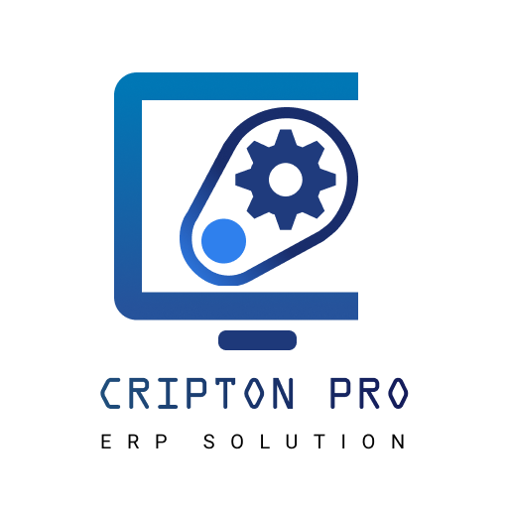

CRIPTON PRO
ERP solution

CORE MODULES
- CRIPTON PRO
- ERP SOLUTION
- Human Resources & Payroll.
- Self Service Portal.
- Purchase & Procurement.
- Inventory Management.
- Commercial.
- Accounts.
- Merchandising.
- IE Planning.
- Production Management System.
- Asset Management System.
- Vehicle Management System.
- Visitor Management System.
- Gate Pass Management System.
- Management Information System (MIS).
- Mobile Application (iOS & Android)

See video
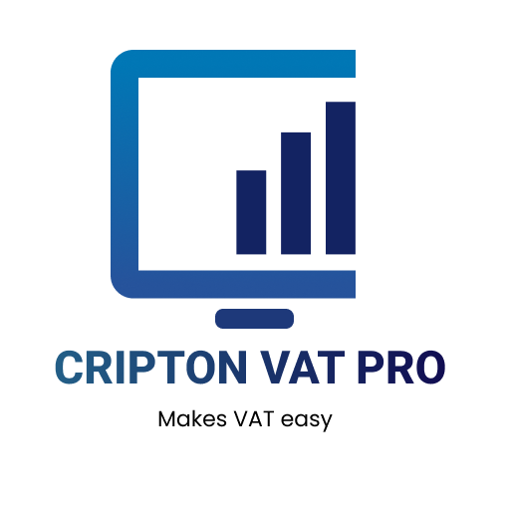

CRIPTON VAT PRO
Makes VAT easy

CORE MODULES
- Dynamic product management for all industries and categories.
- Product HS code integration.
- Supplier and customer management.
- Local and foreign purchase. .
- Multi warehouse manage. .
- Product tracking by barcode system. .
- Product quality control.
- BOM for finished goods. .
- Production process.
- Distribution process.
- Sales and collection.
- Customer relationship management.
- Customer visit log tracking.
- Accounting solution.
- Profit and loss statement
- Accounts receivable and payable.
- Mushak reports (NBR complaint)
See More
See video
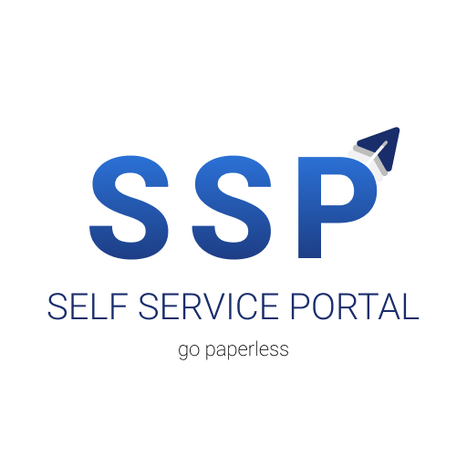

Self Service Portal
Go paperless

CORE MODULES
- Document creation
- Workflow creation
- Requistions
- Approvals
- Implementation
- Audit
See video
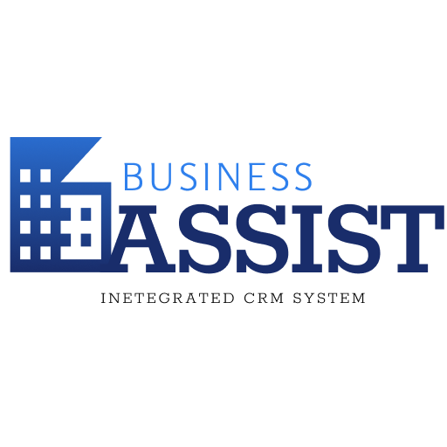

BUSINESS ASSIST
Integrated CRM System

CORE MODULES
- CRIPTON PRO
- ERP SOLUTION
- Human Resources & Payroll.
- Self Service Portal.
- Purchase & Procurement.
- Inventory Management.
- Commercial.
- Accounts.
- Merchandising.
- IE Planning.
- Production Management System.
- Asset Management System.
- Vehicle Management System.
- Visitor Management System.
- Gate Pass Management System.
- Management Information System (MIS).
- Mobile Application (iOS & Android)
See video


ALUMNI CONNECT
Connecting Endless

CORE MODULES
- Easy connection with the alumni & fellows within the institute
- Secure and faster
- Integrated news, shout, job, event, article, advertisement, etc portal feature
- Integrated dynamic notification
- Dynamic user and profile management
- Seamless integration with dynamic admin panel
- One-to-one communication (secure) feature
- All available & important 3rd parties integration (payment, sms, mail, etc)
- Cloud-enabled
- Mobile Application (iOS & Android)
See video



With a mission to deliver Excellence, through Innovation in designing solutions, implementing those in an innovative way using the right technologies. Pakiza Technovation Limited is the newest concern of renowned Pakiza Group, the standard of excellence in all its business sectors. Pakiza Technovation Limited always love to optimize, not to be lowest price, its solution to meet its client’s requirement & thus ensure value for money.

Address
Head office : House# 97, Road# 11/A,
Dhanmondi, Dhaka-1209, Bangladesh
+880 9612 811 111
info@pakizatvl.com
Registered office: Khordo Nowpara,Rasulpur Narsingdi (Sadar), Narsingdi-1600, Bangladesh

Get Connected

App privacy and policy


© 2023 Pakiza Technovation Limited

