
- Home
- About Us
- Products & Services
- How We Work
- Contact Us
- Download

Request for Quotation
Get Demo

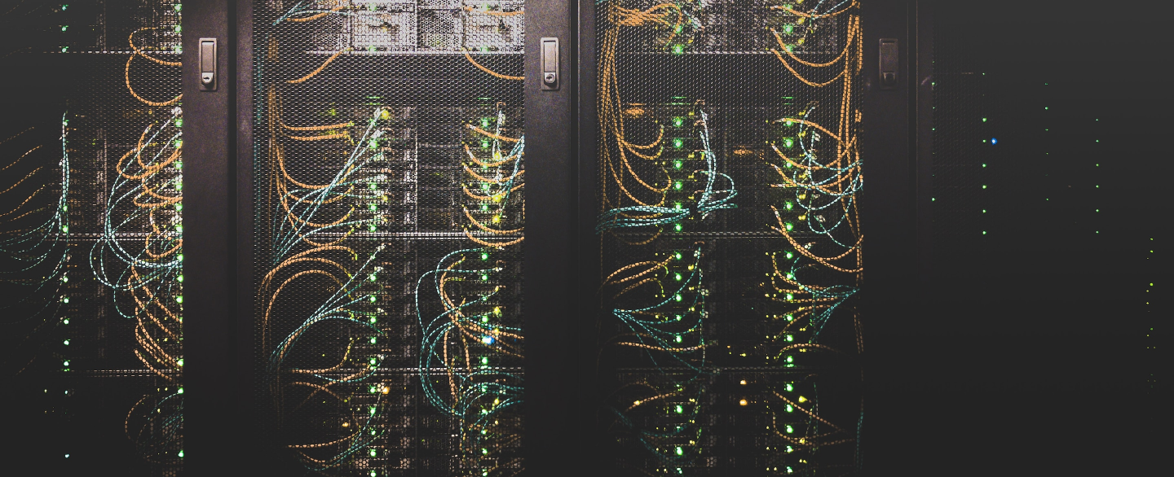


Data center Infra Solution
A Comprehensive architectural solution for growing BUSINESS
A data center infrastructure solution typically refers to the hardware and software components that make up a data center, including servers, storage systems, network equipment, backup and disaster recovery systems, and various management tools. The goal of a data center infrastructure solution is to provide a secure, scalable, and reliable platform for storing, processing, and managing large amounts of data and applications. A comprehensive data center infrastructure solution may also include features such as virtualization, cloud computing, and automation to maximize efficiency and reduce costs.

Solutions We Cover

COMMSCOPE
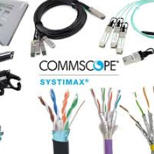
CommScope Inc. is an American global network infrastructure provider company.
“SYSTIMAX” is one of the world's leading networking solutions portfolio under CommScope.

ROSENBERGER
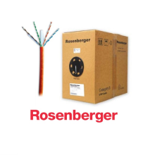
Rosenberger designs and manufactures connectors that are engineered to reliably transmit data and power in numerous types of applications with various requirements.

Precision air conditioner(PAC)
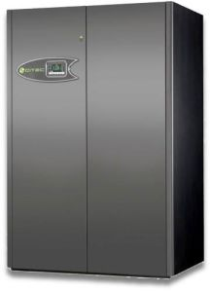
The precision air conditioners are refrigerating equipment specifically designed to provide precise control of temperature and humidity in all applications in which is required a very high degree of precision

Envoirnment management soltuion(EMS)
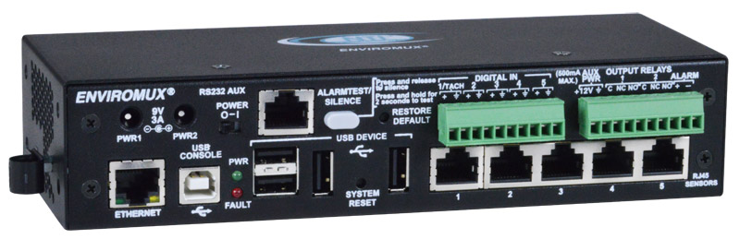
In a data center, there are many pieces of hardware and equipment that make up the moving parts necessary to protect critical information.
- Sensors Types
- Temperature detection
- Humidity detection
- Liquid detection
- Vibration detection

Online UPS
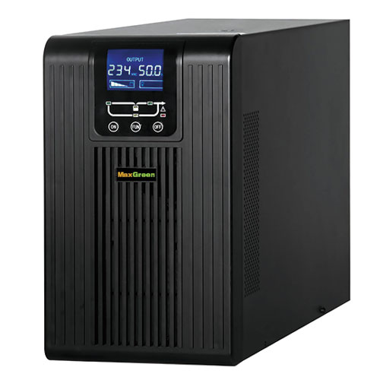
On-line UPS is its ability to provide an "electrical firewall" between the incoming utility power and sensitive electronic equipment. The online UPS is ideal for environments where electrical isolation is necessary or for equipment that is very sensitive to power fluctuations.
“SYSTIMAX” is one of the world's leading networking
- Total IT Infrastructure Solution (Copper & Fiber)
- Modular Data Center Solution (MDC).

Fire protection
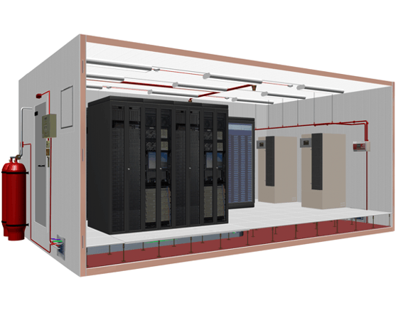
There are numerous fire risks present in data centers, large and small. Fires can occur within the digital equipment, wires, cables, HVAC equipment, raised floors, suspended ceilings, and other combustibles found in data centers

Also discover


Hardware solution
HP, HPE, CISCO, JUNIPER, F5, FORTINET, SHOPHOS



Manged Service
BreakFix, Monitoring, Help desk, Resource outsourcing



Security & Surveillance
HikVision, ZKTEco, Grrrett, Suprema, P A System

Request a Quote
Confuse about product or project budget? Tell us more about your idea. Our expert team will evaluate your idea(s) and provide you a guideline
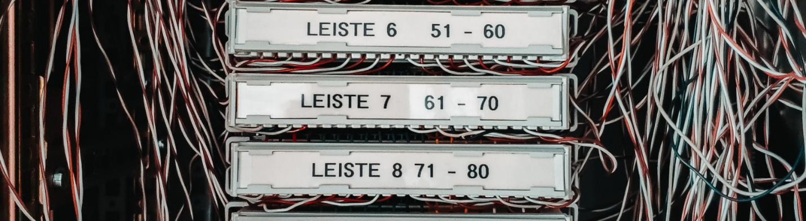
Your Name
Email
Contact No
Company
What You Need ?
Reference Sources
Your Queries
Submit Your Request


With a mission to deliver Excellence, through Innovation in designing solutions, implementing those in an innovative way using the right technologies. Pakiza Technovation Limited is the newest concern of renowned Pakiza Group, the standard of excellence in all its business sectors. Pakiza Technovation Limited always love to optimize, not to be lowest price, its solution to meet its client’s requirement & thus ensure value for money.

Address
Head office : House# 97, Road# 11/A,
Dhanmondi, Dhaka-1209, Bangladesh
+880 9612 811 111
info@pakizatvl.com
Registered office: Khordo Nowpara,Rasulpur Narsingdi (Sadar), Narsingdi-1600, Bangladesh

Get Connected

App privacy and policy


© 2023 Pakiza Technovation Limited

