AUTONOMOUS CRYPTO TRADING SYSTEM
Crypto Trading Bot
Backtested. Paper-proven. Ready to trade — with you in control.

A desktop trading bot that scans markets, proposes trades from proven strategies, and executes on a schedule — while a live equity curve, risk guardrails, and a one-click paper/live switch keep you fully in command.
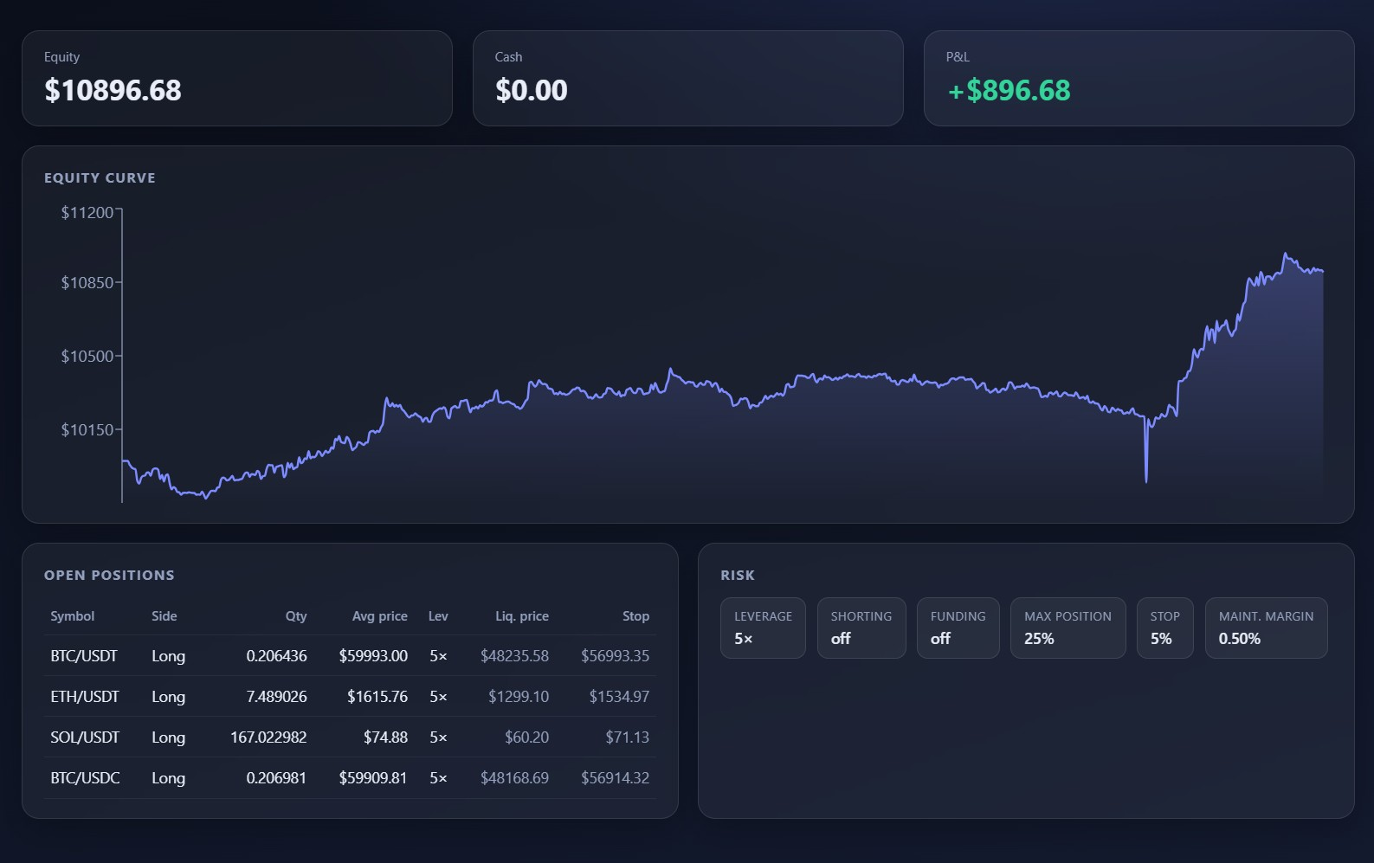
Live paper account: equity $10,896.68 — up +$896.68 (+8.97%) across BTC, ETH and SOL positions, all risk-managed at 5× with hard stops.
The numbers that matter
9,120  strategies backtested | 15 yrs  of market data | +8.97%  paper account P&L | 6  validation filters

What you're getting
The Crypto Trading Bot is a self-contained desktop application that trades crypto for you — end to end. It pulls live prices, runs your chosen strategy every cycle, ranks the best opportunities, and either places the trade automatically or hands you a one-click Execute button. Nothing is a black box: every suggestion shows the exact signal that produced it, every position shows its liquidation and stop price, and every dollar of P&L updates in real time.
Most bots ask you to trust them blindly. This one does the opposite — it shows its work.

Built in
- Real-time dashboard — a live overview with equity, cash, P&L, an equity curve and open-position table.
- Approve-to-trade — trade only when you approve, or let the scheduler run cycles hands-free.
- Paper mode — test any strategy for free against 15 years of history before a single real dollar moves.
- Risk engine — per-trade leverage, max position size, stop-loss and maintenance-margin guardrails baked in.
- Multiple strategies — MA cross, MACD, Bollinger, RSI reversion and more, each independently validated.
- On-device backtesting — a full backtester built into the app, plus market sentiment and activity feeds.

The app, in action
Everything runs from one clean control panel. The left rail switches between Overview, Positions, Pairs, Activity, Sentiment and the Backtester. A permanent Mode switch (Paper / Live) and Strategy selector sit at the bottom — so you always know exactly what the bot is doing and with what money.

1 · Live overview
Equity, cash and P&L across the top. A smooth equity curve underneath. Open positions with entry, leverage, liquidation and stop prices — plus a risk panel showing your live guardrails. This is the paper account compounding a real strategy in real time.
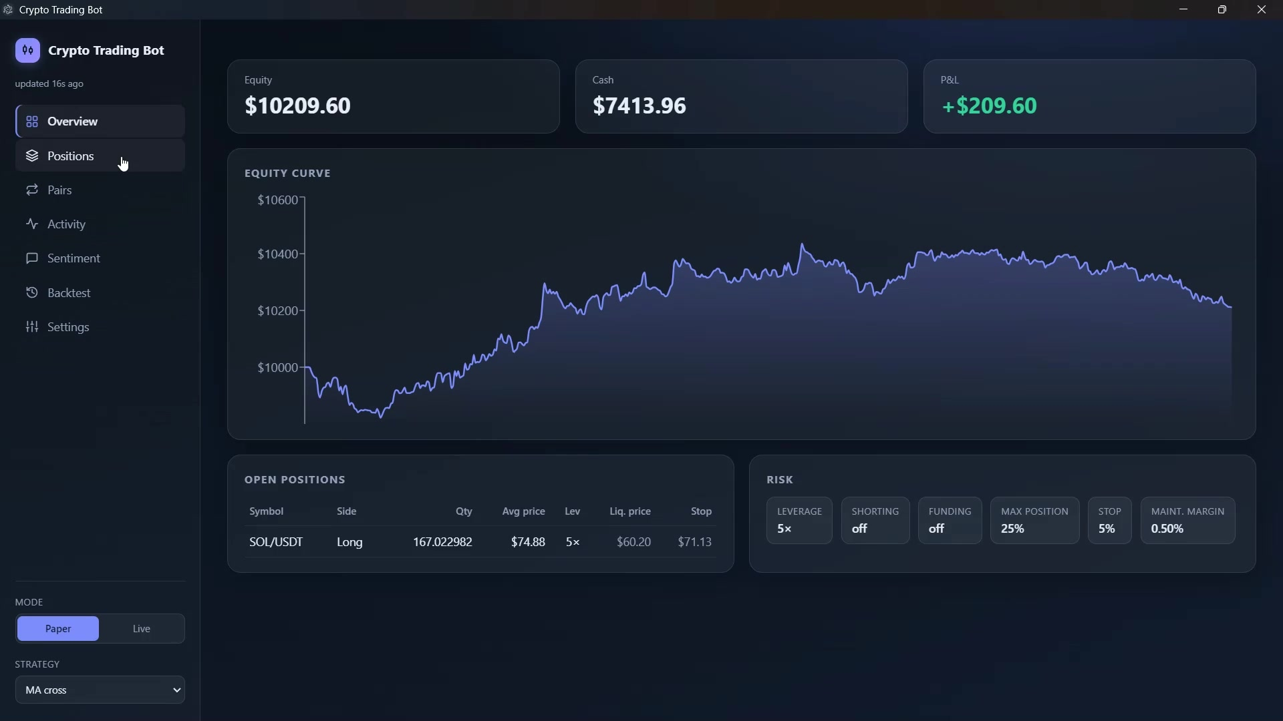
Overview — +$209.60 and climbing on a 5× MA-cross strategy, running in Paper mode.

2 · Approve-to-trade
When auto-execute is off, the bot proposes and you decide. Each card shows the pair, the side, the exact signal (e.g. MA golden cross, fast vs slow), the live price and the time. Hit Execute to take it or Dismiss to skip. No surprises, no hidden orders.
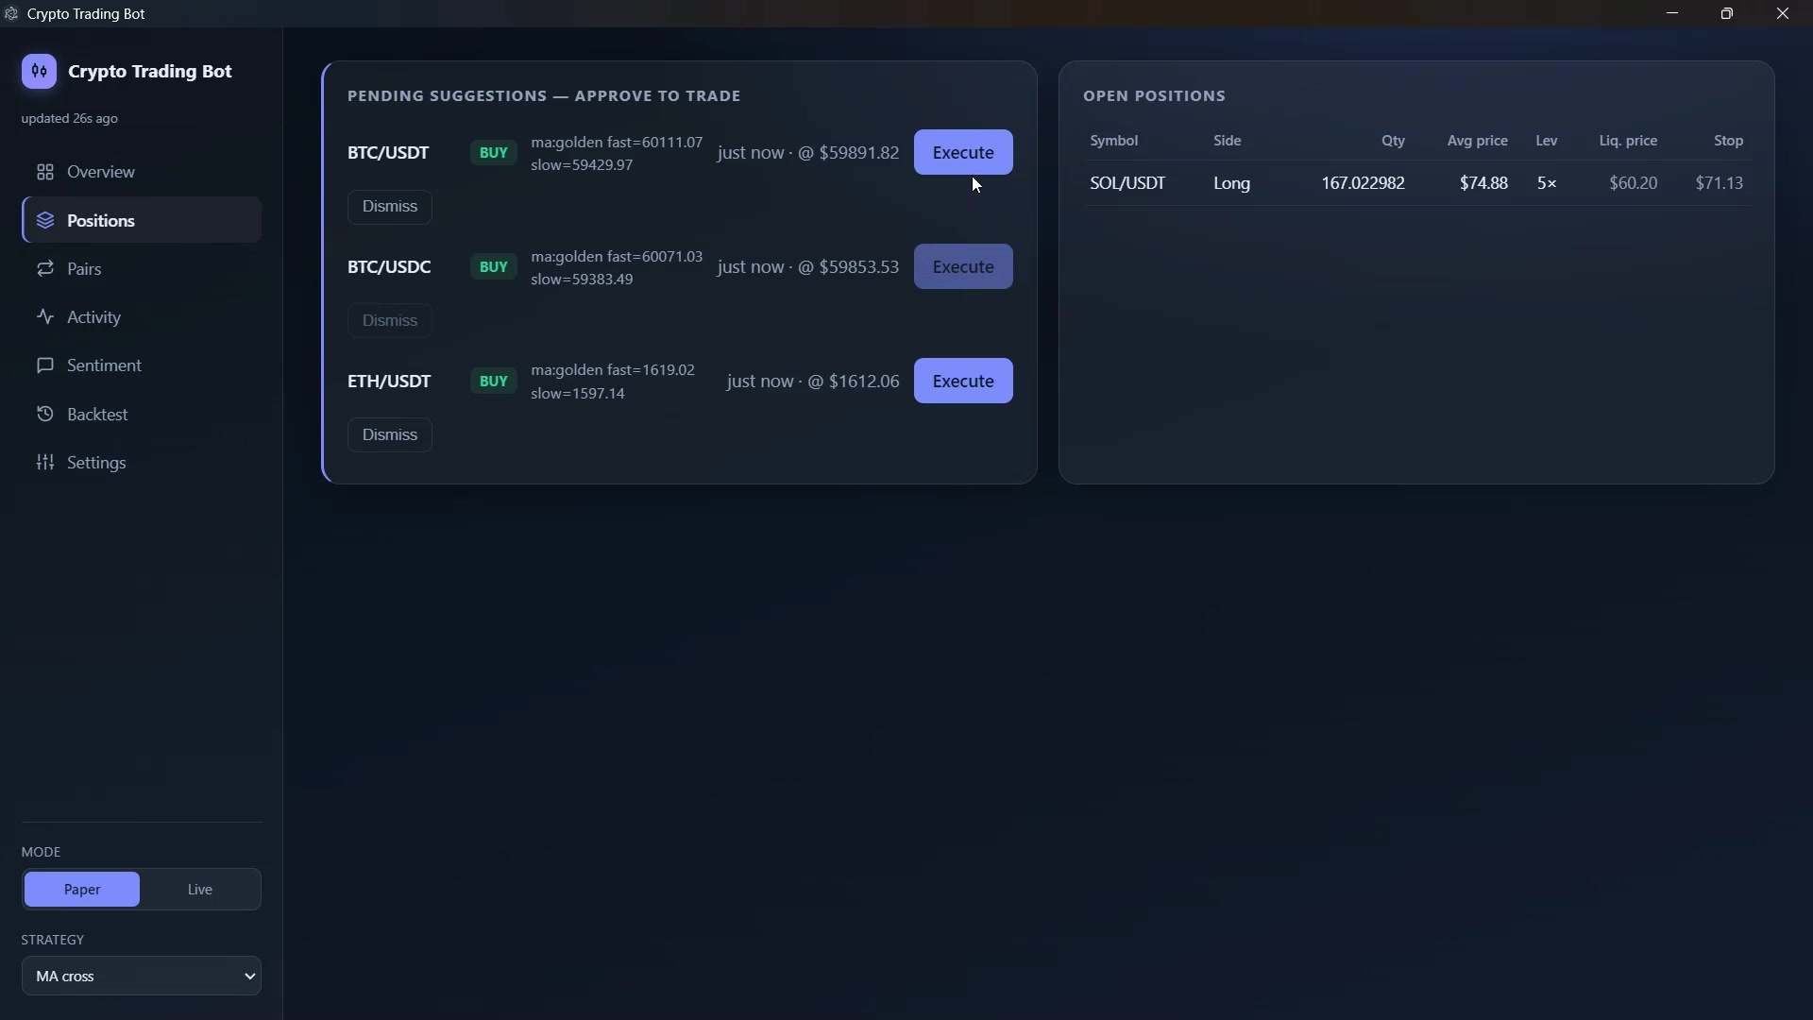
Pending suggestions with the raw signal that generated each one — approve or dismiss with one click.

Paper trading mode — risk nothing while you learn
Every feature works identically in Paper mode, except the money is simulated. Run strategies, take suggestions, watch the equity curve move, backtest across years — all with zero capital at risk. When you're ready, flip a single switch to go Live.
Going Live is deliberately hard to do by accident. The bot double-confirms and will only place real orders when an explicit LIVE_TRADING_ARMED=yes flag is set in its environment — so a stray click can never move real funds.
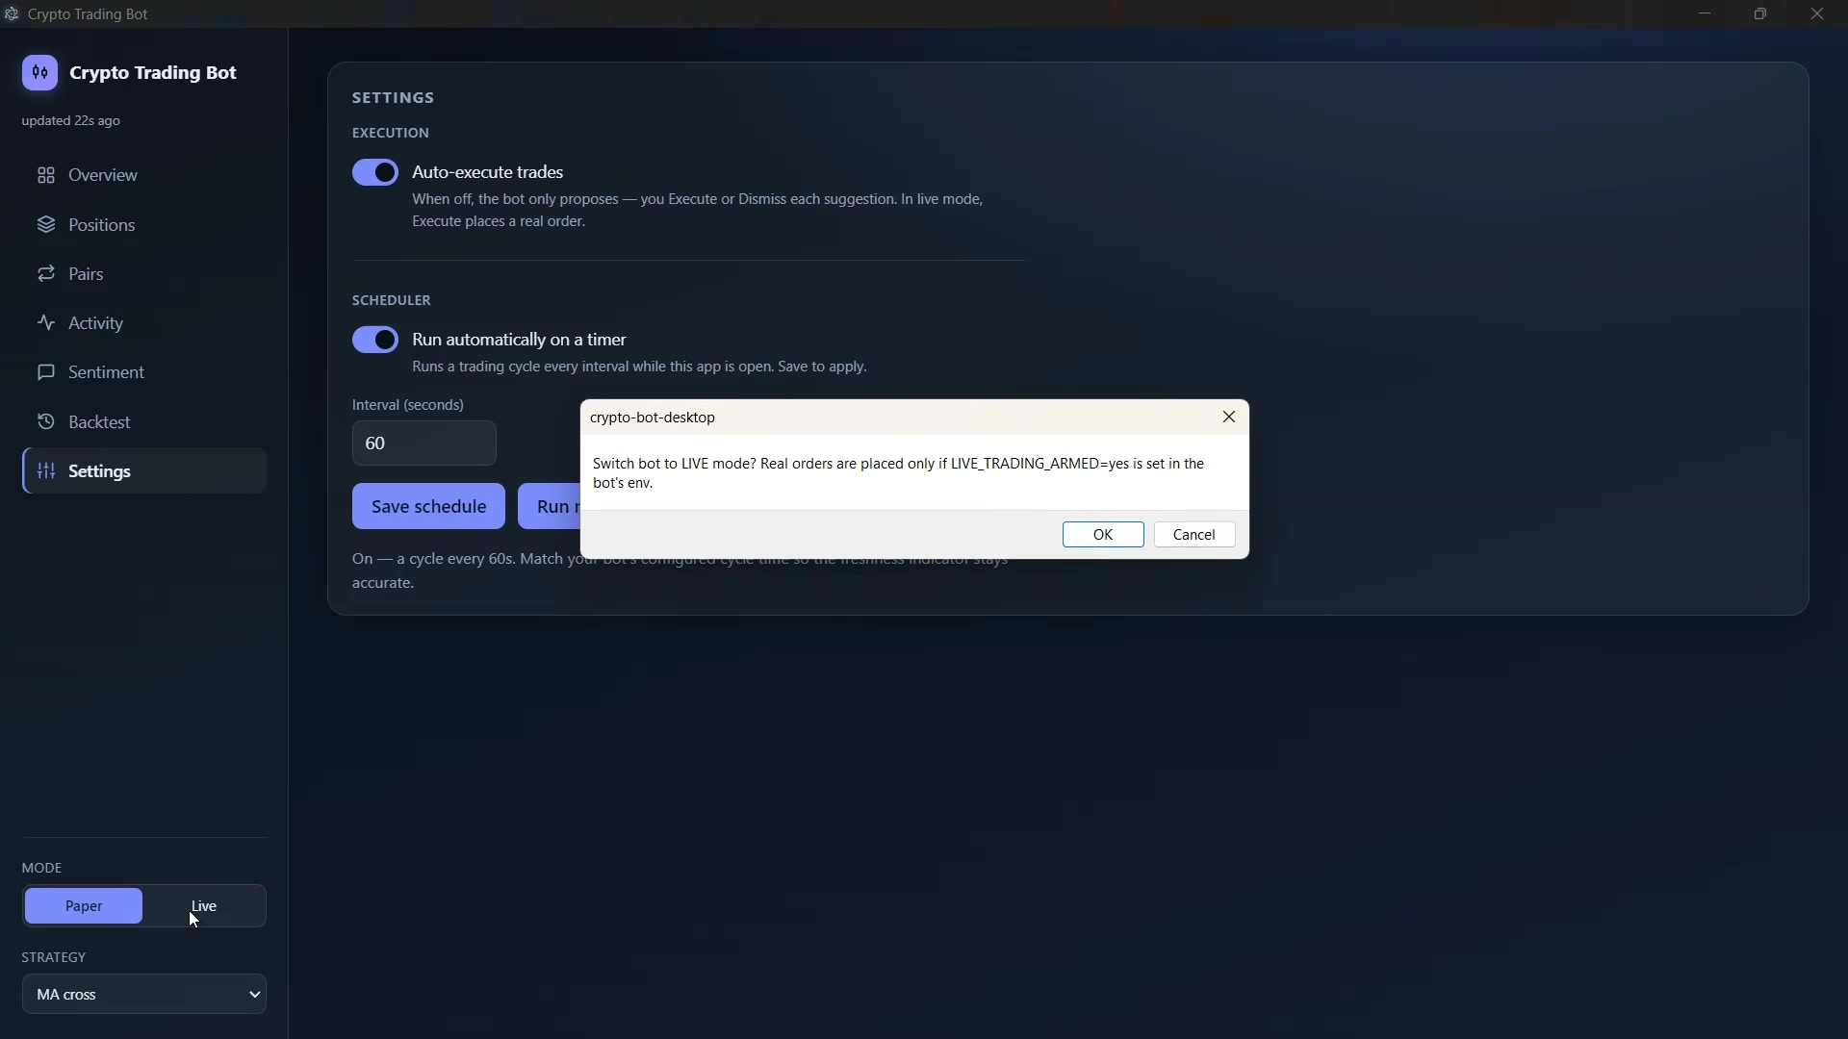
Auto-execute, scheduler and the Paper/Live switch — with a hard safety confirmation before any real order.
Paper  risk-free simulation | 1-click  flip to live when ready | Armed  flag required for real orders

Backtesting is built in
You don't need to trust a marketing number — run it yourself. The in-app backtester replays any strategy across your chosen symbols and date range, then plots your strategy against a simple buy-&-hold benchmark and logs every run with return, alpha vs. hold, trade count and max drawdown.
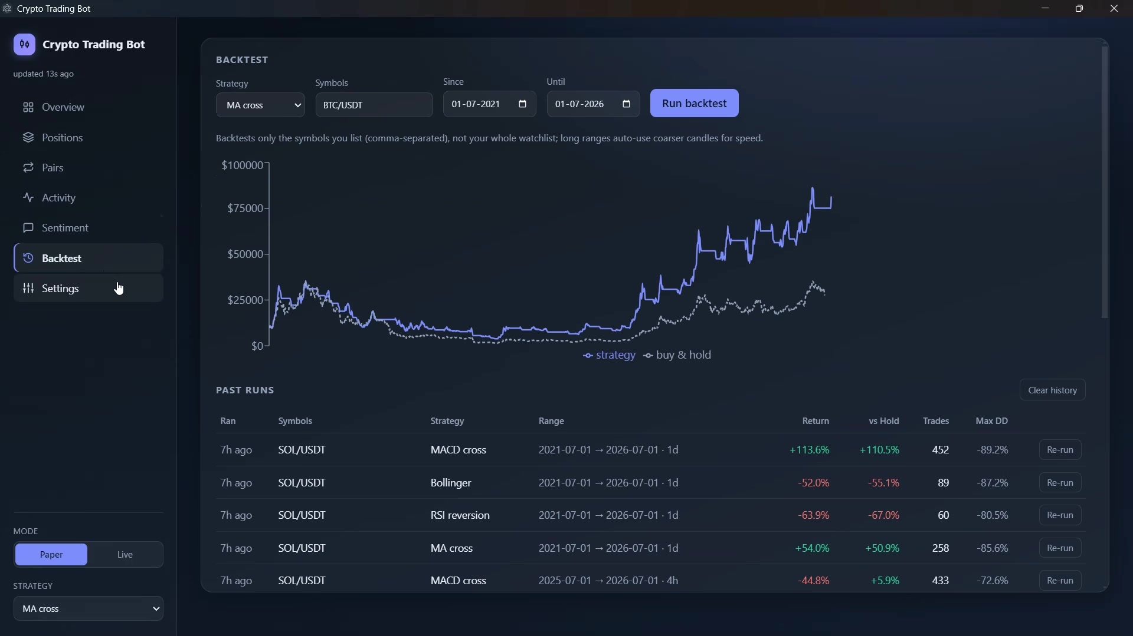
In-app backtest: MA cross on SOL/USDT returns +54.0% (+50.9% vs. buy-&-hold) with the full run history logged.

Sample of logged runs
Strategy | Symbol | Return | vs. Hold | Trades | Max DD
MACD cross | SOL/USDT | +113.6% | +110.5% | 452 | -89.2%
MA cross | SOL/USDT | +54.0% | +50.9% | 258 | -85.6%
RSI reversion | SOL/USDT | -63.9% | -67.0% | 60 | -80.5%
Bollinger | SOL/USDT | -52.0% | -55.1% | 89 | -87.2%
The bot doesn't hide the losers. You see which strategies win, which don't, and on what — so you deploy the edge, not the hope.

I backtested 9,120 strategies with Claude Code
This bot isn't built on a hunch. I used Claude Code to build a full strategy-validation terminal and run 9,120 backtests across 30 assets and 15 years of market data — every popular strategy family, in its raw base form, put through a brutal validation gauntlet. Only the strategies that genuinely survive out-of-sample make it into the bot.
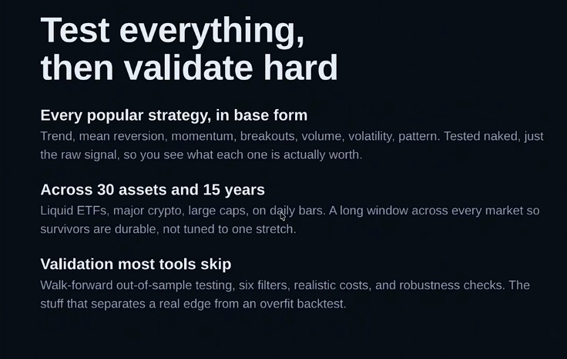
The philosophy: test every popular strategy naked, across 30 assets and 15 years, then validate harder than most tools ever do.
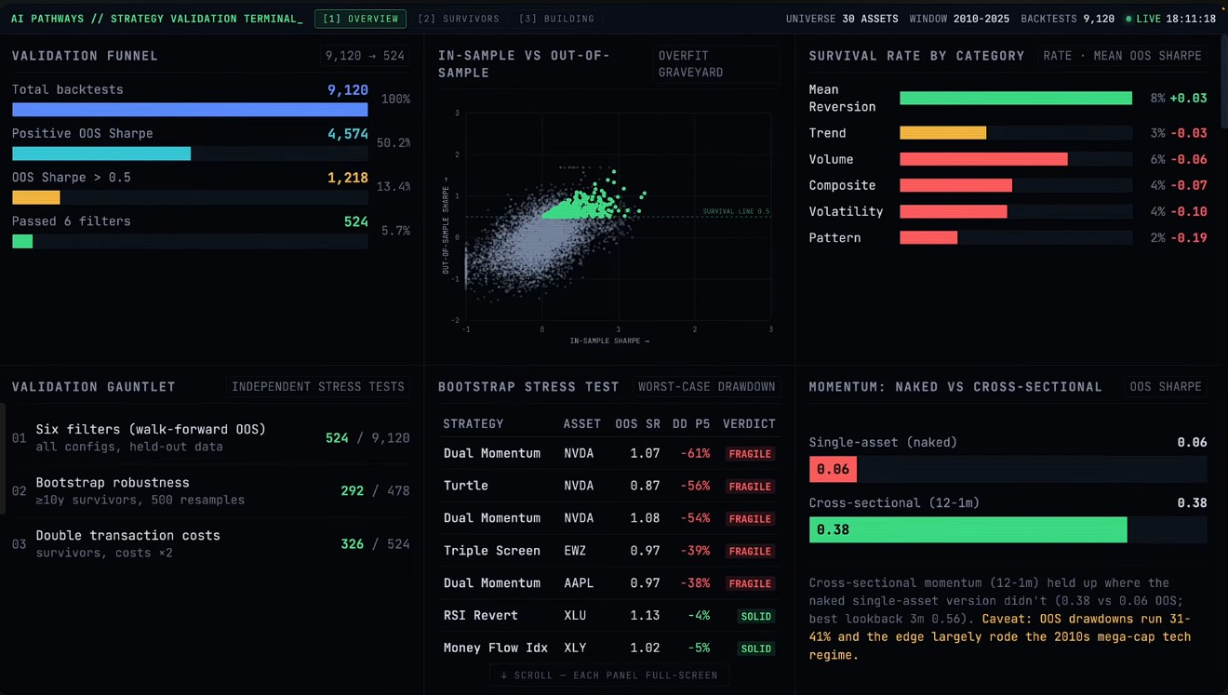
The Strategy Validation Terminal built with Claude Code — 9,120 backtests, survival rates, stress tests and overfit detection in one view.

The validation funnel: 9,120 → 524
A backtest that looks good in-sample means nothing. Every strategy was pushed through six sequential filters on held-out, walk-forward out-of-sample data. Only 524 of 9,120 — 5.7% — survived all six.
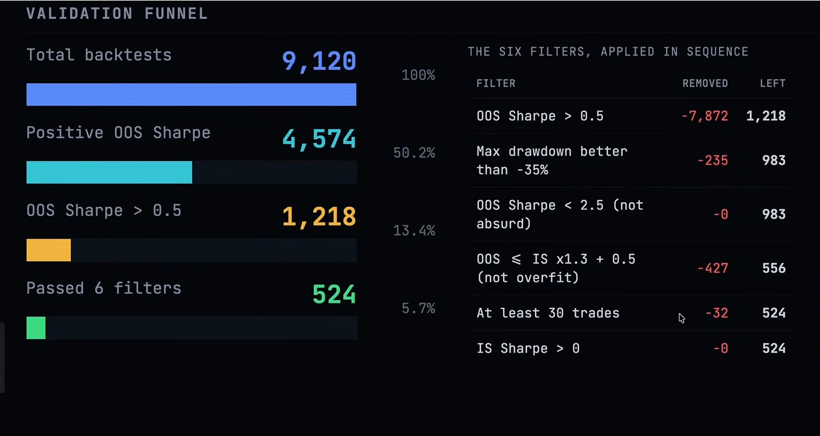
The six filters, applied in sequence: out-of-sample Sharpe, drawdown limits, overfit checks, minimum trade counts and more.
Stage | Strategies left | % of total
Total backtests run | 9,120 | 100%
Positive out-of-sample Sharpe | 4,574 | 50.2%
Out-of-sample Sharpe > 0.5 | 1,218 | 13.4%
Passed all 6 filters | 524 | 5.7%

In-sample vs. out-of-sample: the honesty test
Half of all strategies that looked profitable in-sample went negative out-of-sample. That's exactly the trap that blows up retail traders — and exactly what this validation is designed to catch before your money is involved.
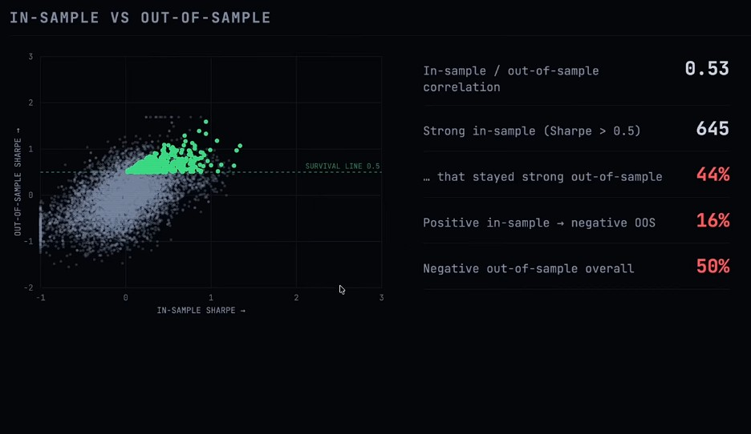
In-sample vs. out-of-sample Sharpe. Only strategies above the 0.5 survival line — that stayed strong out-of-sample — are kept.

What actually held up
Across categories, one clear signal emerged: mean reversion was the only family with a positive average out-of-sample Sharpe. 304 of the 478 survivors — 64% — were mean-reversion strategies. Trend, volume, volatility and pattern strategies clustered at or below zero. The bot is weighted toward what survived, not what sounded good.
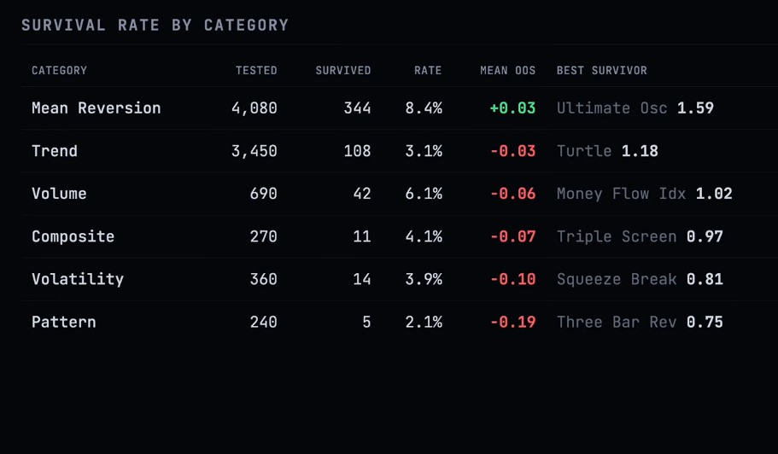
Survival rate by category — mean reversion leads with a positive mean out-of-sample Sharpe; everything else clusters near zero.
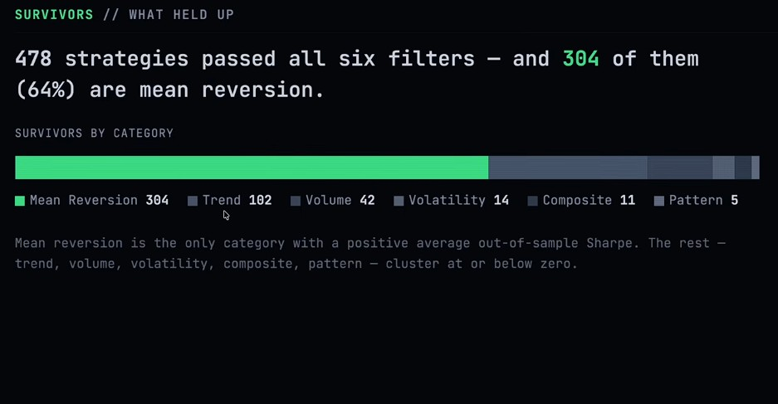
The survivors: 478 strategies passed all six filters — and 64% of them are mean reversion.

Why this bot is different
 | Typical crypto bot | Crypto Trading Bot
Strategy basis | Marketing claims | 9,120 validated backtests
Out-of-sample proof | None shown | 6-filter walk-forward gauntlet
Control | Fully automatic black box | Approve-to-trade + auto mode
Risk-free trial | Rare | Full paper mode, free
Safety | One click to real money | Armed-flag + double confirm
Transparency | Hidden signals | Every signal shown
Most bots sell you a promise. This one hands you the evidence, the controls and a risk-free way to prove it — then lets you decide.

READY TO TRADE SMARTER?
Get the Crypto Trading Bot
Reserve your copy in under 60 seconds. Tell me your setup and I'll get you running in Paper mode today — go Live only when you're convinced.
GET STARTED — FILL THE FORM
forms.gle/Wy3F2ypDu4UYbCiX9
Or reach me directly
EMAIL  govindnarayangoel395@gmail.com | WEBSITE  govindgoel.vercel.app | MY OPERATING SYSTEM  myhermes.cloud
Built with Claude Code. Trade responsibly — crypto is volatile and past backtest performance does not guarantee future results.

