**Software Requirements Specification (SRS)**

**1. Introduction**

1.1 Purpose

This is basically a hospital website that has been created to ensure patients get proper treatment and proper management.

It can also be said that the management of a large hospital has been made easier so that the hospital authority can easily maintain everything.

Therefore, according to the needs, this platform is very important.

Finally, it can be said that this document describes the necessary requirements and specifications of the platform.

1.2 Document Conventions

● Abbreviations:

o SHP: Sakhawat Hosen Pranto

o UI: User Interface

●The document follows IEEE standards for SRS documentation.

1.3 Intended Audience and Reading Suggestions

The main readers of this document are developers, the hospital chairman, and the hospital management team.

Developers should focus on Sections 3 and 4 for the required needs, while the chairman and management should look at Sections 1 and 2 for scope and features

1.4 Project Scope

SHP Hospital is a web application made to connect patients so they can easily get proper treatment with proper management.

This platform includes doctors, nurses, departments, online appointment booking, room booking, and many other facilities.

The main goal is to keep patients healthy by making treatment services easier and at the same time making hospital management more simple and efficient.

1.5 References

● Tailwind CSS documentation

● react with PHP and MySQL database.

**2. Overall Description**

2.1 Product Perspective

My platform is an independent web app built using MySQL, CSS, PHP, and HTML. It will serve as a central hub between patients and the hospital.

2.2 Product Features

● Landing Page: Displays an overview of the platform’s purpose and features.

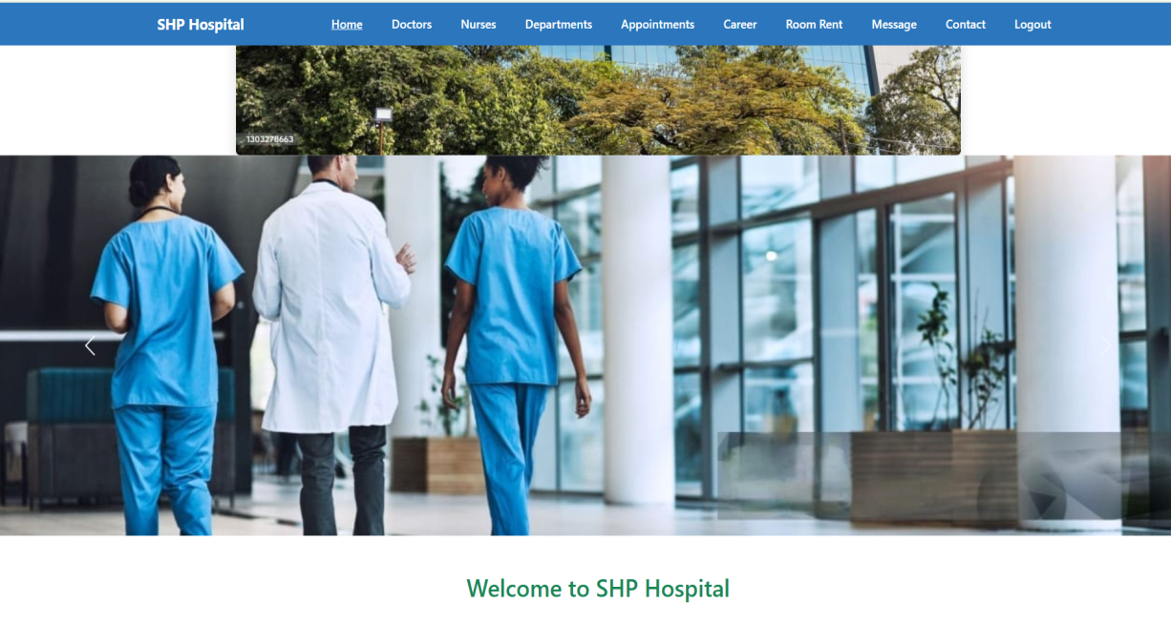

● Add-to-appoinment: Allows patients to add, view doctors and confirm their

appointment.

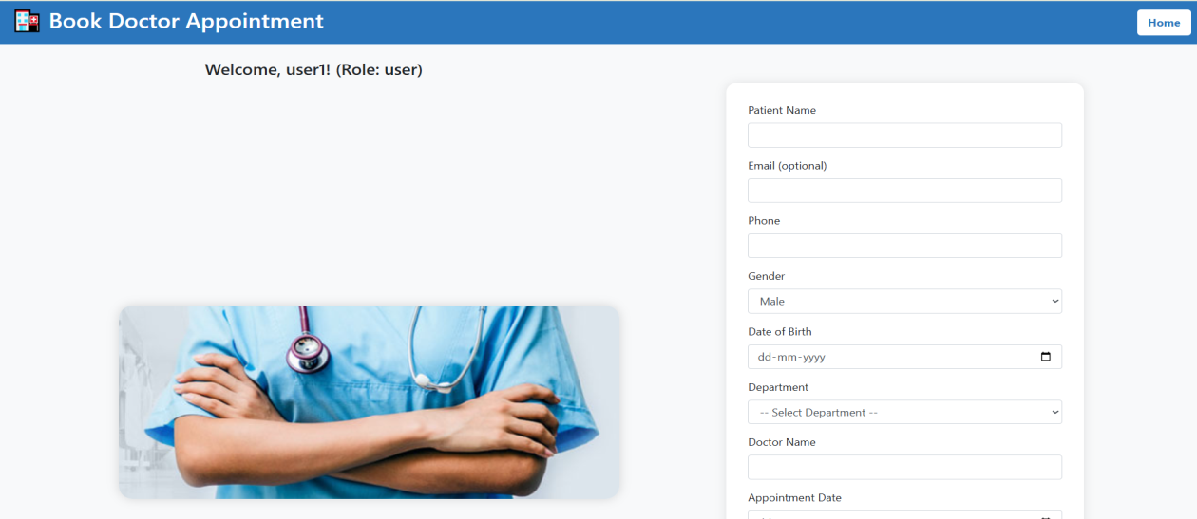

● Categories Page: Categorizes department and doctors for basic

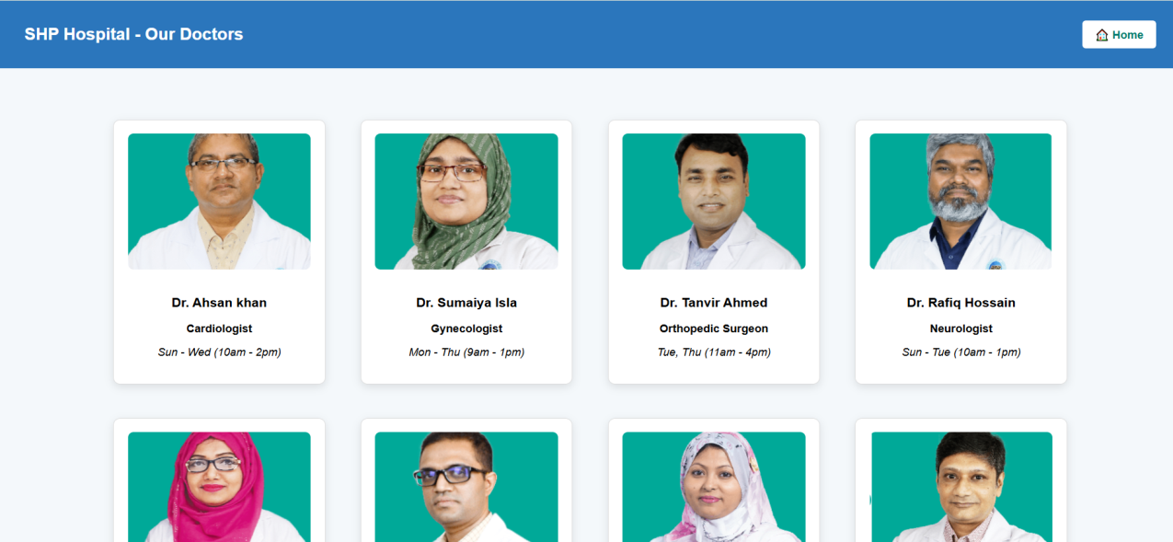

.

●Contact our Page:Patient can contact with the hospital.

.

● Login/Sign-Up Pages: Handles user authentication.

2.3 User Classes and Characteristics

● User1: Patients will receive medical services according to their needs.

● Admins: Users managing the platform.

2.4 Operating Environment

● Frontend: Tailwind CSS,HTML

● Backend: PHP+html

● Database: SQL/MYSQL

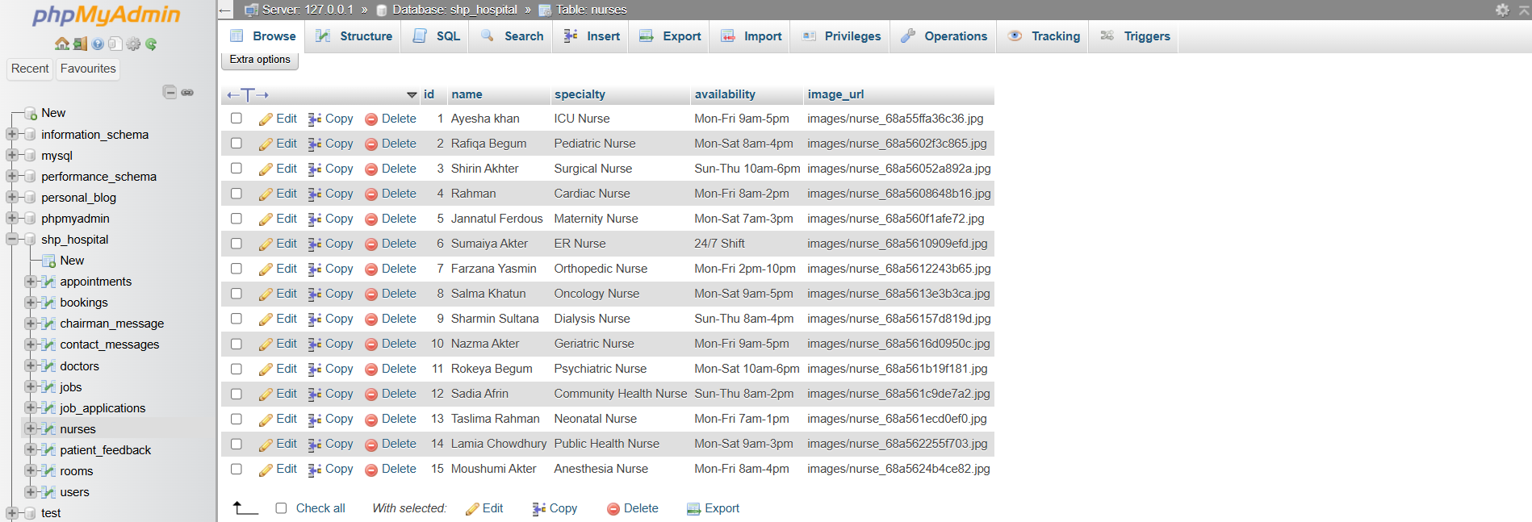

Specify the hardware, software, and other environments the software will run on.

2.5 Design and Implementation Constraints

● Mobile-first design for responsiveness.

●Compliance with all aspects of hospital management.

2.6 User Documentation

● User guides and FAQs accessible via the platform.

2.7 Assumptions and Dependencies

● Users have access to a stable internet connection.

● They comply with all aspects of hospital management.

**3. System Features**

3.1 User Authentication

● Description and Priority: Ensures secure access for patients and website viewer

for High priority.

● Stimulus/Response Sequences: Usersr log in to access features.

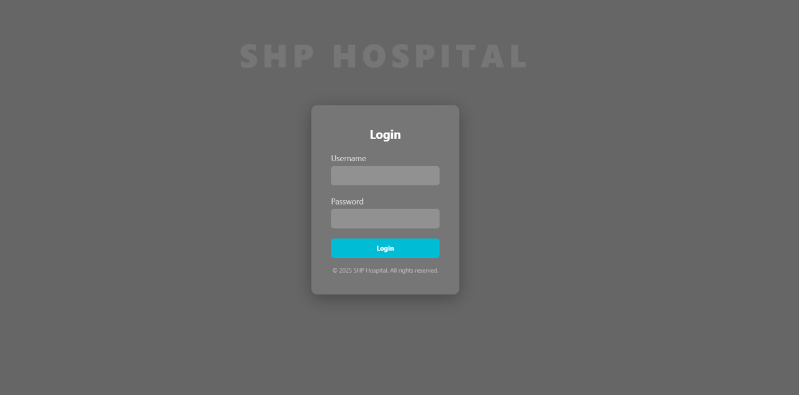

● Functional Requirements:

o Authentication tokens (JWT) for secure sessions.

**3.2 Service Listing and Categories**

● **Description and Priority:** Allows hospital staff to list available medical

services and patients to browse by categories. High priority

●**Stimulus/Response Sequences:** Hospital staff upload service details, and

patients filter services by type or specialty.

●**Functional Requirements**

●Staff can add service descriptions, relevant documents, and costs.

●Patients can search by categories such as General Consultation,

Anesthesia,Cardiology,Dental,ICU,Burn and Plastic surgery e.t.c

3.3 Service Selection & Booking

●**Description and Priority:** Simplifies the appointment process for patients.

High priority.

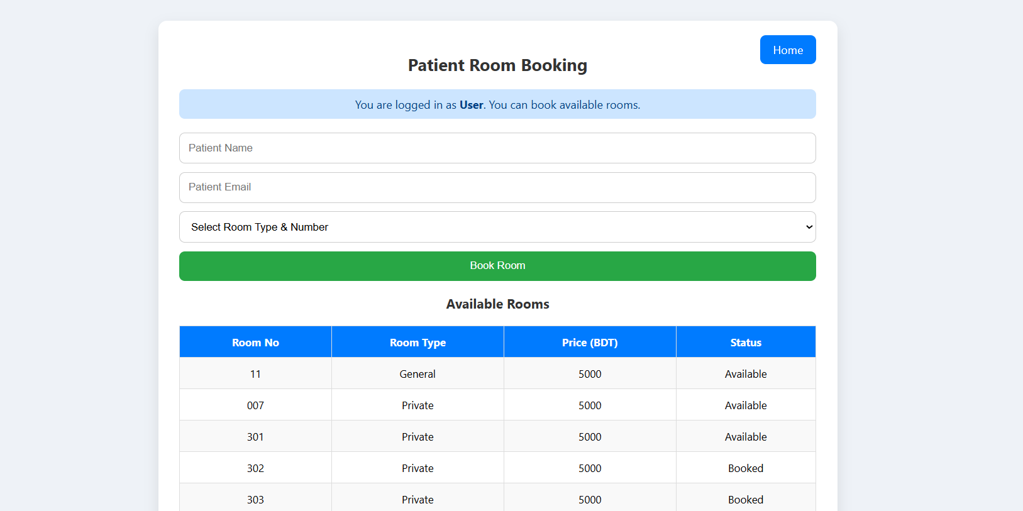

● **Stimulus/Response Sequences:** Patients select a doctor from the list and fill

out the booking form to schedule an appointment.

●**Functional Requirements:**

●Patients can view available doctors and their specialties.

●Patients can fill out a booking form to request an appointment.

● System records appointment details and confirms booking

**4. External Interface Requirements**

4.1 User Interfaces

●Intuitive and responsive UI designed with Tailwind CSS.

●Includes forms, buttons, and tabs for navigation.

4.2 Hardware Interfaces

● Supports standard desktops, laptops, and mobile devices.

4.3 Software Interfaces

●Integrates with MYSQL/SQL for authentication.

●Uses SQL(phpmyadmin) for data storage.

. 4.4 Communications Interfaces

●HTTPS for secure data transmission.

**5. Other Nonfunctional Requirements**

5.1 Performance Requirements

● Fast page loads (<2 seconds).

● Smooth interaction on mobile and desktop.(used bootstrap)

5.2 Safety Requirements

● Secure handling of user credentials.

5.3 Security Requirements

● Data encryption for sensitive information

.

● Protection against common web vulnerabilities (e.g., SQL injection).

5.4 Software Quality Attributes

● We can easily maintain and have a scalable codebase.

● High usability for all user types.

**6. Other Requirements**

● Analytics dashboard for admins to monitor usage.

●Users can book doctors as needed

●rent rooms based on price whenever required.

**Appendices**

A. Terminology

●Doctor:Doctor details are provided so that booking can be done easily.

●Appoinment: Patients can easily make appointments**.**

●Room rent:Room rent is easy, and patients can rent a room whenever

they want.

●Hospital job offer: Hospitals provide also job facilities

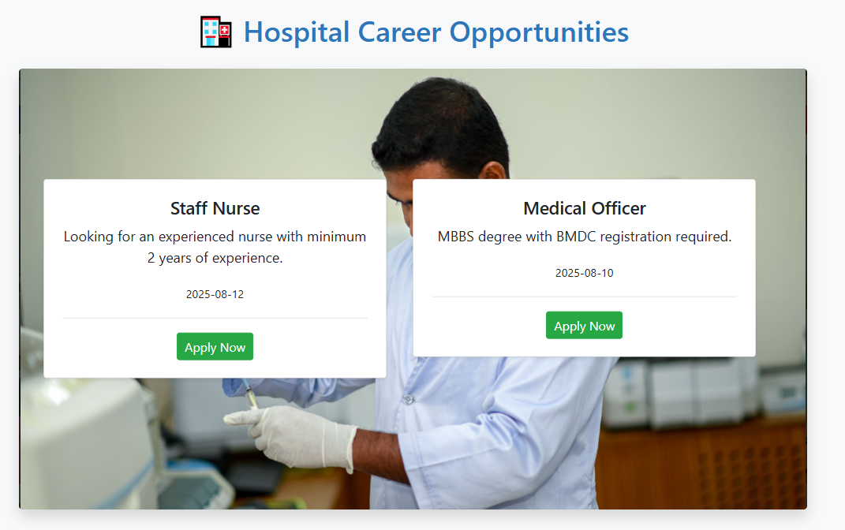

B. Analysis Models

● Use case diagrams for user interactions.

● Sequence diagrams for purchase flow.

C. Issues List

● Pending: Finalize hosting provider.

● Resolved: Database schema design.