
American International University-Bangladesh (AIUB)
Department of Computer Science
Faculty of Science &Technology (FST)
Fall 25-26
Section: D
Software Quality Assurance and Testing
“BookingExpress”- An Event Booking System
A Report submitted
By

SN | Student Name | Student ID
1 | MD. FAHIM SHAHRIYAR PRANTO | 22-48848-3
2 | MOHTASIM-UR-RAHMAN | 22-49461-3
3 | ARPITA MITRA SARA | 22-49433-3

Software Test Plan

for

“BookingExpress”- An Event Booking System
Version 1.0 approved
Prepared by MD. FAHIM SHAHRIYAR PRANTO
, MOHTASIM-UR-RAHMAN, ARPITA MITRA SARA
American International University- Bangladesh
21 January, 2026

Table of Contents
Revision History 3
1. TEST PLAN IDENTIFIER: RS-MTP01.3 3
2. REFERENCES 3
3. INTRODUCTION 3
Background to the Problem 3
Solution to the Problem 4
4. REQUEIREMNT SPECIFICATION 4
4.1 System Features 4
4.2 System Quality Attributes 4
4.3 System Interface 5
4.4 Project Requirements 5
5. FEATURES NOT TO BE TESTED 5
6. TESTING APPROACH 5
6.1 Testing Levels 5
6.2 Test Tools 6
6.3 Meetings 6
7. TEST CASES/TEST ITEMS 6
8. ITEM PASS/FAIL CRITERIA 7
9. TEST DELIVERABLES 7
10. STAFFING AND TRAINING NEEDS 8
11. RESPONSIBILITIES 8
12. TESTING SCHEDULE 8
13. PLANNING RISKS AND CONTINGENCIES 9
14. APROVALS 9

Revision History
Revision | Date | Updated by | Update Comments
0.1 |  | Md. Fahim Shahriyar Pranto | FR_1, FR_2, FR_3, FR_4, FR_7, FR_8, FR_10
0.2 |  | Mohtasim-Ur-Rahman | FR_1, FR_2, FR_4, FR_5, FR_6, FR_8, FR_9
0.3 |  | Arpita Mitra Sara | FR_5, FR_6, FR_7, FR_9, FR_10, FR_3

TEST PLAN IDENTIFIER: TP_BOOKINGEXPRESS_1.0

REFERENCES
Software Requirement Specification (SRS) Document & project:
https://github.com/Pranto78/SQT_TESTING.git

INTRODUCTION

3.1 Background to the Problem
In today's fast-paced digital world, managing and attending events has become a crucial part of both personal and professional life. From corporate conferences and university seminars to concerts, exhibitions, and social gatherings, people regularly seek efficient ways to discover, book, and attend events. However, existing event booking methods often relying on manual processes, scattered platforms, or limited-functionality applications. They fail to provide a seamless, all-in-one experience for users, event organizers, and administrators.
The root cause of this problem lies in the fragmentation and inefficiency of current event management systems. Many platforms do not offer real-time updates, secure payment gateways, dynamic seat selection, or user-friendly interfaces, which leads to user frustration, mismanagement, and revenue loss for organizers. Additionally, a lack of personalization and communication tools often results in low engagement and poor attendance rates.
This problem is important to address because a well-structured event booking system not only enhances user satisfaction but also contributes to better event management, improved ticket sales, and stronger brand engagement. In academic institutions, companies, and public platforms alike, the demand for a centralized and intelligent solution is growing rapidly. Therefore, "BookingExpress" has been designed to bridge this gap, offering a modern, efficient, and interactive platform that simplifies the entire lifecycle of event booking and management for all stakeholders involved.

3.2 Solution to the Problem
The solutions we are going to propose to deal with the problem: The proposed solution is the development of BookingExpress- An Event Booking System. It is an integrated web-based platform that streamlines the entire event booking process for users and admisnstration. The system allows users to register and explore events based on categories, dates, or popularity. It includes features such as seat selection, ticket purchasing with secure payment integration, real-time filtering, and booking history. Admins can create, update, and manage events, view user statistics, and receive feedback. BookingExpress is designed to work for various types of events, including academic, cultural, corporate, and entertainment programs.
The reason the solution is appropriate to solve the problem: This solution is appropriate because it solves the key issues of event mismanagement, lack of centralized control, and poor user experience. By offering a unified platform with real-time updates, secure payments, and user-friendly interfaces, BookingExpress eliminates the need for manual coordination and scattered systems. The platform ensures transparency, reliability, and convenience for all stakeholders. It is also scalable and capable of handling an increasing number of events and users over time, making it suitable for both small and large organizations. The built-in flexibility and automation make it feasible to meet business objectives like increasing attendance, improving event visibility, and generating revenue through ticket sales.
Short description of the software being specified and its purpose: BookingExpress is a complete event management and booking system designed to simplify the process of organizing, promoting, and attending events. Its purpose is to serve as a one-stop platform for users to discover and book events while enabling organizers to efficiently manage their offerings. Key features include user registration, profile management, event calendars, ticket type selection, real-time filtering using AJAX, and secure online payments. The objectives of BookingExpress is to improve accessibility, enhance user experience. The goal is to build a platform that increases efficiency, saves time, and ensures a smoother booking experience across a wide range of events.
Existing studies presented in the problem area: Several existing platforms like Eventbrite, Ticketmaster, and Cvent already address event management and booking needs. However, these platforms often cater to larger markets, come with high subscription fees, and may not offer customization for smaller or more localized events. Additionally, many existing systems do not prioritize user experience for specific communities such as universities or small event organizers. BookingExpress aims to fill this gap by offering a more affordable, flexible, and user-centered solution that supports local and institutional needs while maintaining modern standards of performance and usability. By doing so, it ensures broader accessibility and neutrality, making it a more inclusive and practical alternative.

REQUEIREMNT SPECIFICATION

System Features
4.1.1. User Authentication (Signup & Sign in)
4.1.1.1. User Signup
Functional Requirements:
1.1. The system shall allow users to sign up by providing full name, email, password, and role (User/Organizer).
1.2. The system shall validate that the email is unique before allowing registration.
1.3. The password shall be at least 8 characters long and contain at least one special character.
1.4. The system shall require users to confirm their password during signup.
Priority Level: High
Precondition: User must provide valid signup credentials.

4.1.1.2. User Sign in
Functional Requirements:
1.1. The system shall allow users to log in using their registered email and password.
1.2. If incorrect credentials are entered more than 3 times, a CAPTCHA or verification code shall be required.
1.3. If login fails more than 5 times, the system shall block login attempts for one hour.
Priority Level: High
Precondition: User has a registered account with correct credentials.
4.1.2. Event Management (Admin)
4.1.2.1. Create Event
Functional Requirements:
1.1. The system shall allow admin to create a new event by providing event name, description, date, location, category, and available seats.
1.2. The admin shall be able to upload an image for the event banner.
1.3. The system shall validate that all required fields are filled before submission.
Priority Level: High
Precondition: Admin is logged in and verified.
4.1.2.2. Edit/Delete Event
Functional Requirements:
1.1. The system shall allow Admin to edit existing event details.
1.2. The system shall allow Admin to delete an event before it begins.
Priority Level: Medium
Precondition: Event exists and is owned by the logged-in Admin.
4.1.2.3. Admin Control Panel
Functional Requirements:
1.1. The admin shall have access to manage all events, users.
1.2. The admin shall be able to approve or block users.
1.3. The admin shall be able to generate reports on event performance and revenue.
Priority Level: High
Precondition: Admin must be logged in and authorized.
4.1.3. Event Booking (User)
4.1.3.1. Book Event Ticket
Functional Requirements:
1.1. The system shall allow users to book a ticket for an available event.
1.2. The system shall allow users to choose seat type and quantity (if applicable).
1.3. The system shall deduct the booked ticket from available seats in real-time.
1.4. The user shall receive a confirmation email upon successful booking.
Priority Level: High
Precondition: User is logged in and the event has available seats.
4.1.4. Real-Time Event Filtering (AJAX)
Functional Requirements:
1.1. The system shall allow users to filter events by date, category, and location without reloading the page.
1.2. AJAX shall be used to update the event list dynamically as filters are applied.
Priority Level: Medium
Precondition: Events must exist in the database.
4.1.5. Payment Integration
Functional Requirements:
1.1. The system shall allow users to pay for event tickets using a secure payment gateway.
1.2. The system shall confirm the payment and generate a booking ID.
1.3. In case of payment failure, the system shall notify the user and cancel the booking attempt.
Priority Level: High
Precondition: Event is marked as paid and user has selected tickets.

System Quality Attributes
Usability: The system should provide an intuitive and responsive interface, allowing users to browse events, select tickets, and complete bookings within an average of three and a maximum of five minutes, even with minimal training.
Performance: The system shall display event listings, search results, and seat selection data within 2 seconds of user interaction. AJAX will be used to reduce reload times and improve responsiveness.
Scalability: BookingExpress should support up to 10,000 concurrent users browsing and booking events without noticeable performance degradation. The platform shall scale horizontally to accommodate increasing demand.
Security: Only authorized users shall be permitted to access sensitive operations like creating events, processing payments, or managing users. The system shall use role-based access control, encrypted data transmission (HTTPS), and CAPTCHA for login security.
Availability: The event booking platform must be accessible 24/7, with a maximum allowable downtime of 0.1% per month, ensuring high availability for both users and organizers.
Maintainability: The system shall support modular development, allowing updates to features (like event editing or calendar syncing) without requiring complete system downtime. Admins should be able to update content through the control panel.
Responsiveness: The application shall provide responsive layouts and interactions, ensuring full usability across mobile, tablet, and desktop devices without functional limitations.
Reliability: BookingExpress should accurately process ticket bookings and payments, ensuring that no data is lost or corrupted even in the event of a network error. All transactions should be logged.

System Interface
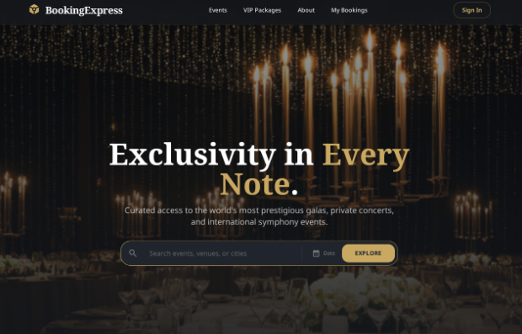
Figure 1: Landing Page
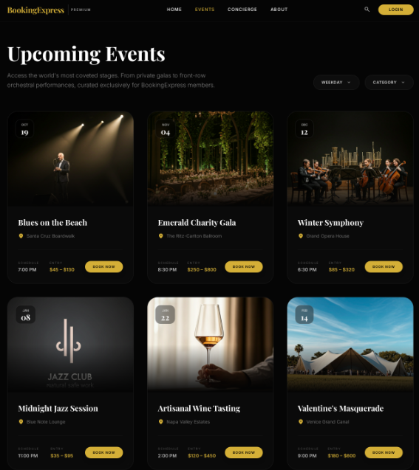
Figure 2: Event Page
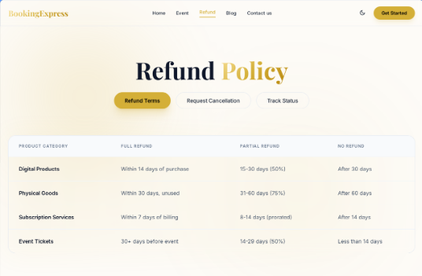
Figure 3: Refund Policy Page
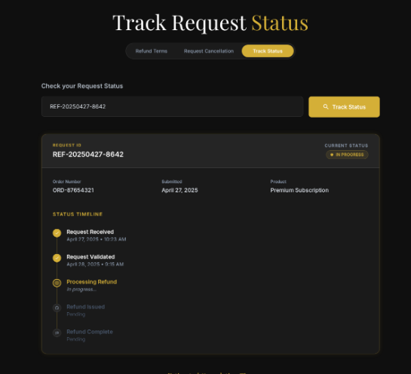
Figure 4: Track Status
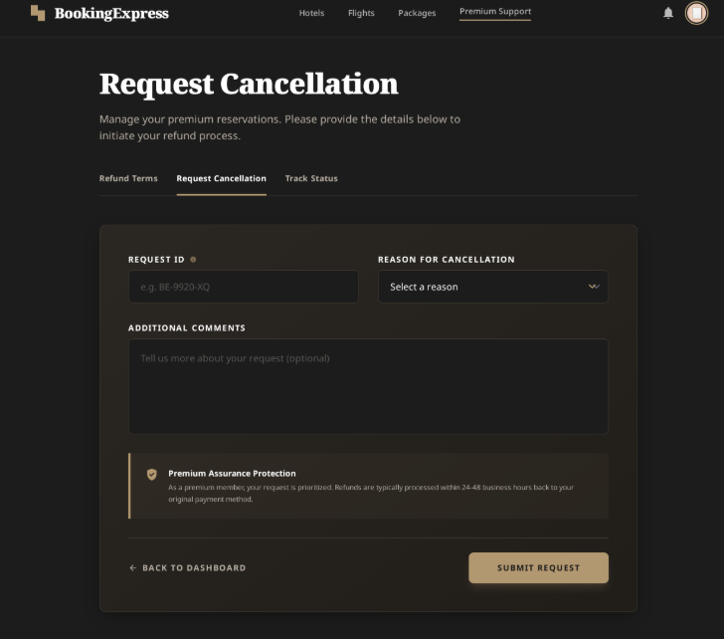
Figure 5: Request Cancellation
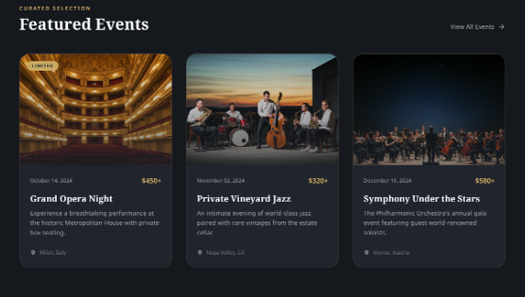
Figure 6: News and Feature
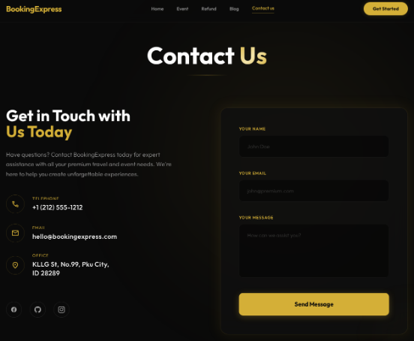
Figure 7: Contact Us Page
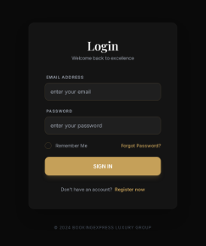
Figure 8: Log In Page
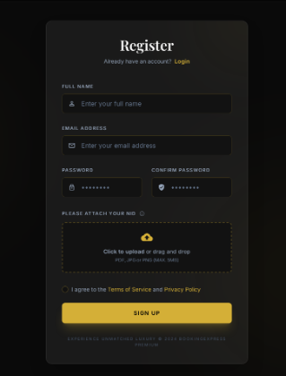
Figure 9: Registration Page
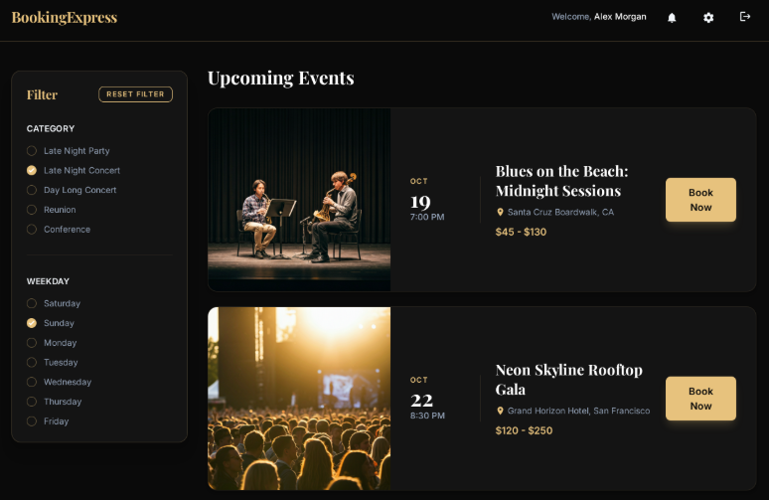
Figure 10: User’s Landing Page
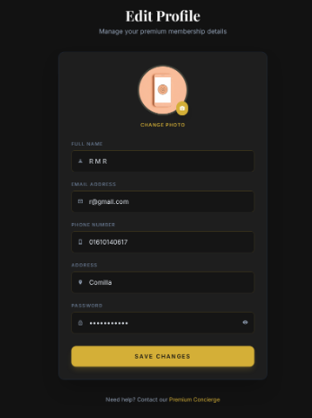
Figure 11: Edit Profile Page
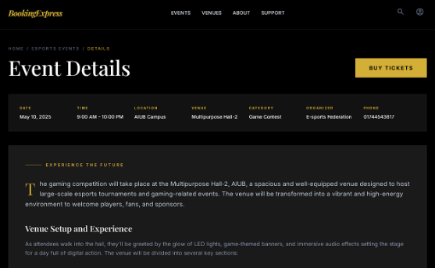
Figure 12: Venue Details Page
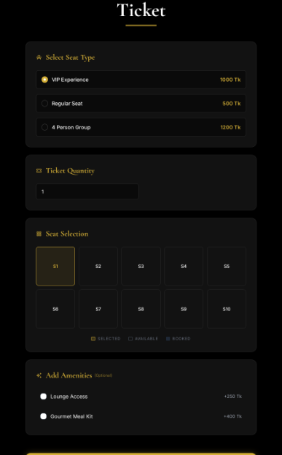
Figure 13: Ticket Page
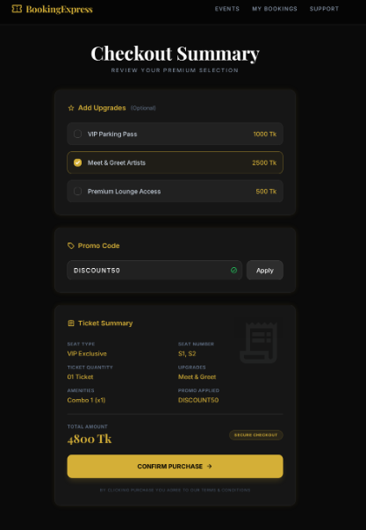
Figure 14: Ticket Summary
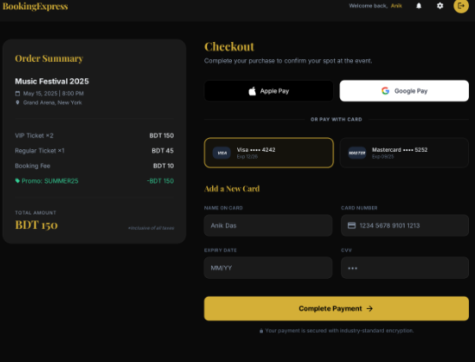
Figure 15: Checkout Page
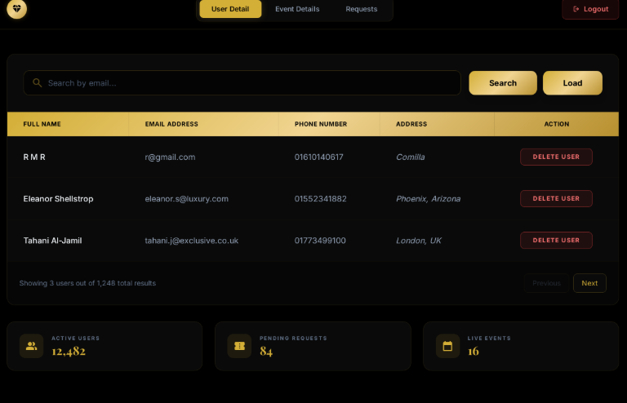
Figure 16: Admin Page
4.4. Project Requirements

4.4.1 Time Estimation
We used COCOMO (Constructive Cost Model) to analyze the effort and team requirement, though actual development time.
Software Project Type | Coefficient  <Effort Factor> | P | T
Organic | 2.4 | 1.05 | 0.38
Semi-Detached | 3.0 | 1.12 | 0.35
Embedded | 3.6 | 1.20 | 0.32

Effort Estimation: a × (SLOC / 1000) ^{b}
As the project is organic, a = 2.4, b = 1.05
Here, SLOC = 5450
Effort = 2.4 × (5450/1000)^{1.05}
≈ 2.4 × (10)^{1.05}
≈ 13.99 person-months
Development Time = c × (Effort)^{d}
Here, c = 2.5, d = 0.38 [organic]
Development Time = 2.5 × (13.99)^{0.38}
≈ 2.5 × 1.51
≈ 3.77 months
≈ 4 months

Number of People Required: Effort / (Development Time)
Number of People = (13.99) / 3.77
≈ 3.71 people
≈ 3 people (We are 3 in numbers)

4.4.2 Budget Estimation:

Personnel Costs:
- Developers (3): $150/month × 3 developers × 4 months = $1,800
- UI/UX Designer: Not applicable (UI/UX handled by developers using Figma)
Total Personnel Cost = $1,800

Hardware and Software Costs:
- Testing Devices (e.g., mobile phones and PCs for responsiveness testing): $1,000
- Software Tools and Licenses (Figma Professional Plan, design plugins, etc.): $600
- Cloud Services: Free (using XAMPP and MySQL)
Total Hardware and Software Cost = $1,600

Miscellaneous Costs:
- Office Space and Utilities: $50/month × 4 months = $2,00
- Training Costs (online courses/tools on tech stacks used): $100
- Contingency Budget (10% of total estimated cost): $370 (approximate)
Total Miscellaneous Cost = $670

Total Project Budget:
- Personnel Cost: $1800
- Hardware and Software Cost: $1,600
- Miscellaneous Cost: $670
- Total Estimated Budget = $4070 (approximately 4,88,400 BDT, assuming 1 USD = 120 BDT)

4.4.3 Resources:
Team Composition: The development team consists of three developers. The roles of UI/UX design and QA testing were handled collaboratively by the development team using professional tools.
Hardware and Software: Development will be utilized standard computing equipment and licensed tools such as Figma for UI/UX design. The project will be developed using free hosting and database platforms, including XAMPP and MySQL, for local deployment and testing.

4.4.4 Environment:
Development Environment: The project will be developed using HTML, CSS, JavaScript, and PHP for the front-end and back-end. A local server environment will be maintained using XAMPP, and the MySQL database for data storage and management.
Testing Environment: Testing will be conducted locally using the same environment (XAMPP) to simulate production behavior. Cross-browser testing and responsiveness checks will be done on various devices using in-house hardware.

4.4.5 Other Constraints:
- Integration with third-party payment gateways must be completed and tested by Month 4 to allow sufficient time for performance validation.

FEATURES NOT TO BE TESTED
There are some features like image upload, backend functions etc. that will not be tested as they work as a part of another testing. The followings are a list of features that will not be tested in this project.
- Backend Functionalities: The system will check whether the email or any given information is valid or not and other functions like that of the ticket booking section are done in server side.
- Cross Browser Compatibility: As Selenium IDE runs on the browser it was installed on so it is not suitable for checking the responsiveness of the web application.
- File Upload Validation: Even though the NID photo upload was captured, the Selenium IDE by itself cannot confirm how the uploaded file was handled in the backend.
- Third Party Service Integration: The system will send notification to the user by email for purchasing a ticket but the testing will not cover how the server-side email functions are working.

TESTING APPROACH

Testing Levels
The testing approach for the Event Booking System is designed for validating the core functionalities, user interactions, and administrative operations of the application. This approach is based on three primary levels of testing: Unit Testing, System/Integration Testing, and Acceptance Testing.
- Unit Testing: This testing will be performed by individual developers during the coding phase. Core functions and modules like registration, log in, ticket booking etc. will be tested separately and every test case and their outputs and the detected bugs and its reports will be documented.
- System/Integration Testing: It will be conducted by both the developing team and the test manager. It will ensure that all the interactions between different modules including user registration, login flows, admin functions, ticket booking, contact us and log out. All the major bugs should be resolved before coming to this phase.
- Acceptance Testing: This is conducted by the stakeholders of the project including the end users and the admin. They will use real data by registering, logging in, booking events, changing profile information, deleting and searching users and requests for admin etc. Upon successfully doing all these will validate that the system has met the requirements and is ready for deployment. This acceptance testing phase will simulate live usage for at least one full week to validate the functionality and usability of the system.

Test Tools
Selenium IDE which is a browser-based testing tool, had been used to test the Event Booking System. It is designed for testing web applications automatically.

Selenium IDE:
Selenium IDE is a browser extension that has the capability to record and playback user’s interaction with a software and it can do those records and playbacks continuously. So, it was used throughout the whole project to test the project’s functions.
At the beginning of the testing, Selenium IDE extension was opened on the browser and the test project was created with the landing page as the base URL. Then all the test cases were recorded one by one. Once recording ended, ‘Run all Test’ feature was used to test all the function altogether which verified that the web application was working properly. Selenium IDE successfully helped identify issues with form validations, incorrect redirects, and input handling during this process.
For all the test cases, firstly the playback URL was set and then record was clicked to record the input and expected output values for the test to run. When everything was done recording, the test was run to see if the test was successful or not.
The following features were tested using the Selenium IDE:

User Registration: The record function of selenium was used to save fname, email, password, re-enter password, NID picture adding data and the expected results which was shown after clicking the ‘Sign up’ button. After that recording was turned off. Then the test was run by clicking ‘Run current test’ button. Selenium repeated the process and confirmed that the success message was shown.

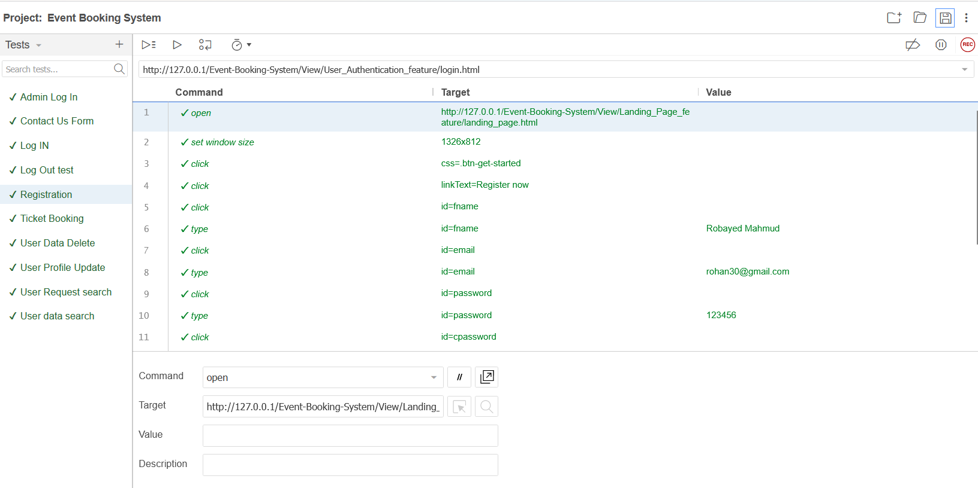
Figure 17: User registration test

User Log In: Using the record function, the valid email and password was typed and then ‘sign in’ button was clicked which led to the user landing page that shows ‘Upcoming Events’ which is the expected result. After that recording was turned off. Then the test was run by clicking ‘Run current test’ button. Selenium repeated the process and confirmed the expected result.
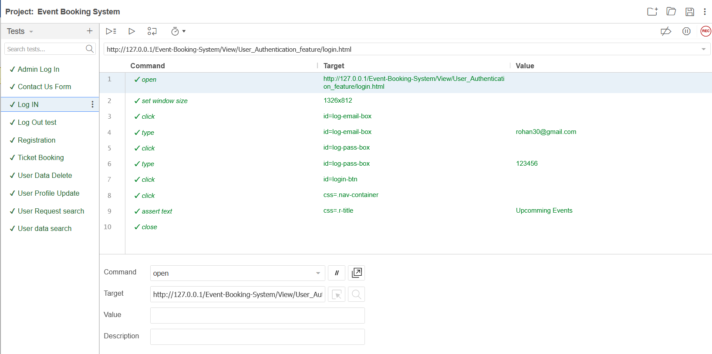
Figure 18: User Log In test

Admin Log In: Using the record function, the admin email and password was typed and then ‘sign in’ button was clicked which led to the admin landing page that shows User Details which is the expected result. After that recording was turned off. Then the test was run by clicking ‘Run current test’ button. Selenium repeated the process and confirmed the expected result.
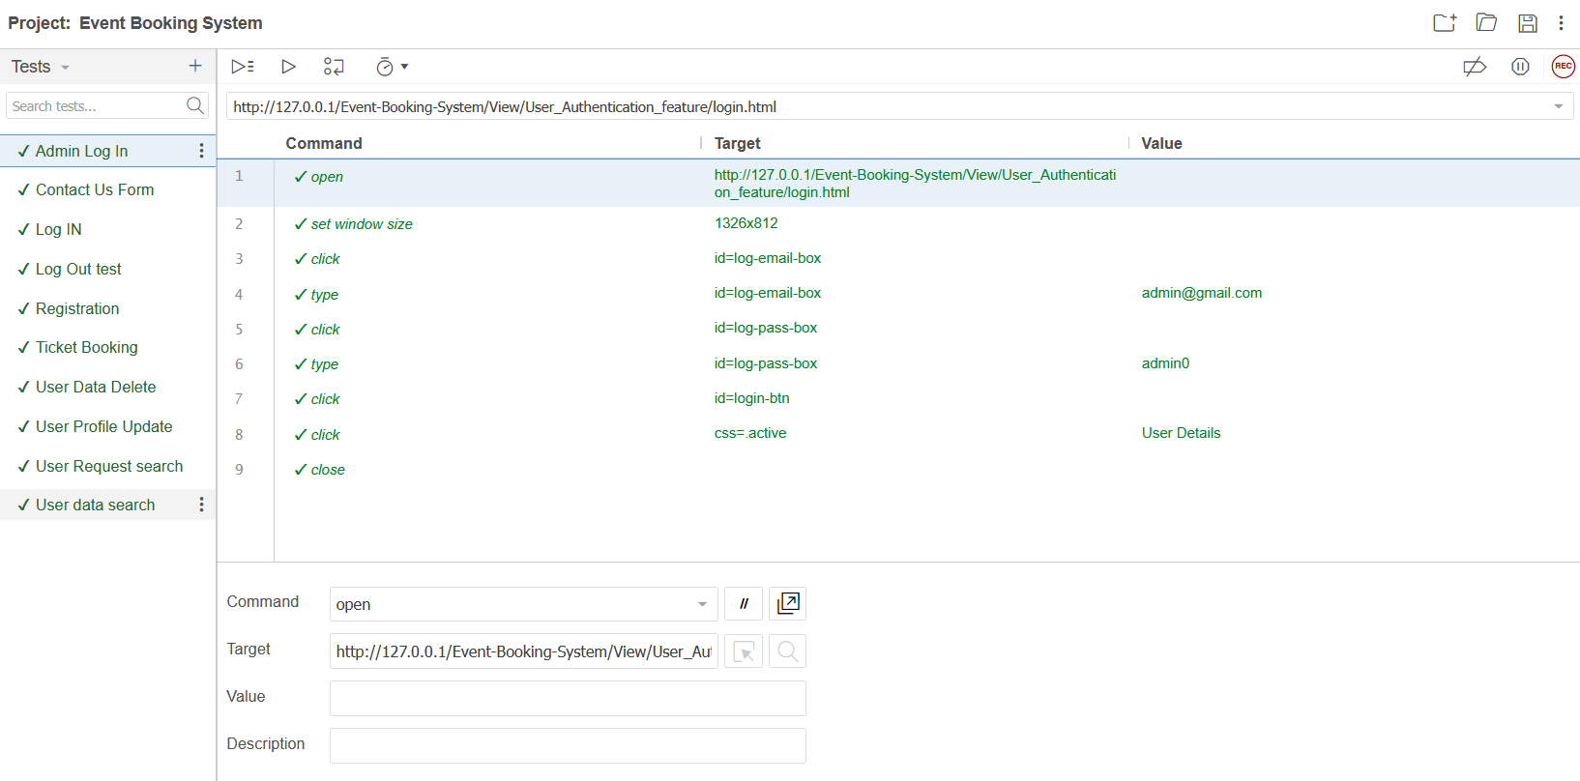
Figure 19: Admin Log In test

User Profile Update: Using the record function, the valid email and password was typed and then ‘sign in’ button was clicked which led to the user landing page. Then the ‘User’ button was clicked which led to the profile page. After that the user Full Name, Phone Number, Address were changed as the given data. Then the ‘Submit’ button was clicked which showed the ‘Successfully updated’ message. After that recording was turned off. Then the test was run by clicking ‘Run current test’ button. Selenium repeated the process and confirmed the expected result.
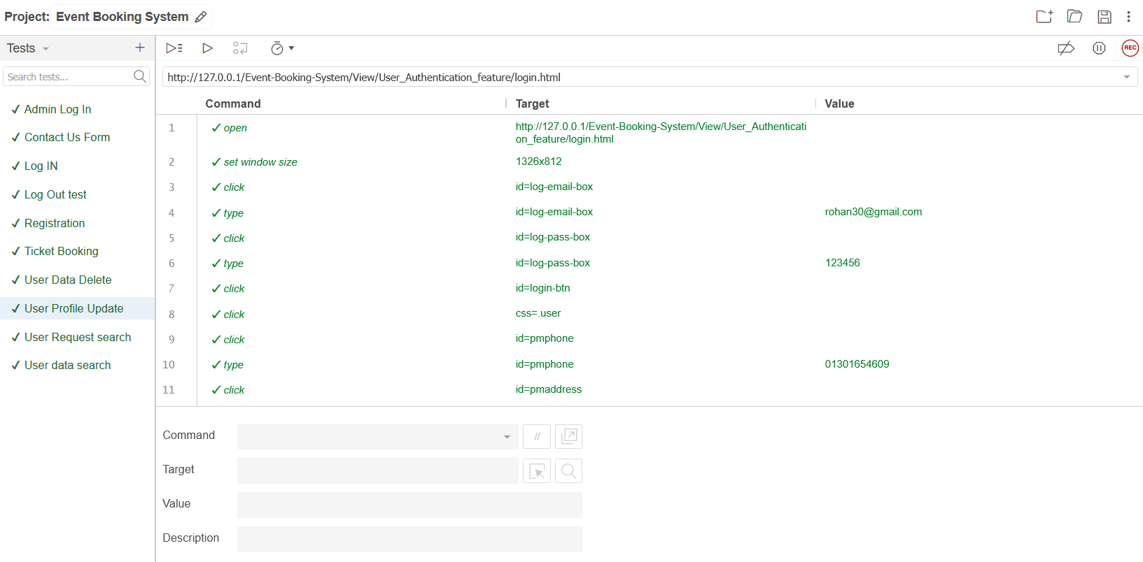
Figure 20: User Profile Update test

Contact Us Form: For this test after starting recording, first we clicked the contact us button on the nav bar. Then the name, email and the query message were given. After that the Send message button was clicked which showed ‘Message Sent Successfully’ message and the recording was turned off. Then the test was run by clicking ‘Run current test’ button. Selenium repeated the process and confirmed the expected result.
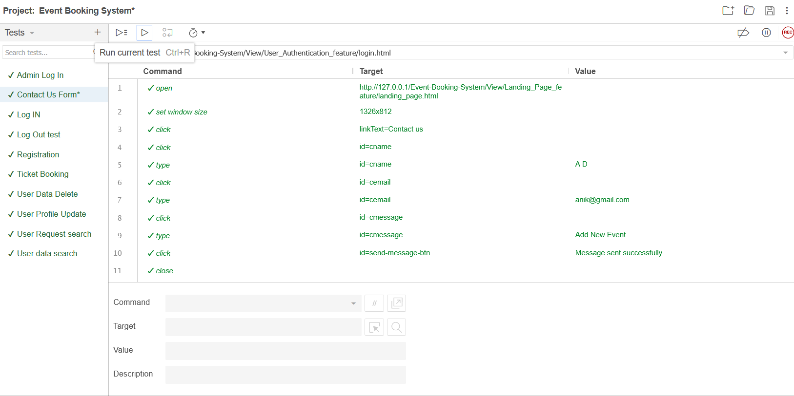
Figure 21: Contact Us Form test

User Data Delete: Using the record function, the admin email and password was typed and then ‘sign in’ button was clicked which led to the admin landing page that shows User Details. Then at the third row of the table that contains a user data and the delete button at the end column was clicked. After that the user removed message was shown and the recording was turned off. Then the test was run by clicking ‘Run current test’ button. Selenium repeated the process and confirmed the expected result.
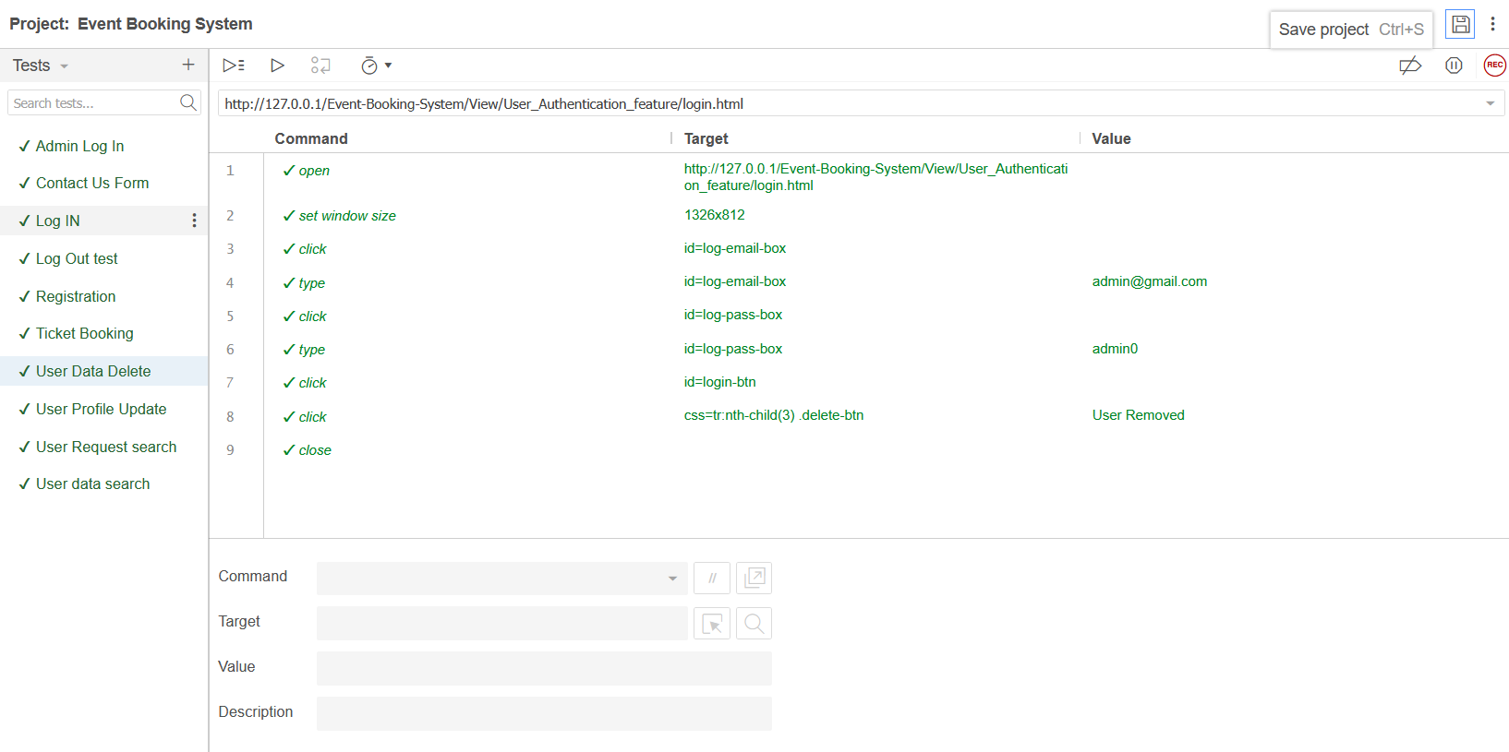

Figure 22: User Data Delete test

Search User: Using the record function, the admin email and password was typed and then ‘sign in’ button was clicked which led to the admin landing page that shows User Details. Then the target value was inputted and the search button was clicked. The user detail with the searched value was shown. After that recording was turned off. Then the test was run by clicking ‘Run current test’ button. Selenium repeated the process and confirmed the expected result.
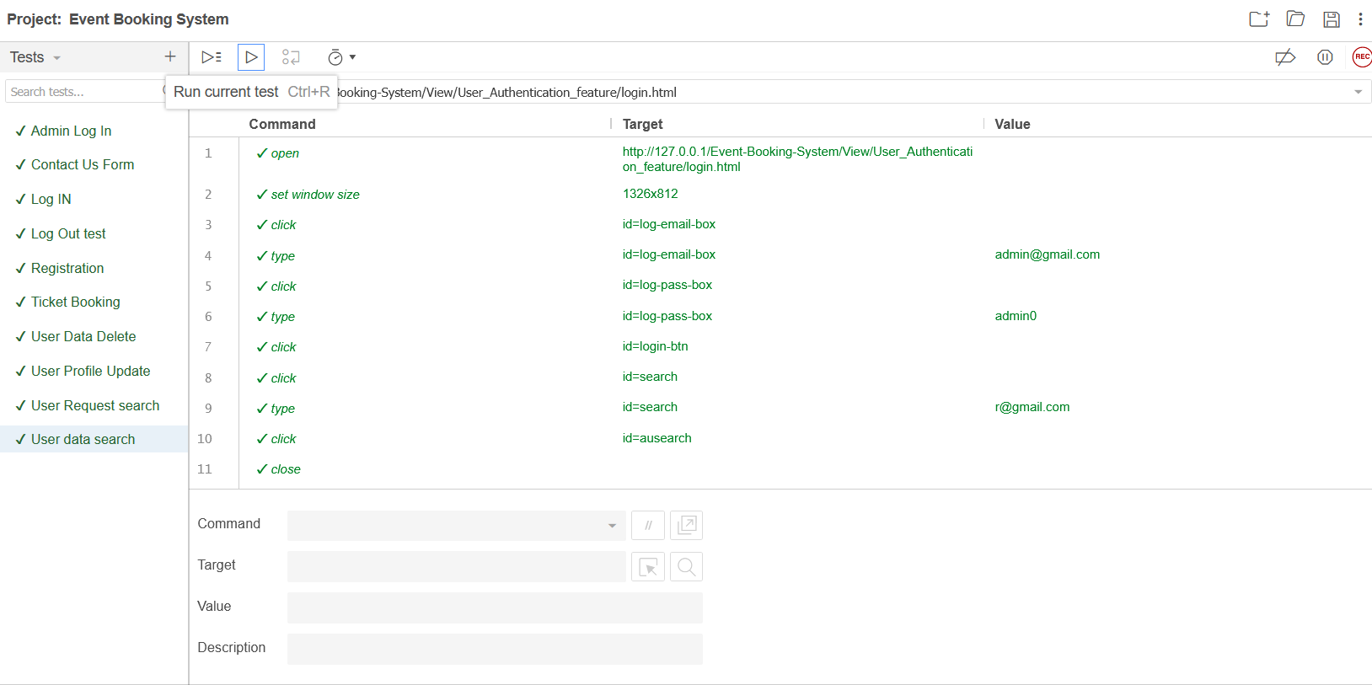
Figure 22: Search User test

Search Requests: Using the record function, the admin email and password was typed and then ‘sign in’ button was clicked which led to the admin landing page that shows User Details. After that the Requests button was clicked. Then the target value was inputted and the search button was clicked. The user requests with the searched value were shown. After that recording was turned off. Then the test was run by clicking ‘Run current test’ button. Selenium repeated the process and confirmed the expected result.
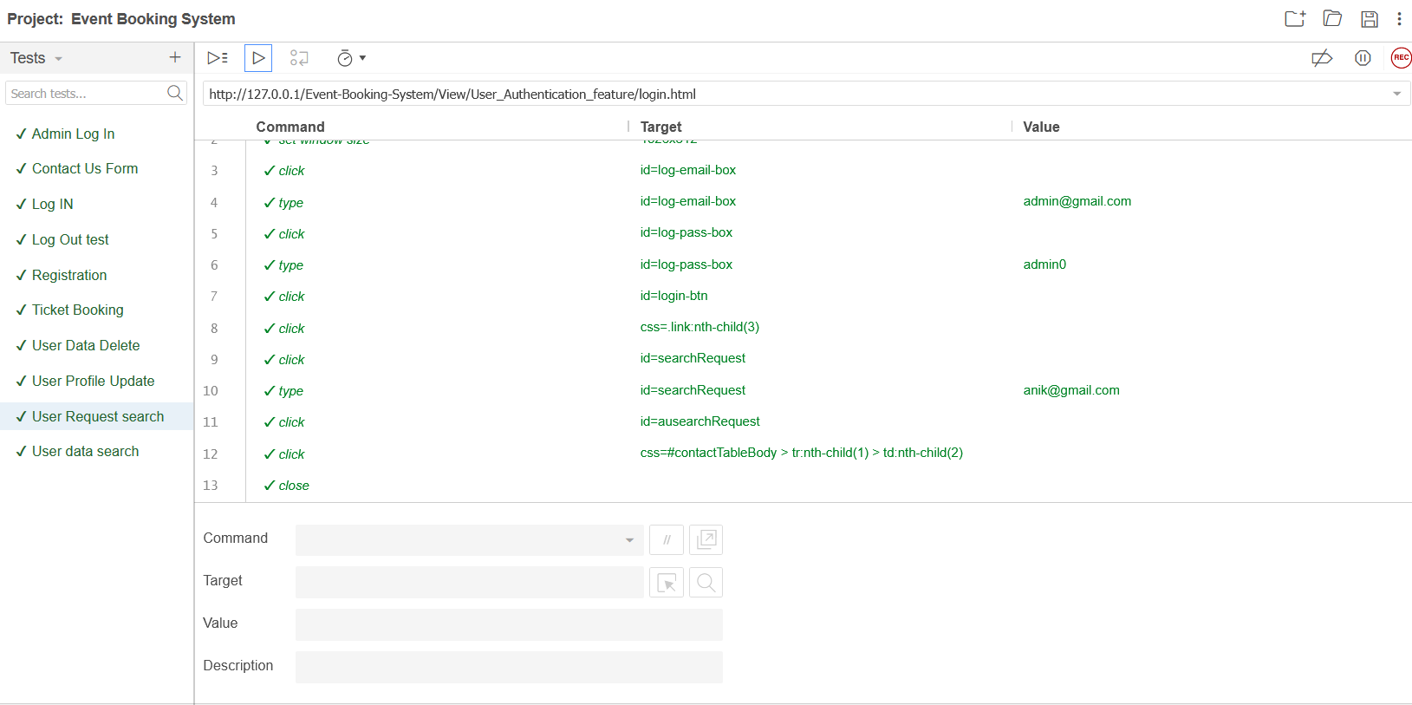
Figure 23: Search Requests test

Ticket Booking: First the recording was turned on. Then we logged in as a valid user and clicked on an event. After that the venue details were shown and from there the buy ticket button was clicked that took us to the ticket page. After that the ticket type, seat quantity, seats, add amenities, add upgrades and discount values were selected as per the test case. Then after scrolling down the ticket details can be seen where all the inputted data will be shown and the value will be the same as the test case. After that recording was turned off. Then the test was run by clicking ‘Run current test’ button. Selenium repeated the process and confirmed the expected result.
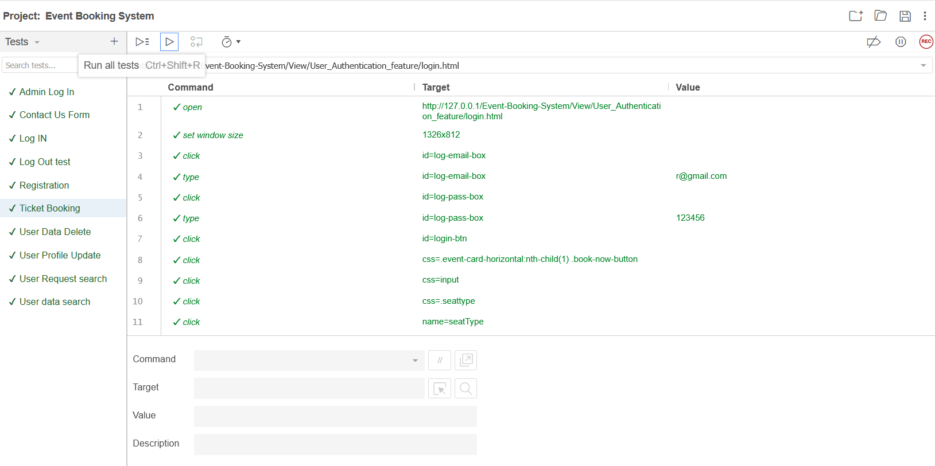
Figure 24: Ticket Booking test
Log Out: After turning on recording, the log in page was shown. Then we logged in as a valid user and clicked the log out button at the top right corner. It led us to the log in page again. After that recording was turned off. Then the test was run by clicking ‘Run current test’ button. Selenium repeated the process and confirmed the expected result.
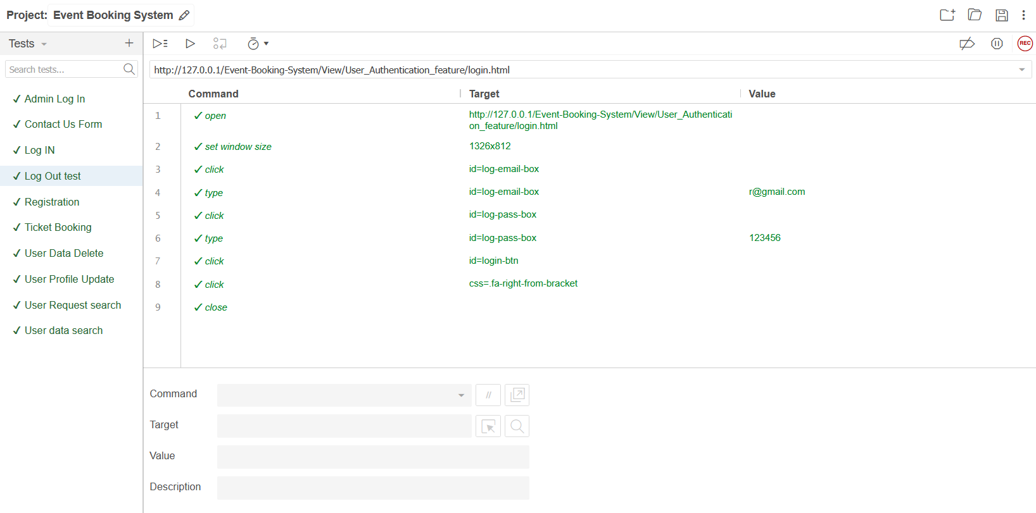
Figure 25: Log Out test

Meetings
The test team will meet once in every week to evaluate progress to date and to identify error trends and problems as early as possible. The test team leader will meet with development and the project manager once every two weeks as well. These two meetings will be scheduled on different weeks. Additional meetings can be called as required for emergency situations.

TEST CASES/TEST ITEMS
Project Name: BookingExpress |  | Test Designed by: MD. Fahim Shahriyar Pranto
Test Case ID: FR_1 |  | Test Designed date: 10/01/2026
Test Priority (Low, Medium, High): High |  | Test Executed by: MOHTASIM-UR-RAHMAN
Module Name: Registration session |  | Test Execution date: 14/01/2026
Test Title: Verify user registration
Description: Test website’s registration page
Precondition (If any):
Test Steps | Test Data | Expected Results | Actual Results | Status (Pass/Fail)
- Go to the web page  - Click Get Started  - Click Register now  - Enter Full Name  - Enter an Email Address  - Enter password  - Re-enter password  - Submit NID photo  - Click Sign up | Full Name: Fahim shahriyar pranto  Email: pranto30@gmail.com  Password: 123456  Confirm Password: 123456  Please Attach your NID: enter NID photo | User should see the “Registration Successful” dialogue box. | As expected, | Pass
Post Condition: The user goes to the log in page

Project Name: BookingExpress |  | Test Designed by: MOHTASIM-UR-RAHMAN
Test Case ID: FR_2 |  | Test Designed date: 10/01/2026
Test Priority (Low, Medium, High): Medium |  | Test Executed by: MD. Fahim Shahriyar Pranto
Module Name: Log in Session |  | Test Execution date: 14/01/2026
Test Title: Verify user log in
Description: Test webpage’s Log In page
Precondition (If any): User must be a registered user
Test Steps | Test Data |  | Expected Results | Actual Results | Status (Pass/Fail)
- Enter Email  - Enter Password  - Click Sign In | Email or Phone: pranto30@gmail.com  Password:123456 |  | Show “Upcoming  Events” on the page | As expected, | Pass
Post Condition: Users can see upcoming events
Project Name: BookingExpress |  | Test Designed by: MD. Fahim Shahriyar Pranto
Test Case ID: FR_3 |  | Test Designed date: 10/01/2026
Test Priority (Low, Medium, High): High |  | Test Executed by: ARPITA MITRA SARA
Module Name: Admin Log in Session |  | Test Execution date: 14/01/2026
Test Title: Verify admin log in
Description: Test webpage’s admin log ln page
Precondition (If any):
Test Steps | Test Data |  | Expected Results | Actual Results | Status (Pass/Fail)
- Enter Email  - Enter Password  - Click Sign In | Email or Phone: admin@gmail.com  Password: adminadmin |  | Show “User  Details” on the page | As expected, | Pass
Post Condition: Admin can see user details, event details, user requests, create events

Project Name: BookingExpress |  | Test Designed by: MOHTASIM-UR-RAHMAN
Test Case ID: FR_4 |  | Test Designed date: 10/01/2026
Test Priority (Low, Medium, High): Low |  | Test Executed by: MD. Fahim Shahriyar Pranto
Module Name: User Profile Update Session |  | Test Execution date: 14/01/2026
Test Title: Verify user profile update
Description: Test webpage’s user profile update page
Precondition (If any): User must log in first
Test Steps | Test Data |  | Expected Results | Actual Results | Status (Pass/Fail)
- Click the User button at the nav bar  - Enter any accessible field (like Full Name, Address, Phone Number, Password) and change its value  - Click Submit | Full Name: R M R  Phone Number: 01610140617  Address: Comilla |  | Show “Successfully updated” message | As expected, | Pass
Post Condition: User will see the updated data on profile

Project Name: BookingExpress |  | Test Designed by: ARPITA MITRA SARA
Test Case ID: FR_5 |  | Test Designed date: 10/01/2026
Test Priority (Low, Medium, High): Low |  | Test Executed by: MOHTASIM-UR-RAHMAN
Module Name: Contact Us Session |  | Test Execution date: 14/01/2026
Test Title: Verify Contact Us form
Description: Test webpage’s Contact Us form
Precondition (If any):
Test Steps | Test Data |  | Expected Results | Actual Results | Status (Pass/Fail)
- Go to the web page  - Click Contact Us  - Type your Name, Email, Message  - Click Send Message | Your Name: A D  Your Email: mohtasim@gmail.com  Your Message: Add new event |  | Show “Message sent successfully!” message | As expected, | Pass
Post Condition: User will see the “Message sent successfully!” message and can fill for further messages

Project Name: BookingExpress |  | Test Designed by: MOHTASIM-UR-RAHMAN
Test Case ID: FR_6 |  | Test Designed date: 11/01/2026
Test Priority (Low, Medium, High): Medium |  | Test Executed by: ARPITA MITRA SARA
Module Name: User Data Delete Session |  | Test Execution date: 14/01/2026
Test Title: Verify Admin’s user data delete event
Description: Test admin’s user data delete event
Precondition (If any): Admin must log in first.
Test Steps | Test Data |  | Expected Results | Actual Results | Status (Pass/Fail)
- Find out the user to be deleted  - Click Delete button in the table | No test data needed. |  | Shows “User removed” message | As expected, | Pass
Post Condition: The user data will be removed from both user and registration table and the user cannot log in anymore.

Project Name: BookingExpress |  | Test Designed by: ARPITA MITRA SARA
Test Case ID: FR_7 |  | Test Designed date: 11/01/2026
Test Priority (Low, Medium, High): low |  | Test Executed by: MD. Fahim Shahriyar Pranto
Module Name: Search User session |  | Test Execution date: 14/01/2026
Test Title: Verify Search User Information
Description: Test admin’s search User Information page
Precondition (If any): Admin must log in first.
Test Steps | Test Data |  | Expected Results | Actual Results | Status (Pass/Fail)
- Go to the user details page in admin  - Input any email or part of the email in the input box  - Click search | Search data: pp@gmail.com |  | Shows data related to  ‘pp@gmail.com’ message | As expected, | Pass
Post Condition: The user data will be shown.

Project Name: BookingExpress |  | Test Designed by: MD. Fahim Shahriyar Pranto
Test Case ID: FR_8 |  | Test Designed date: 12/01/2026
Test Priority (Low, Medium, High): High |  | Test Executed by: MOHTASIM-UR-RAHMAN
Module Name: Ticket Booking session |  | Test Execution date: 15/01/2026
Test Title: Verify ticket booking functionalities
Description: Test ticket booking functionalities like seat selection and quantity, adding amenities and upgrades, promocode, calculating cost.
Precondition (If any): User must log in first.
Test Steps | Test Data |  | Expected Results | Actual Results | Status (Pass/Fail)
- Go to the ticket page through any event  - Select a Seat Type  - Input Ticket Quantity  - Select seat from seat selection  - Select any from Add Amenities  - Input the Quantity  - Select from Add Upgrades  - Enter Promo Code | Select seat type: VIP (1000 Tk)  Ticket Quantity: 2  Seat Selection: S1, S2  Add Amenities: Combo 1 (350 Tk)  Quantity: 2  Add Upgrades: VIP Parking Pass (1000 Tk)  Promo Code: DISCOUNT50 |  | Shows the selected data on Ticket summary and total price of 3650 Tk | As expected, | Pass
Post Condition: The information about the selected items will be shown on Ticket Summary.

Project Name: BookingExpress |  | Test Designed by: MOHTASIM-UR-RAHMAN
Test Case ID: FR_9 |  | Test Designed date: 12/01/2026
Test Priority (Low, Medium, High): low |  | Test Executed by: ARPITA MITRA SARA
Module Name: Search Admin Requests session |  | Test Execution date: 15/01/2026
Test Title: Verify Search Admin Requests
Description: Test admin’s search request page
Precondition (If any): Admin must log in first.
Test Steps | Test Data |  | Expected Results | Actual Results | Status (Pass/Fail)
- Go to the Requests page in admin  - Input any email or part of the email in the input box  - Click search | Search data: mohtasim@gmail.com |  | Shows data related to ‘mohtasim@gmail.com’ message | As expected, | Pass
Post Condition: The user’s requests will be shown.

Project Name: BookingExpress |  | Test Designed by: Md. Fahim Shahriyar Pranto
Test Case ID: FR_10 |  | Test Designed date: 12/01/2026
Test Priority (Low, Medium, High): Medium |  | Test Executed by: MOHTASIM-UR-RAHMAN
Module Name: Log Out Session |  | Test Execution date: 15/01/2026
Test Title: Verify user log out
Description: Test user Log out function
Precondition (If any): User must log in first
Test Steps | Test Data |  | Expected Results | Actual Results | Status (Pass/Fail)
- Click log out icon | No test data needed |  | Shows “Login” the page | As expected, | Pass
Post Condition: User logs out of the account

ITEM PASS/FAIL CRITERIA
8.1 Registration Session:
Pass: Users can successfully register using a valid fullname, email address, password and photo of NID.
Fail: This system prevents users from creating invalid information or allows users to register by providing valid information.

8.2 Log in Session:
Pass: After creation of account user can successfully log in using a valid email address and password.
Fail: Users cannot log in without correct credentials and registration or can experience system errors.

8.3 Admin Log in Session:
Pass: After having knowledge of proper admin email address and password a person can enter the admin page.
Fail: Invalid or improper email address and password is the cause of failure.

8.4 User Profile Update Session:
Pass: Users must be valid first, after giving correct information, the system will allow the user to update profile.
Fail: Without giving correct and valid information, the system will deny the update profile session.
8.5 Contact Us form:
Pass: The massage should be sent from a valid email address.
Fail: A invalid email address will interrupt the users from sending by the system.

8.6 User Data Delete Session:
Pass: Search for a valid user, verify the user should be removed and by deleting the user he/she will not be able to access the system again.
Fail: User him/herself and the admin panel have access of deletion or system error.
8.7 Search User Session:
Pass: After knowing the email address admin will be able to find the user information.
Fail: Without being an admin, wrong input or any system error can be the cause of fail.
8.8 Ticket Booking Session:
Pass: Selection of valid event type, seat type, quantity of ticket, selection of seat, amenities (if any), add upgrade (if any), promo code (if any) will allow the user to select ticket.
Fail: Missing of any of these criteria or delaying for selection will cause system failure.
8.9 Search Requests Session:
Pass: After knowing the email address of the admin whose request is to verify will be able to find the request of the admin.
Fail: Without admin login or invalid email address can be the of this cause error.
8.10 Log Out Session:
Pass: After successfully login as a user or admin can be logged out by clicking Logout Button.
Fail: Without any activity the system will log user out by itself.

TEST DELIVERABLES

9.1 Acceptance Test Plan: A document that lists the criteria for passing, the test scenarios, and the expected results to make sure the system is ready for deployment.
9.2 System/Integration Test Plan: A plan that lists the test cases and steps needed to make sure that different parts of the system work together.
9.3 Unit Test Plans/Turnover Documentation: These are test cases for each part, along with other documents that need to be looked over and approved.
9.4 Screen Prototypes: Early-stage UI mock-ups that show how the system will look and make sure that user needs are addressed before production starts.
9.5 Report mock-ups: Sample reports that show how event details, user interactions, and system data will be shown.
9.6 Defect/Incident Reports and Summaries: This is a record of problems that have been found, together with their severity, status of resolution, and impact analysis.
9.7 Test Logs and Turnover Reports: These are logs that keep track of how tests are going, how defects are being fixed, and how final approvals are being made before moving on to the next step.

STAFFING AND TRAINING NEEDS
10.1 Testing Personnel: There will be at least one full-time tester allocated to the system/integration and acceptability testing stages. At first, a part-time tester will be involved in project evaluations. After around four months, they will switch to full-time work. If there isn't a dedicated tester, the project manager or test manager will take on this duty.
10.2 Training for Developers and Testers: Developers and testers will learn about the system's main features, such as how to connect to other systems and handle data.
10.3 Training for Operations Staff: Before the project is officially accepted, the operations staff will learn how to use the system, including how to manage events and process data.
10.4 Training for End Users: The system's administrative users, such as event planners and sales administration staff, will learn how to manage events, make reports, and use the system's interfaces.

RESPONSIBILITIES
 | Test Manager | Project Manager (PM) | Development Team | Test Team | Client
Acceptance Test Documentation & Execution | X |  |  | X | X
System/Integration Test Documentation & Execution | X |  | X | X
Unit Test Documentation & Execution |  |  | X
System Design Review | X | X | X |  | X
Detail Design Reviews |  | X | X |  | X
Test Procedures & Rules | X | X |  | X
Screen & report prototype Reviews |  | X | X |  | X
Change Control & Regression Testing | X | X |  | X

TESTING SCHEDULE
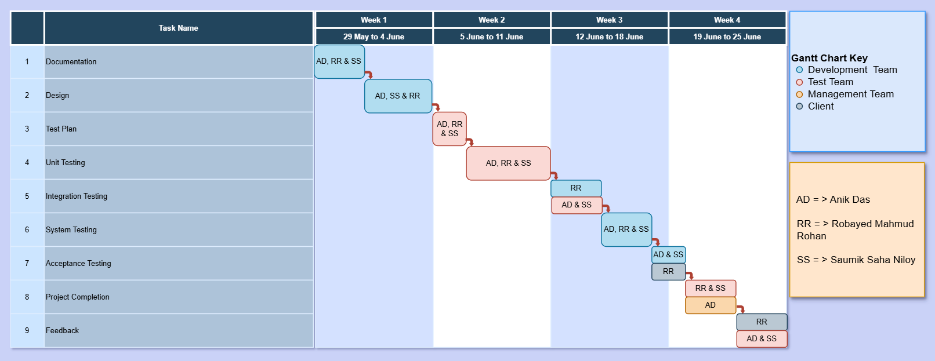

PLANNING RISKS AND CONTINGENCIES
13.1 Limited Testing Resources: One big danger is that there aren't enough testers because of financial limits. There is no one who is a full-time tester for system/integration and acceptability testing. This could make it take longer to find and fix problems. To reduce this risk, the test manager and developers will help with testing when needed to make sure deadlines are fulfilled.

13.2 Client Availability for Testing of Acceptance: If customer representatives can't make it to the scheduled reviews and acceptance testing, it could cause big delays. When this happens, testing schedules will be changed, but no part of the testing process will be ignored to keep quality assurance.

13.3 Delays in Development: If serious bugs are found late in the testing phase, it may take longer to resolve them, which could cause delays. To fix this, developers will focus on correcting major bugs early on to keep things running smoothly and make sure testing goes smoothly.

APROVALS
Project Sponsor | Approved
Development Management | Approved
EDI Project Manager | Approved
RS Test Manager | Approved
RS Development Team Manager | Approved
Reassigned Sales | Approved
Order Entry EDI Team Manager | Approved

