**USE case diagram for login and Register subsystem:(Mst Shapna Akter)**

**Register:**

**Actor:** primary user : new user

**Scenario: 1.** Input user Id and password, confirm password,name, address, DOB.

2. check user id and password (unique or not)

3.store new user account into database

4.view products

**Exception: 1.**required page not found

2. no database connection

**Precondition: 1.** url of new user page from web browser

**Post-condition: 1.successful login-**logging in to the system

**2.unsuccessful login-**stay in same page showing in error

**3.exception-**stay in same page if possible

**Login:**

**Actor:** registered user

**Scenario: 1.** Input user Id and password.

2. check user id and password (user authentication)

3.save id and password

4.remember password

5.view products

**Exception: 1.**required page not found

2. no database connection

**Precondition: 1.** url of new user page from web browser

**Post-condition: 1.successful login-**logging in to the system

**2.unsuccessful login-**stay in same page showing in error

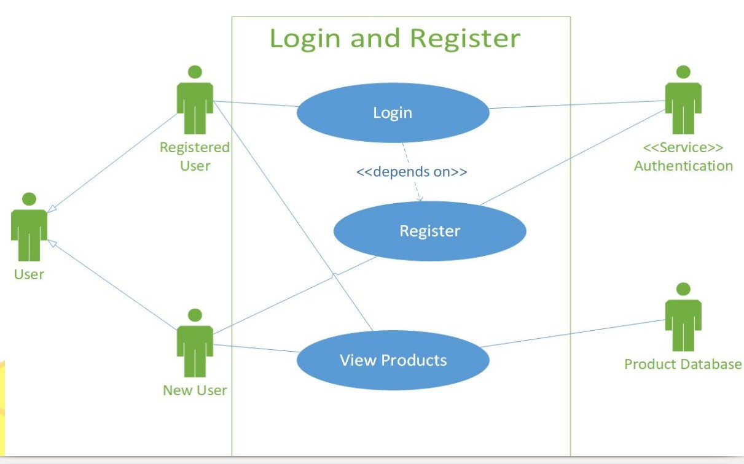**figure1: use case diagram for login and Register**

**USE case diagram for Buyer and Seller subsystem:(Jyotimay Roy)**

**Buyer:**

**Actor:** Buyer

**Scenario :** 1**.** View product

2. Add to cart

3. Order product

**Exception:** 1**.** Original product

2.Database connection

**Precondition: 1.** Pay the right person or right account.

**Post-condition: 1. Complete payment –** Deliver Product.

**2. Incomplete Payment –** Return Product.

**Seller:**

**Actor:** Seller.

**Scenario:** 1. Add Product

2. Remove Product

3. Change Price

**Exception: 1.** Profit without hard working.

**Precondition: 1.** Take order by our system, and hire delivery man to deliver that product.

**Post-condition:** Notify the buyer

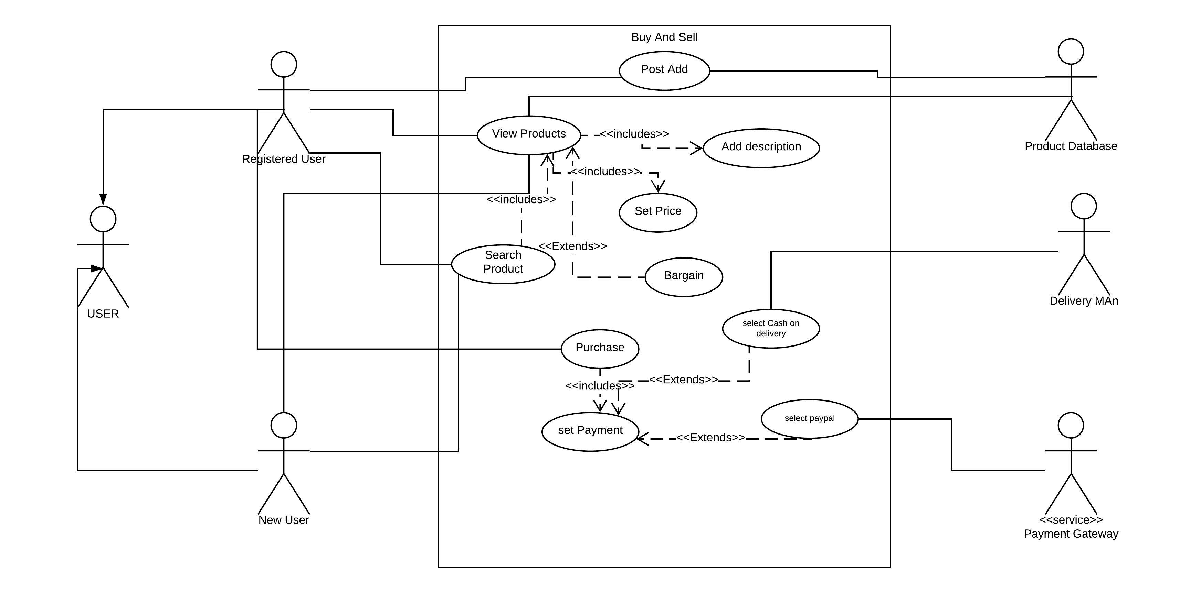

**Figure 2: use case diagram for Buy and sell subsystem**

**USE case diagram for Payment and Delivery subsystem:(Pranto Kumar)**

**Payment:**

**Actor:** Buyer

**Scenario:** 1**.** Online payment

2. Cash On Delivery

**Exception:** 1**.** Successful payment

2.Database connection

**Precondition: 1.** Pay the right person or right account.

**Post-condition: 1. Complete payment –** Deliver Product.

**2. Incomplete Payment –** Return Product.

**Delivery:**

**Actor:** Seller, Buyer and the Delivery man.

**Scenario:** 1. Delivery man pick up the product from seller

2. Notify buyer after pick up the product

3. Deliver it to buyer.

**Exception: 1.**Successful delivery

**Precondition: 1.** Call the buyer after reach his/her location.

**Post-condition: 1.successful Delivery –** Rating website

**2. Unsuccessful Delivery –** Call the system hotline.

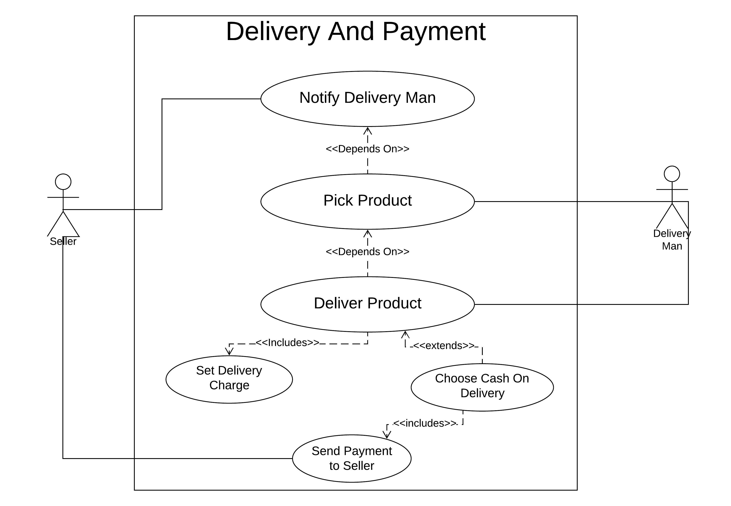

**Figure :03 use case diagram for Delivery and payment**

Image Source : Google