American International University-Bangladesh (AIUB)  
**Department of Computer Science  
Faculty of Science & Technology (FST)**

**e-Ballot**

A Software Requirement Engineering Project Submitted

By

|  |  |  |  |  |
| --- | --- | --- | --- | --- |
| **Semester: Spring_22_23** | | **Section:** | **Group Number: 06** | |
| SN | Student Name | Student ID | Contribution (CO1+CO2) | Individual Marks |
| 19 | ISRAD AHMED AYON | 19-40638-1 |  |  |
| 18 | SHANJIDA SULTANA JIM | 19-40621-1 |  |  |
| 20 | PRANTO SARKER | 19-40646-1 |  |  |
| 24 | SHOPNAMOY SAHA PRONOY | 19-41199-2 |  |  |

The project will be Evaluated for the following Course Outcomes

|  |  |  |
| --- | --- | --- |
| Evaluation Criteria | Total Marks (50) | |
|  | |
| Revision History, Test Plan Identifier, Reference Materials, Problem Background, Solutions | [10 Marks] |  |
| Requirements Specification (System feature, Quality Attributes, System Interface, Project Requirements) | [10 Marks] |  |
| Item Not to be tested, Testing approach (Testing levels, tools, meetings), Test cases | [10 Marks] |  |
| Item pass/fail criteria, Test deliverables, Staffing and Training, Responsibilities, Scheduling, Risk | [10 Marks] |  |
| Approval, Format, Submission, and Defense | [10 Marks] |  |

Software Test Plan

for

<e-Ballot>

Version 1.0 approved

Prepared by <ISRAD AHMED AYON, SHANJIDA SULTANA JIM, PRANTO SARKER & SHOPNAMOY SAHA PRONOY >

<AMERICAN INTERNATIONAL UNIVERSITY- BANGLADESH>

<20-April-2023>

**Table of Contents**

**REVISION HISTORY………………………………………………………………………..4**

1. TEST PLAN IDENTIFIRE………………………………………………………………….4

2. REFERENCES……………………………………………………………………………….4

3. INTRODUCTION ……………………………………………………………………………5

3.1 Background of the problem ………………………………………………………………5

3.2 Solution of the problem…………………………………………………………………...5

4. REQUIREMENT SPECIFICATION ……………………………………………………6-17

4.1 System Features…………………………………………………………………………6-7

4.2 System Quality Attributes ………………………………………………………………7-8

4.3 System Interface………………………………………………………………………8-16

4.4 Project Requirements………………………………………………………………….16-17

5. FEATURES NOT TO BE TESTED ………………………………………………………17

6. TESTING APPROACH ……………………………………………………………………17

6.1- Testing levels ………………………………………………………………………17-18

6.2- Test tools ………………………………………………………………………………18

6.3- Meetings ……………………………………………………………………………….18

7. TEST CASES ……………………………………………………………………………19-22

8. ITEM PASS/FAIL CRITERIA ……………………………………………………….22-23

9. TEST DELIVERABLES …………………………………………………………………..23

10. STAFFING AND TRAINING NEEDS………………………………………….…..23-24

**11. RESPONSIBILITIES…………………………………………………………………24**

**12. TESTING SCHEDULE………………………………………………………………25**

**13. PLANNING RISK AND CONTINGENCIES ……………………………………..25-26**

14. APPROVALS …………………………………………………………………………….26

# Revision History

|  |  |  |  |
| --- | --- | --- | --- |
| Revision | Date | Updated by | Update Comments |
| 0.1 | 16-03-2023 | PRANTO SARKER | Check function |
| 0.2 | 20-03-2023 | ISRAD AHMED AYON | System Working Process |
| 0.3 | 22-03-2023 | SHANJIDA SULTANA JIM | Send the bug for decoding |
| 0.4 | 28-03-2023 | SHOPNOMOY SAHA PRONOY | Solve the bugs |
| 0.5 | 30-03-2023 | PRANTO SARKER | Check the functions after regression testing |
| 0.6 | 04-04-2023 | ISRAD AHMED AYON | Check the whole system |
| 0.7 | 06-04-2023 | SHANJIDA SULTANA JIM | Recheck requirements |
| 0.8 | 09-04-2023 | SHOPNOMOY SAHA PRONOY | Run the system |

# TEST PLAN IDENTIFIER:

# FR1 - System login (TP-001-2023)

FR2 -Create Account (TP-002-2023)

FR3 -Ballot Creation (TP-003-2023)

FR4 -Mobile Compatibility (TP-004-2023)

# REFERENCES

* *How to create a test plan for software testing* (no date) *RSS*. Available at: https://www.wearedevelopers.com/magazine/how-to-create-a-test-plan-for-software-testing (Accessed: April 16, 2023).

# INTRODUCTION

## 3.1 Background to the Problem

## Many people's dreams as citizens of a country include voting for their preferred candidate. People become disinterested in voting for their preferred candidates for a variety of reasons, including conflicts between candidates. As a result, people are depressed and upset about the situation. Because Bangladesh is an independent country, citizens have the right to vote for the candidates of their choice. People may be unable to vote for their customers for a variety of reasons. As a result, conflicts between voters and candidates are becoming more common.

We all came up with the idea of a "e-Ballot" to solve this problem. The term "e-Ballot" refers to an online voting system. People will be able to vote for their preferred candidates from the comfort of their own homes using this system. This system can help to reduce the political divide between voters and candidates. Because, as we all know, many people are killed for political reasons. As a result, many people are losing interest in voting and participating in politics.

## 3.2 Solution to the Problem

Our e-Ballot concept is an online voting platform. This is specifically for people who are citizens of a nation but live abroad and are unable to cast ballots for their preferred candidates. Also, individuals who do not currently reside overseas may cast their votes online for the candidates of their choice. In order to participate in an online voting session, he or she must be a citizen of their nation. This will lessen voting-area friction and prevent candidates from stealing votes. Moreover, additional candidates can be added online by signing up on the e-Ballot website.

People must be citizens of our country in order to do all of the things mentioned above. They must also have their own NID card. Because voters and candidates must register their accounts using an NID card. Our system will not allow anyone to create multiple accounts using the same NID card. As a result, there is no way to cast a vote. Voters will be able to vote peacefully for their preferred candidates. This system can help to reduce conflict between political leaders. Because Bangladesh is a developing country, this concept can be implemented for the betterment of our country and its people. The goal of the e-Ballot project is to create an online voting system that provides a safe, convenient, and accessible platform for people to vote in a timely basis. The system will ensure the safety and accuracy of the voting process while also providing users with an easy-to-use interface.

There are some software programs available for online voting like Election Runner, Election Buddy etc.

# REQUEIREMNT SPECIFICATION

## System Features

1. **System Login**  
   Functional Requirements
   1. The software shall allow users to login with their given username and password
   2. If the username and/or password has been inserted wrong for more than three times, the random verification code will be generated by the system to retry login.
   3. If the number of login attempt exceed its limit (5 times), the system shall block the user account login for one hour *[optional function]*

Priority Level: High  
 Precondition: user have valid user id and password

1. **Create Account**

Functional Requirements

* 1. User must create account with their NID information.
  2. User must have a verified phone number

Priority Level: High  
Precondition: user have valid NID

1. **Ballot Creation**

Functional Requirements

* 1. The system should allow for the creation and management of ballots, including the ability to add or remove candidates, and setting voting dates and times.

Priority Level: High  
Precondition: Only election commission can create ballot for election.

1. **Notification**

Functional Requirements

* 1. The system should provide automated notifications to voters regarding the status of their vote, including confirmation of receipt and any discrepancies or issues that may have occurred.

Priority Level: Medium  
Precondition: Voters must login to get notifications

1. **Mobile Compatibility**

Functional Requirements

* 1. The system should be compatible with mobile devices, allowing for ease of access and use for voters.

Priority Level: High  
Precondition: User must have a smartphone to use this.

1. **Technical Support**

Functional Requirements

* 1. The system should provide technical support to users in case of any issues that may arise during the voting process.

Priority Level: High  
Precondition: User must have a smartphone to use this.

## System Quality Attributes

**QA1** - Usability: The system must be easy to use, with a simple intuitive user interface. It should be accessible to voters with different levels of technical expertise and disabilities.

**QA2** – Reliability: The system should be reliable and provide consistent performance, with minimal downtime or system failures.

**QA3**-Availability: The system should be available to voters at all times during the voting period, with minimal disruption to the voting process.

**QA4**-Accessibility: The system should be accessible to voters with disabilities, including those with visual or hearing impairments.

**QA5**-Interoperability: The system should be able to integrate with other systems and platforms, such as voter registration databases or electronic ballot counting systems.

**QA6**-Maintainability: The system should be easy to maintain and update, with minimal disruption to the voting process.

**QA7**-Performance: The system should provide fast and responsive performance, with minimal delays or latency during the voting process.

**QA8**-Compliance: The system should comply with all relevant laws, regulations, and standards related to online voting, including data protection and privacy laws.

**QA9**-Security: The system should be secure and provide protection against unauthorized access, tampering, and data breaches.

**QA10**-Scalability: The system should be able to handle a large volume of traffic during peak voting periods, and should be able to scale up as needed to accommodate future growth.

## System Interface

**Admin**

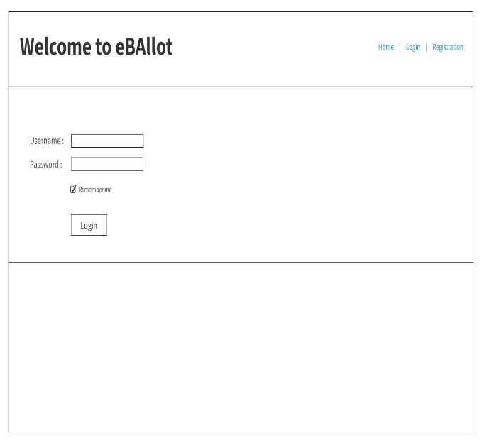

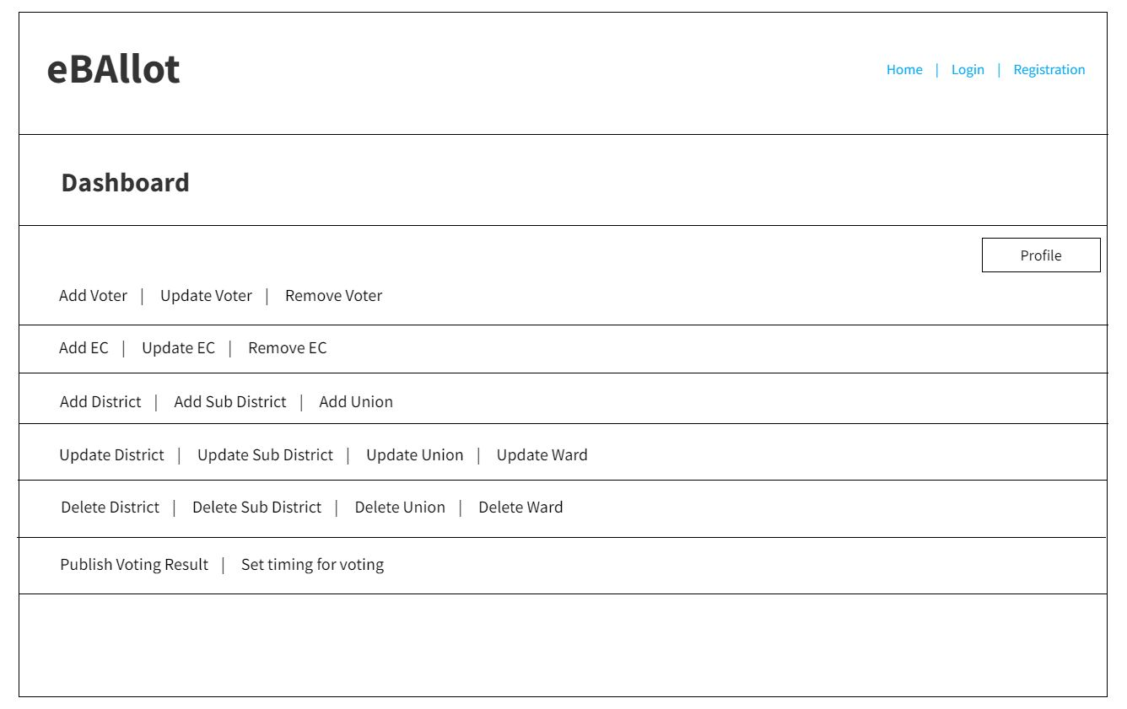

**Candidate**

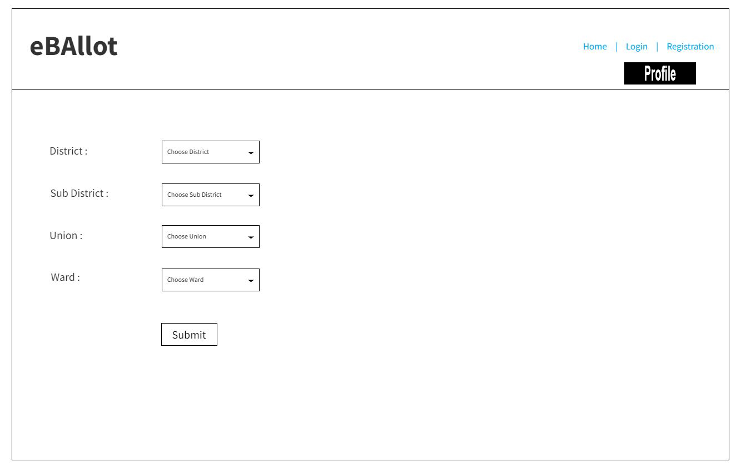

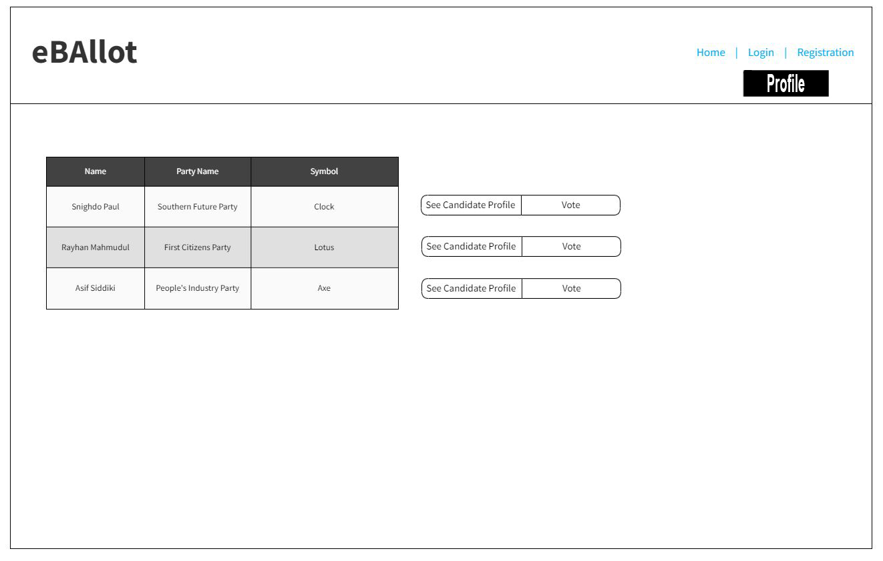

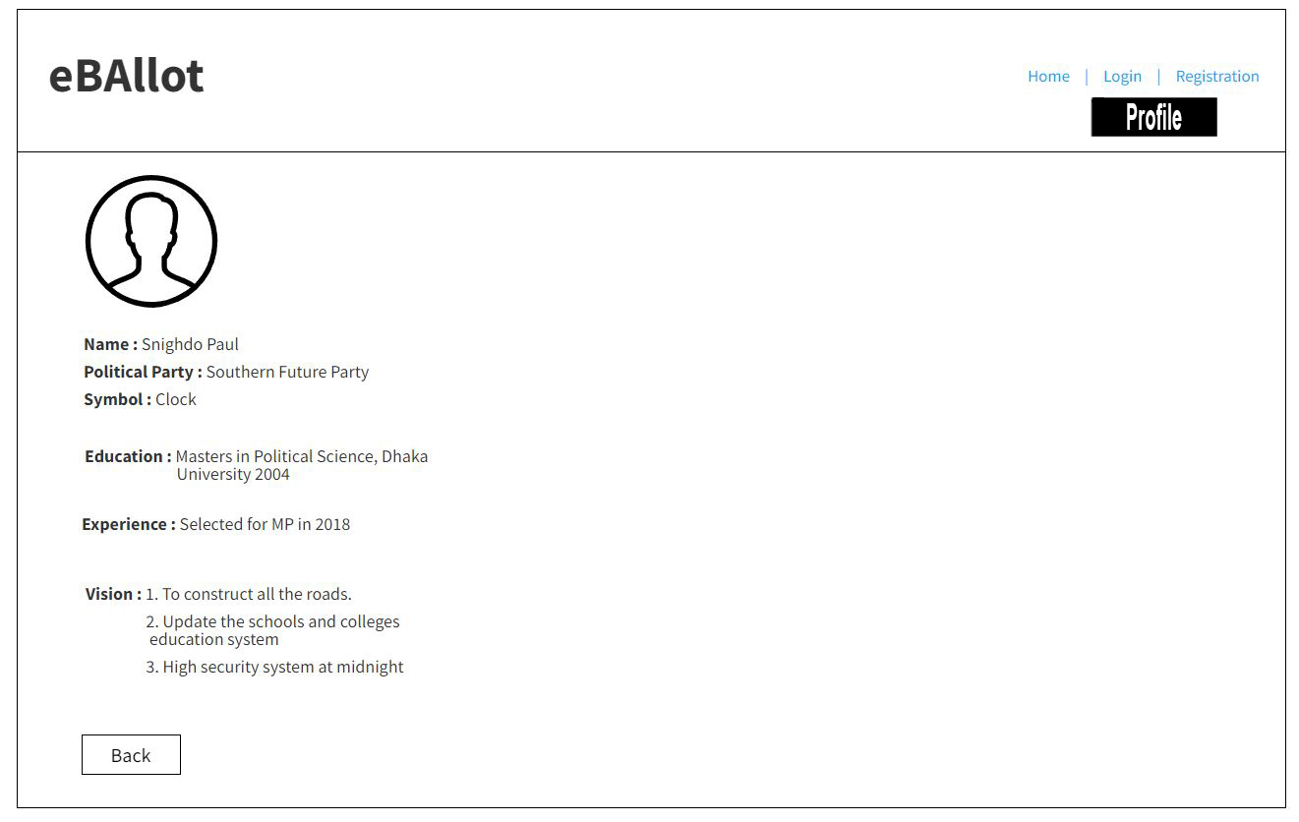

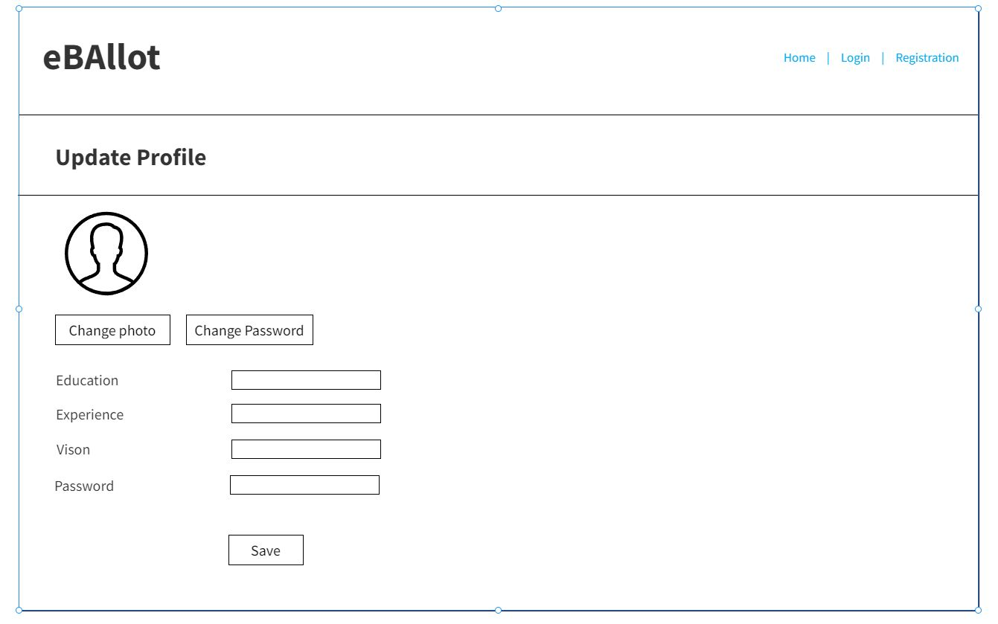

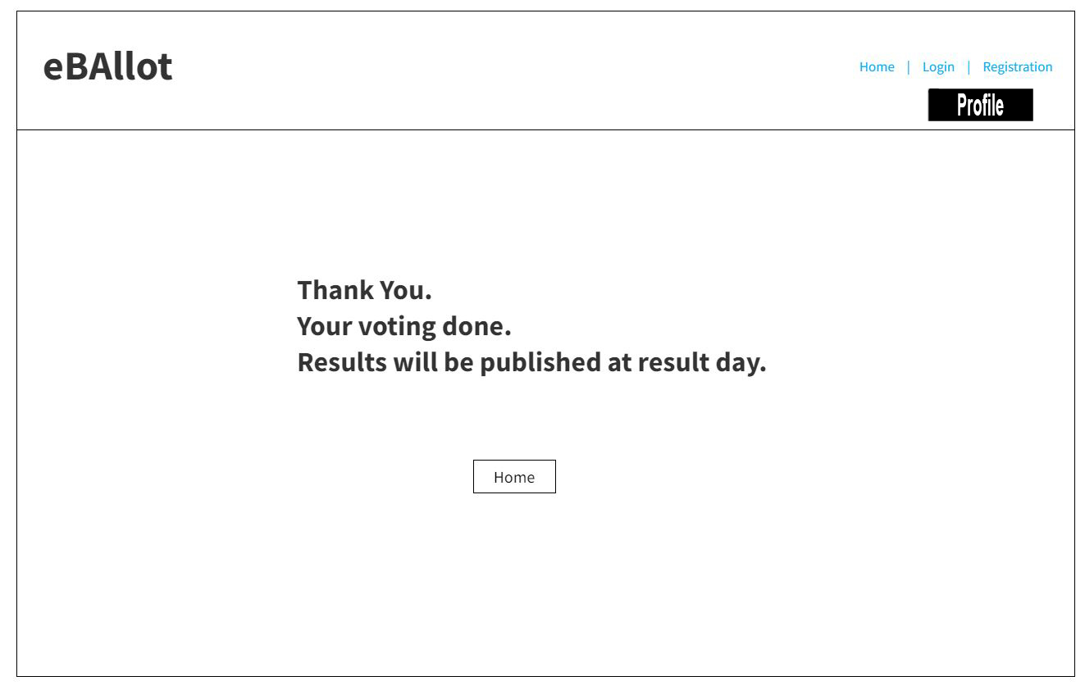

**EC**

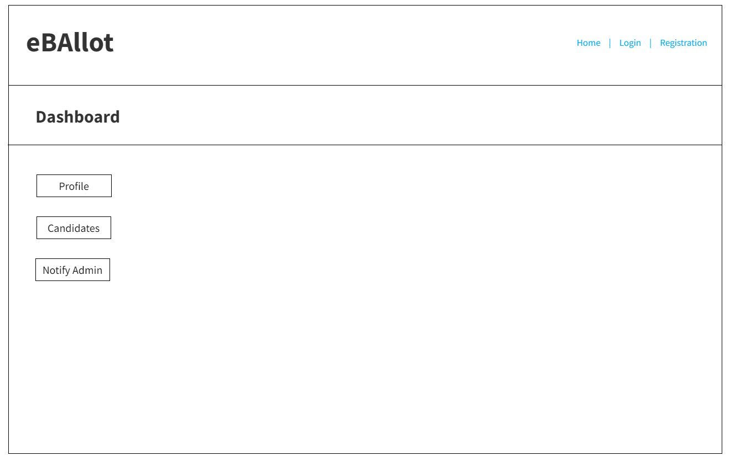

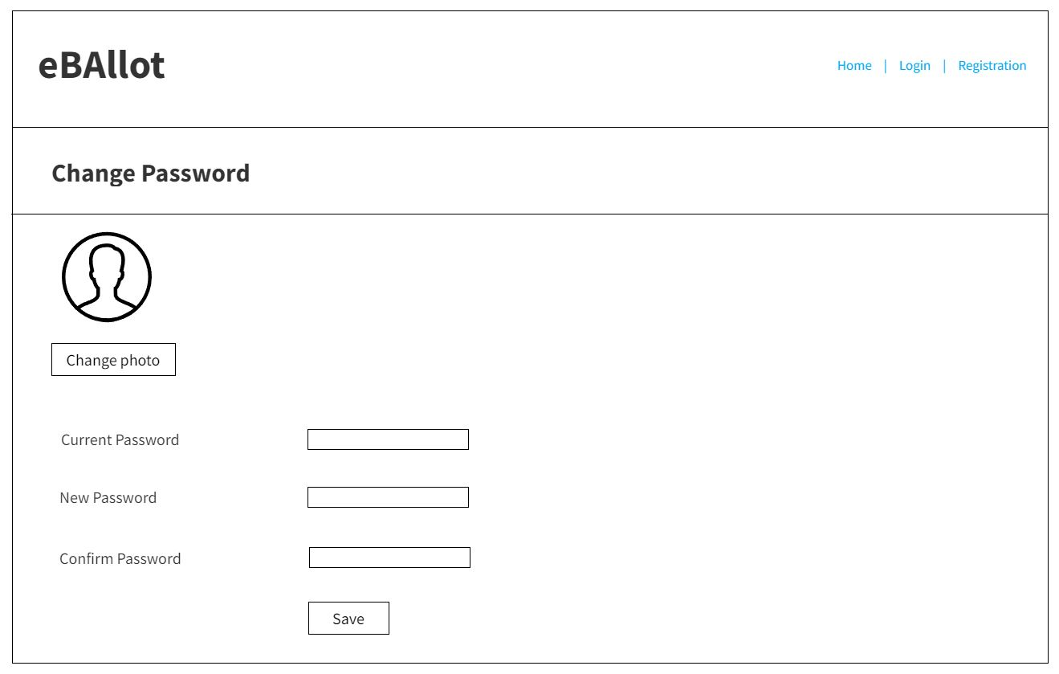

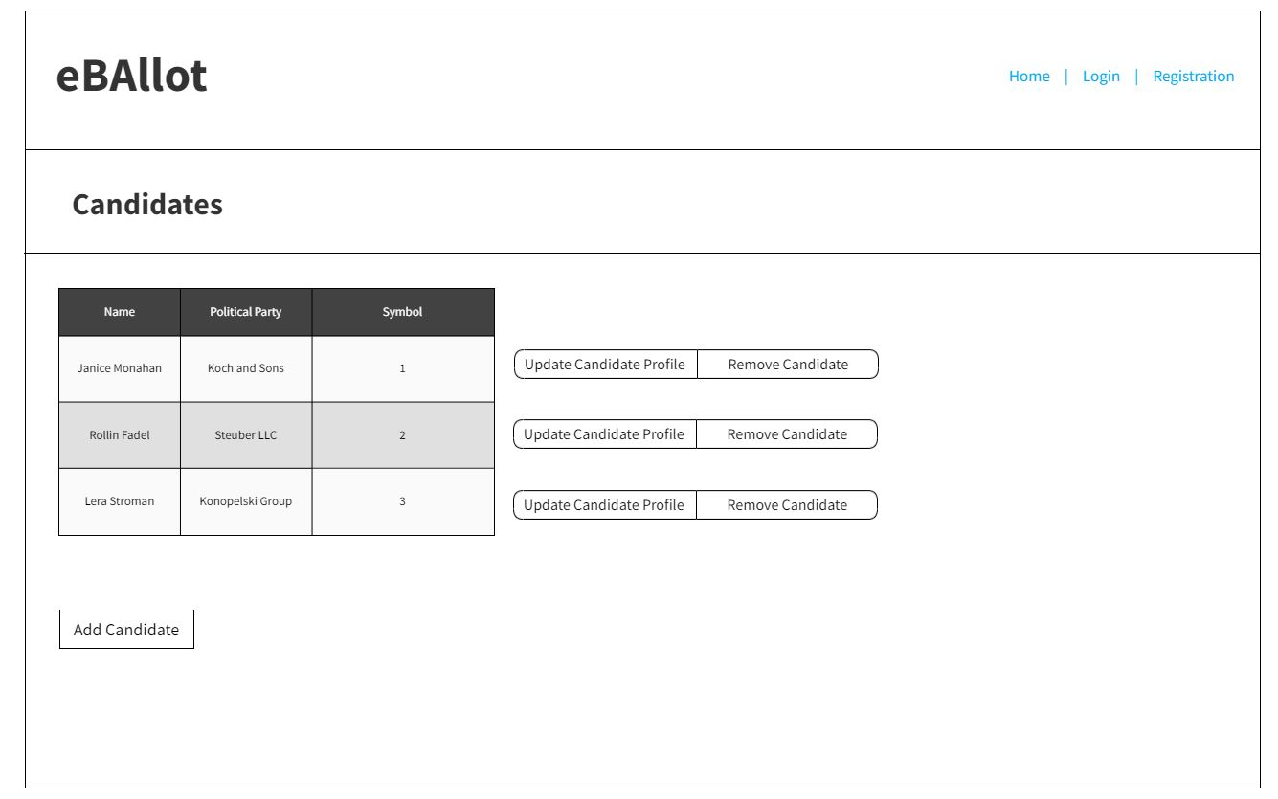

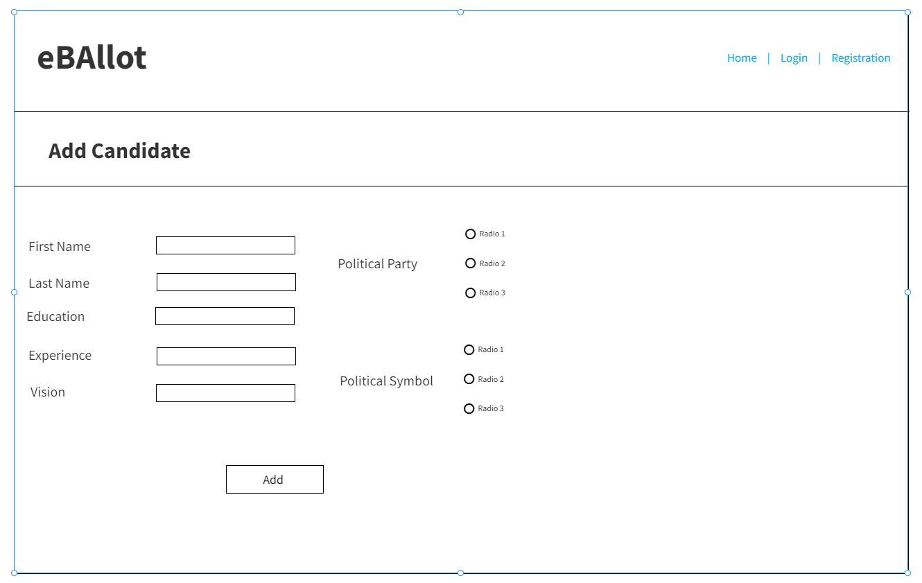

**Voter**

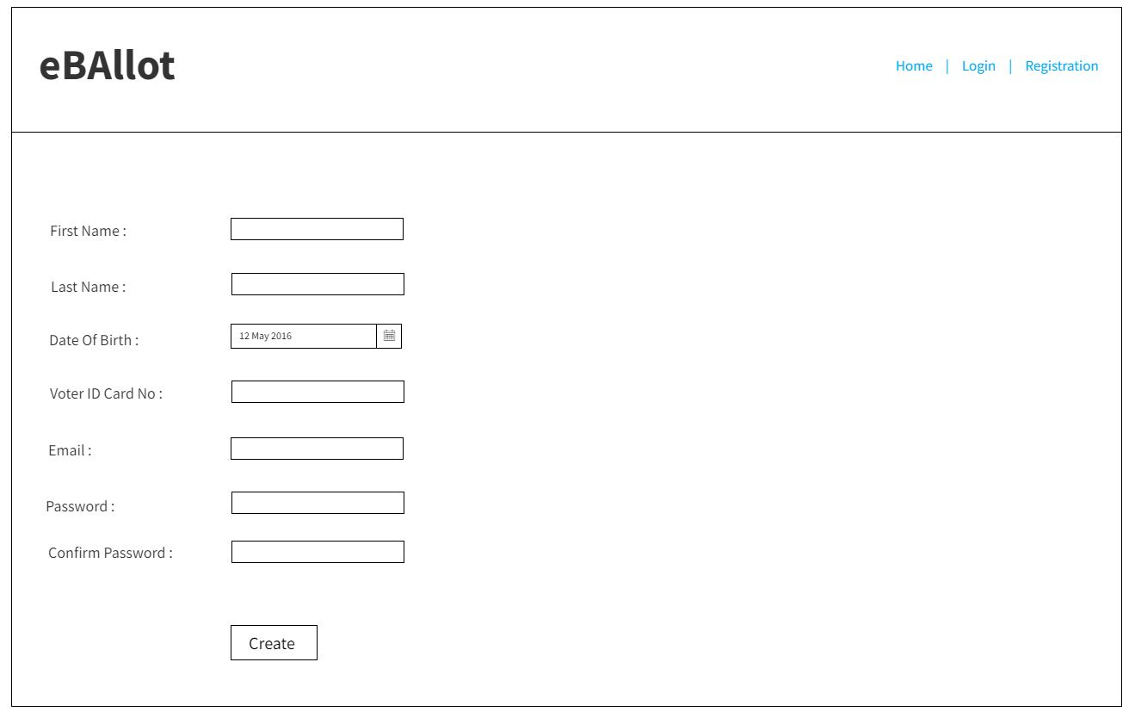







## Project Requirements

From the manager's point of view, the following project requirements are necessary to develop this project. They are not a component of the software and are only here to support the project's development.

• Human recourses

• Budget

• Time

• Tools

• Hardware

• Network connection

Delivering the product on time, within budget, and with the expected level of quality is our main objective in project management activities. Time, Cost, Scope, Resources, and Environment are the main obstacles. We must complete our work by the deadline, on schedule, and within our allocated budget. We must also add the necessary functionality to the system. We must maintain and effectively manage the necessary resources. A good output will be obtained if we properly manage all the constraints.

* By 20 weeks, a sensible solution ought to be available.
* The program shouldn't consume more than 80mb of storage after installation.
* Although developers prefer Visual Studio code, they can also use other editors.
* The standard version control system and code management tool will be Git.
* Unit testing will be performed using Selenium.
* Selenium will be used to carry out unit testing. With the use of a Figma, interactive prototyping will be carried out.
* The estimated cost of the project is 1,70,000 BDT.

# FEATURES NOT TO BE TESTED

The areas that won't be specifically tested are listed below.

* + **Third-party software integration**: While the software may need to integrate with third-party software, the testing team will not test the functionality or performance of the third-party software.
  + **Operating system compatibility**: The software may need to run on different operating systems, but the testing team will not test the compatibility of the software with each operating system.
  + **Network performance**: The software may communicate with other systems over a network, but the testing team will not test the performance of the network or the reliability of the communication.
  + **Security features of the operating system**: While the software may need to run on a secure operating system, the testing team will not test the security features of the operating system.
  + **User training**: While the software may require training for end-users, the testing team will not test the effectiveness of the training materials or the knowledge of the end-users.
  + **Performance of the hardware**: While the software may be installed on different hardware configurations, the testing team will not test the performance of the hardware itself. The ability to log out of numerous devices.

# TESTING APPROACH

## Testing Levels

Our system will be tested by the test manager and the development team and they will perform unit testing. system testing and Acceptance testing.

**Unit Testing** The developer will conduct unit testing using the white box testing technique. After that, the development team leader will confirm. Before unit testing is approved, the programmer will give it to the team leader. All of the information pertaining to this testing will also be given to the test subject. Control flow testing, data flow testing, and domain flow testing will be included under unit testing.

**System Testing** Following unit testing, all of the functions are connected and the entire system is tested. The development team leader, test manager, and each individual developer will work together to conduct this testing. Additionally, it is used to assess whether the software satisfies customer requirements.

**Acceptance Testing** We will perform acceptance testing as the last test after unit testing and system testing. The beta testing team or the end user will carry out this testing process. They will check to see if the program meets all of the requirements and test the system. The software will be ready for delivery if this test is successful.

## Test Tools

The system can be tested using IBM's iSeries, a midrange server series originally known as AS/400: This testing service is assessing:

* Testing metrics analysis and decision making
* Tracking
* Communicates
* Quality compliance
* Analyzing defects

It can be combined with Testbench software for test data management and certified IBM iSeries, AS/400 solution.

## Meeting

|  |  |  |
| --- | --- | --- |
| Meeting Date | Meeting Criteria | Objective |
| 16-3-23 | Feature Analysis | * Check the functions * System working process |
| 22-3-23 | Bug Fixed | * Send the bugs for decoding * Solve the bugs |
| 30-3-23 | Feature Analysis | * Again check the functions after regression testing |
| 9-4-23 | Revise The System | * Check the whole system * Recheck requirements * Run the system |

# 7.TEST CASES/TEST ITEMS

**Test Case 01:**

|  |  |  |  |  |  |
| --- | --- | --- | --- | --- | --- |
| Project Name: e-Ballot | | | Test Designed by: Israd Ahmed Ayon | | |
| Test Case ID: FR_1 | | | Test Designed date: 13-03-2023 | | |
| Test Priority (Low, Medium, High): High | | | Test Executed by: | | |
| Module Name: System login | | | Test Execution date: | | |
| Test Title: Verify login with given username and password | | |  | | |
| Description: Test system login page, whether the users are successfully able to login with their username and password. | | |  | | |
| Precondition (If any): User must have valid username and password. | | | | | |
| Test Steps | Test Data | Expected Results | | Actual Results | Status (Pass/Fail) |
| 1. Go to the website 2. Enter username 3. Enter password 4. Click submit | Username: User012  Password: 321489 | User should able to login to the application | |  |  |
| Post Condition: User should successfully login to the system using valid username and password. | | | | | |

**Test Case 02:**

|  |  |  |  |  |  |
| --- | --- | --- | --- | --- | --- |
| Project Name: e-Ballot | | | Test Designed by: Israd Ahmed Ayon | | |
|  | | |  | | |
| Test Case ID: FR_2 | | | Test Designed date: 13-03-2023 | | |
| Test Priority (Low, Medium, High): High | | | Test Executed by: | | |
| Module Name: Create Account | | | Test Execution date: | | |
| Test Title: User must create account with their valid NID information and verified phone number | | |  | | |
| Description: Test user account creation with valid NID number and a valid phone number | | |  | | |
| Precondition (If any): User must have valid NID and phone number | | | | | |
| Test Steps | Test Data | Expected Results | | Actual Results | Status (Pass/Fail) |
| Go to the website   1. Enter username 2. Enter NID 3. Enter Phone 4. Click submit | Username: User012  NID: 9154301264  Phone: 016897542166 | User should able to Create account to the system | |  |  |
| Post Condition: User should successfully create account to the system using valid NID and phone. | | | | | |

**Test Case 03:**

|  |  |  |  |  |  |
| --- | --- | --- | --- | --- | --- |
| Project Name: e-Ballot | | | Test Designed by: Shanjida Sultana Jim | | |
| Test Case ID: FR_3 | | | Test Designed date: 15.03.2023 | | |
| Test Priority (Low, Medium, High): Medium | | | Test Executed by: | | |
| Module Name: Ballot Creation | | | Test Execution date: | | |
| Test Title: Election commission can create ballot for elections. | | |  | | |
| Description: EC can create ballots for elections | | |  | | |
| Precondition (If any): Only EC can create ballots | | | | | |
| Test Steps | Test Data | Expected Results | | Actual Results | Status  (Pass/Fail) |
| 1. Go to the website 2. Enter username 3. Enter password 4. Create ballot | EC012  Password: 321 | EC should enroll into the application and get the option to create ballot | |  |  |
| Post Condition: EC should successfully login to the system with valid username and password and get the option to create ballot. | | | | | |

**Test Case 04:**

|  |  |  |  |  |  |
| --- | --- | --- | --- | --- | --- |
| Project Name: e-Ballot | | | Test Designed by: Shanjida Sultana Jim | | |
| Test Case ID: FR_4 | | | Test Designed date: 09.04.2023 | | |
| Test Priority (Low, Medium, High): Medium | | | Test Executed by: | | |
| Module Name: Mobile Compatibility | | | Test Execution date: | | |
| Test Title: verify login with in mobile devices | | |  | | |
| Description: Can login using a mobile device | | |  | | |
| Precondition (If any): User must have a smartphone with internet connection | | | | | |
| Test Steps | Test Data | Expected Results | | Actual Results | Status  (Pass/Fail) |
| 1. Go to the website 2. Enter username 3. Enter password 4. Click vote | Fahim  99999999999  Password: 321 | User should enroll into the application | |  |  |
| Post Condition: User is validated with database and successfully login to account. The account session details are logged in the database. | | | | | |

# 8.ITEM PASS/FAIL CRITERIA

A process will determine whether a test case item passes or fails:

After all test cases have been successfully completed, recommendations will be made. These choices will be made by the team leader in light of the trial's outcomes. The software framework cannot be removed until all bugs have been found in it. There will always be some bugs in the system when the final program is issued. The decision regarding whether to release the program and which test numbers will pass will therefore be made by the test leader and project manager. The test lead and project manager are solely responsible for it. If 98% of the test cases are successfully completed during the test session, we will in this instance remove the device.

**Evaluation team:** Each item's condition will be monitored by the evaluation team. The participants will be checking the things in this section:

* A Development Team
* User Acceptance Testing Manager
* UAT Analyst
* BAT Analyst
* Project Manager

**Evaluation Process:**

**Evaluate Business Scenarios:** Each open incident is traced back to the business scenarios, as well as any closed incidents that are acknowledged to be acceptable. The technological effect is evaluated, as well as whether they can supply the functionality that the company requires.

**Estimate Business Impact:** The impact of each open incident on the company is then assessed. The impact, the frequency of business impact, and remedies like schedule fixes and workarounds are all studied and recorded.

**Make an Acceptance Decision:** The analyses are then assessed to determine whether or not they should be accepted.

**Acceptance in its whole:** The system will be accepted in its entirety. Any unresolved incidents will be addressed.

# 9.TEST DELIVERABLES

* **Acceptance test plan:** Acceptance testing criteria, test cases, objectives, scope, approach, resources, and schedule are documented.
* **System/Integration test plan:** System/Integration testing criteria, test cases, objectives, scope, approach, resources, and schedule are documented.
* **Screen prototypes:** The layout and the design of the testing approach are documented.
* **Transmittal Reports for Test Items**: Developers' handover report.
* **Test Logs:** These are the outcomes of the tests.
* **Incident Reports:** Unexpected outcomes are documented.
* **Investigation Report Logs:** Incident Report Summary.
* **Test Summary Report:** A report that summarizes the testing.

# STAFFING AND TRAINING NEEDS

STAFFING NEEDS

There will require a team of developers, testers and project managers. The staffing needs for each role will depend on the size and complexity of the project.

So, the team needs for this development phase-

* 3 developers with expertise in Java, Python, and JavaScript
* 2 testers with experience in manual and automated testing
* 1 project manager with experience in agile software development methodologies

TRANING NEEDS

To ensure that our team members have the necessary skills and knowledge to complete the project carefully, we will provide training in the following areas:

* Java, Python, and JavaScript programming language
* Agile software development methodologies, including scrum
* Manual and automated testing techniques
* Continuous integration and deployment (CI/CD) tools and processes
* Code review and quality assurance best practices

We will also provide ongoing training and support to ensure that our team members stay up-to-date with the latest technologies and industry best practices.

By addressing strafing and training needs in this way, we can ensure that we have the right team in place with the skills and knowledge necessary to successfully complete the software the software development project.

# RESPONSIBILITIES

|  |  |  |  |  |  |
| --- | --- | --- | --- | --- | --- |
| Work | TM | PM | DEV Team | Test Team | Client |
| Acceptance test documentation &  execution | Done | Done | Pending | Pending | Done |
| System test documentation | Done | Done | Done | Done | Pending |
| Unit test documentation | Done | Done | Done | Done | Pending |
| System design | Done | Done | Done | Done | Done |
| Detail design | Done | Done | Done | Done | Pending |
| Test procedures and rules | Done | Done | Done | Done | Pending |
| Screen & Report prototype reviews | Done | Done | Done | Done | Done |
| Change control and regression testing | Done | Done | Done | Done | Pending |

# TESTING SCHEDULE

The following testing tasks are included in the project plan. The project plan timetable specifies the specific dates and durations for each work. The individual required for each procedure is also specified in the project schedule and evaluation plan.

|  |  |  |  |  |  |  |  |  |
| --- | --- | --- | --- | --- | --- | --- | --- | --- |
| Week Task | 1 | 2 | 3 | 4 | 5 | 6 | 7 | 8 |
| Documentation |  |  |  |  |  |  |  |  |
| Design |  |  |  |  |  |  |  |  |
| Test Plan |  |  |  |  |  |  |  |  |
| Unit Testing |  |  |  |  |  |  |  |  |
| IntegrationTesting |  |  |  |  |  |  |  |  |
| System testing |  |  |  |  |  |  |  |  |
| Acceptance testing |  |  |  |  |  |  |  |  |
| ProjectCompletion |  |  |  |  |  |  |  |  |
| Feedback |  |  |  |  |  |  |  |  |

# PLANNING RISKS AND CONTINGENCIES

PLANNING RISKS

Risk Identification: Identifying potential risks that could affect the project is the first stage in developing a plan for risks and contingencies.

* Changes in requirements could cause delays or require additional work.
* Technical issues could cause the project to be delayed or fail.
* Staffing issues, such as turnover or lack of expertise, could impact the project timeline or quality.
* External factors such as market changes or economic conditions could impact the success of the project.

Risk Assessment: In this stage is to evaluate each risk's likelihood and impact when it has been identified.

* It is possible that requirements may change, and these changes could have a moderate effect on the project's budget and schedule.
* Although they are less likely to happen, technical problems could have a significant impact on the project.
* Staffing problems are moderately likely to arise, and if they do, they could significantly affect the project.
* Though unpredictable, external factors have the potential to significantly affect the project if they do.

Risk Mitigation: Creating ways to reduce each risk is the next step.

* The project team may design a change control procedure to handle any alterations to the project requirements in order to reduce the risk of requirements modifications.
* The project team may perform routine code reviews and testing to find and fix errors early in the development process, reducing the chance of technical issues.
* The project team could cross-train team members and keep a contingency plan in place to deal with any staffing shortages in order to reduce the risk of staffing concerns.
* The project team could routinely analyze market conditions and economic trends to detect potential hazards and alter the project plan as necessary to reduce the risk of external factors.

CONTINGENCIES

Contingency Planning: The project team should also include backup strategies to deal with hazards that cannot be completely eliminated.

* If technical problems do arise, the project team might have a backup plan in place to deal with them right away, for as by bringing in more technical experts.
* If there are staffing problems, the project team may have a backup plan to hire more people or modify the schedule as needed to deal with any delays or quality problems.

By planning for risks and contingencies, the project team can be better prepared to address any challenges that arise during the software development project and ensure that the project is completed successfully

# APROVALS

|  |  |
| --- | --- |
| Project Sponsor | AYON, JIM, PRANTO&PRONOY |
| Development Management | JIM |
| EDI Project Manager | AYON |
| RS Test Manager | PRANTO |
| RS Development Team Manager | PRANTO |
| Reassigned Sales | PRONOY |
| Order Entry EDI Team Manager | PRONOY |