

American International University-Bangladesh (AIUB)  
**Department of Computer Science  
Faculty of Science & Technology (FST)**

**Writer your PROJECT TITLE here**

A Software Requirement Engineering Project Submitted

By

|  |  |  |  |  |
| --- | --- | --- | --- | --- |
| **Semester: Fall_22_23** | | **Section:** | **Group Number:** | |
| SN | Student Name | Student ID | Contribution (CO1+CO2) | Individual Marks |
|  |  |  |  |  |
|  |  |  |  |  |
|  |  |  |  |  |
|  |  |  |  |  |
|  |  |  |  |  |

The project will be Evaluated for the following Course Outcomes

|  |  |  |
| --- | --- | --- |
| **CO1:** *Apply* the principles of engineering management and economic decision to manage thesis/project as a team member/team leader. | Total Marks | |
|  | |
| **Project/Thesis Value:** Project Value is reasonable to the current market value and have promising Profitability. | [5 Marks] |  |
| **Stakeholder Perspective:** Thoughtfully consider perspectives of diverse relevant stakeholders and articulate these with great clarity, accuracy, and empathy. | [5Marks] |  |
| **Code of Ethics Consideration:** Clearly articulate relevant Code of Ethics considerations and address these in discussing approaches to resolve the  problem(s). Make linkages between ethical considerations and stakeholder interests and discuss ways to mediate dilemmas or suggest tradeoffs. | [5Marks] |  |
| **CO2:** *Evaluate* the scope of independent and life-long learning in solving complex engineering problems and change of technologies | Total Marks | |
|  | |
| **Motivation of the work:** Explore the project/thesis topic with evidence rich awareness indicating intense interest in the area. | [5Marks] |  |
| **Critical Thinking:** Understands the concepts very well and creates new knowledge | [5Marks] |  |
| **Future studies:** The scope of future studies is stated and discussed elaborately with details of how this study can be extended in future endeavored | [5Marks] |  |

Table of Contents

Revision History 3

1. Introduction 3

1.1 Purpose 3

1.2 Intended Audience and Reading Suggestions 3

1.3 References 4

2. Overall Description 4

2.1 Product Perspective 4

2.2 Product Functions 4

2.3 User Classes and Characteristics 5

2.4 Operating Environment 5

2.5 Design and Implementation Constraints 5

3. System Requirements 5

3.1 User Scenario 5

3.2 System Features 6

Functional Requirements (FRs): 7

3.3 Non-Functional/Quality Requirements 7

3.4 Project Requirements 8

4. Interface Requirements 8

4.1 UML Diagram: 8

Use-Case Diagram: 8

Election Authority Panel: 11

Candidate Panel: 12

4.2 UI Design: 16

5. Conclusion 19

# Revision History

|  |  |  |  |
| --- | --- | --- | --- |
| **Name** | **Date** | **Reason for Changes** | **Version** |
|  |  |  |  |
|  |  |  |  |

# Introduction

## Purpose

EVM App is a Electronic Voting Machine App . Version is 1.0 . A simple electronic device called an electronic voting machine (EVM) is used to record votes in place of the ballot papers and boxes that were previously utilized in conventional voting systems. Democracy's foundation is its fundamental right to vote, or simply the ability to cast a ballot. In previous elections, whether they were state or center elections, a voter would mark the name of their preferred candidate with a stamp, fold the ballot paper according to the instructions, and then place it in the ballot box. This is a laborious, error-prone process that takes a lot of time. This arrangement persisted until computerized voting machines drastically altered the election scene. There is no longer a need for ballot paper, ballot boxes, stamping, etc. The electronic voting machine's ballot unit is a straightforward box. So, it is more trustworthy than conventional token or knowledge-based approaches for person recognition since they cannot be readily lost, faked, or exchanged. Therefore, the electronic voting system needs to be enhanced using the most recent technology, namely the biometric system.

The scope of this project-

* This system applies to the online voting app. This product facilitates users to a hassle-free and user-friendly online voting experience.
* Generate Reports of elections and Generate result transcripts finally authorize the result of elections.
* Maintaining the database of voters and candidates.
* Voters and candidates can reach out to the admin for help/ file a complaint or to give feedback through the application itself.

## Intended Audience and Reading Suggestions

* developers
* project managers
* marketing staff
* users
* testers
* documentation writers.

## References

[1] D Ashok Kumar and T Ummal Sariba Begum. “Electronic voting machine—A review”. In: International Conference on Pattern Recognition, Informatics and Medical Engineering (PRIME-2012). IEEE. 2012, pp. 41–48.

[2] Arthur M Keller, David Mertz, Joseph Lorenzo Hall, et al. “Privacy issues in an electronic voting machine”. In: Proceedings of the 2004 ACM workshop on Privacy in the electronic society. 2004, pp. 33–34.

# Overall Description

## Product Perspective

We are going to introduce a web-based online electronic voting app which will able to process data with computer software and record voting data. In this app voter can easily cast his vote

## Product Functions

* store voter’s information
* observe voter’s status
* check room availability for waiting
* generate list for the voters from the system
* calculate total
* cancel the appointment request from users.
* reschedule any appointment.
* consider the special needs.
* check voter identity.
* check voter ID Card Number.
* voters and votes.

## User Classes and Characteristics

Admin can manage all those things like manage voter, voter authentication, add manager and staffs, add election etc. For the secrecy of the vote, Admin will avoid any connection between the voter’s identity and the vote cast in this app. In this way, This app can more secure for all users.

## Operating Environment

Windows , Linux , Mac , Android and Ios

## Design and Implementation Constraints

Because the program was built for large-scale public usage, it was necessary to keep design and implementation limitations as minimal as feasible. However, there are several limitations, such as:

* Because the software is built with the Solidity programming language which is under development and frequently changing, providing subsequent updates to the application can be costly.
* The budget may be a large restriction; for example, if the client desires more alternatives but has a limited budget, this becomes a major design constraint.
* The user needs to be somewhat literate to operate the GUI.
* The user should have a basic understanding of computers or android phone.
* Many nodes need to be setup by the Government and the general population for a true decentralized database system, which can take years to accomplish.

# System Requirements

## User Scenario

* Write the user scenario that clearly depict a user’s journey through the most important   
  functionality of the project.

|  |  |  |
| --- | --- | --- |
| **Sample use-case** | **Actor** | **Corresponding user scenario** |
| Update Customer Profile | Customer | As a customer, I want to update my customer profile so that future purchases are billed to a new credit card number |

## System Features

In this Online Voting App, there are four types of users will use this system:

* + 1. Voter:
       - Voter Can Register and login by his own voter ID card.
       - Voter can view candidates.
       - Voter can cast vote
       - Voter can provide and scan fingerprint for casting vote in this app .
    2. Admin: Admin can alter each thing. Additionally, can maintain entire system, delete something in case he will find any offensive.
       - Admin can maintain the entire system.
       - Modify candidate’s Information.
       - Modify Election authority Information.
       - Modify Electoral Information.
       - Add voting time duration.
    3. Election Authority: They can verify single-vote verification, which ensures members

don’t inadvertently vote more than once

* + - * Verify/edit results
      * Generate Reports of election
      * Generate result transcript
      * Authorize result of elections.
    1. Candidate:
       - Register for his Nomination
       - Login profile with username and password.
       - View update of voting result.

### Functional Requirements (FRs):

1. Database Store voter’s information which is save record of all Voters
2. Observing voter’s status which is check the voter is eligible to cast for vote or not
3. check room availability for waiting
4. generate list for the voters from the system
5. calculate total
6. cancel the appointment request from users.
7. reschedule any appointment.
8. consider the special needs.
9. check voter identity.
10. check voter ID Card Number.voters and votes.

## Non-Functional/Quality Requirements

Non-functional requirements are focused on the system’s operation rather than its behavior

**Compliance:** Our application complies with software standards, it's less likely to contain bugs, security weaknesses, and design flaws.

**Privacy:** Privacy software can built to protect the privacy of its users. The software typically works in conjunction with Internet usage to control or limit the amount of information made available to third parties. The software can apply encryption or filtering of various kinds.

**Quality:** It’s very important factor for a software. It helps identify errors and flaws in the software code and design throughout the development process to prevent loss of time and money.

**Reliability:** It is an important non-functional requirement for most software. Itis usually defined as the probability that our software will operate without failure for a specified number of uses (transactions) or for a specified period of time

**Response time:** It refers to the amount of time Application Server takes to return the results of a request to the user**.** System good and fast response is most important for software. We will try to keep the response time very fast.

**Scalability:** Scalability is the measure of a system's ability to increase or decrease in performance and cost in response to changes in application and system processing demands. It is very important requirement for software system.

**Stability:** It means a state or quality of being stable. We will stability testing in our software which involves ascertaining a software application's capacity to execute or accomplish tasks within defined conditions or duration. We will measure the system stability by analyzing the impact of change in a software system for every element of the system.

## Project Requirements

* **Tools:** The system developer needs Database , IDE , Browsers , Operating System which is required

# Interface Requirements

## UML Diagram:

# Use-Case Diagram:

**Voter Panel:**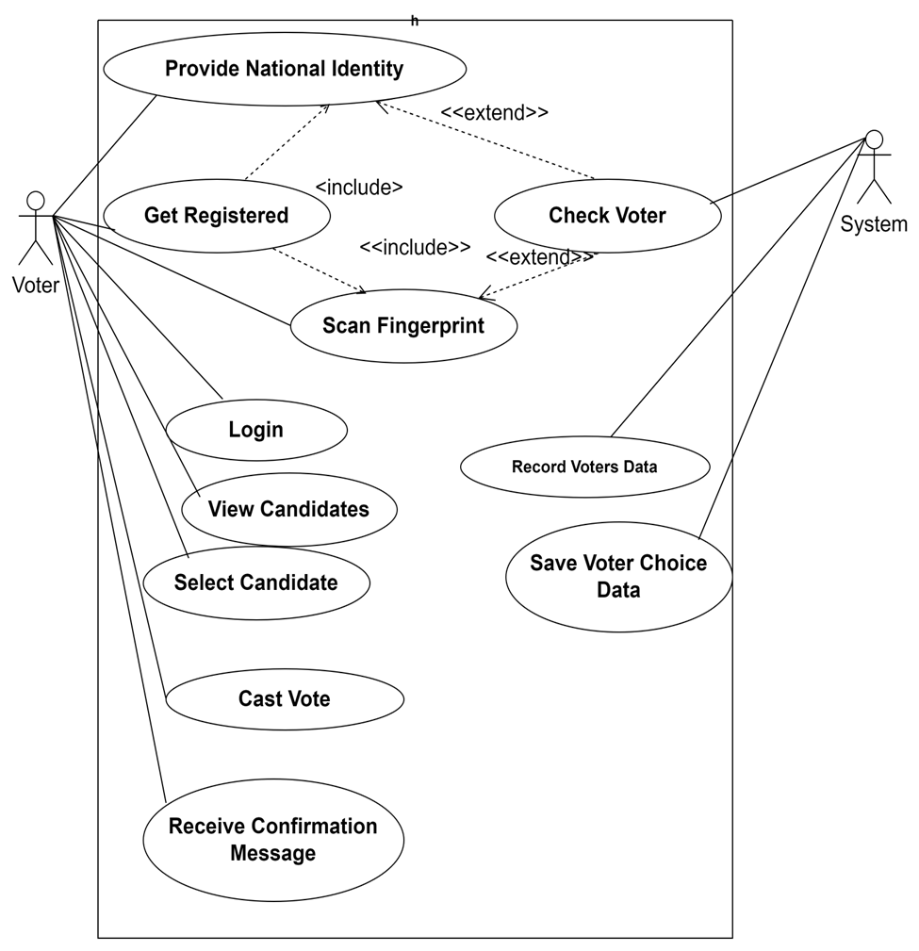

**Admin Panel:**

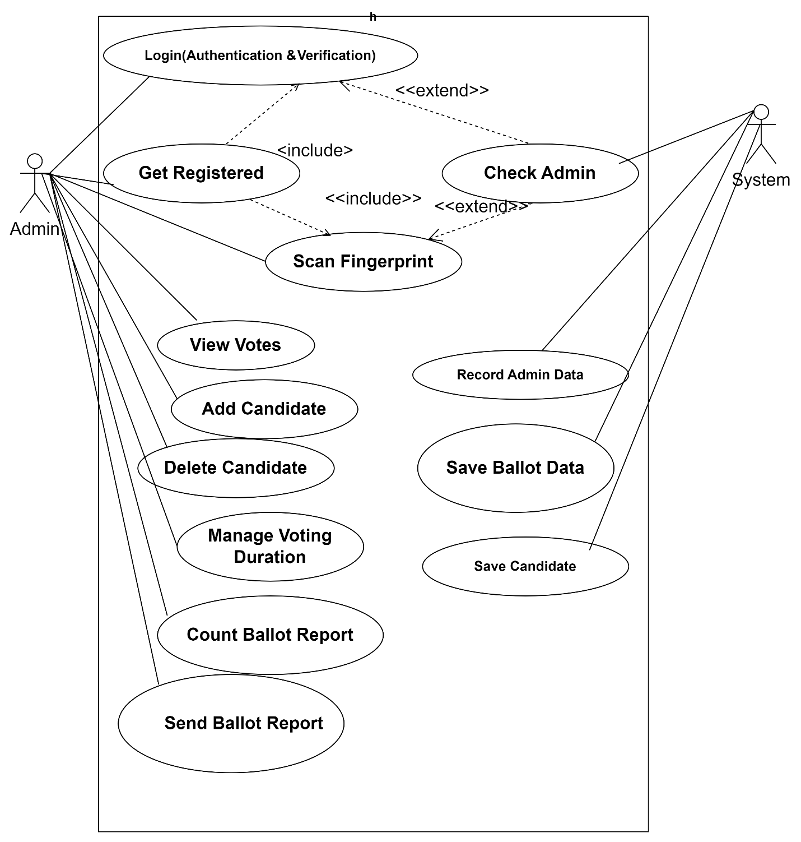

# Election Authority Panel:

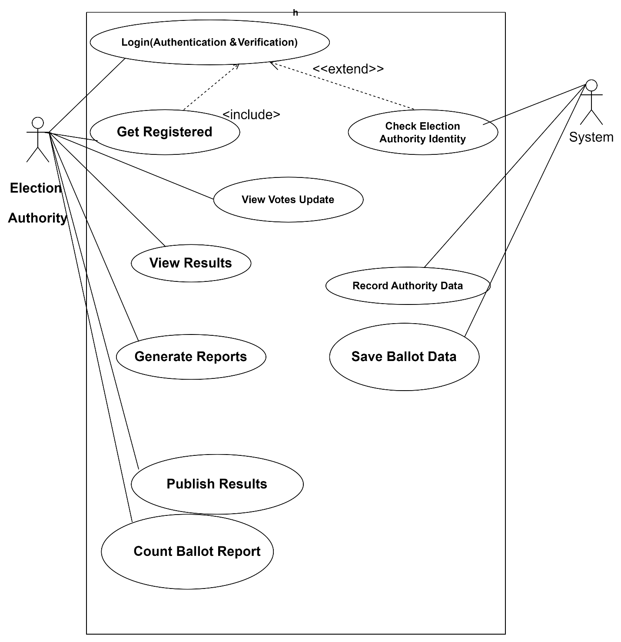

# Candidate Panel:

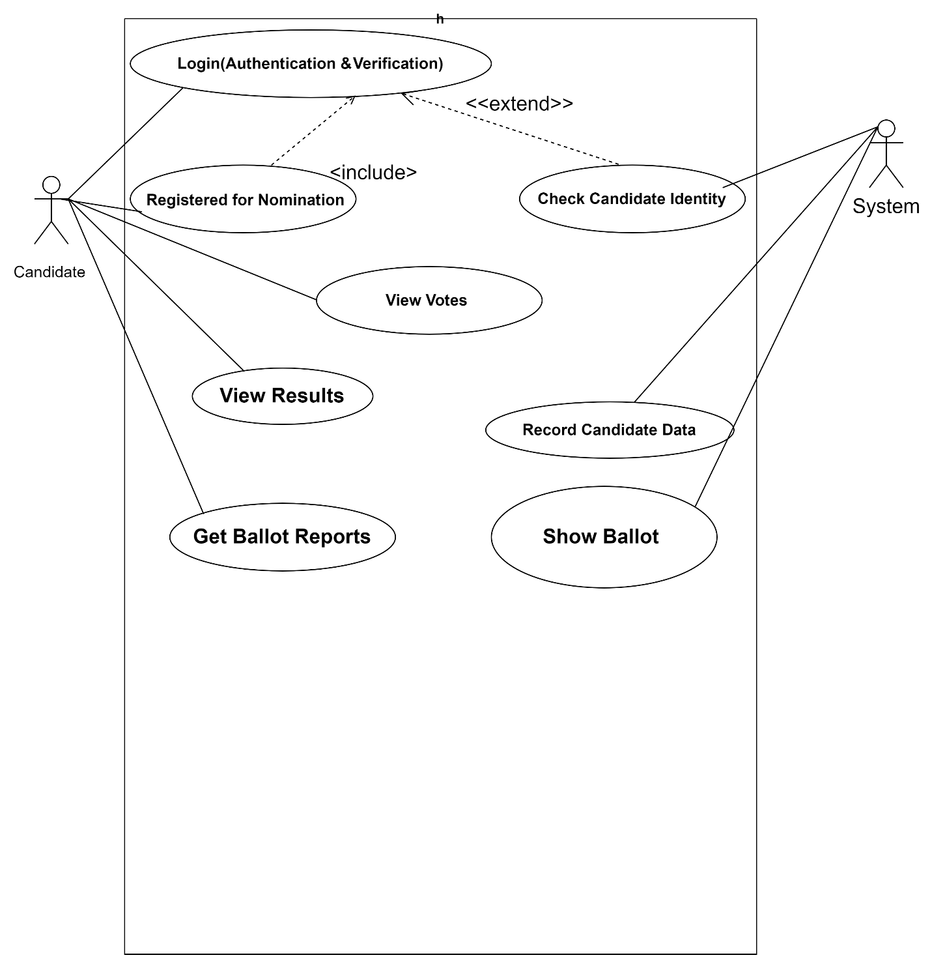

**UML Activity Diagram: Voter**



**Register voter**

Is voter register?

**Login voter**

**View Candidate Details**



**Select Candidate**



**Cast Vote**



**Update vote count**



**Show Confirmation message**



**Display error message**



**Back to profile**

If No

If yes

Is vote successful

If yes

**Class Diagram**

**CAST VOTE**

+candidate id +Voter id +Time stamp

**CANDIDATEE**

**VOTER**

+Submit vote() +Cancel vote()

+ cast

+Voter id +Voter Password +Voter Name

+candidate id +candidate name +Party symbol +Constitute

+Submit report()

+Voter id +Voter number

**ADMIN**

+get Votes count() +Display()

+Caste Vote() +View Result()

VOTER PROFILE

+Voter id +Voter Password +Voter Name +Voter Information

+Caste vote() + View Result()

+has

+Submit nomination() +Cancel nomination()

+has

+save results +add

+updates

+Publish

**VOTING SERVER**

+Voter id +Candidate id +Time stamp +Votes count

+Get Votes

**RESULT**

+candidate id +Party symbol

+Send reports() +Count Votes()

**ER Diagram**

cast

has

**Candidate**

**Cast Vote**

**Voter**

**Get Votes**

Publish

**Result**

Update

Add

**Admin**

**Save results**

**Voting Server**

**Voter Profile**

has

## UI Design:

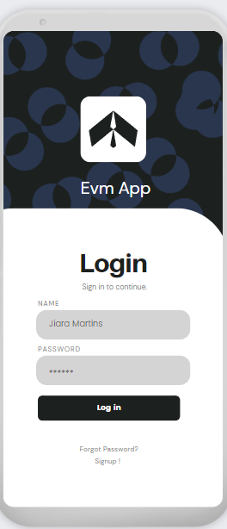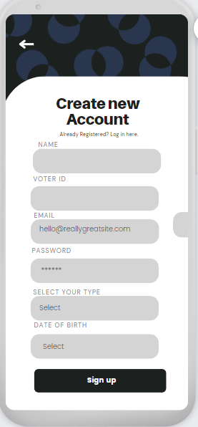

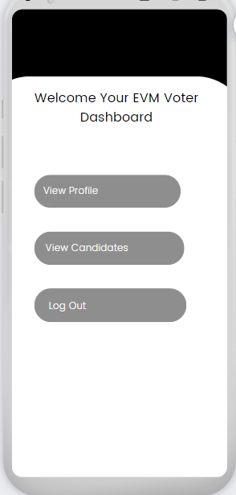 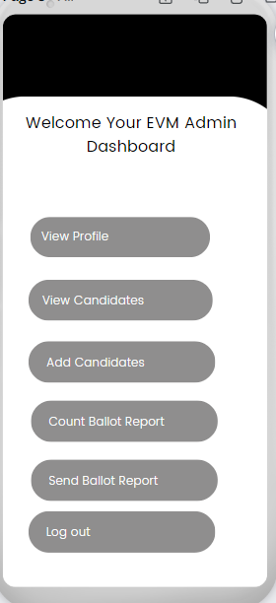

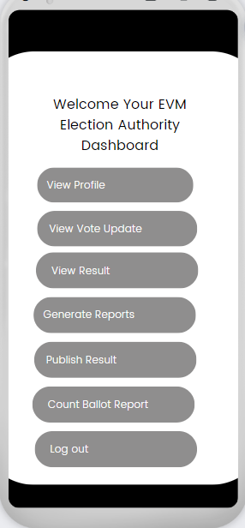 

# Conclusion

Our Digital Online Electronic voting app will allow people in today’s mobile and digitally advanced society to participate in the democratic process over the internet. This online voting app will offer the highest levels of transparency, control, security and efficiency of election processes. This voting app will provide society people or voters with a comfortable and secure voting experience and allow election organizers to save resources in planning their next election. For organize an election, planning postal or ballot box elections is a high costs process. Paper-based election voting is cost-intensive and burdensome for the environment. People can get opportunity to give their vote within a short time with internet access in this online voting app. By eliminating the use of physical post and manual vote counting we can avoid result-distorting mistakes such as loss of voting documents and miscounted votes. This online voting allows to access results shortly after the election.

Results can also be verified by the election authority after the election by using this app. This can help society people to save time and reduce cost. It is also very important to Social media marketing. It is the use of social media platforms to connect with people of society to this Online voting app. Publicity at social media about a new lunched software has a great good impact. So that time, when a company choose this online voting app company will select which platform will best for their work promoting. Since social arrange is huge issue presently in days.