**Terraform Task-2**

**Task Description:** Create 2 EC2 instances on 2 different regions and install nginx using terraform script.

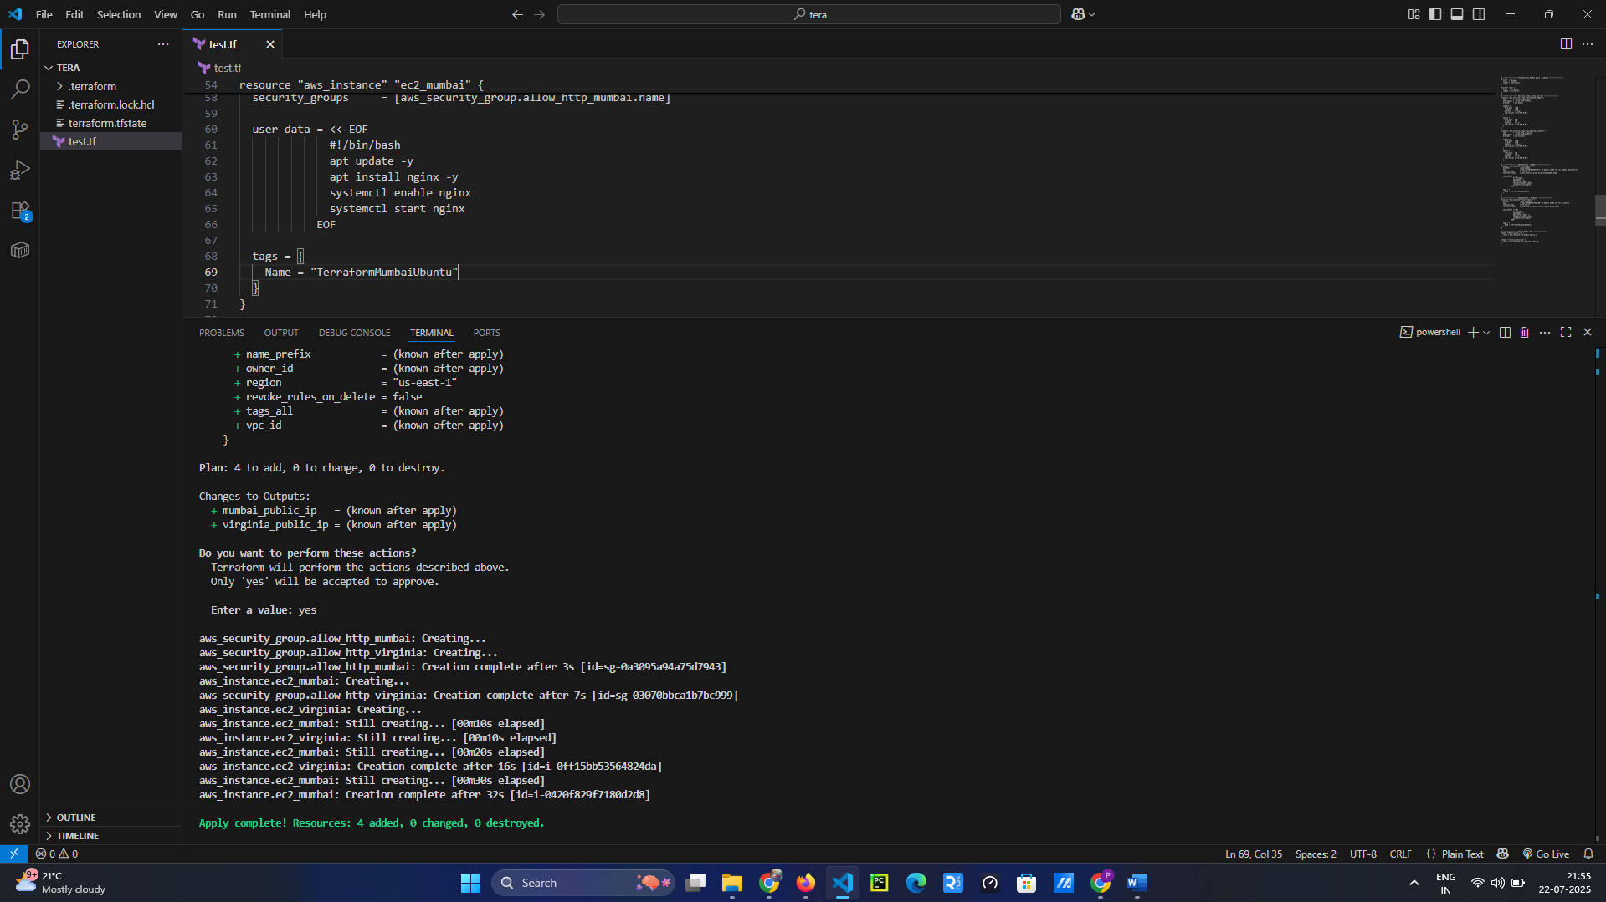

**Mumbai Region- ap-south-1**

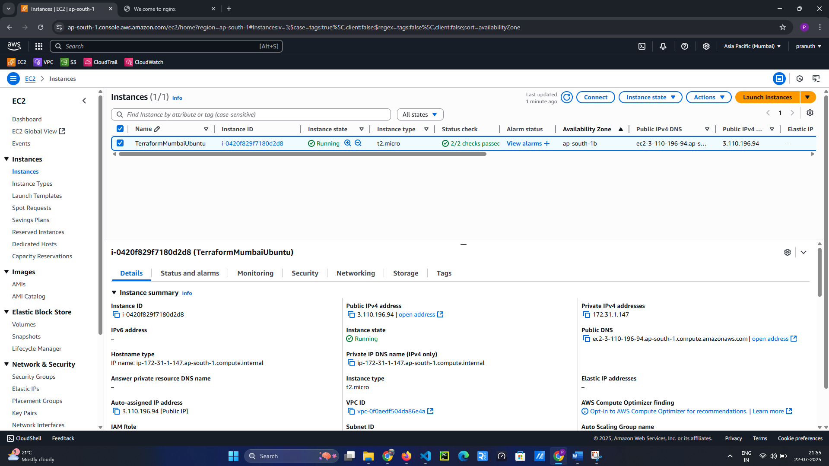

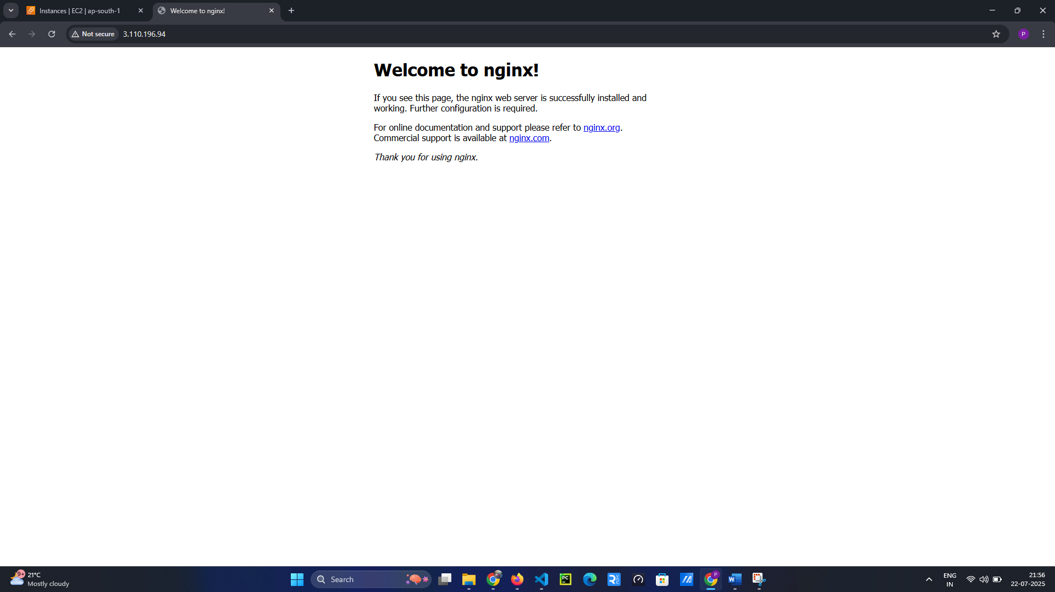

**United States N. Virginia- us-east-1**

