**VCS Task**

**Task Description**

Establish a new directory, populate it with script files, initiate an empty repository on GitHub, convert the local directory into a Git repository, and link it to GitHub for pushing the code into the repository.Perform merge, rebase, stash commands in following github repo.

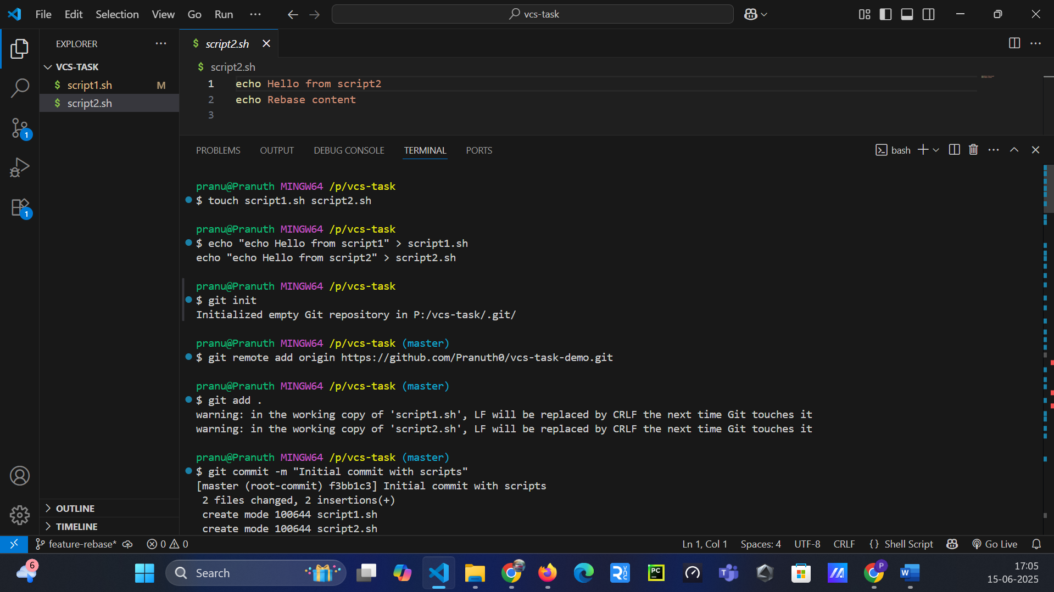

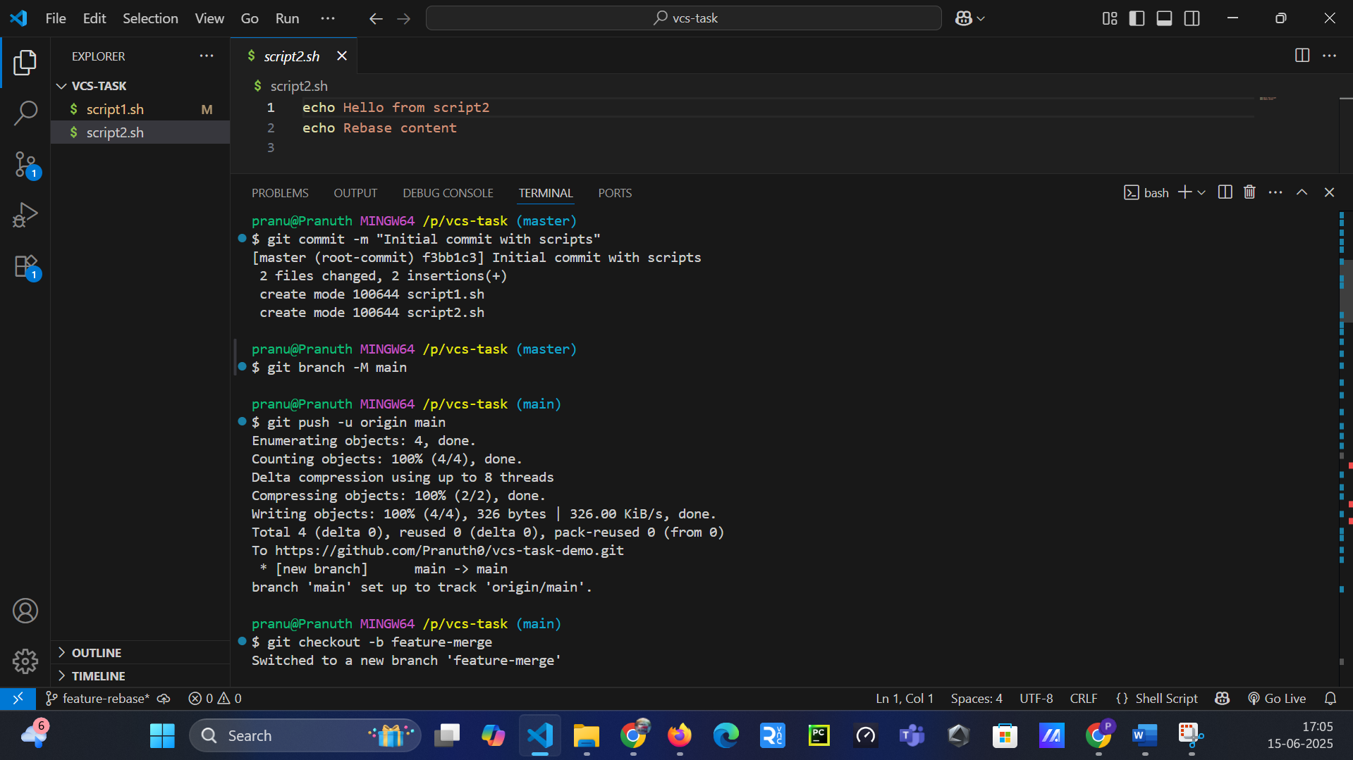

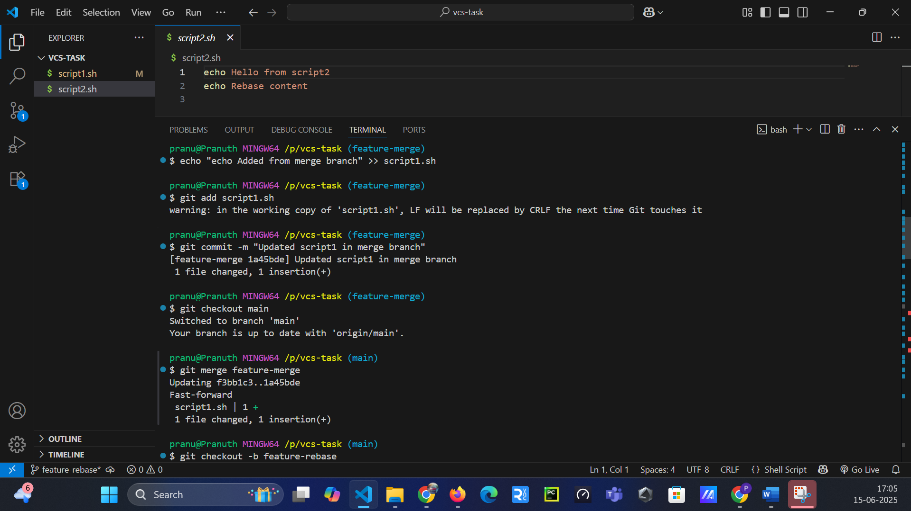

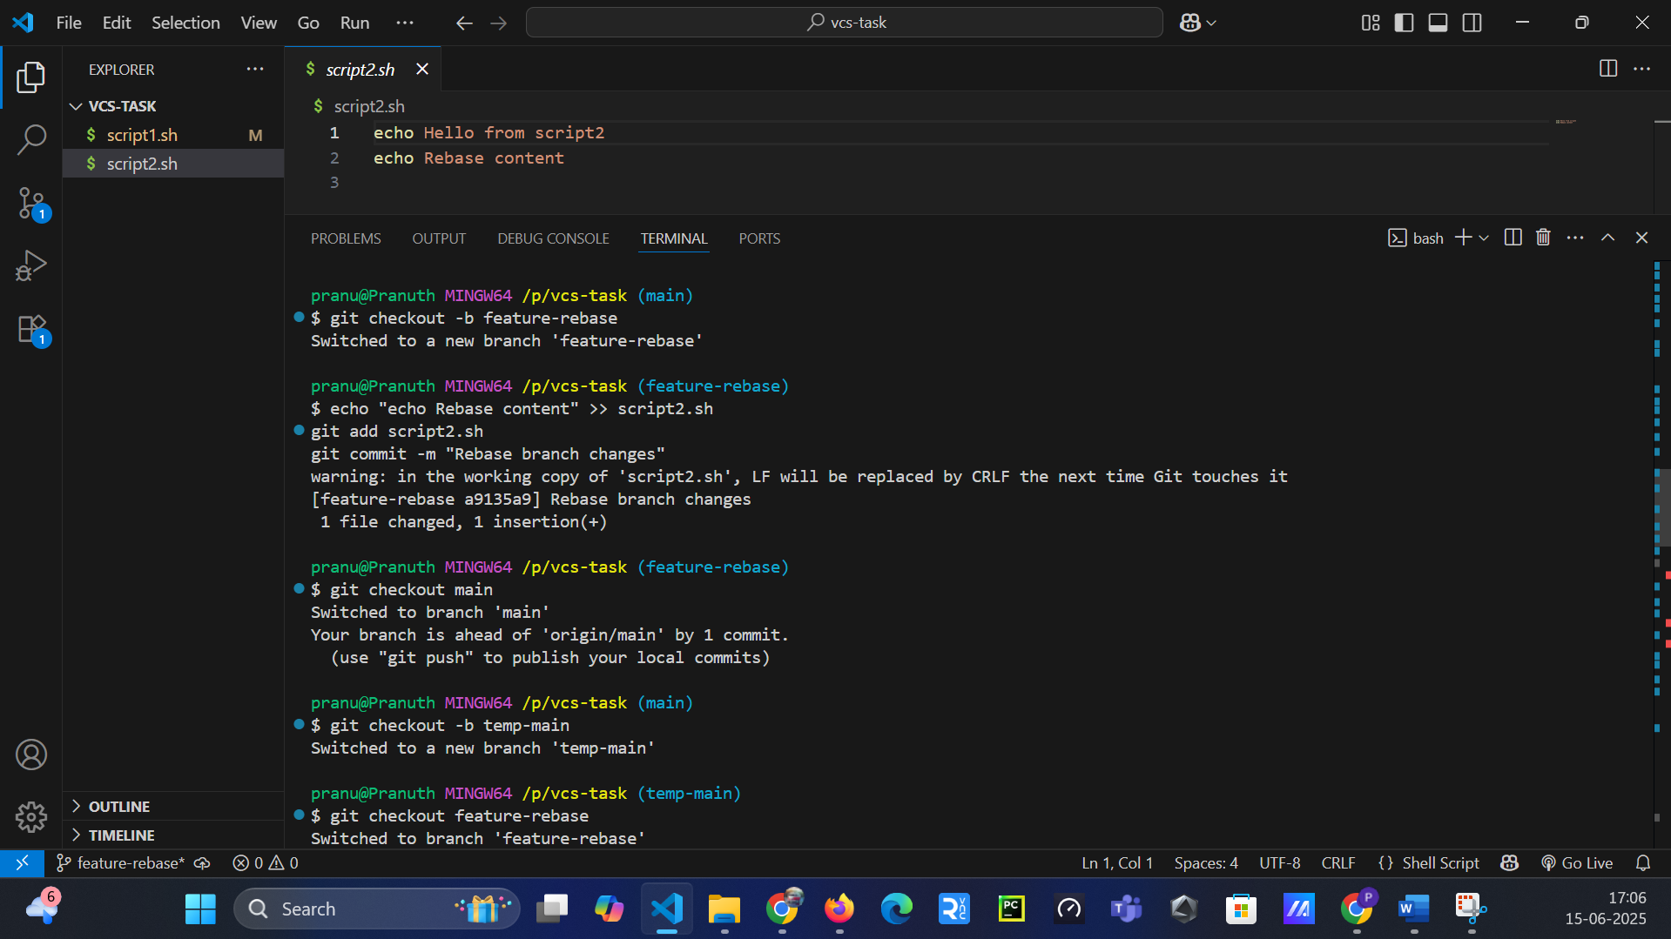

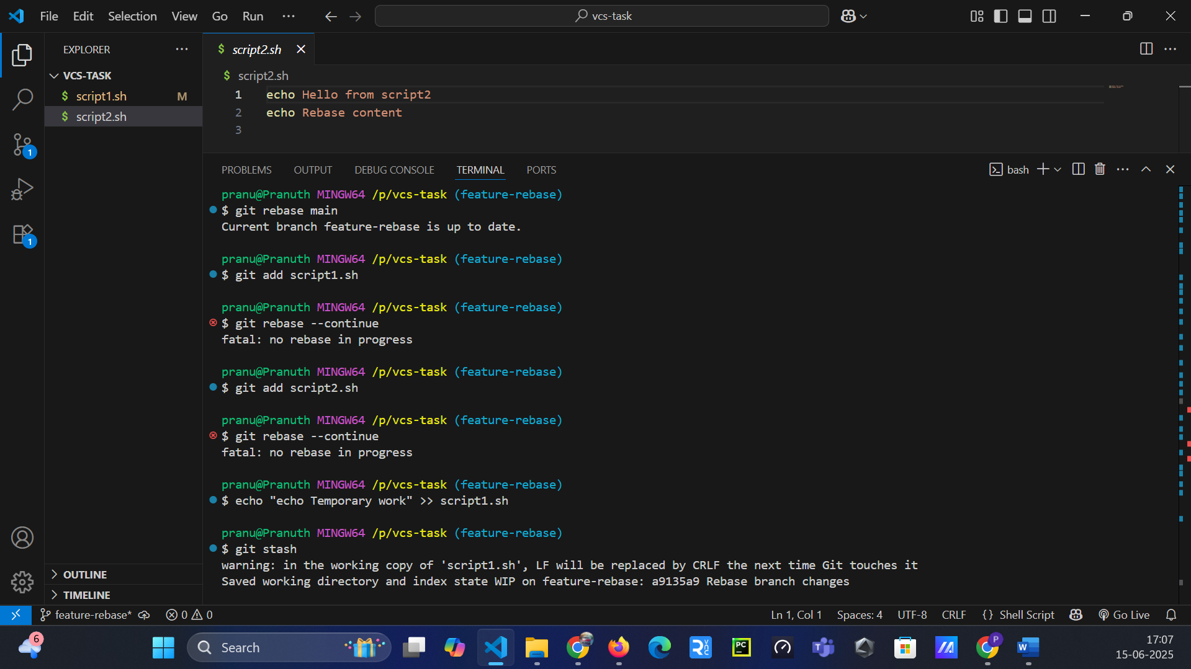

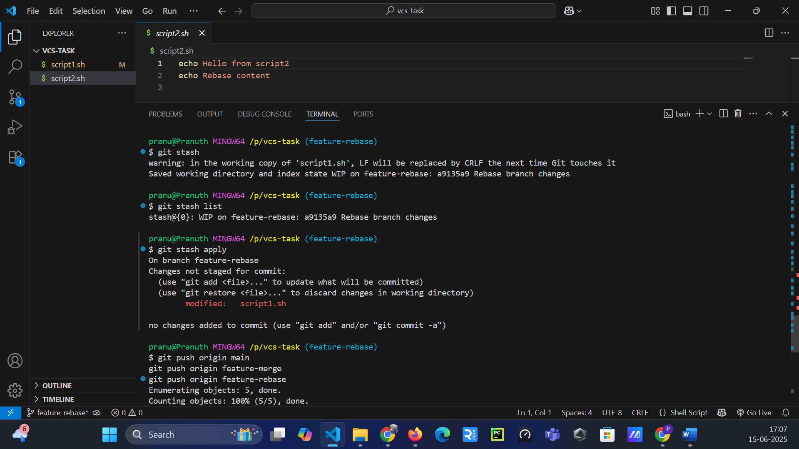

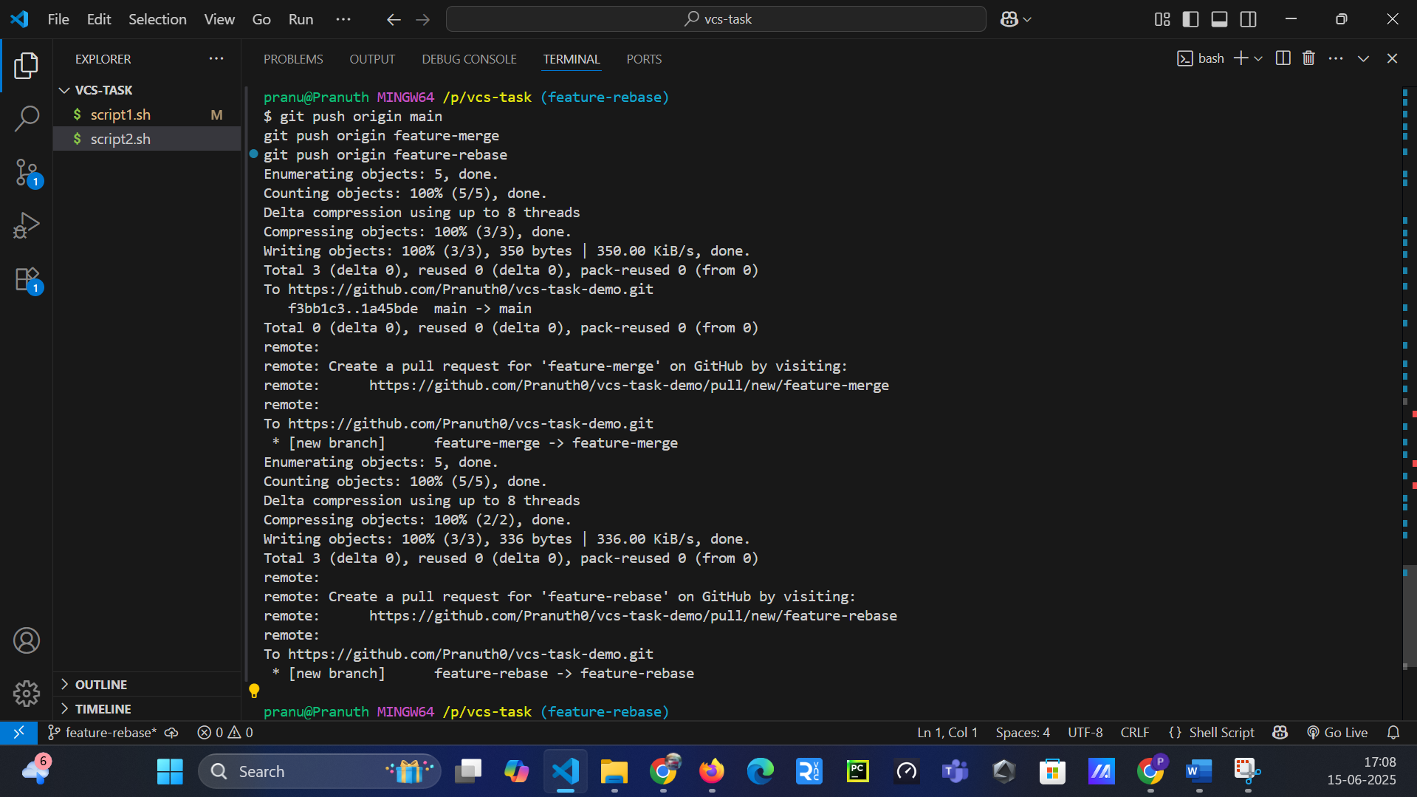

**GitHub Link:** https://github.com/Pranuth0/vcs-task-demo