CODE FUSION 2026
Web Development Class Mini Hackathon
12 Teams • 12 Sections • 1 Static Website
Class: 3CSE07 | Course: Web Technologies | Duration: 2 Hours
1. Purpose of Code Fusion
Code Fusion is a classroom mini hackathon designed to help students practise Module I – HTML/XHTML and Module II – CSS through one common website. The activity converts the individual laboratory topics into a collaborative project. Each bench acts as one development team, creates one section of the website, submits the work through GitHub, and the faculty integrates the twelve sections into one final static website.
The activity is intentionally beginner-friendly. Students are expected to use HTML and CSS concepts already demonstrated in class rather than introduce JavaScript, frameworks, databases, or other advanced technologies.
2. Learning Objectives
- Practise HTML document structure, headings, paragraphs, text formatting, links, images, lists, tables and forms.
- Practise external CSS using selectors, colours, fonts, borders, padding, margins and simple layout properties.
- Apply contextual selectors, pseudo-classes, pseudo-elements, positioning and basic floating/layout concepts where assigned.
- Understand how separate HTML/CSS sections can be combined to form one website.
- Practise a simple GitHub workflow: fork, clone, edit, commit, push and pull request.
- Develop teamwork and responsibility by completing one clearly defined section within a fixed time.
3. Academic Basis
The supplied Lab Sheets and teaching material cover basic HTML/XHTML structure and tags, text formatting, images, hyperlinks, lists, tables, forms and frames. Lab Sheet 2 specifically requires basic tags, images, tables and list tags. Lab Sheet 3 applies these ideas to a resume. Lab Sheet 4 applies forms and a multi-page/static book-store structure. Lab Sheet 5 introduces CSS through an online shopping catalogue with items, images, descriptions and Add to Cart links. Lab Sheet 6 uses a multi-page quiz with registration, radio-button questions and external/inline CSS.
The Module I material also introduces the standard HTML structure, images, hyperlinks, lists, tables, forms and frames. The Module II material introduces CSS types including external CSS, normal flow, positioning, floating elements, contextual selectors, pseudo-classes and pseudo-elements. The Code Fusion tasks are based on these taught areas.
4. Team Arrangement
Team | Bench | Students | Assigned Section
Team 1 | Bench 1 | 4 students | Welcome to CodeFusion
Team 2 | Bench 2 | 4 students | Web and WWW
Team 3 | Bench 3 | 4 students | HTML Foundations
Team 4 | Bench 4 | 4 students | Lists and Hobbies
Team 5 | Bench 5 | 4 students | Tables
Team 6 | Bench 6 | 4 students | Images and Links
Team 7 | Bench 7 | 4 students | Student Registration
Team 8 | Bench 8 | 4 students | CSS Selectors
Team 9 | Bench 9 | 4 students | CSS Box Model
Team 10 | Bench 10 | 4 students | Positioning and Float
Team 11 | Bench 11 | 4 students | Pseudo Classes and Elements
Team 12 | Bench 12 | 4 students | Contact and Final Message
5. Common Project Rules
- There are 12 teams. Each bench is one team and has four students.
- Each team gets one laptop and works only on its assigned section.
- Each team must create exactly two main files inside its assigned folder: index.html and style.css.
- The CSS must be external. The HTML file must link to style.css using the <link> element.
- Do not use JavaScript, Bootstrap, React, PHP, databases or other frameworks for this mini hackathon.
- Use simple HTML and CSS that students have already learned in the supplied labs and Module I/II material.
- Do not modify another team's folder or section.
- Keep class names unique to the assigned team so that CSS does not accidentally change another team's section.
- The section should occupy approximately the full browser screen using min-height: 100vh.
- Students may use the exact sample content or replace it with simple suitable content without changing the required structure.
- Before submitting, open index.html in the browser and check that there are no obvious layout or link errors.
- Only one student from each team needs to perform the GitHub push if the team is sharing one laptop/account.
6. Common File Structure
The expected working structure is:
CodeFusion_2026/
├── Team1/index.html
├── Team1/style.css
├── Team2/index.html
├── Team2/style.css
...
├── Team12/index.html
├── Team12/style.css
└── Final_Website/ (faculty integration area)
7. Twelve Section Requirements
Team 1 – Welcome to CodeFusion
Concept focus: Basic HTML structure, headings, paragraphs, bold/italic text, hyperlink and a simple call-to-action link.
Task: Create a welcoming first screen for the project. Include a team label, main heading, short description and a link to the next section. Use simple text formatting and an anchor link.
Expected output: one full-screen section with a clear heading, readable content, simple styling, and no horizontal overflow.
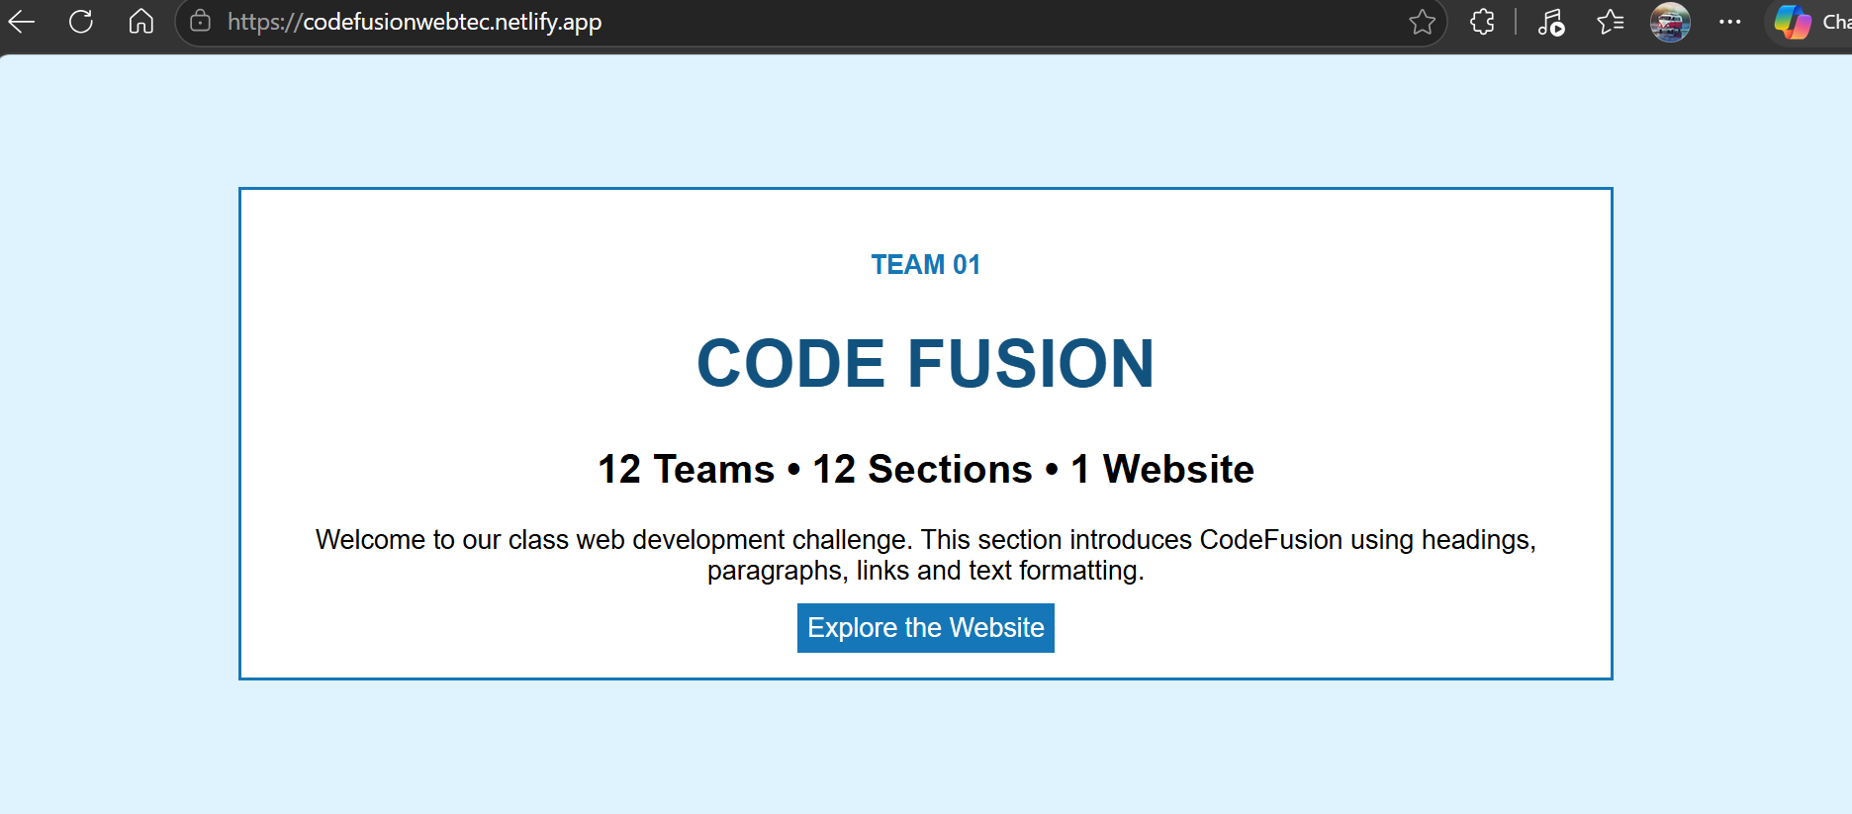
Team 2 – Web & World Wide Web
Concept focus: Web, WWW, client/server idea, headings, paragraphs, divs and simple CSS layout.
Task: Explain the Web in simple words and show Client → Internet → Server using three simple boxes. Use headings, paragraphs and basic CSS.
Expected output: one full-screen section with a clear heading, readable content, simple styling, and no horizontal overflow.
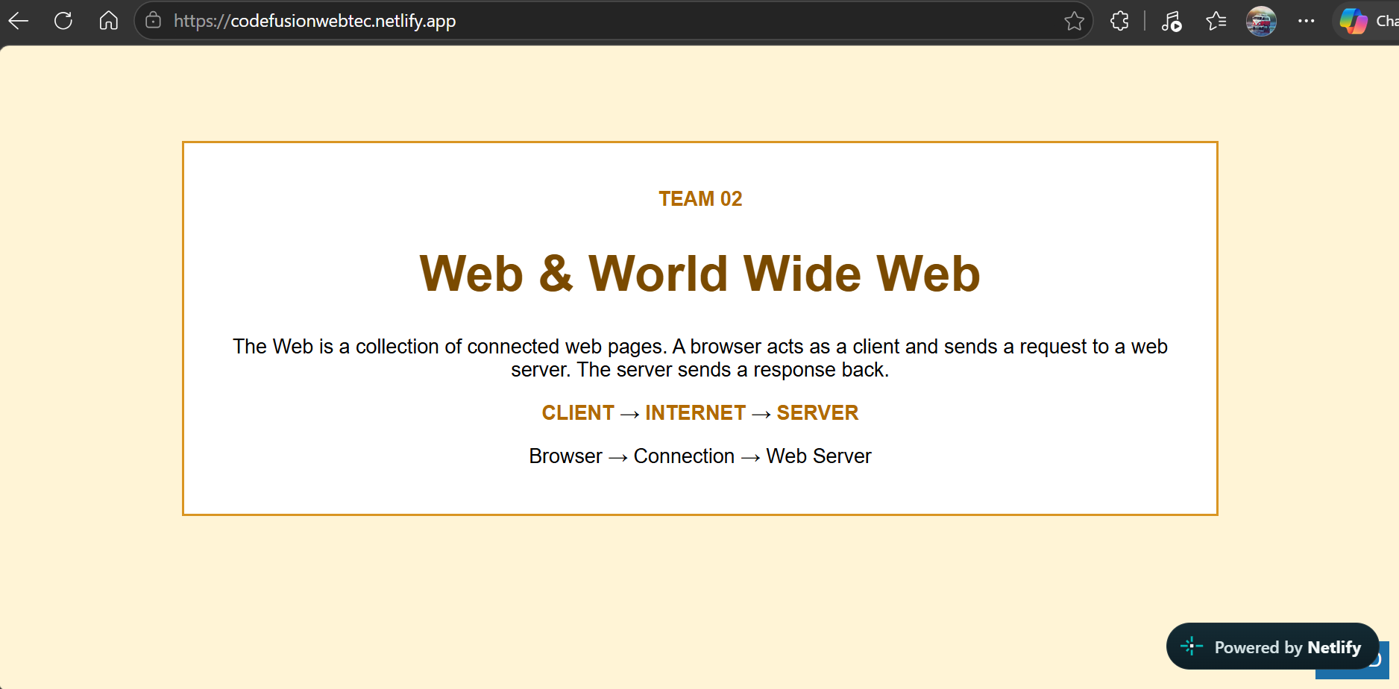
Team 3 – HTML Foundations
Concept focus: Basic HTML tags such as headings, paragraphs, br, hr, b, i, u and sup.
Task: Demonstrate basic HTML elements through a small explanatory section. Include examples of heading, paragraph, horizontal rule and text formatting.
Expected output: one full-screen section with a clear heading, readable content, simple styling, and no horizontal overflow.
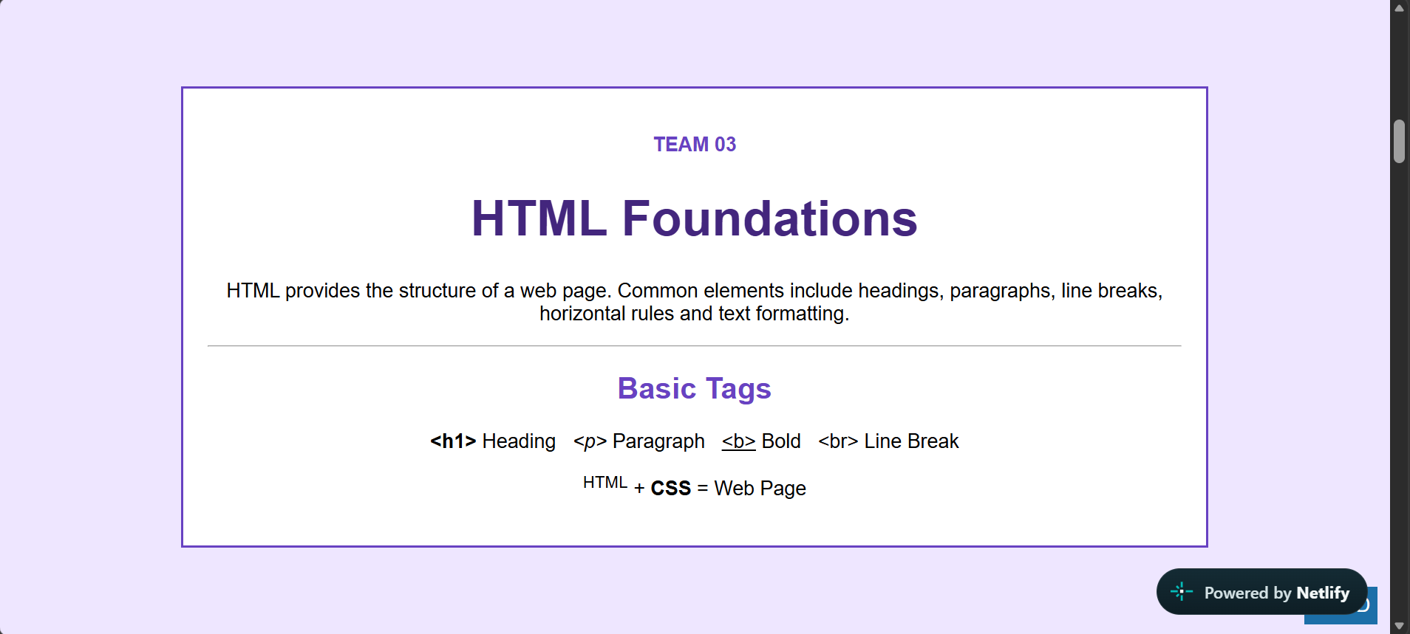
Team 4 – Lists and Hobbies
Concept focus: Ordered list, unordered list and list items.
Task: Present student hobbies using an unordered list and learning steps using an ordered list. Style the two lists as two simple boxes.
Expected output: one full-screen section with a clear heading, readable content, simple styling, and no horizontal overflow.
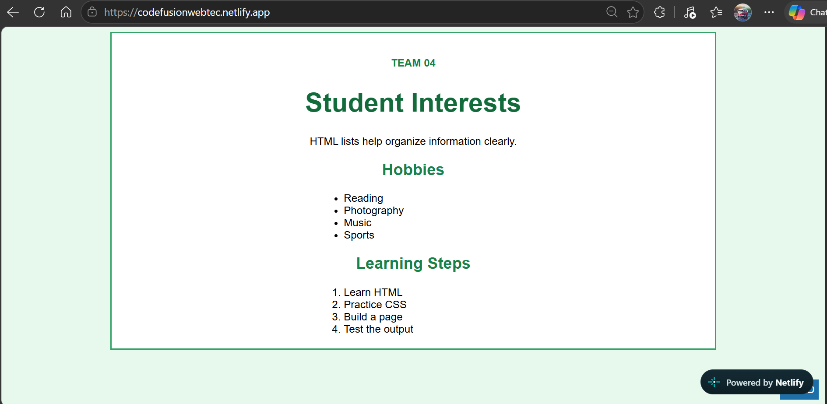
Team 5 – Tables
Concept focus: Table, table row, table heading and table data cells.
Task: Create a simple web-development schedule using a table. Include headings and at least five rows.
Expected output: one full-screen section with a clear heading, readable content, simple styling, and no horizontal overflow.
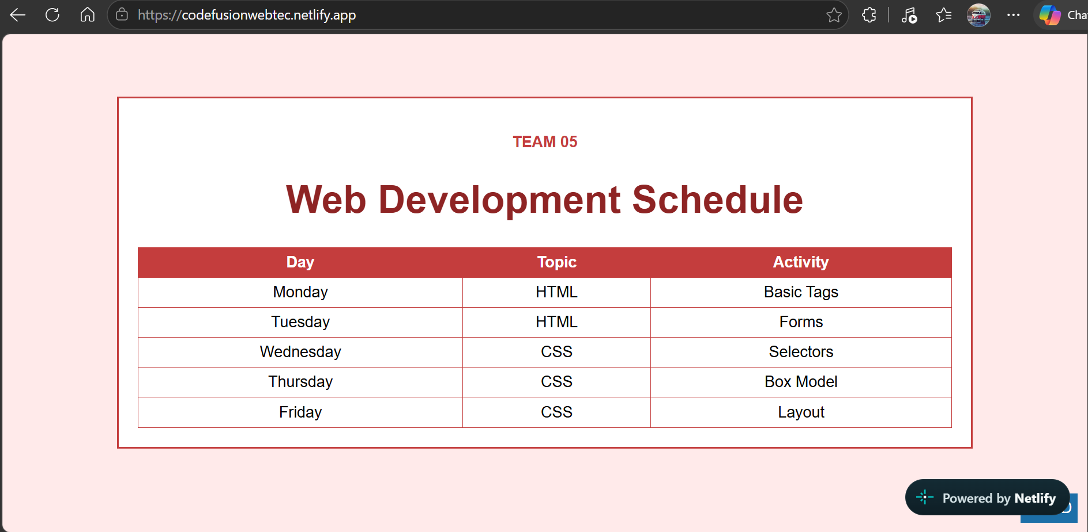
Team 6 – Images and Hyperlinks
Concept focus: img, alt, width/height, a, href and target.
Task: Show an image area and explain the purpose of images and hyperlinks. Include a working external link and an internal link to the next section.
Expected output: one full-screen section with a clear heading, readable content, simple styling, and no horizontal overflow.
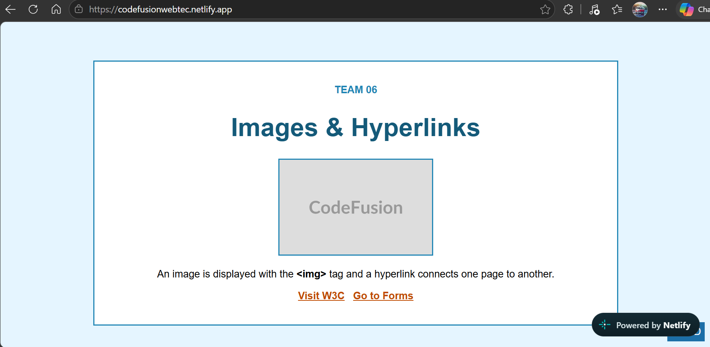
Team 7 – Student Registration
Concept focus: form, label, input, radio, select, textarea, placeholder, required and button.
Task: Create a simple registration form with name, email, department, gender and address. Keep the form static; no backend is required.
Expected output: one full-screen section with a clear heading, readable content, simple styling, and no horizontal overflow.
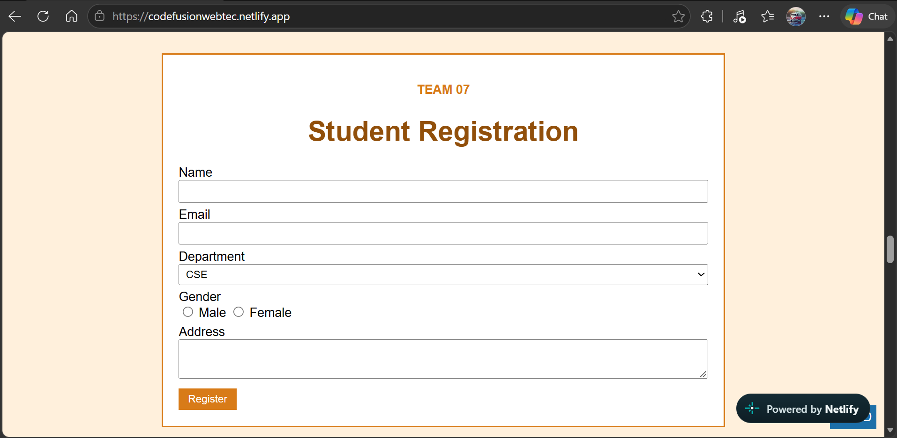
Team 8 – CSS Selectors
Concept focus: Element/class selector and contextual selectors: descendant, child, adjacent sibling and general sibling.
Task: Explain CSS selectors using simple examples. The displayed text should show div p, div > p, div + p and div ~ p.
Expected output: one full-screen section with a clear heading, readable content, simple styling, and no horizontal overflow.
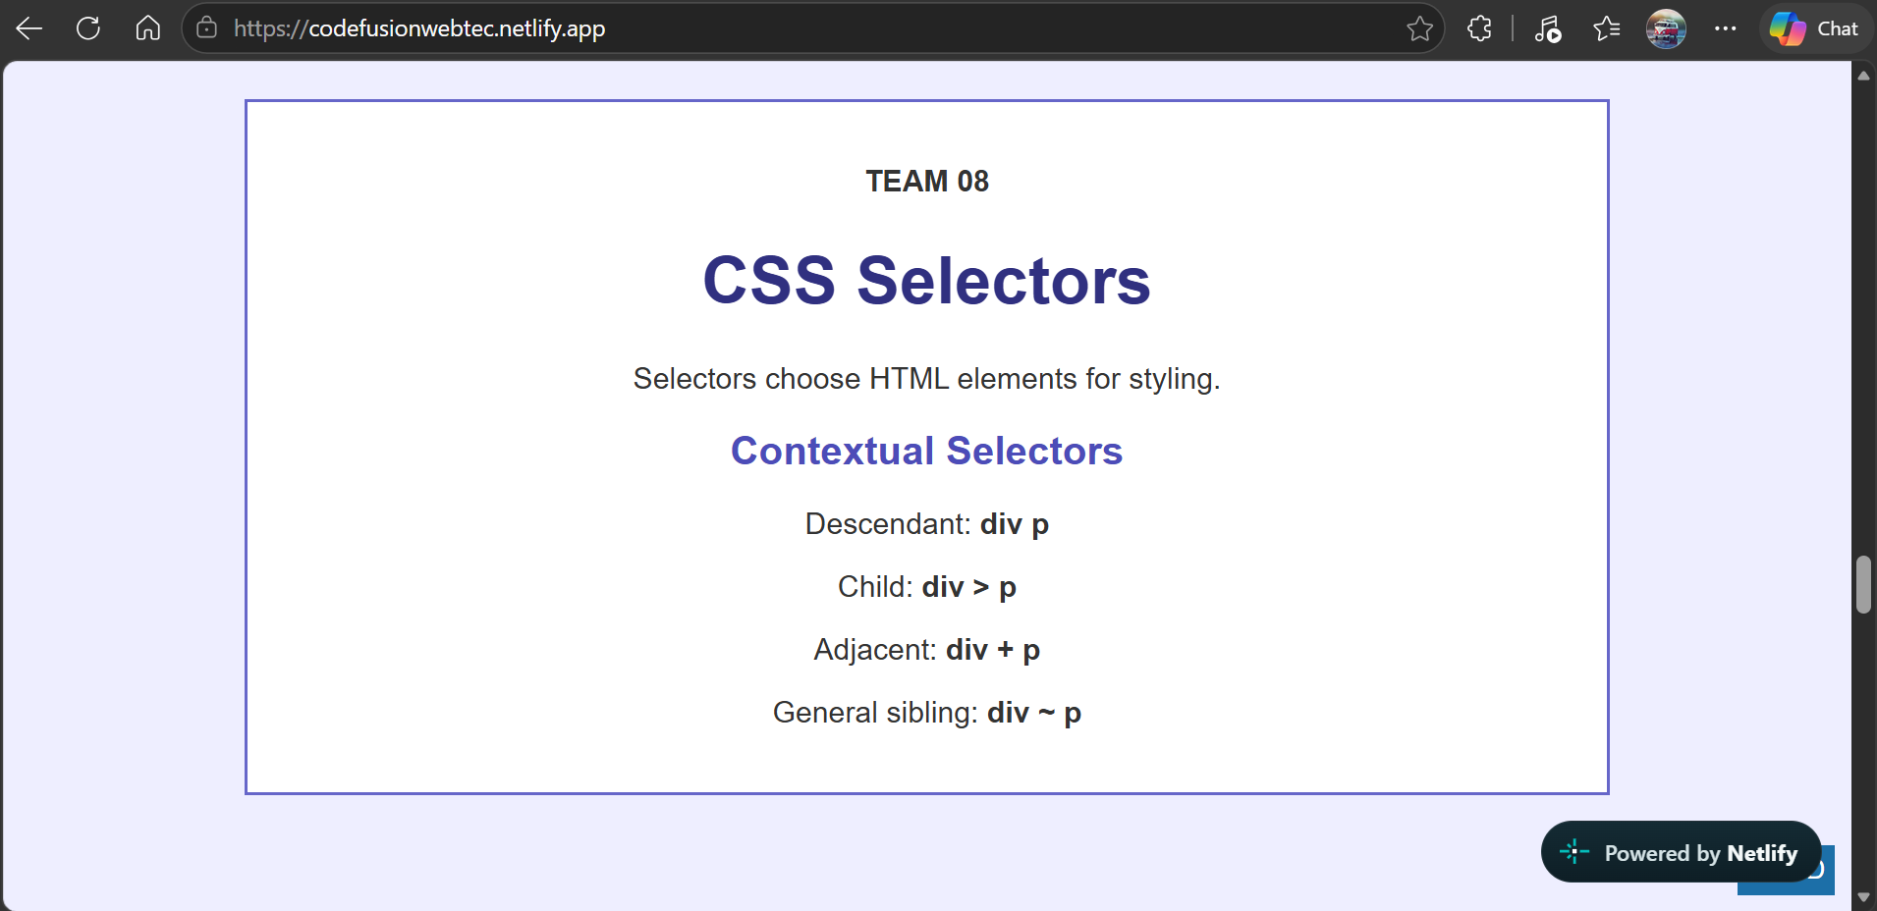
Team 9 – CSS Box Model
Concept focus: Content, padding, border, margin, width and height.
Task: Create a large box-model demonstration and label the main idea: Content → Padding → Border → Margin.
Expected output: one full-screen section with a clear heading, readable content, simple styling, and no horizontal overflow.
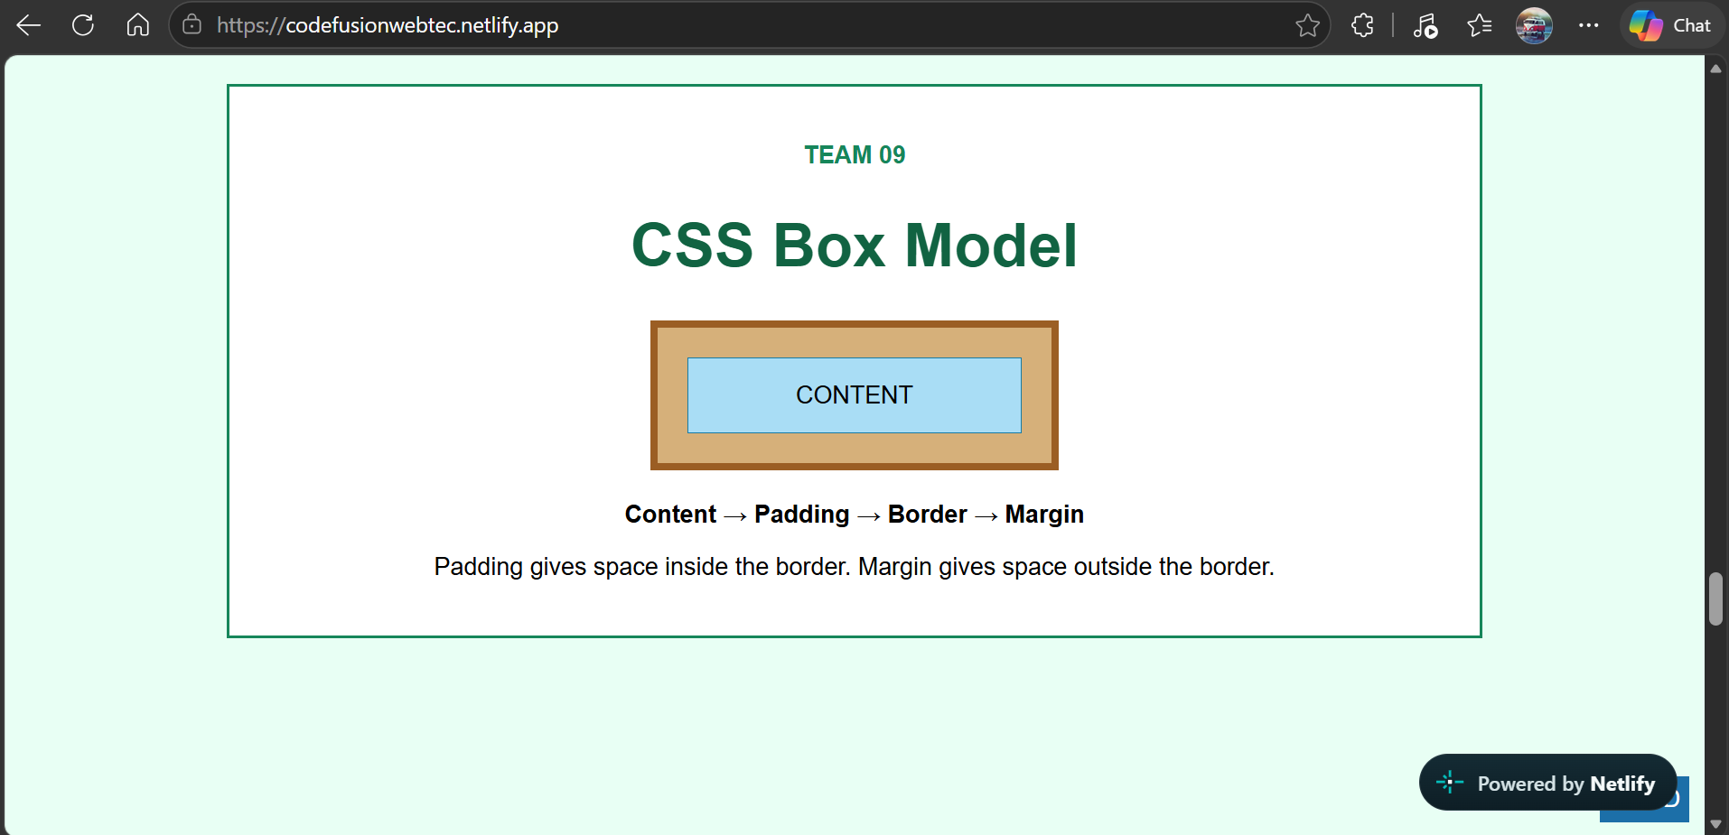
Team 10 – CSS Positioning
Concept focus: Normal flow and position values: static, relative, absolute and fixed.
Task: Show a positioned parent with relative and absolute examples and a small fixed element. Add a short explanation of each position value.
Expected output: one full-screen section with a clear heading, readable content, simple styling, and no horizontal overflow.
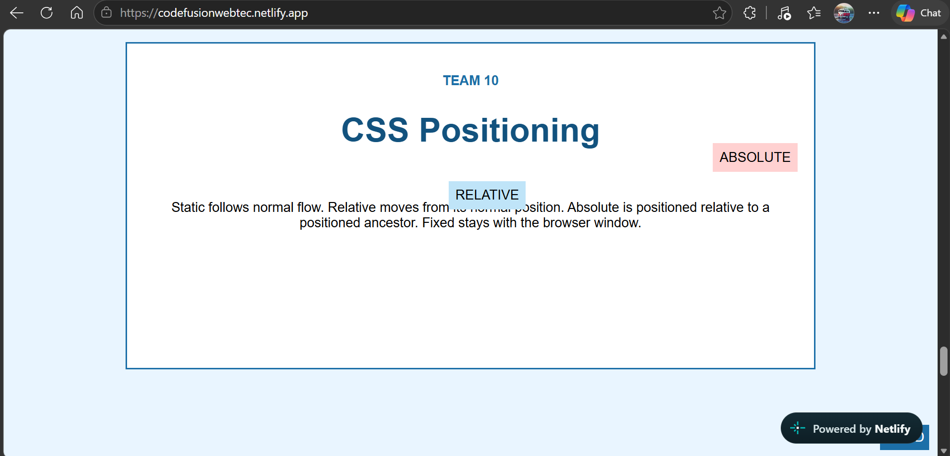
Team 11 – Pseudo Classes & Elements
Concept focus: :hover and ::first-line; optionally link states such as :link and :visited.
Task: Provide simple buttons/links that change on hover and a paragraph whose first line is styled differently.
Expected output: one full-screen section with a clear heading, readable content, simple styling, and no horizontal overflow.
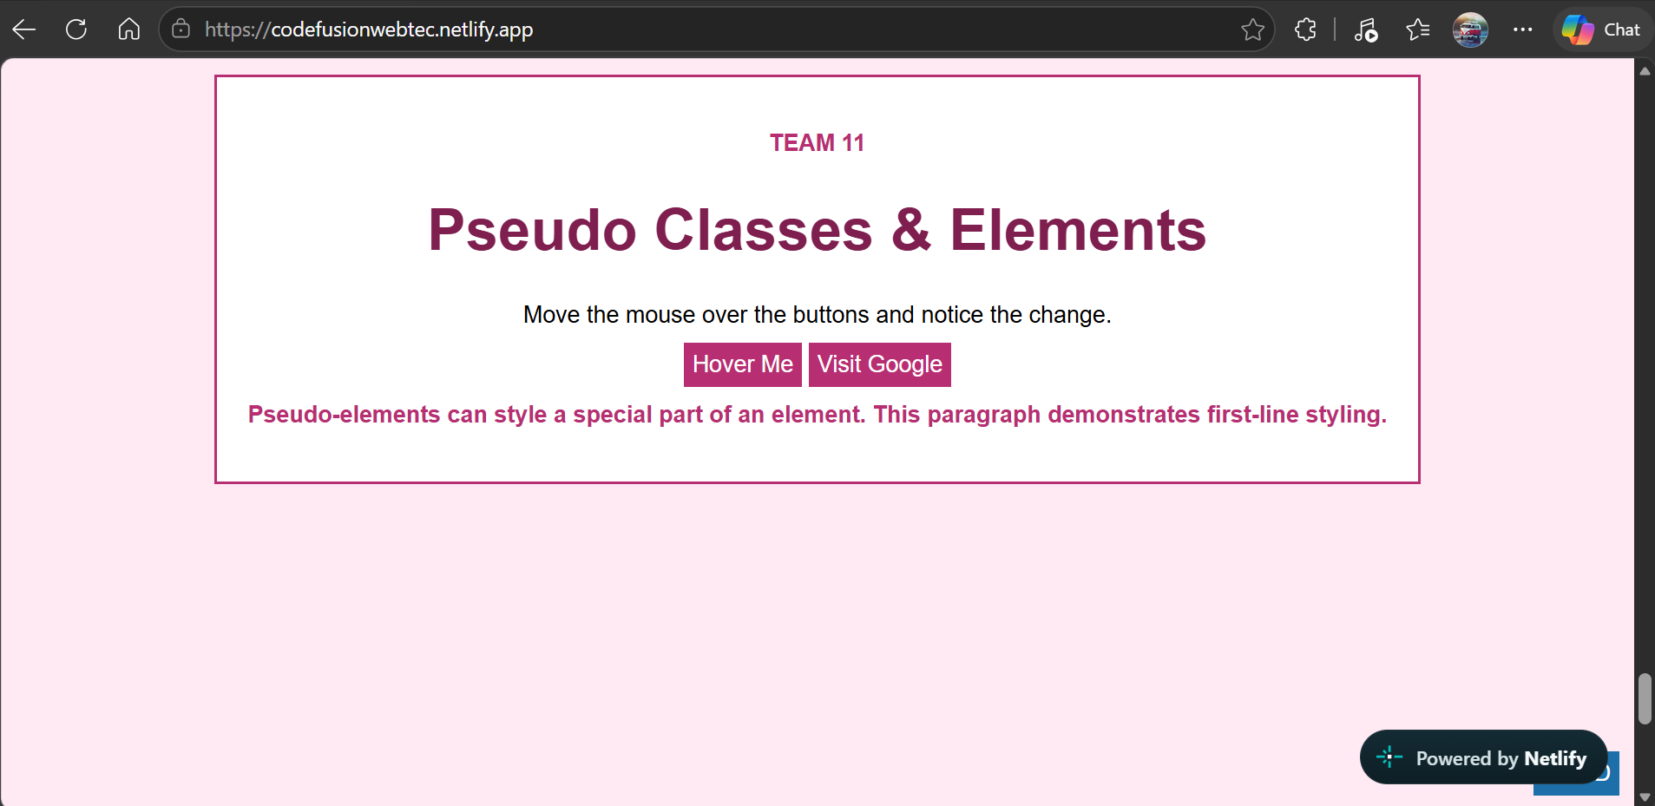
Team 12 – Final Message
Concept focus: Headings, paragraphs, hr, anchor link and simple external CSS.
Task: Create the closing section with a thank-you message, project completion message and a Back to Top link.
Expected output: one full-screen section with a clear heading, readable content, simple styling, and no horizontal overflow.
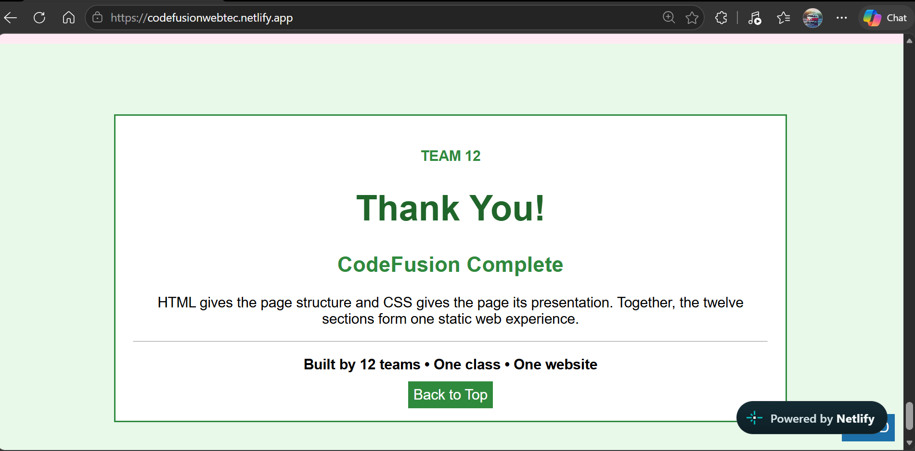
8. Two-Hour Suggested Schedule
Time | Activity
0–10 minutes | Introduction, explain the final output, rules and team assignments.
10–20 minutes | GitHub setup: fork the repository and create/prepare the local working copy.
20–75 minutes | Main development period. Teams create their assigned HTML and CSS section.
75–90 minutes | Browser testing, fixing HTML/CSS errors and checking the required output.
90–105 minutes | Commit and push the final work to the team's fork.
105–115 minutes | Create the Pull Request to the faculty repository and inform the faculty.
115–120 minutes | Faculty checks submissions and explains the integration/Code Fusion result.
9. GitHub Instructions for Students
The faculty repository is the central repository. Students should work through a fork so that the faculty's main repository is protected from direct changes.
- Open the faculty repository: https://github.com/PranuthHM/CodeFusion_3CSE07_WebDevelopment_AY2026
- Click the Fork button and create a copy under the student's/team member's GitHub account.
- Open the forked repository and copy its HTTPS URL.
- On the team laptop, open VS Code or another editor and use Git to clone the forked repository.
- Open the cloned folder and locate the assigned Team folder. For example, Team 4 works only inside Team4.
- Create or edit index.html and style.css in that folder. Do not rename these files.
- Open index.html in the browser and verify the output.
- Open the terminal in the repository folder and run: git status
- Add the changes using: git add Team4
- Create a commit using: git commit -m "Complete Team 4 section"
- Push the changes using: git push
- Open the student's fork on GitHub and click Compare & pull request when GitHub offers it.
- Set the destination as the faculty repository and submit the Pull Request.
- Tell the faculty that the team's Pull Request is ready for checking.
Replace Team4 in the commands with the actual team number. If a student is not comfortable using terminal commands, the GitHub website can be used to upload or edit files, but the team must still keep the same folder and file names.
10. Simple Git Commands Reference
git clone <YOUR-FORK-URL>
cd CodeFusion_3CSE07_WebDevelopment_AY2026
git status
git add Team1
git commit -m "Complete Team 1 section"
git push

11. Faculty Integration Procedure
- Review each Pull Request and confirm that the correct team folder contains index.html and style.css.
- Check that the team section opens correctly in a browser.
- Merge acceptable Pull Requests into the main repository.
- Copy the HTML section from each team into the final combined index.html in Team order from 1 to 12.
- Combine the CSS rules into one final style.css. Keep the team-specific class names to avoid conflicts.
- Check that each section uses min-height: 100vh and that internal links move to the correct section IDs.
- Open the final website and scroll through all twelve sections.
- The final project is considered complete when all twelve required sections are present, readable and visually consistent with the stated requirements.
12. Final Success Criteria
- All 12 teams have submitted their assigned section.
- Each team has an index.html and an external style.css.
- The HTML and CSS are simple and based on the taught Module I and Module II concepts.
- The 12 sections can be combined without major CSS conflicts.
- Each section occupies approximately one browser viewport height.
- Required HTML/CSS concepts are visibly demonstrated.
- The final combined website can be opened in a browser without requiring a server or database.
13. Student Rules During the Hackathon
- Work as a team of four/five; share the laptop and divide the work sensibly.
- Do not copy another team's assigned section.
- Do not change the main repository directly.
- Do not delete or rename another team's folder.
- Do not use code outside the permitted HTML/CSS scope unless the faculty specifically allows it.
- Ask the faculty for clarification if a requirement is unclear; do not change the assigned requirement on your own.
- The final submission must be the code that your team actually tested.
14. Faculty Note
The supplied project files in this package contain a simple reference implementation for all twelve sections. They are intended as the faculty's integration/reference output. During the live hackathon, students should receive the requirement for their own section rather than being given the completed implementation if the objective is independent practice.
15. Source Alignment
This project is aligned to the supplied Lab Sheets and Module I/II materials. Lab Sheet 2 covers basic tags, images, tables and lists. Lab Sheet 3 covers a resume using basic HTML, tables and lists; Lab Sheet 4 covers registration forms and a static multi-page/book-store structure; Lab Sheet 5 covers CSS and an online shopping catalogue; and Lab Sheet 6 covers a multi-page quiz, registration, radio buttons and external/inline CSS. The supplied Module II material covers external CSS, normal flow, positioning, floating elements, contextual selectors, pseudo-classes and pseudo-elements. The project therefore uses these concepts as the basis for the twelve sections.

