**SQL ASSIGNMENT**

Q1

CREATE TABLE `doctor` (`name` varchar( 100 ),`DID` varchar( 100 ) NOT NULL,`dept` varchar( 100 ), PRIMARY KEY (`DID`))

INSERT INTO doctor ( name, DID, dept ) VALUES ( 'Rohit', '1', 'ear' );

INSERT INTO doctor ( name, DID, dept ) VALUES ( 'Ram', '2', 'eye' );

INSERT INTO doctor ( name, DID, dept ) VALUES ( 'Shyam', '3', 'ear' );

INSERT INTO doctor ( name, DID, dept ) VALUES ( 'Priya', '4', 'neuro' );

INSERT INTO doctor ( name, DID, dept ) VALUES ( 'Abhi', '5', 'heart' );

CREATE TABLE `patient` (`Name` varchar( 100 ),` PID` varchar( 100 ) PRIMARY KEY, `DID` varchar(100), `day` varchar(20), `date` date NOT NULL , FOREIGN KEY (DID) REFERENCES doctor(DID));

INSERT INTO patient (`Name`, `PID`, `DID`,`day`, `date` ) VALUES ( 'Pooja', '1', '1','Mon', 2020-08-15 );

INSERT INTO patient (`Name`, `PID`, `DID`,`day`, `date`) VALUES ( 'Daman', '11', '1', 'Tue', 2020-08-02 );

INSERT INTO patient (`Name`, PID, ``DID`,`day`, `date` ) VALUES ( 'Harman', '21', '4', 'Thu', 2020-08-13 );

INSERT INTO patient (`Name`, PID, `DID`,`day`, `date`) VALUES ( 'Harman', '21', '4', 'Mon', 2020-08-13 );

INSERT INTO patient (`Name`, PID, `DID`,`day`, `date`) VALUES ( 'Neelu', '56', '3', 'Wed', 2020-08-16 );

Q2

select d.name, d.dept, p.Name from doctor d left join patient p on d.DID=p.DID

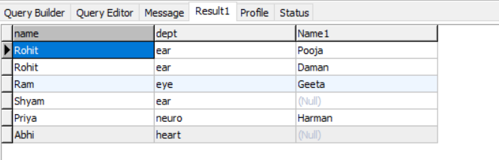

Q3

select count(p.name), p.day from patient p where p.date BETWEEN DATE_SUB( CURDATE( ) ,INTERVAL 7 DAY ) AND CURDATE( ) group by day

