# ****Prerequisites****

In order to complete this tutorial, you should have knowledge of beginner or intermediate Java 8 programming skills, some familiarity with Spring Boot, and also you should have a general familiarity with the Windows command prompt.

# Tools Used in this Project

1. Java 8
2. Spring Boot
3. Gradle
4. MongoDB
5. Postman

# ****Step 2. Spring boot Project Setup****

We will make use of the Spring Initializr tool for quickly setting up the project. Don’t forget to add the dependencies Spring WEB & Spring Data MongoDB.

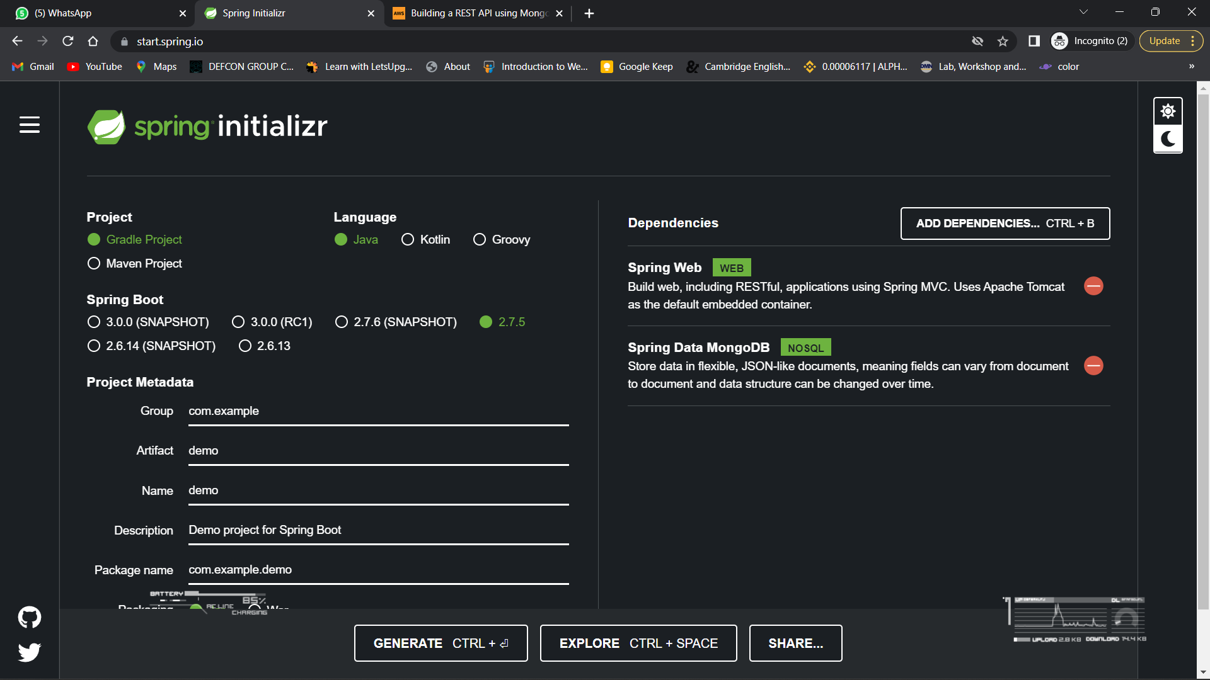

# ****Step 3. Configure MongoDB****

To configure our MongoDB in Spring boot, we will need to add connection details of our DB to the **application.properties** file, located in the “src/main/resources” folder. Add the following lines to the property file and replace the information in brackets with the information specific to your MongoDB instance:

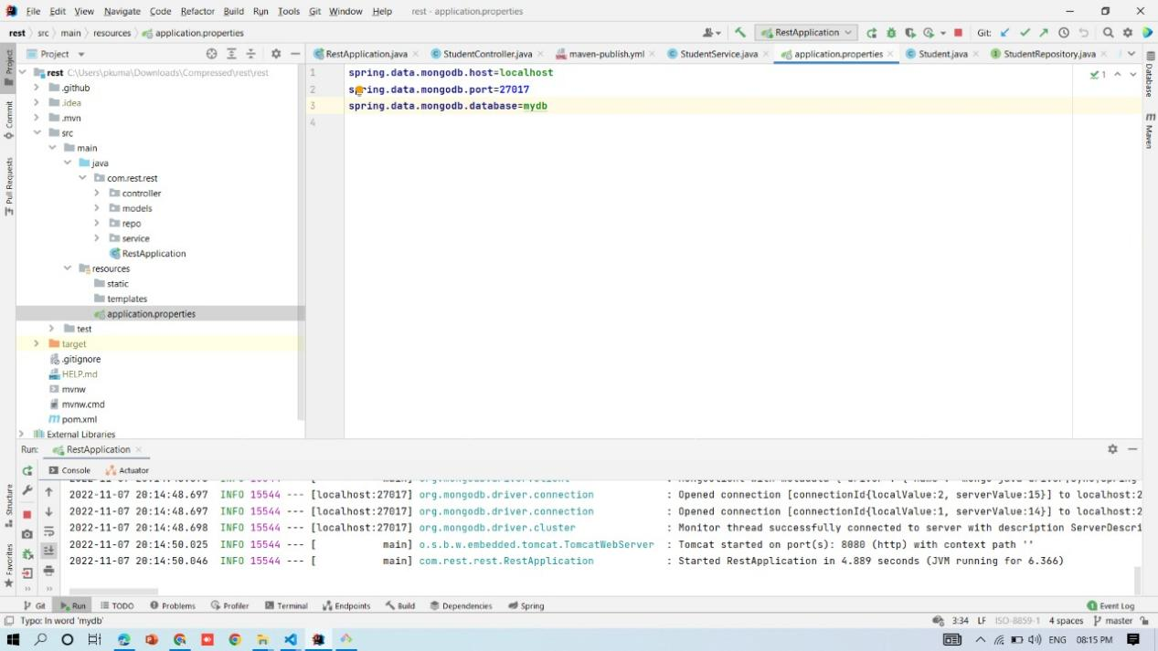

# Adding Model to Spring boot Project

Let’s start by create a simple Model class.

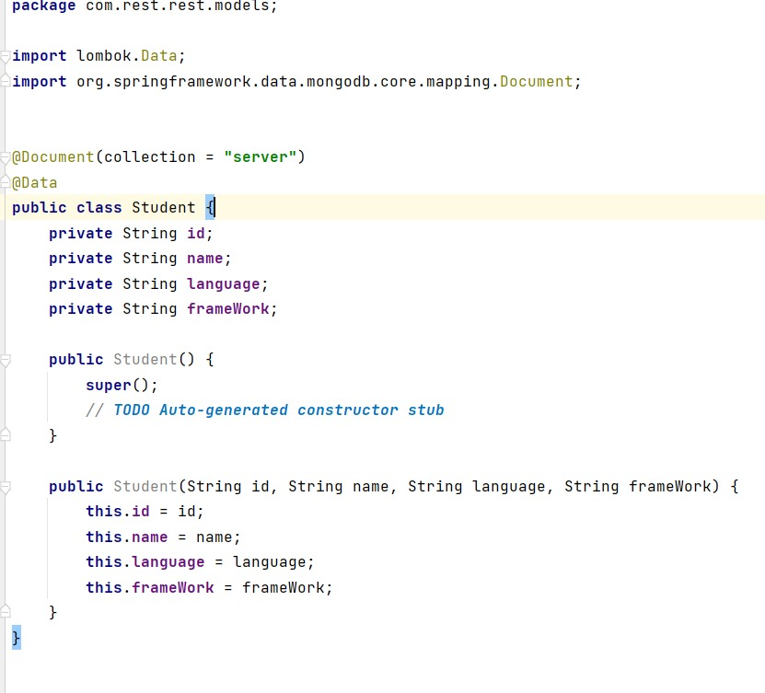

Here you have a Student class with four attributes: id, name, language, and frameWork. The **@Document** annotation marks a class as being a domain object that we want to persist to the database. Note: This annotation is the Mongo equivalent of **@Entity** in JPA.

The id is mostly for internal use by MongoDB. The **@Id** annotation tells spring that the id field will be used as the primary identifier. The rest of the class contains the basic constructors,and in place of getters, and setters I used lombook for Student object.

# ****Step 5. Spring Data MongoDB — MongoRepository****

We will now create a repository by making an interface.

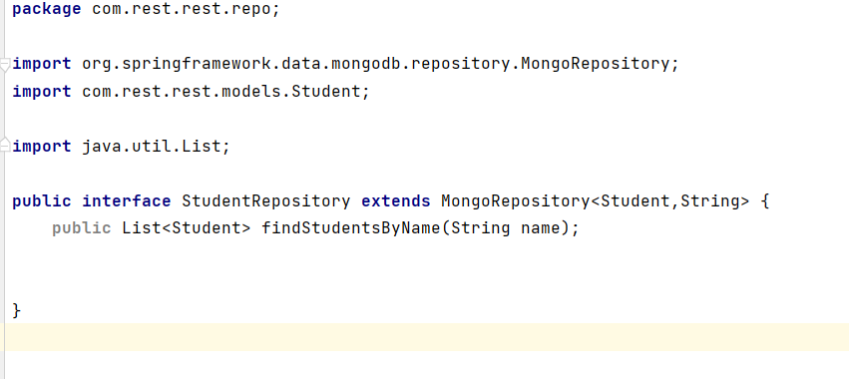

StudentRepository extends the MongoRepository interface and plugs in the type of values and ID that it works with: Movie and Integer, respectively. This will give us access to all the CRUD (create, read, update, and delete) operations around the MongoDB collection.

# ****Step 6. Defining the Controller****

Finally, we will create the REST controller. The APIs which we will be creating will access the studentService.

**GET - Get all StudentData & Get student by ID & Get student by NAME**

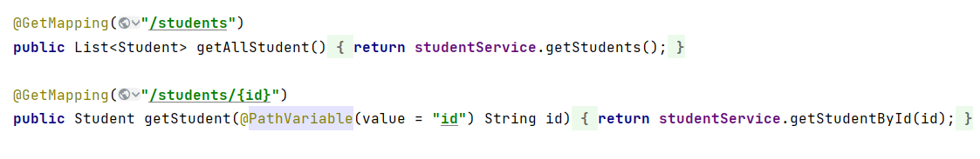

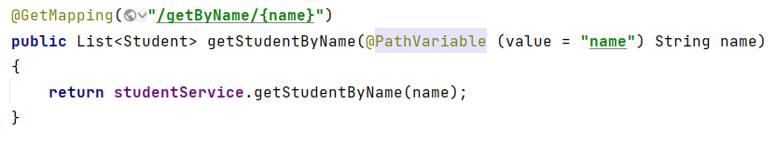

**POST - Add a STUDENT**



**DELETE - Delete a student**

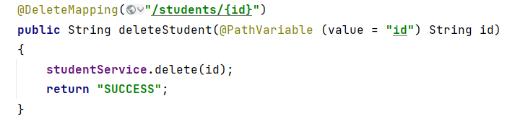

## ****Completed Controller****

Here is the completed controller with all the methods added to it

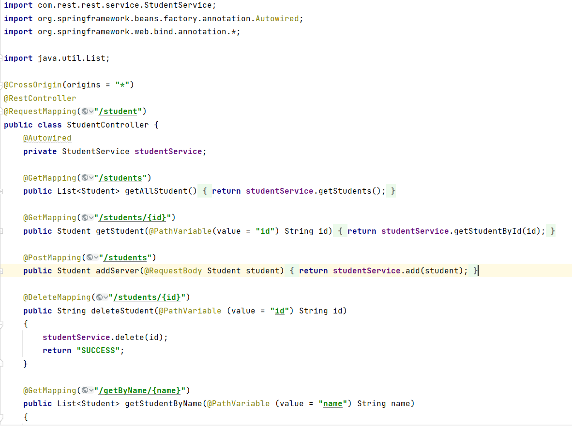

# ****Step 6. Defining the Service****

Finally, we will create the Service. The APIs which we will be creating will access the studentRepository dependency, which will internally use Spring Data MongoRepository API. NOTE: We do not have to write any database interaction code in the interface as Spring Data does it all for us ;).

## ****Adding the REST Endpoints****

The @Autowired annotation creates an instance of the studentRepository object that will allow us to access and modify the student database.

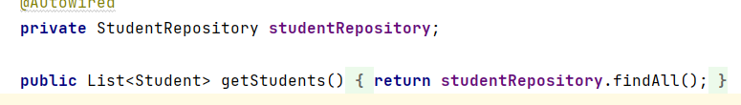

Service

Output

Get Method Output

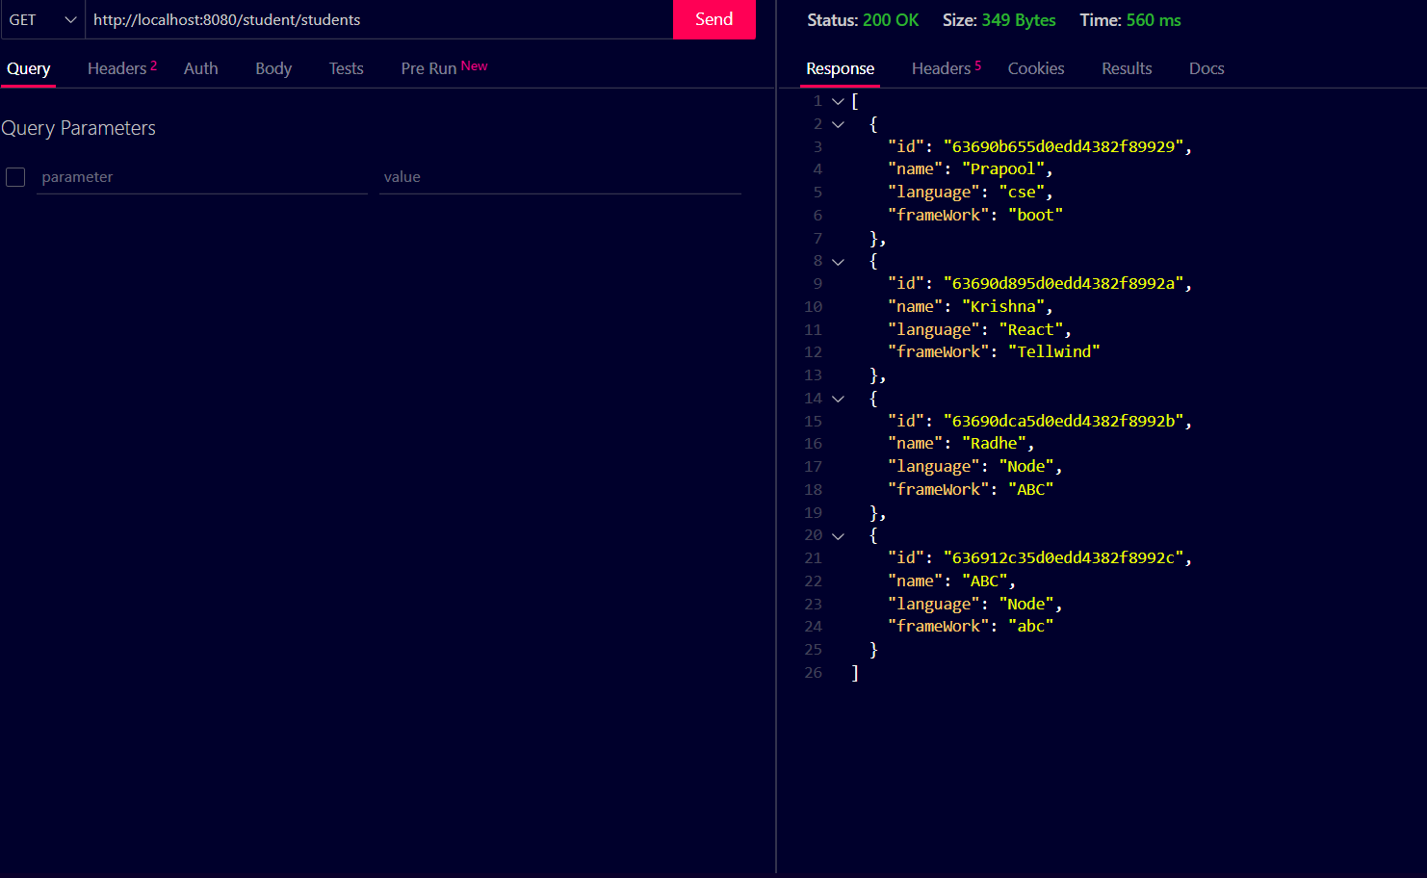

Post

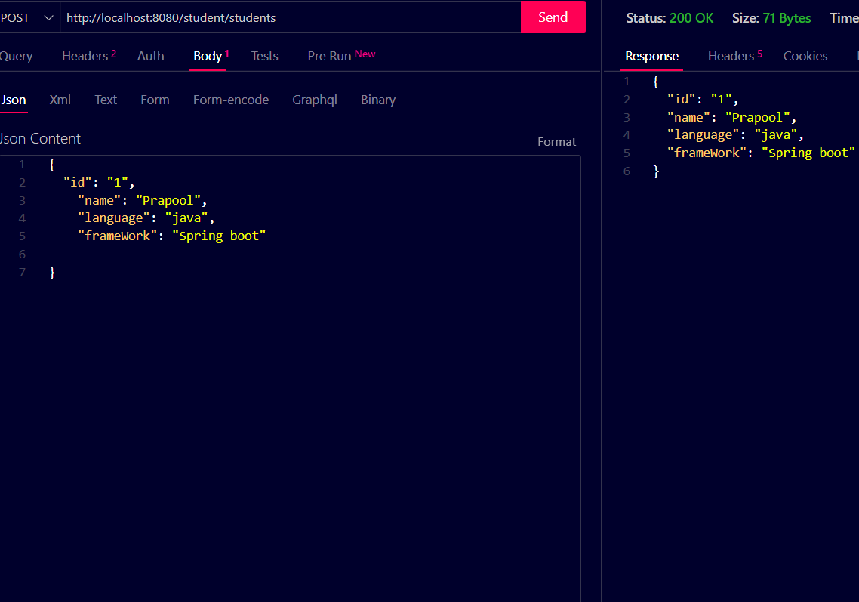

Delete

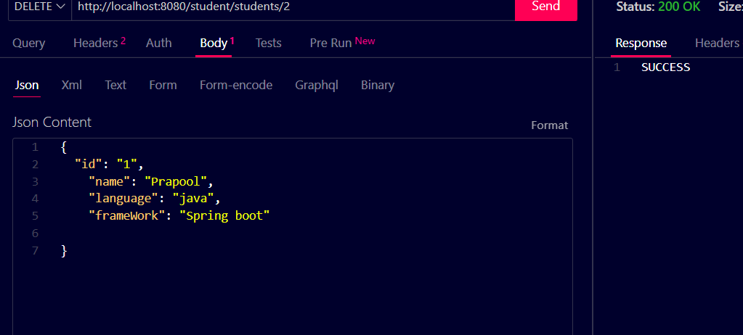

On MongoDb compass

