**Results:**

Comparison between Yen’s, Bidirectional Yen’s & One to One Yen’s Algorithm when 25 nodes graph is used and k is is the range of 1 to 15.

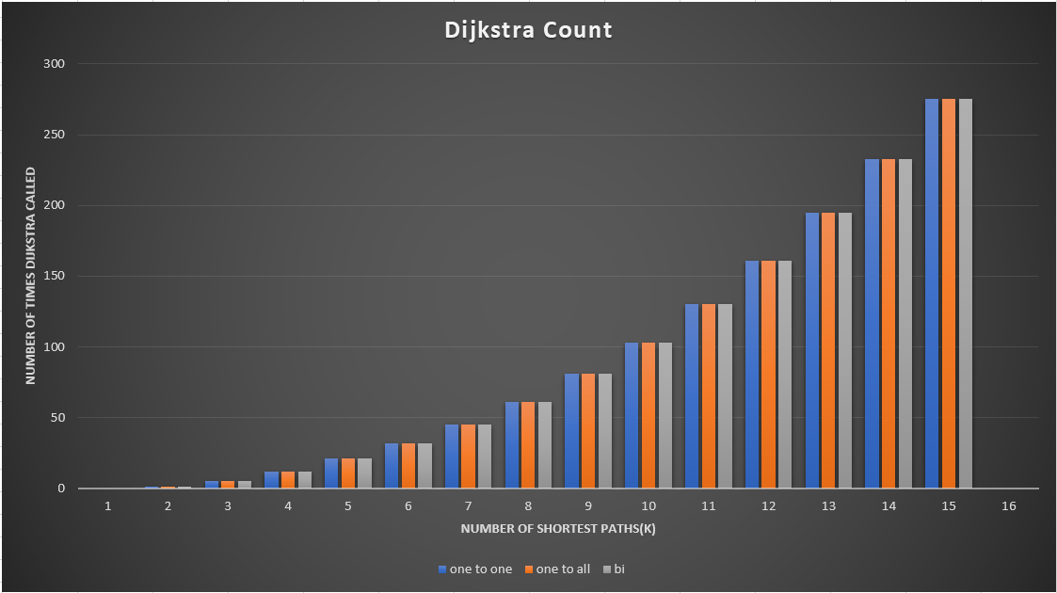

Dijkstra Count for 25 Nodes Graph

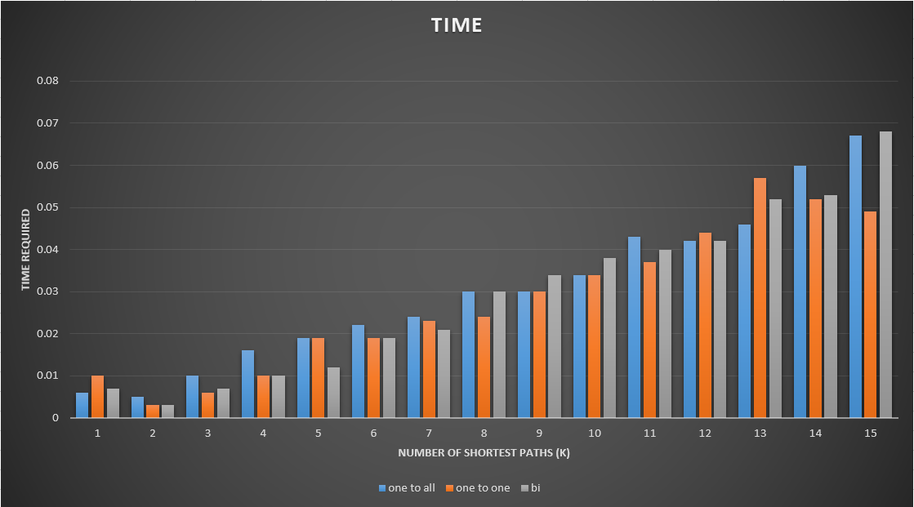

Time Required for 25 Nodes Graph