**Industrial Internship Report on**

**Python Quiz Game**

**Prepared by**

**Prapti Sharma**

|  |
| --- |
| *Executive Summary* |
| This report provides details of the Industrial Internship provided by upskill Campus and The IoT Academy in collaboration with Industrial Partner UniConverge Technologies Pvt Ltd (UCT).  This internship was focused on a project/problem statement provided by UCT. We had to finish the project including the report in 6 weeks’ time.  My project was a Python Quiz Game using the python programming language.  This internship gave me a very good opportunity to get exposure to Industrial problems and design/implement solution for that. It was an overall great experience to have this internship. |

**TABLE OF CONTENTS**

1 Preface 3

2 Introduction 4

2.1 About UniConverge Technologies Pvt Ltd 4

2.2 About upskill Campus 8

2.3 Objective 9

2.4 Reference 9

2.5 Glossary 10

3 Problem Statement 11

4 Existing and Proposed solution 12

5 Proposed Design/ Model 13

5.1 High Level Diagram (if applicable) 13

5.2 Low Level Diagram (if applicable) 13

5.3 Interfaces (if applicable) 13

6 Performance Test 14

6.1 Test Plan/ Test Cases 14

6.2 Test Procedure 14

6.3 Performance Outcome 14

7 My learnings 15

8 Future work scope 16

# Preface

I feel immense pleasure in presenting this project report, documenting the comprehensive six-week Python Internship program that I pursued at upskill Campus. This internship has been an invaluable experience, as it has provided me with a strong foundation in Python programming and enriched my understanding of various Python libraries.

Throughout the internship, I was equipped with the essential course instructions, accompanied by a well-structured Python book, which served as an excellent reference material. The program initiated with Python basics and regular Python quiz tests.

Undeniably, this internship has proven to be an essential stepping stone in my career development. The ever-increasing demand for Python in various domains, including data science, web development, and automation, highlights the need for relevant internships that provide hands-on experience in this versatile language.

My project during the internship revolved around creating a Python quiz game utilizing the powerful language python. The project aimed to develop an engaging and interactive quiz platform, wherein users could have fun while playing quiz and also, they can create their own quiz.

I am deeply grateful to upskill Campus and The IoT Academy for providing me with the opportunity to partake in this enlightening Python Internship program. Their unwavering support and belief in fostering students' growth have been instrumental in my learning journey.

The program was meticulously planned, encompassing both theoretical training and practical assessments. Regular tests were administered to gauge our progress, ensuring we stay on track with the learning objectives. The final phase of the program involved working on individual projects, where we were encouraged to apply the knowledge gained throughout the internship.

As I conclude this preface, I want to share a message with all my fellow juniors and peers. Embrace every opportunity to learn and grow, just like this Python Internship has allowed me to do. Python's vast potential opens doors to exciting possibilities in diverse fields. Let's support and inspire one another, knowing that together, we can achieve greatness. Carry the knowledge gained here into your future endeavors, and let's make a positive impact on the world.

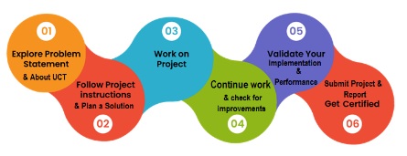

# Introduction

## About UniConverge Technologies Pvt Ltd

A company established in 2013 and working in Digital Transformation domain and providing Industrial solutions with prime focus on sustainability and RoI.

For developing its products and solutions it is leveraging various**Cutting Edge Technologies e.g. Internet of Things (IoT), Cyber Security, Cloud computing (AWS, Azure), Machine Learning, Communication Technologies (4G/5G/LoRaWAN), Java Full Stack, Python, Front end**etc.



1. UCT IoT Platform **(****)**

**UCT Insight** is an IOT platform designed for quick deployment of IOT applications on the same time providing valuable “insight” for your process/business. It has been built in Java for backend and ReactJS for Front end. It has support for MySQL and various NoSql Databases.

* It enables device connectivity via industry standard IoT protocols - MQTT, CoAP, HTTP, Modbus TCP, OPC UA
* It supports both cloud and on-premises deployments.

It has features to  
• Build Your own dashboard  
• Analytics and Reporting  
• Alert and Notification  
• Integration with third party application(Power BI, SAP, ERP)  
• Rule Engine

 

1. **Smart Factory Platform (****)**

Factory watch is a platform for smart factory needs.

It provides Users/ Factory

* with a scalable solution for their Production and asset monitoring
* OEE and predictive maintenance solution scaling up to digital twin for your assets.
* to unleased the true potential of the data that their machines are generating and helps to identify the KPIs and also improve them.
* A modular architecture that allows users to choose the service that they what to start and then can scale to more complex solutions as per their demands.

Its unique SaaS model helps users to save time, cost and money.

 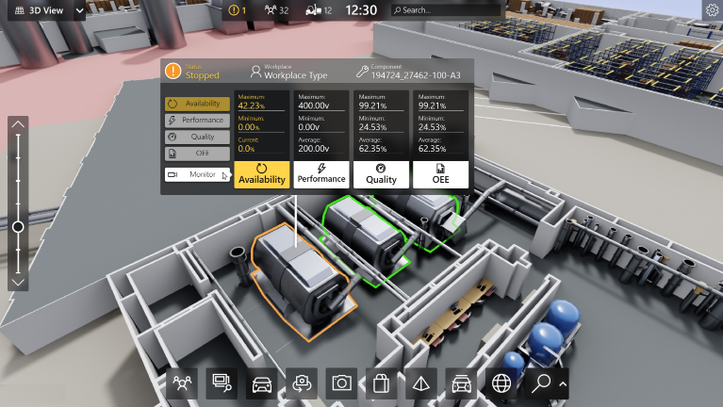

1.  based Solution

UCT is one of the early adopters of LoRAWAN teschnology and providing solution in Agritech, Smart cities, Industrial Monitoring, Smart Street Light, Smart Water/ Gas/ Electricity metering solutions etc.

1. Predictive Maintenance

UCT is providing Industrial Machine health monitoring and Predictive maintenance solution leveraging Embedded system, Industrial IoT and Machine Learning Technologies by finding Remaining useful life time of various Machines used in production process.



## About upskill Campus (USC)

upskill Campus along with The IoT Academy and in association with Uniconverge technologies has facilitated the smooth execution of the complete internship process.

USC is a career development platform that delivers **personalized executive coaching** in a more affordable, scalable and measurable way.





Seeing need of upskilling in self paced manner along-with additional support services e.g. Internship, projects, interaction with Industry experts, Career growth Services

<https://www.upskillcampus.com/>

upSkill Campus aiming to upskill 1 million learners in next 5 year

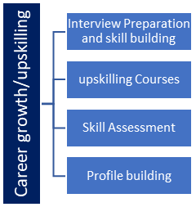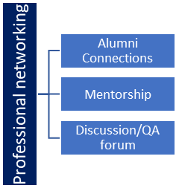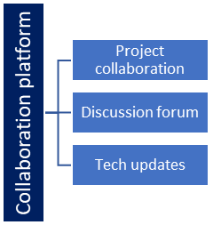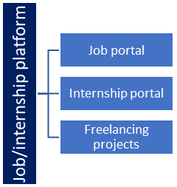

## The IoT Academy

The IoT academy is EdTech Division of UCT that is running long executive certification programs in collaboration with EICT Academy, IITK, IITR and IITG in multiple domains.

## Objectives of this Internship program

The objective for this internship program was to

 ☛ get practical experience of working in the industry.

 ☛ to solve real world problems.

 ☛ to have improved job prospects.

 ☛ to have Improved understanding of our field and its applications.

 ☛ to have Personal growth like better communication and problem solving.

## Reference

[1] GeeksforGeeks

[2] Personal python notes

[3] Youtube

**2.6 Glossary**

|  |  |
| --- | --- |
| **Terms** | **Acronyms** |
| Command Line Interface | **CLI** |
| Continuous Integration/ Continuous Deployment | **CI/CD** |

# Problem Statement

The quiz game is a Python project that quizzes users on various topics. It reads questions and answers from a file or database, presents them to the user, and keeps track of their score. The user can create their own quiz as well.

# Existing and Proposed solution

The python quiz project works simply on command line interface which can be easily managed by a non-coder as well which makes it more interactive and easily understandable.

## Code submission (Github link)

[Prapti007/python_quiz_ (github.com)](https://github.com/Prapti007/python_quiz_)

## Report submission (Github link) : first make placeholder, copy the link.

# Proposed Design/ Model

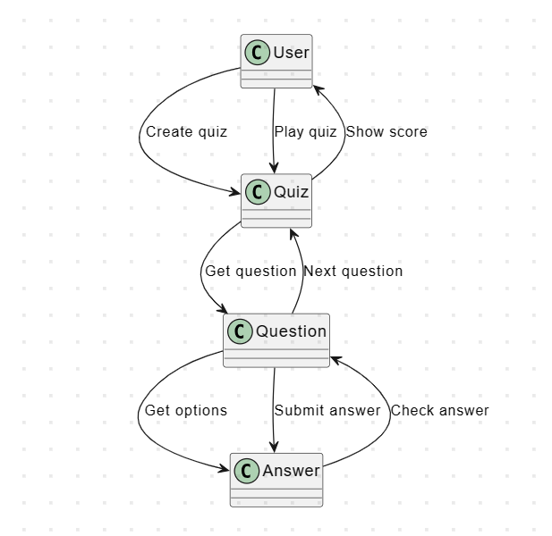

# Performance Test

The Performance Test evaluates the performance and responsiveness of the Python Quiz Project. The objective of this test is to assess the application's ability to handle various user interactions, such as creating quizzes and playing quizzes, while ensuring optimal response times and minimal resource consumption.

**Test Environment**

Operating System: [Windows 11]

Python Version: [Python 3.8]

Hardware: [CPU]

## Test Plan/ Test Cases

Scenario 1 - Creating a New Quiz:

|  |  |
| --- | --- |
| Number of Questions | Average Response Time (ms) |
| 5 | 0.2 |
| 10 | 0.4 |
| 20 | 0.7 |

Scenario 2 - Playing a Quiz:

|  |  |
| --- | --- |
| Number of Questions | Average Response Time (ms) |
| 5 | 0.3 |
| 10 | 0.6 |
| 20 | 0.8 |

## Test Procedure

The following test procedure were executed to evaluate the performance of the Python Quiz Project:

1. Scenario 1 - Creating a New Quiz:

- Objective: Measure the time taken to create a new quiz with a varying number of questions.

- Parameters: Number of questions (5).

2. Scenario 2 - Playing a Quiz:

- Objective: Measure the time taken to play a quiz with a varying number of questions.

- Parameters: Number of questions (5).

Based on the performance test results, the following recommendations are suggested:

1. Optimize Database Operations: Consider optimizing database queries and data retrieval processes to further enhance response times during peak usage.

2. Scaling Considerations: As the application's user base grows, monitor resource utilization, and consider horizontal scaling to maintain optimal performance.

3. Load Testing: Conduct regular load testing to identify application bottlenecks and ensure continued performance improvement.

## Performance Outcome

The Python Quiz Project performed well under various test scenarios. The response times remained within acceptable limits, and the application demonstrated good throughput under concurrent usage. Resource utilization was found to be reasonable and well-optimized.

Overall, the Python Quiz Project is deemed suitable for handling multiple user interactions and quizzes while providing a smooth user experience.

# My learnings

The development of the Python Quiz Project has been a valuable learning experience. I have gained skills in Python, data handling, project management and problem-solving. This project has boosted my confidence and provided a strong foundation for my career growth in Python related jobs.

# Future work scope

1. An interactive user interface can be added to make the project more user friendly and interactive.
2. More features like background music and more addition to user choices for quiz game.
3. Android compatibility.