**High-Level Solution Design Document**

Vertica Web Test

Version: 1.00

Updated: 06/03/2022

Author: Prapulla Srikanta

# Overview

Vertica Web Test to display a single page, with a header and a footer and a display area.

# Requirement Summary

* The header contains some fixed text, a basic radio control, a clock and some help text. The centre display area contains a small panel. This panel can be manually positioned or positioned by the radio control.
* The page should have a fixed height position header and fixed height footer. The footer should stay attached to the bottom of the page and of the defined fixed height regardless of browser resize action. The browser should not display a scrollbar until interior components become too large.
* The interior display area should be a fixed height of 400 pixels regardless of browser size. The footer will be allowed to separate from the display area as the window is resized. See image below.
* The window will contain a floating panel that cannot enter the header or footer area.
* There should be a clock on the upper right corner of the page in the black header area and it should be up to date. It should be vertically centered if possible in the header.
* The header bar will contain a positional control for the floating panel. Radio options for the "Position" should be mutually exclusive and the selection state should be properly hooked up with the position of the floating block in the middle of the page. Ideally these will be vertically centered in the header.
* Whatever the position option is selected, the floating block in the display area.should have text indicating its position. Example "Lower Right" for option 2, "Center" for option 1.
* When the position option is set to "Center", the floating block should be perfectly centered in the browser viewable window, and it should readjust itself when the browser is resized, but always sticks to the center.
* When the position option is set to "Lower Right", the floating block should stick to the lower right corner of the page, just above the black footer area. It should remain in its position even when the window is resized.
* The grey floating block should be draggable, but ONLY WITHIN THE LIGHT GREAY AREA under the black header, it should not be able to be dragged outside the the grey containment even in the event of resizing of the browser. Dragging it from the picture above should snap it back into the area.
* The floating block should disappear if the user hits the Escape key on the browser and reappears when the Enter key is hit.

# Assumptions and Prerequisites

* An access to chrome or any browser to load the single page file.
* jQuery UI: v1.10.1
* jQuery JavaScript Library v1.9.1

# [High-Level Design](https://softwaredominos.com/home/software-design-development-articles/high-level-solution-design-documents-what-is-it-and-when-do-you-need-one/)

* When the position option is set to "Center", the floating block should be perfectly centered in the browser viewable window, and it should readjust itself when the browser is resized, but always sticks to the center.

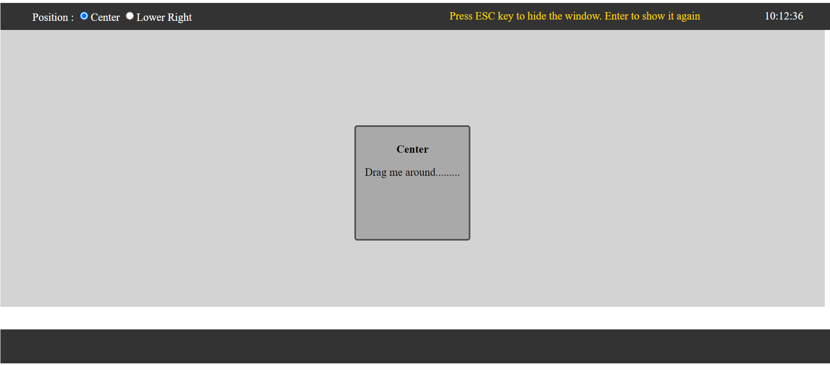

* When the position option is set to "Lower Right", the floating block should stick to the lower right corner of the page, just above the black footer area. It should remain in its position even when the window is resized.

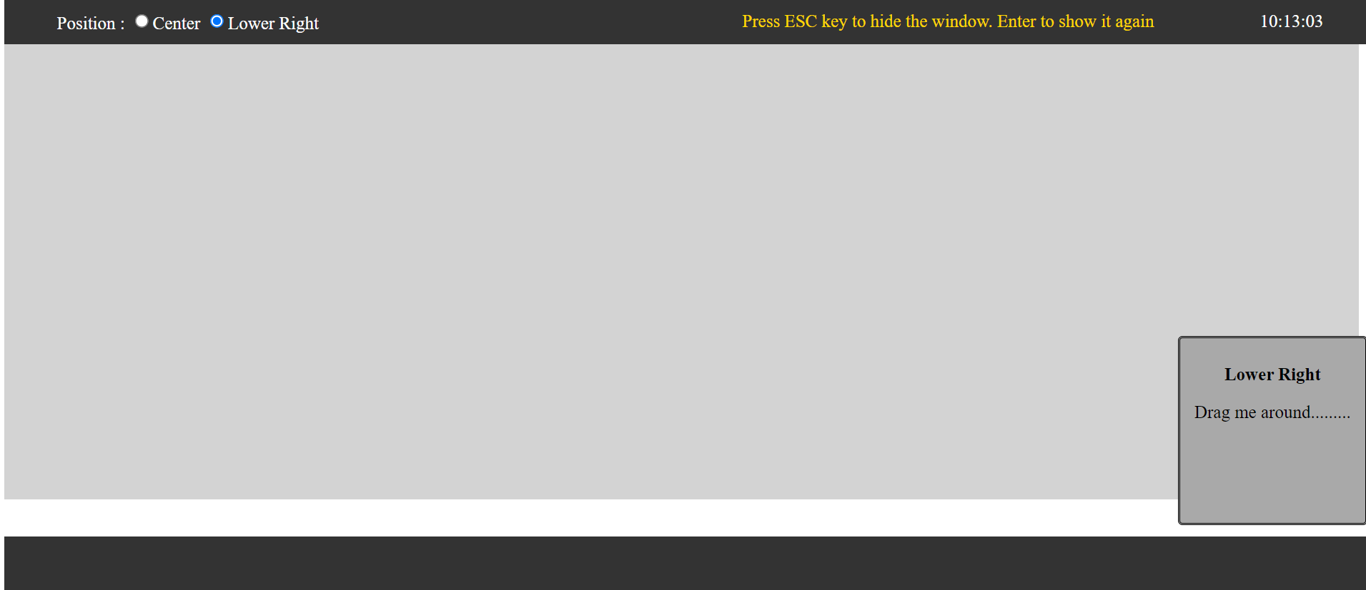

* The grey floating block should be draggable, but ONLY WITHIN THE LIGHT GREAY AREA under the black header, it should not be able to be dragged outside the the grey containment even in the event of resizing of the browser. Dragging it from the picture above should snap it back into the area.

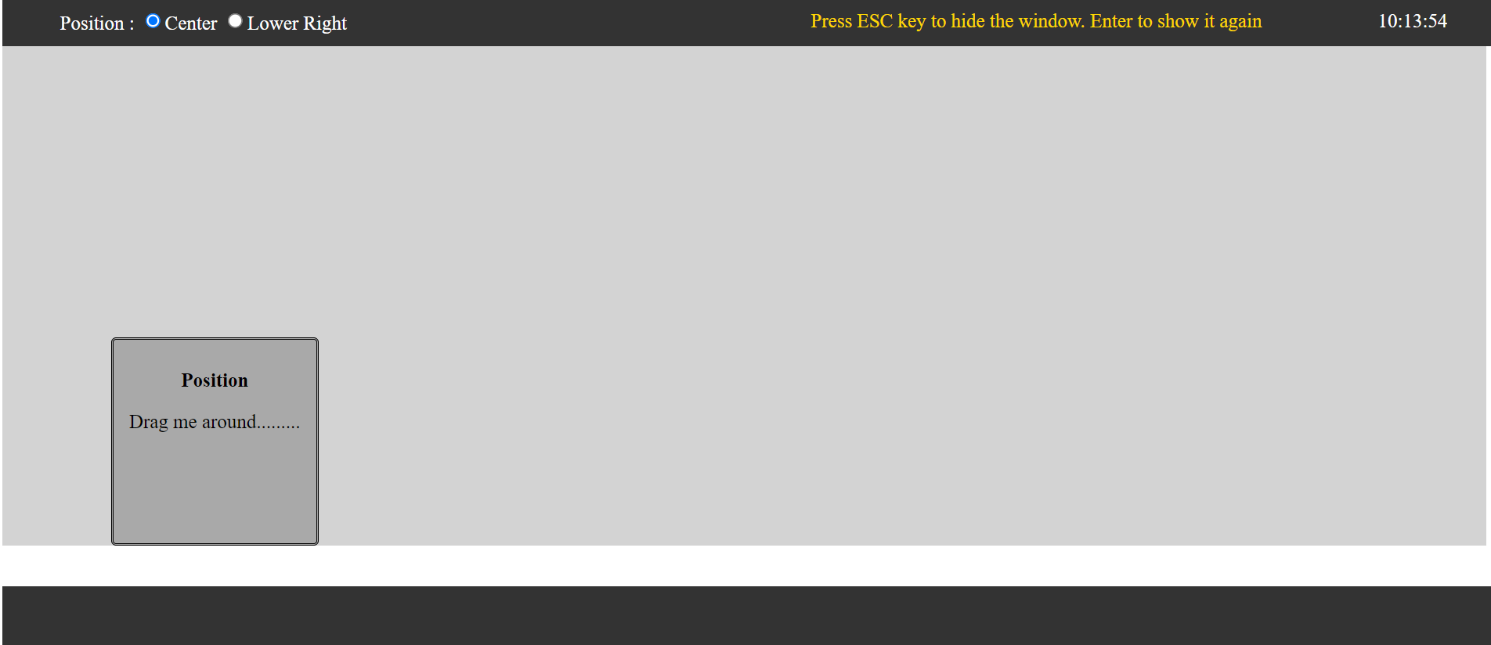

* The interior display area should be a fixed height of 400 pixels regardless of browser size. The footer will be allowed to separate from the display area as the window is resized. See image below.

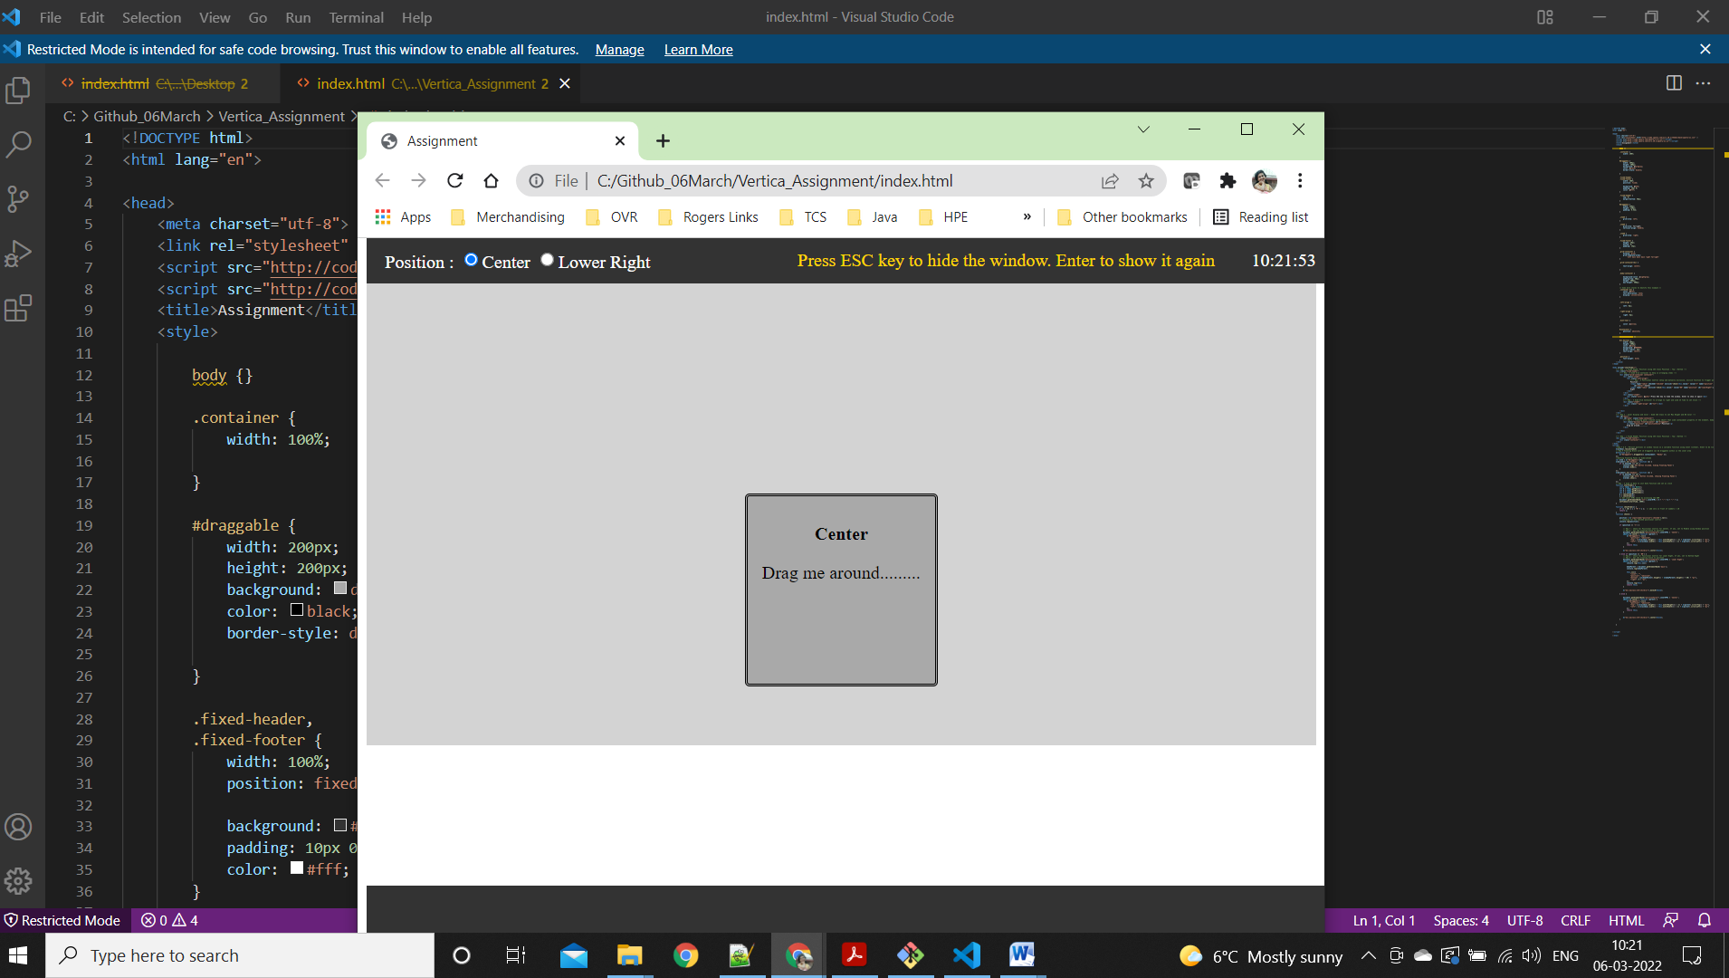

* The floating block should disappear if the user hits the Escape key on the browser

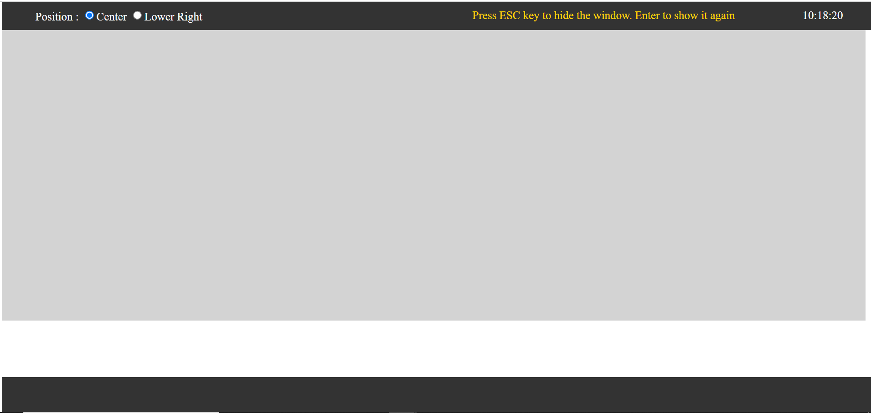

* The floating block should reappear when the Enter key is hit.

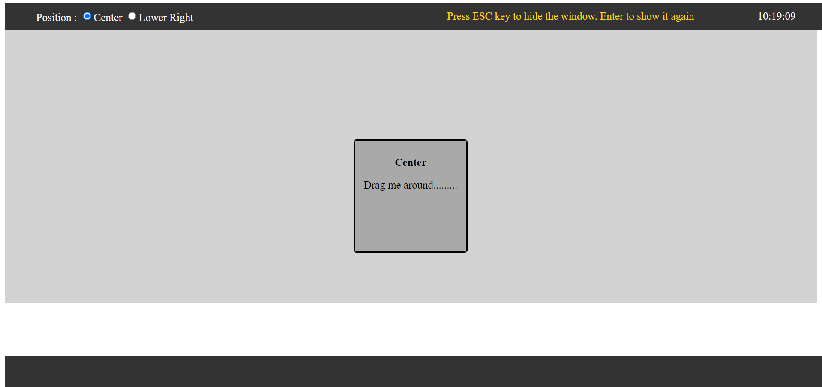

## Architectural Plan

* Fix Header Position using CSS Class Position : Top / Bottom
* Create Inner Display and set Color : Used CSS Class to set Max Height and BG Color
* Create Floating panel using JQuery that used containment property of the element, body
* Grid Container to help in arranging items and to arrange to right and used JS Time to set Clock
* JS Date to initialize Date Function and set as clock
* Positional Control setup and mutually exclusive, on click function to trigger position changes using JS
* Set the floating block to position
* Check for Positional Control for Center, If yes, set to Middle using Window position
* Check for Positional Control for Lower Right, If yes, set to Bottom Right
* Floating Block with id draggable can be draggable within in the inner area

## Application Modules

Includes the following:

* CSS Styling
* jQuery UI: v1.10.1
* jQuery JavaScript Library v1.9.1
* An access to chrome or any browser to load the single page file.

## Transactions and User Flows

* NA

# Out-of-scope

* NA

# Appendices

* NA