

Minor Project Synopsis

Query-Adaptive Multimodal Self-RAG for Evidence-Grounded
Medical Reasoning for Epilepsy Analysis

Submitted in partial fulfillment of Minor Project [ARP-455]

Parth Saini
06219051923

Under the supervision of
Dr Ruchika Lalit
Assistant Professor
University School of Automation & Robotics (USAR)

Introduction
Electroencephalography (EEG) provides time-varying measurements of electrical brain activity and is widely used in epilepsy and seizure analysis. However, interpreting long EEG recordings together with clinical context and medical knowledge is a knowledge-intensive task. Conventional AI systems generally focus on seizure detection or classification and do not provide an evidence-grounded reasoning layer that can adapt its information sources to the user's question.
This project proposes a query-adaptive EEG reasoning framework that combines an EEG processing module with two complementary external knowledge sources: a vector database containing medical documents and an epilepsy/neurology-focused knowledge graph. A query-understanding stage classifies the information need and decomposes complex questions into subqueries when required. A retrieval scorer then estimates the usefulness of each source and activates only the sources whose scores exceed a threshold. Retrieved evidence is fused and passed through a Self-RAG reflection process to check relevance, support, and sufficiency before producing the final response.
Problem Statement
Existing EEG analysis systems are primarily designed for signal-level tasks such as seizure detection, while general medical language models may lack direct access to patient-specific EEG evidence and structured medical relationships. Applying all available retrieval sources to every question is also inefficient and can introduce irrelevant evidence. There is therefore a need for an adaptive evidence-grounded framework that can select the appropriate combination of EEG evidence, medical documents, and structured knowledge according to the information need of the query.
Motivation
Epilepsy-related reasoning may require different forms of evidence. A definition question can often be answered from medical documents, a question about relationships between seizure types and brain regions can benefit from a knowledge graph, and a patient-specific question about an EEG requires signal evidence in addition to clinical knowledge. A query-adaptive architecture can reduce unnecessary retrieval while making complex EEG reasoning more transparent and evidence-grounded.
Objective
To develop a query-adaptive Self-RAG framework for evidence-grounded reasoning over EEG signals and epilepsy-related medical knowledge.
- Process annotated scalp EEG recordings for seizure-related evidence.
- Build an epilepsy/neurology-focused knowledge graph and a medical-document vector store.
- Classify and decompose complex user queries into retrieval-oriented subqueries.
- Score the suitability of vector, graph, and EEG evidence sources and activate them selectively.
- Use Self-RAG reflection to assess evidence relevance, support, and sufficiency before answering.
- Evaluate retrieval efficiency, evidence quality, and answer correctness against non-adaptive baselines.

Literature Review
Recent work on retrieval-augmented generation has shown that external evidence can improve the factual grounding of language-model responses. Retrieval-Augmented Generation (RAG) combines a language model with a retriever over an external corpus, while GraphRAG uses graph-structured entities and relationships to support structured and multi-hop retrieval. Self-RAG extends this idea by allowing the model to reflect on whether retrieved evidence is relevant and whether a generated response is adequately supported.
Medical question answering systems such as Med-PaLM 2 demonstrate the potential of large language models combined with medical-domain adaptation and retrieval-oriented prompting. However, a healthcare reasoning system that directly incorporates patient-specific EEG evidence and dynamically selects among signal, document, and graph sources remains a distinct engineering and research problem.
For the signal component, the CHB-MIT Scalp EEG Database provides annotated scalp EEG recordings containing seizure events and is suitable for developing and evaluating seizure-related EEG representations. Knowledge-graph approaches provide a complementary representation of entities such as seizure types, symptoms, brain regions, disorders, and relationships, while document retrieval provides explanatory definitions and literature-based evidence.
A key research gap is therefore the integration of query-adaptive source selection with Self-RAG in an EEG-focused medical reasoning pipeline. Instead of assuming that every query needs every source, the proposed system learns or estimates the information need and selects only the evidence channels required for that query.

Proposed Design Flow
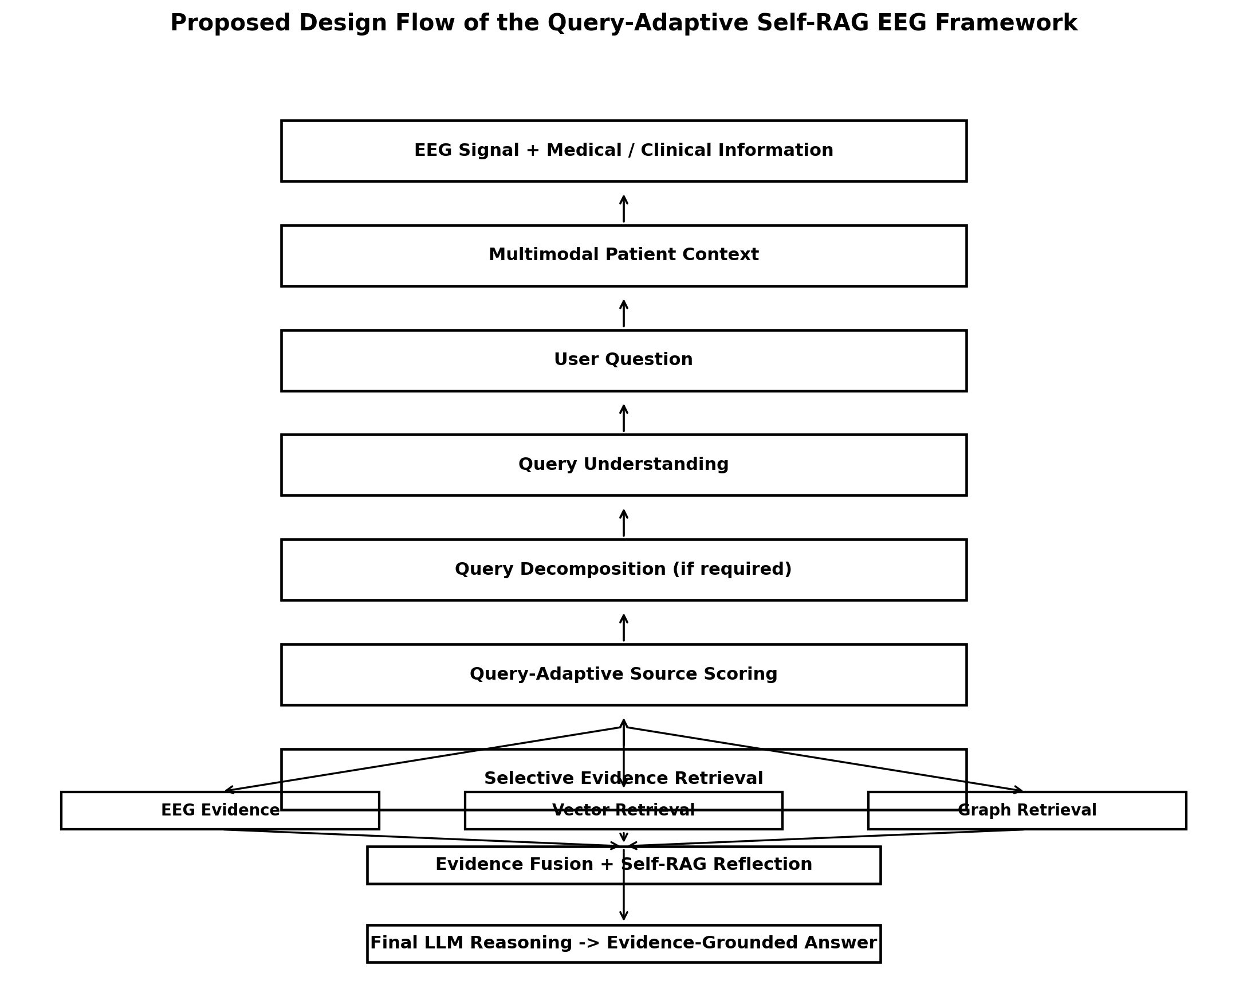
Fig. 1. Proposed design flow showing query understanding, adaptive source selection, evidence fusion, and Self-RAG reflection.
The flow begins with EEG and clinical information forming the multimodal patient context. The user query is understood and decomposed when necessary. Source suitability is estimated for EEG, vector, and graph evidence. Selected evidence is fused and checked by Self-RAG for relevance, support, and sufficiency before final reasoning.
Proposed Methodology
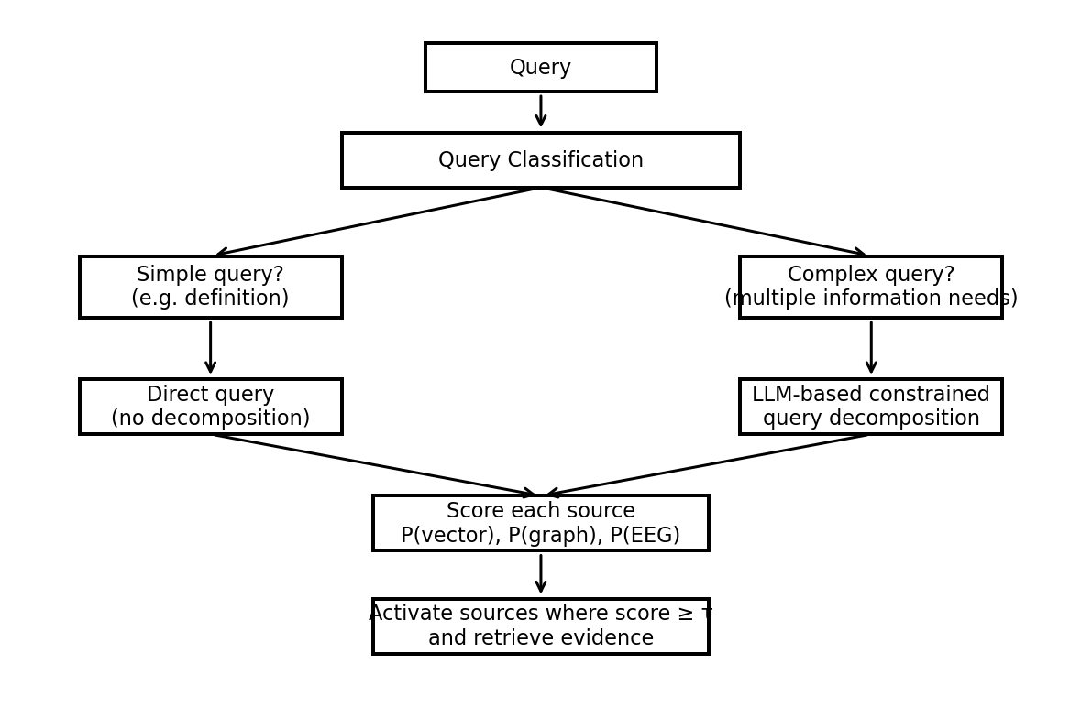
Fig1. Query decomposition and query-adaptive source scoring for the proposed EEG reasoning framework
- Query Understanding: classify the question as definitional, relational, EEG-specific, clinical, or complex.
- For complex questions, constrained query decomposition converts one question into smaller retrieval-oriented subqueries while preserving their information needs.
- Query-Adaptive Scoring: estimate source suitability as S_vector, S_graph, and S_EEG. A source is activated when its score exceeds a threshold τ; alternatively, the top-k sources may be selected.
- Simple queries can bypass decomposition. For example, a definition query may activate only document retrieval, whereas an EEG interpretation query can activate EEG, graph, and document evidence.
- Retrieved evidence is fused before the reasoning stage. Self-RAG then checks whether evidence is relevant, supports the response, and is sufficient; if not, retrieval can be revised and repeated.

- EEG Processing Layer: preprocess scalp EEG, segment recordings, extract or encode seizure-relevant representations, and associate retrieved EEG evidence with the query.
- Vector Retrieval Layer: index medical documents and literature-oriented passages using embeddings and retrieve semantically relevant evidence.
- Knowledge Graph Layer: construct or extract an epilepsy/neurology-focused subgraph containing clinically meaningful entities and relations; graph retrieval supports relation and multi-hop questions.
- Evidence Fusion Layer: combine selected text, graph, and EEG evidence into a structured context for the reasoning model.
- Self-RAG Reflection Layer: evaluate retrieved evidence for relevance and answer support. If the evidence is inadequate, the system updates the retrieval decision rather than accepting an unsupported answer.
- Output Layer: generate an answer with supporting evidence and an uncertainty/confidence indication suitable for research evaluation rather than autonomous clinical diagnosis.
System Architecture
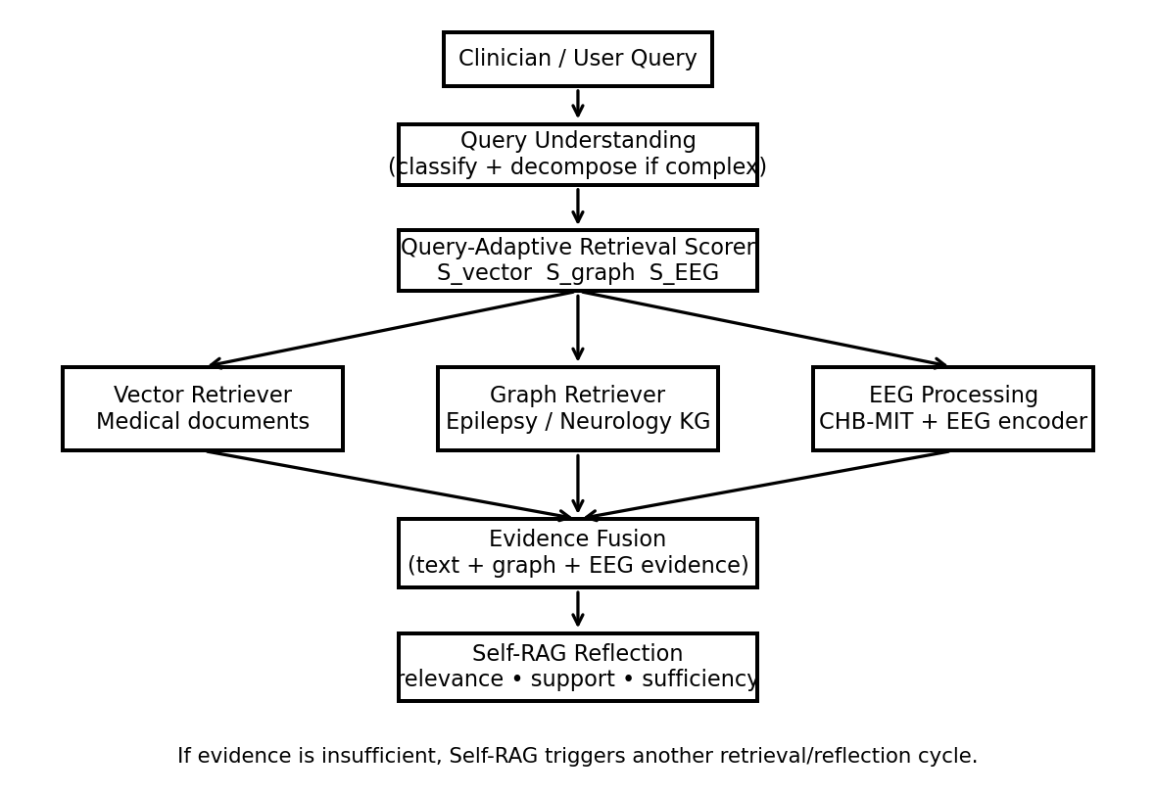
Fig 2. System architecture of the proposed Query-Adaptive Self-RAG EEG reasoning framework.

Hardware and Software Requirements
Component | Requirement
Processor | Intel i5 / Ryzen 5 or better
RAM | 16 GB
GPU | NVIDIA RTX 3060/4060 or equivalent (6–8 GB VRAM)
Storage | 50–100 GB free
Dataset | CHB-MIT Scalp EEG Database

Software | Purpose
Python / PyTorch / Scikit-learn | EEG processing and ML
Hugging Face / Open-source LLM | Reasoning and constrained query decomposition
FAISS / Chroma / equivalent | Vector retrieval
Neo4j / graph database | Knowledge-graph storage and retrieval
FastAPI | Backend / API
Git / GitHub, VS Code | Development and version control

Results (Till Now)
At the current synopsis stage, quantitative experimental results are not yet reported. The documented progress consists of defining the problem, research gap, query-adaptive architecture, EEG/vector/graph evidence channels, query decomposition and source-scoring methodology, Self-RAG reflection, dataset selection, and the implementation plan. Quantitative evaluation will be conducted after the retrieval, reasoning, and integration stages are implemented.

Gantt Chart
Task | Dates | Week 1 | Week 2 | Week 3 | Week 4 | Week 5 | Week 6 | Week 7 | Week 8
Dataset & Requirements | Sep 14-20 | ■
EEG Preprocessing & Baseline | Sep 21-27 |  | ■
Knowledge Graph Construction | Sep 28-Oct 4 |  |  | ■
Vector DB & Document Retrieval | Oct 5-11 |  |  |  | ■
Query Decomposition & Scoring | Oct 12-18 |  |  |  |  | ■
Self-RAG & Evidence Fusion | Oct 19-25 |  |  |  |  |  | ■
Integration & Evaluation | Oct 26-Nov 1 |  |  |  |  |  |  | ■
Testing & Documentation | Nov 2-8 |  |  |  |  |  |  |  | ■
Fig 3. Project Gantt chart showing the planned development and implementation timeline.
References
1. Lewis, P., Perez, E., Piktus, A., et al. (2020). Retrieval-Augmented Generation for Knowledge-Intensive NLP Tasks. Advances in Neural Information Processing Systems (NeurIPS).
2. Asai, A., Wu, Z., Wang, Y., et al. (2024). Self-RAG: Learning to Retrieve, Generate, and Critique through Self-Reflection. ICLR.
3. Edge, D., Trinh, H., Cheng, N., et al. (2024). From Local to Global: A Graph RAG Approach to Query-Focused Summarization. arXiv preprint.
4. Singhal, K., Azizi, S., Tu, T., et al. (2023). Large Language Models Encode Clinical Knowledge. Nature, 620, 172–180.
5. Singhal, K., Tu, T., Gottweis, J., et al. (2023). Towards Expert-Level Medical Question Answering with Large Language Models. arXiv preprint / Med-PaLM 2.
6. Shoeb, A. (2009). Application of Machine Learning to Epileptic Seizure Onset Detection and Treatment. PhD thesis, Massachusetts Institute of Technology.
7. Goldberger, A. L., Amaral, L. A. N., Glass, L., et al. (2000). PhysioBank, PhysioToolkit, and PhysioNet: Components of a New Research Resource for Complex Physiologic Signals. Circulation, 101(23), e215–e220.
8. CHB-MIT Scalp EEG Database, PhysioNet. Pediatric scalp EEG recordings with seizure annotations.

