**LEVEL-1: LANDING PAGE(TASK -1):**

<!DOCTYPE html>

<html>

<head>

    <meta charset="UTF-8">

    <meta name="viewport" content="width=device-width, initial-scale=1.0">

    <title>My E-Commerce Website</title>

    <style>

        body {

            background-image: url('C:\Users\User\Pictures\Screenshots\logo-png.png');

            background-repeat: no-repeat;

            background-attachment: fixed;

            background-size: cover;

            font-weight: bold;

        }

        header {

            background-image: linear-gradient(pink, navy);

        }

        .logo {

            text-align: left;

            font-weight: bolder;

            text-decoration: none;

        }

        .nav {

            text-align: center;

            font-weight: bolder;

        }

        .nav ul {

            list-style: none;

            padding: 0;

        }

        .nav li {

            display: inline;

            margin-right: 20px;

        }

        .nav a {

            color: #f2f2f2;

            text-decoration: none;

            font-size: 17px;

        }

        .login {

            background-color: rgb(145, 33, 49);

            color: #fff;

            padding: 8px 16px;

            text-decoration: none;

            border-radius: 5px;

            font-weight: bold;

            transition: background-color 0.3s;

            float: right;

        }

        .signup {

            background-color: rgb(58, 75, 208);

            color: #fff;

            padding: 8px 16px;

            text-decoration: none;

            border-radius: 5px;

            font-weight: bold;

            transition: background-color 0.3s;

            float: right;

        }

        .login:hover {

            background-color: white;

            color: rgb(145, 33, 49);

        }

        .signup:hover {

            background-color: white;

            color: rgb(58, 75, 208);

        }

        .active{

            background-color: #63bbb7;

        }

        .logo{

            text-decoration: none;

            position: relative;

            text-shadow: #f2f2f2;

            animation: forwards;

            animation-duration: 3s;

        }

    </style>

</head>

<body style="background-color:rgb(150, 198, 207);">

    <header>

        <div class="logo"><a href="#">Landing Page</a></div>

        <nav>

        <div class="nav">

                <ul>

                    <li><a href="#" class="active">Home</a></li>

                    <li><a href="#about.txt" >About</a></li>

                    <li><a href="#">Services</a></li>

                    <li><a href="#">Contact</a></li>

                    <button class="login">Log-In</button>

                    <button class="signup">Sign-Up</button>

                </ul>

            </nav>

        </div>

    </header>

    <main>

       <p>

        <strong>This landing page is used to display the content in a single HTML page </strong>

        <p>

            <strong> Services</strong>

            <hr>

        1. Content management systems

        Interaction with your website does not always start from the main page. If you have a relevant blog, your customers can find the articles, lists, and reviews. But creating valuable content needs organization and planning. Content management services help optimize it.

        WordPress is using the popular technologies of building the website. Though it needs some technical knowledge for competent use, the benefits are apparent:

        your blog can be easily adapted to your company’s changing needs,

        bright blog appearance without coding,

        the extended functions with plugins,

        the support of the wordpress community.

        Designed initially for blogging support, now the service helps run large corporations’ sites and empowers more than a quarter of business websites as of now. WordPress enables post navigation, calculating the time for reading the post (min read), attracts new readers, and raises the site’s attendance.<br>

        2. Online ordering services

        The need for an online ordering system has extremely increased with lockdown challenges. The systems have become many restaurants’ factor of survival during the pandemic. When everyday life becomes “usual” again, online ordering is going to remain an essential part of the business processes.

        The ordering systems include web and mobile services. Some restaurants have their websites; some of them have mobile applications. But the combination of both types of software boosts the system’s efficacy, saves time and streamlines the ordering operations.

        The systems have much in common with CRMs, as they help manage ordering and delivery processes. Mobile apps for the employees can be connected with the website’s ordering page and send notifications to the staff when the order is received.

        A vital advantage of online ordering services for the business is tracking all the cash flow in the restaurant and calculating revenue and expenses.

        </p>

       </p>

    </main>

    <footer>

        for <strong> terms&condition</strong> click here and get cookies

        <p>for queries-<strong>ecomleather@gmail.com</strong>

        contact-us:8764239876 </p>

    </footer>

</body>

</html>

OUTPUT:

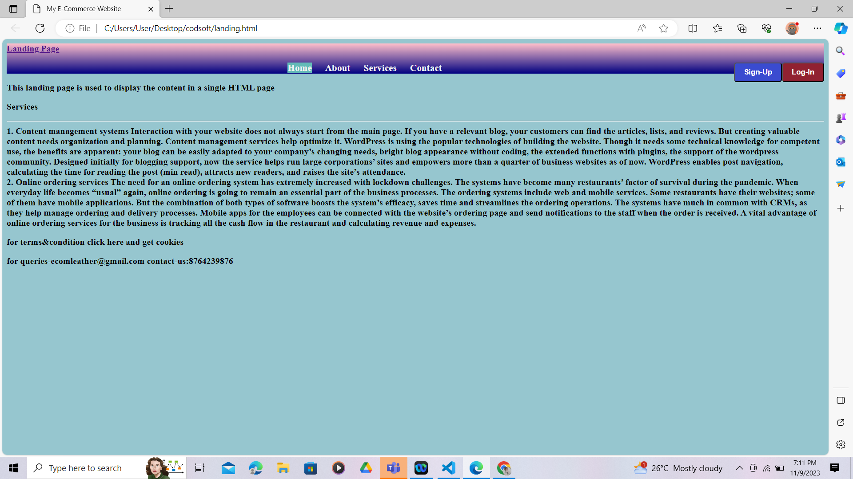

**LEVEL-1 (TASK-3 CALCULATOR):**

<!DOCTYPE html>

<html lang="en">

<head>

    <meta charset="UTF-8">

    <meta name="viewport" content="width=device-width, initial-scale=1.0">

    <title>Calculator</title>

    <style>

        *{

    margin:0;

    padding: 0;

    box-sizing: border-box;

    background-color: #ecf0f3;

    font-family: sans-serif;

    outline: none;

}

.container{

    height: 100vh;

    display: flex;

    justify-content: center;

    align-items: center;

}

.calculator{

    background-color: #ecf0f3;

    padding: 15px;

    border-radius: 30px;

    box-shadow: inset 5px 5px 12px #ffffff ,

                      5px 5px 12px rgb(0,0,0,16);

    display: grid;

    grid-template-columns: repeat(4,70px);

}

input{

    grid-column: span 4;

    height: 70px;

    width: 260px;

    background-color: #ecf0f3;

    box-shadow: inset -5px -5px 12px #ffffff,

                inset -5px -5px 12px rgba(0, 0,0,16);

    border: none;

    border-radius: 30px;

    color: rgb(70,70,70);

    font-size: 50px;

    text-align: end;

    margin: auto;

    margin-top: 40px;

    margin-bottom: 30px;

}

button{

    height: 48px;

    width: 48px;

    background-color: #ecf0f3;

    box-shadow: -5px -5px 12px #ffffff,

                -5px -5px 12px rgba(0, 0,0, 16);

    border: none;

    border-radius: 50px;

    margin:8px;

    font-size: 16px;

}

.equal{

    width: 115px;

    border-radius: 40px;

    background-color: #cb341a;

    box-shadow: -5px -5px 12px #ffffff,

                -5px -5px 12px rgba(0, 0,0, 16);

}

.clr{

    background-color: orange;

}

.dlt{

    background-color: aliceblue;

}

.h1{

text-align: center;

font-weight: bold;

}

    </style>

</head>

<body>

 <h1> CALCULATOR</h1>

  <main>

    <div class="container">

        <div class="calculator">

            <input type="text" placeholder="0" id="output-screen">

            <button class="clr" onclick ="Clear()">CLR</button>

            <button  class="dlt"onclick ="Delete()">DEL</button>

            <button onclick ="display('%')">%</button>

            <button onclick ="display('/')">/</button>

            <button onclick ="display('7')">7</button>

            <button onclick ="display('8')">8</button>

            <button onclick ="display('9')">9</button>

            <button onclick ="display('*')">*</button>

            <button onclick ="display('4')">4</button>

            <button onclick ="display('5')">5</button>

            <button onclick ="display('6')">6</button>

            <button onclick ="display('-')">-</button>

            <button onclick ="display('1')">1</button>

            <button onclick ="display('2')">2</button>

            <button onclick ="display('3')">3</button>

            <button onclick ="display('+')">+</button>

            <button onclick ="display('.')">.</button>

            <button onclick ="display('0')">0</button>

            <button onclick ="calculate()" class="equal">=</button>

        </div>

    </div>

    <script>

        let outputScreen=document.getElementById("output-screen");

        function display(num){

            outputScreen.value+=num;

        }

        function calculate(){

            try{

                outputScreen.value=eval(outputScreen.value);

            }

            catch(err){

                alert("invalid");

            }

        }

        function Clear(){

            outputScreen.value=" ";

        }

        function Delete(){

            outputScreen.value=outputScreen.value.slice(0,-1);

        }

    </script>

</body>

</html>

**OUTPUT:**

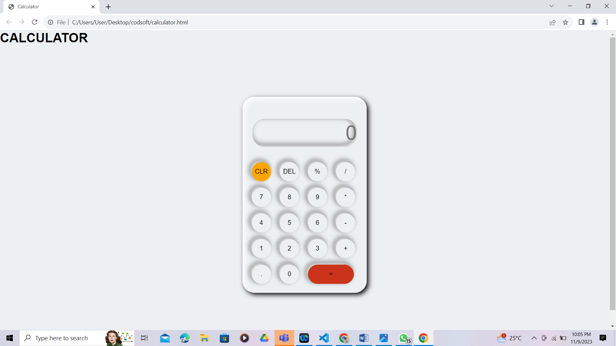

**LEVEL-2 :TRIBUTE PAGE(TASK-1)**

<!DOCTYPE html>

<html lang="en">

<head>

    <meta charset="UTF-8">

    <meta name="viewport" content="width=device-width, initial-scale=1.0">

    <title>tribute page</title>

   <style>

   body{

    background-color: rgb(15, 122, 180);

    color: aliceblue;

    font-family: 'Trebuchet MS', 'Lucida Sans Unicode', 'Lucida Grande', 'Lucida Sans', Arial, sans-serif;

    line-break:50%;

   }

   .title{

    font-weight: bolder;

   }

   </style>

</head>

<body>

    <header>

        <img src="https://static.india.com/wp-content/uploads/2023/07/WhatsApp-Image-2023-07-18-at-7.48.15-PM.jpeg",alt="steve img">

    </header>

    <main>

        <p class="title"> <strong>Timeline of Steve Jobs</strong><p>

        The events in Steve Jobs's extraordinary life.

        Youth & Apple's early years

        NeXT Pixar and wilderness

        Rebuilding Apple

        The Big Apple

        Back to top

        Youth & Apple's early years 1955-1985

        24 Feb 1955

        Steven Paul was born in San Francisco, the son of Abdulfattah Jandali and Joanne Schieble. He is quickly adopted by Paul and Clara Jobs.

        1960

        The Jobs family moves from San Francisco to Mountain View, a suburban town in Santa Clara county, more famous under the name Silicon Valley.

        Summer 1968

        13-year-old Steve Jobs calls up Bill Hewlett and gets a summer job at the HP factory.

        1969

        Steve Jobs meets Steve Wozniak, 5 years his elder, through a mutual friend. Woz and Steve share a love of electronics, Bob Dylan, and pranks.

        1972

        Phone Phreaks

        Steve and Woz build and illegally sell 'blue boxes' that let one make phone calls for free.

        1973

        Steve spends the fall semester at Reed College, Oregon, then drops out. He stays on campus and attends classes that interest him for a while, then moves to a hippie commune.

        1974

        Steve gets his first job at video game maker Atari, and later makes a trip to India to 'seek enlightenment' with his college friend Dan Kottke.

        Mar 1976

        Woz and Steve show off the early Apple I board at the Homebrew Computer Club.

        1 Apr 1976

        Apple Computer Inc. is incorporated by Steve Jobs, Steve Wozniak and Ron Wayne.

        Spring 1976

        Steve and Woz start assembling Apple I computers in the Jobses' garage, and sell them to computer hobbyists, including 50 for the Byte Sho

        In him

        The SEC clears Steve Jobs of any responsibilities in the options backdating scandal.

        Late 2008

        Apple starts its popular 'There's an app for that' campaign to illustrate the growing popularity of the App Store and the thousands of iPhone apps it offers.

        5 Jan 2009

        Steve Jobs announces he will not speak at Macworld 2009 because of his health, and takes a six-month medical leave of absence.

        Apr 2009

        Steve receives a liver transplant at the Methodist University Hospital in Memphis, Tennessee. He was weeks away from dying when he got the surgery.

        3 Aug 2009

        Google CEO Eric Schmidt leaves Apple's board because of conflicting interests due to Android. Steve Jobs is furious at Google for having built a competing mobile operating system.

        28 Aug 2009

        Apple releases Mac OS X 10.6 Snow Leopard, stripped off any code from the original Mac OS.

        9 Sep 2009

        Back at Apple, Steve Jobs makes the first public appearance after his transplant to introduce new iPods at the 'It's Only Rock'N'Roll' event.

        6 Jun 2011

        The Last Keynote

        At his last keynote at WWDC 2011, a frail Steve Jobs unveils Apple's cloud offering, iCloud, a centerpiece in Apple's product offering for decades to come.

        7 Jun 2011

        Steve Jobs appears at the Cupertino City Council to unveil Apple's plans for its new 'Spaceship' campus. This would prove to be his last public appearance.

        24 Aug 2011

        Steve Jobs resigns as CEO of Apple, with the words 'I have always said if there ever came a day when I could no longer meet my duties and expectations as Apple's CEO, I would be the first to let you know. Unfortunately, that day has come.' Tim Cook becomes Apple CEO.

        5 Oct 2011

        Steve Jobs dies at home, surrounded by his family.

        16 Oct 2011

        A private service is held at Stanford University's Memorial Church in memory of Steve Jobs, attended by many of his friends, former colleagues and industry peers.

        24 Oct 2011

        After two years of work, and forty interviews with Steve Jobs, Walter Isaacson publishes his authorized biography of the Apple and Pixar co-founder, simply named Steve Jobs.

        </p>

    </p>

    </main>

</body>

</html>

**OUTPUT:**

