PROGRAMMING IN JAVA
ASSIGNMENT 1 – CO1
CAMPUS SMART-PARKING SYSTEM

Student Name: Prartana T
Register Number: 192421099
Course: Programming in Java
Assignment: Design, Implement and Validate an Object-Oriented Model for a Campus Smart-Parking System
Total Marks: 50

Introduction
The Campus Smart-Parking System manages a multi-level university parking facility. It allocates a suitable free slot when a vehicle enters, issues a unique ticket, records entry time, releases the slot on exit and calculates the fee. The model supports two-wheelers, cars and electric vehicles, with student/staff monthly passes and visitor charges. The extended design also supports e-bikes, delivery vans and visitor one-day passes.
Assumptions: each vehicle occupies one slot; registration numbers are unique while parked; slots are allocated in floor-major order; every started hour is billed as a complete hour; monthly and one-day passes cover the parking stay; charging is billed separately for chargeable vehicles; delivery-van double rate applies when the parking interval overlaps 09:00–17:00.

Task 1 – Understand the Problem and Identify the Objects

Candidate classes and responsibilities
Class / Object | Responsibility and justification
ParkingFacility | Owns the floors and slots; allocates and releases slots; tracks active tickets and occupancy.
ParkingSlot / slot position | Represents one physical space and its occupied/free state. In the compact implementation, each array cell represents a slot.
Vehicle | Common identity and fee behaviour shared by all vehicle categories.
TwoWheeler, Car, ElectricCar | Represent different vehicle categories and supply their hourly rates; ElectricCar also supports charging.
ParkingTicket | Stores ticket number, vehicle, floor, slot, entry time and pass type; computes exit fee.
PassType | Represents visitor, student monthly, staff monthly and visitor day-pass categories.
Chargeable | Capability for vehicles that can incur charging fees.
Main | Demonstrates entry, exit, fee calculation and occupancy reporting.

Business rules
- A slot cannot contain two vehicles at the same time.
- A vehicle registration number cannot have two active tickets.
- A ticket number is generated uniquely and is not reused during the process.
- An invalid floor or slot cannot be released.
- A vehicle must be allocated a compatible free slot; this basic model uses the first free slot because no size restrictions are specified.
- Student and staff monthly pass holders park free; the extended visitor day pass is also free for its validity period.
- A visitor pays the vehicle-specific parking fee; charging is additional for chargeable vehicles.

Alternative: vehicle objects versus parallel arrays
With Vehicle objects, related fields and behaviour are kept together. Searching by registration still requires O(n) in a simple list, or expected O(1) with a HashMap. Adding an attribute means adding a field, constructor parameter and accessor in the relevant class. With parallel arrays such as regNo[], type[] and entryTime[], every index must remain synchronized; adding an attribute requires another array and coordinated updates. A linear search is O(n) in both array and list approaches. Object storage uses O(n) references plus per-object headers and fields; parallel arrays use O(n) values across arrays and may have lower object overhead, but are less maintainable.

Task 2 – Choose the Data Representation
Field | Chosen type | Reason
Floor and slot number | int | Non-negative integer indexes.
Vehicle registration | String | Contains letters and digits.
Entry / exit time | LocalDateTime | Stores date and time without losing minute precision.
Duration | long minutes / int minutes | Duration is a whole number of minutes; long avoids overflow in time calculations.
Fee and hourly rate | double | Represents fractional currency values in this educational model; BigDecimal is preferable for production financial systems.
Occupancy / capacity | int | Counts vehicles and slots.
Pass category | enum PassType | Restricts values to known categories.
Input is read from method parameters in the reusable model; a console user interface can use Scanner. For money, integer division is dangerous: 61 / 60 equals 1, which would undercharge if each started hour is billed. The implementation uses ceiling division with integer arithmetic: (minutes + 59) / 60. Thus 61 minutes becomes 2 billable hours. No narrowing cast is used before validating the duration.

Alternative representations
A jagged array Vehicle[floor][] is suitable when floors have different slot counts. A flat array can use a prefix-offset table to translate (floor, slot) into one index; lookup by known coordinates is O(1), but mapping requires offsets and careful handling of unequal floor sizes. A two-dimensional rectangular array wastes cells or misrepresents floors with unequal capacities. ArrayList<Vehicle[]> also supports unequal floor lengths and dynamic floor management, with O(1) indexed access and O(F) references for F floors, plus all slot cells.

Task 3 – Design the Control Logic

Slot allocation pseudocode
START\nINPUT vehicle\nFOR each floor f from 0 to numberOfFloors - 1\n FOR each slot s from 0 to slotsOnFloor[f] - 1\n IF slot[f][s] is empty THEN\n slot[f][s] = vehicle\n RETURN (f, s)\n END IF\n END FOR\nEND FOR\nRETURN NO_SLOT\nSTOP

Fee computation pseudocode
START\nINPUT vehicle, durationMinutes, passType\nIF durationMinutes < 0 THEN report invalid duration\nELSE IF passType is STUDENT_MONTHLY or STAFF_MONTHLY or VISITOR_DAY THEN fee = 0\nELSE\n billableHours = (durationMinutes + 59) / 60 using integer division\n fee = billableHours × vehicle hourly rate\n IF vehicle is chargeable THEN fee = fee + charging fee\nEND IF\nRETURN fee\nSTOP
The allocation loops stop immediately after the first free slot is found. If no free slot exists after all floors are scanned, allocation returns null. Fee slabs use a decision for pass eligibility and polymorphic vehicle rates; the ceiling formula implements the started-hour rule.

Complete the Code – ParkingFacility
The completed source is supplied in Task03_CompleteCode/ParkingFacility.java. It scans floor by floor, places the registration in the first null cell, returns the coordinate, and validates both indexes and occupancy before release. Expected output:
[0, 0]\n[0, 1]\n[1, 0]\nnull\ntrue false false\n[0, 1]

Alternative: free-slot stacks
A stack of free slot coordinates per floor allows allocation and release in O(1) average time, compared with O(F×S) worst-case scanning for F floors and S slots per floor. A free-count array is O(F) extra space and helps skip full floors, but does not alone identify a free coordinate. A stack stores up to F×S coordinates, so it requires O(F×S) extra space; the scanning array itself already requires O(F×S) slot storage.

Task 4 – Classes, Objects and Constructors
ParkingTicket uses overloaded constructors: one accepts the required ticket data and delegates to another constructor that accepts an explicit entry time. Constructor chaining through this(...) avoids duplicated validation and initialization. The vehicle reference, coordinates, pass type and entry time are validated before a ticket becomes usable. The this keyword distinguishes instance fields from parameters.
A default constructor followed by setters can temporarily create an invalid ticket and requires validation on every setter. A static factory method can provide named creation paths and still invoke a validating constructor. Creating n tickets takes O(n) total time and O(n) total object storage in all three approaches; constructor chaining has constant work per object. The principal difference is validity and maintainability, not asymptotic complexity.

Task 5 – Static Members and Object Life Cycle
The ticket counter is static because ticket numbering belongs to the ParkingTicket class, not to an individual ticket. If it were an instance variable, every object could start from the same number. Occupancy is an instance field of ParkingFacility because separate facilities must maintain separate counts. Static methods are appropriate for class-wide utilities that do not need object state; a static initialization block could initialize shared configuration, but is unnecessary in this small model.
On exit, the ticket is removed from the active-ticket map and the slot is cleared. Once no references remain to the ticket, it becomes eligible for garbage collection; collection timing is controlled by the JVM. Methods receive object references and can return objects such as ParkingTicket. Java passes the reference value by value.

Task 6 – Design the Inheritance Hierarchy
Vehicle is the abstract superclass. TwoWheeler and Car are subclasses (hierarchical inheritance). ElectricCar extends Car (multilevel inheritance). EBike extends TwoWheeler and implements Chargeable. DeliveryVan extends Vehicle. Shared registration validation and identity are inherited; subclasses supply category-specific hourly rates and capabilities.
The Vehicle constructor executes before the Car constructor, followed by the ElectricCar constructor. In a direct ElectricCar extends Car hierarchy, the trace is Vehicle → Car → ElectricCar. The super(...) call initializes inherited state.

UML class diagram
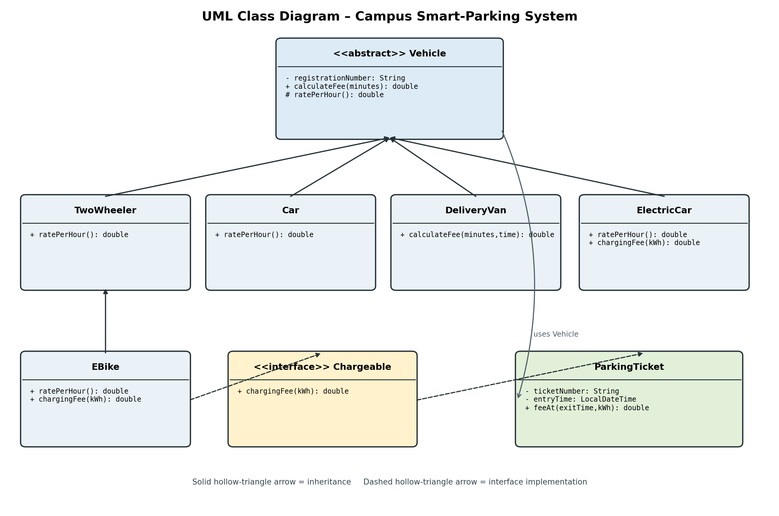
Composition alternative: one Vehicle class could hold a VehicleType/rate strategy. This makes adding categories possible without subclass proliferation, but category-specific capabilities still need interfaces or strategy objects. Inheritance expresses an is-a relationship and supports polymorphism; composition is more flexible when rates or vehicle behaviours change independently.

Task 7 – Method Overriding and Object Methods
Each concrete vehicle overrides ratePerHour(), which Vehicle.calculateFee() calls polymorphically. The @Override annotation lets the compiler detect signature mistakes. An overriding method must have a compatible signature and return type, and cannot reduce visibility. The registration number is final because identity should not change after construction. The Vehicle class is abstract so it cannot be instantiated directly.
equals() compares registration numbers, and hashCode() uses the same identity field so equal objects have equal hash codes. This means a Car and ElectricCar with the same normalized registration compare equal in the demonstration. This is acceptable only if registration number uniquely identifies a physical vehicle regardless of subtype; otherwise equality should include category.
A switch on a type field could calculate rates in one method, but every new category would require modifying the switch. With overriding, adding a subclass can leave tested base and facility logic unchanged. A switch has O(1) dispatch for a fixed finite set of cases, while virtual dispatch is also effectively O(1); the larger difference is coupling and maintenance.

Task 8 – Apply Polymorphism
Compile-time polymorphism is demonstrated by overloaded ParkingTicket constructors. Runtime polymorphism occurs when a Vehicle reference refers to a TwoWheeler, Car or ElectricCar and calculateFee() invokes the actual object's ratePerHour(). For example, declared type Vehicle, actual type ElectricCar, executed override ElectricCar.ratePerHour(). This avoids long if–else chains and makes extension easier.
The completed FeeDemo program is supplied in Task08_CompleteCode/FeeDemo.java. Expected output from the PPT:
TwoWheeler TN01A1 -> Rs 30.0\nCar TN02B2 -> Rs 90.0\nElectricCar TN03C3 -> Rs 210.0\ntrue
The last line is true because equals() checks registration number only. Whether that is correct depends on the system identity rule; this report adopts registration number as the unique vehicle identity.

Task 9 – Abstract Classes and Interfaces
Vehicle is an abstract class because all vehicles share state (registration number), a constructor and common fee logic. Chargeable is an interface because charging is an optional capability that unrelated vehicle types may implement. A class can implement multiple interfaces to combine behaviours. Interface default methods are useful for shared optional behaviour; static interface methods are suitable for related utility functions.
If Vehicle became an interface, it could not hold per-object instance fields initialized by constructors in the same way, and constructor chaining through super would disappear. Java classes can implement multiple interfaces but extend only one class. Making Chargeable an abstract class would prevent a vehicle already extending Vehicle or Car from extending it, due to single class inheritance. Method-call time remains effectively O(1); object storage is determined by fields in concrete classes.

Task 10 – Encapsulation, Packages and Access Modifiers
The implementation uses package smartparking. Fields are private, constructors validate input, getters expose read-only state, and methods control state transitions. protected is used for the abstract rate method and superclass constructor where subclasses need access. Public methods form the external API. Package-private access is suitable for helpers used only inside the package.
Wrapper classes are used where generic collections require objects, for example Integer in collections. Autoboxing converts between int and Integer. Comparing Integer references with == can compare object identity rather than numeric value; use equals() or intValue() for value comparison. Public fields would allow callers to bypass validation. Repeating validation in every caller increases the number of locations that can contain bugs; validation in the owning class costs O(1) per update.

Task 11 – Implement, Test and Defend the Design
The complete implementation is in src/smartparking. It uses a jagged array for floors, a HashMap keyed by normalized registration number for active tickets, and polymorphic vehicle fee behaviour. The HashMap provides expected O(1) ticket lookup and update; a linear array search would take O(n) in the number of parked vehicles. Both structures use O(n) storage for n active tickets, with a map's additional hashing/bucket overhead.
Test | Expected result / assertion
Different vehicle entry | Each valid vehicle receives a ticket and a free slot.
Duplicate registration | Second active entry is rejected.
Last free slot | Vehicle is allocated to the final available coordinate.
Facility full | Entry returns null.
Zero-minute stay | Parking charge is zero.
60-minute two-wheeler | One billable hour; Rs 15.
61-minute two-wheeler | Two billable hours; Rs 30.
Student/staff monthly pass | Parking charge is zero.
Invalid slot release | Returns false without changing occupancy.
Electric vehicle charging | Charging fee is added to parking fee.
Run the commands in README.md and record the actual console output. The supplied test plan distinguishes expected behaviour from actual execution; screenshots must be captured from the student's own machine after running the programs.

Task 12 – Re-evaluate and Adapt the Design

A. Impact analysis
E-bikes add a new vehicle category with a flat charging fee; delivery vans need a time-window pricing rule; visitors can buy a one-day pass; and the facility grows to five floors with unequal slot counts. Unequal floor capacities require a jagged array or a collection of arrays rather than assuming a rectangular matrix. The supplied ParkingFacility already accepts a per-floor capacity array.

B. Evaluation of original design
The abstract Vehicle class and Chargeable interface allow new vehicle types to be added through subclasses and capabilities. The original rate-per-hour override is suitable for basic vehicle-specific rates. The delivery van's time-dependent pricing is more complex and requires an entry-time-aware calculation. Pass handling is centralized in ParkingTicket.feeAt(). Existing slot allocation and ticket storage can remain unchanged. A centralized strategy/policy layer would further isolate future pricing rules.

C. Adaptation decision
Decision: MODIFY, not fully redesign. Retain the abstract Vehicle hierarchy, jagged floor array, ticket class, and HashMap. Add EBike and DeliveryVan subclasses, implement Chargeable for e-bike charging, extend PassType with VISITOR_DAY, and add a time-aware fee calculation for delivery vans. Existing vehicle classes and slot allocation remain unchanged. The trade-off is that DeliveryVan has a specialized fee method; a separate PricingStrategy would be preferable if many time-dependent rules are introduced.
The implementation includes the new categories and visitor day-pass behaviour. The delivery van calculation checks whether its parking interval overlaps 09:00–17:00 and doubles the car rate when it does. The five-floor example uses different capacities {3, 2, 4, 3, 2}.

Conclusion
The design applies encapsulation, abstraction, inheritance, overriding, polymorphism, interfaces, arrays, constructors and static members to the parking scenario. It can accommodate the stated changed requirements with localized extensions. The final GitHub submission must contain executed programs, genuine output screenshots, this report, README.md and a progressive commit history.

