Manual on

Tensor Flow Installation on Window

バタズ　プラルタナ

2017.09.27

# Requirement to run TensorFlow 1.3 with GPU support

* Step1: Download and Install Anaconda 3
* Step 2: Download and install cud toolkit 8.0 for GPU
* Set CUDA Path in Environment variable
  1. Path to “bin” folder. [For e.g. C:\Program Files\NVIDIA GPU Computing Toolkit\CUDA\v8.0 ]
  2. Path to libnvvp folder.
  3. Click OK.
* Step 3: Download CUDNN(ver 5.1 for tensorflow 1.1 and ver 6 for tensorflow 1.3)
  + Put the folder in the C drive and set path to bin folder in environmental variable as in Step 2(i).
* Step 4: Download and update latest NVIDIA drivers(see your computer GPU configuration)

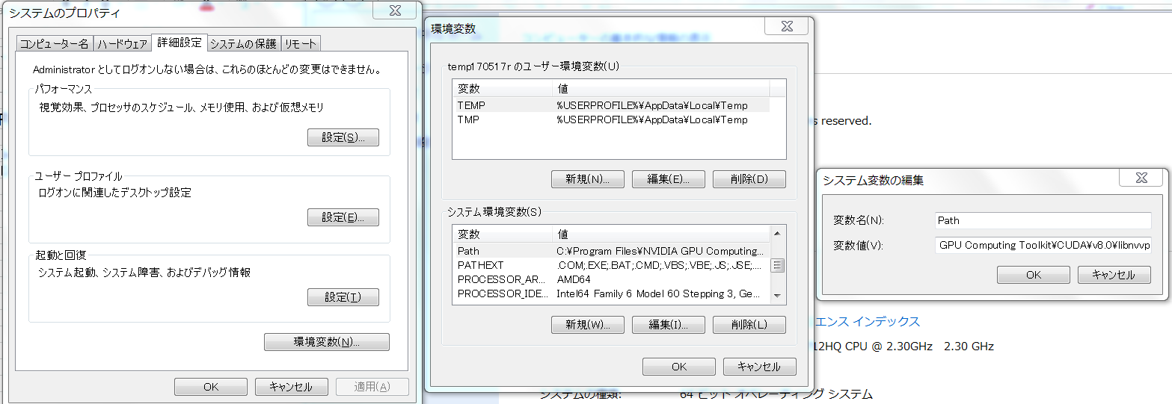

Environmental Variable Setting

*\* Note: The above steps are not required for CPU version.*

* Determine how to install tensorflow
* Step 1: Open Anaconda prompt.
* In anaconda command prompt:
* Step 2 : Install python 3.5.0 using following command line:
  + - *conda create -n env_name anaconda python=3.5.0*
      * For e.g. env_name = tensorflow(any name)
* Step 3: Activate the conda environment by issuing the following command
  + - *activate tensorflow*
* Step 4: To install the GPU version of TensorFlow, enter the following command (on a single line):
  + - *pip install --ignore-installed --upgrade* [*https://storage.googleapis.com/tensorflow/windows/gpu/tensorflow_gpu-1.1.0-cp35-cp35m-win_amd64.whl*](https://storage.googleapis.com/tensorflow/windows/gpu/tensorflow_gpu-1.1.0-cp35-cp35m-win_amd64.whl)
  + To install the CPU-only version of TensorFlow, enter the following command：
    - *pip install --ignore-installed --upgrade https://storage.googleapis.com/tensorflow/windows/cpu/tensorflow-1.1.0-cp35-cp35m-win_amd64.whl*

After completion of above steps1-4 check your installation

* Validate your tensorflow
* Step 1: Start your terminal, anaconda prompt command window
* Step 2: Activate tensorflow with command:
  + - * *activate tensorflow*
* Step 3: Write python then enter
* Step 4: Enter the following short program inside the python interactive shell:
  + - >>> import tensorflow as tf  
      >>> hello = tf.constant('Hello, TensorFlow!')  
      >>> sess = tf.Session()  
      >>> print(sess.run(hello))
  + If the system outputs the following, then you are ready to begin writing TensorFlow programs:
* *Hello, TensorFlow!*

Visualization of

MNIST DATA

In

Tensor Board

* Step 1: Create a folder in your computer drive and put the mnist.py file in the folder).
* Step 2: Open the mnist.py in notepad or sypder then give the path of your 　　　Step 1 folder in LOGDIR as below and save it:
  + - * + *LOGDIR = 'D:\\TensorFlow\\MnistVisualization2\\'*

Change this PATH

Code Path : \\172.24.207.160\モデル開発統括部門\システム開発U\02_CADデータ\TensorFlow_MnistCode

*\* Note: I have already edited some line of code, so no need to change the code except LOGDIR*

* Step 3: Run anaconda prompt then activate tensorflow.
* Step 4: After activation run the mnist.py file from anaconda prompt

*python mnist.py*

* Step 5: After completion, we will see lots of data file in the folder where you have put your mnist.py file.
* Step 6: Launch tensor board in command prompt

*tensorboard --logdir=path/to/log-directory*

PATH of your folder of mnist.py

* For e.g. tensorboard --logdir = D:\TensorFlow\MnistVisualization
* Step 7: Run tensorboard in browser

*localhost:6006*

* Step 8: In the Projector Tab, we will see the visualization of MNIST Data.

*Successfully Completed!! ☺*