***Collaborative Notes to Team (Internal)***

***Goal of Website:***

1. *Get electrical contractors and microgrid developers interested in selling systems with our tech.*
2. *Get investors excited enough to reach out to us to learn about investing in us.*
3. *Get end-users (e.g. Sonoma farms, hospitals, college campuses) to reach out to us to pilot our tech.*

***Proposed Sections***

1. *Home*
2. *About Us*
3. *Press Recognition*
4. *Team*
5. *Products*
6. *Clients & Customers*
7. *Blog*
8. *Careers*
9. *Contact Us*

*Note: in the future, we can feature 1) advisory board.*

***Some General Guidelines***

* *Include as many pretty non-copyrighted pictures (that convey next generation big data / electric utility / renewables)*
* *Don’t provide too many details about what our technology is*
* *Consider modeling our webpage after things like this: Bolt (*[*here*](https://boltthreads.com)*) or Motiv (*[*here*](http://mymotiv.com/#home2)*).*

**Home**

Intelligent Power Made Easy

1. For Microgrid Developers:
2. For Microgrid Integrators

For Technology Providers

**About Us**

Heila Technologies an MIT startup with the mission of enabling simple and intelligent power. Our flagship product, Heila IQ, is a decentralized control platform that allows for plug&play deployment and remote optimized operation of microgrids.

**Awards and Press Recognition**

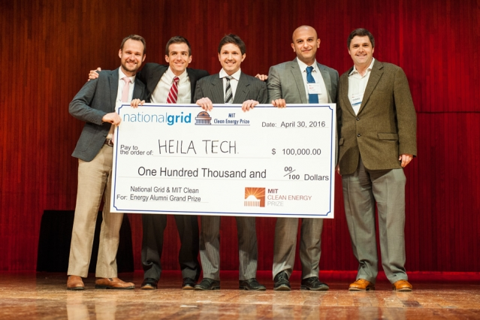



<http://energy.gov/articles/cleantech-university-prize-highlights-next-generation-clean-energy-innovators>

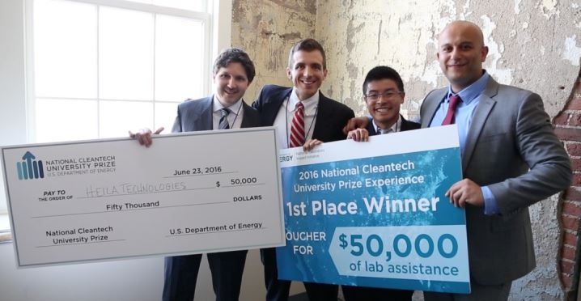





<http://news.mit.edu/2016/brain-microgrids-wins-clean-energy-prize-0502>



<http://blogs.scientificamerican.com/plugged-in/m-i-t-prize-winners-help-microgrids-speak-a-common-language/>

Team

Products

**Customers & Partners**

Blog

Careers

Contact Us