**RECOMMENDING A GOOD SMALL-SCALE BUSINESS START UP IN BANGALORE**

**1.BUSINESS PROBLEM**

Goal of many people is to earn money. Money can be earnt in many ways. This project deals with one way of earning money. My goal in this project is to find out the right way to head start towards a small-scale business in Bangalore. Bangalore is not a small town or area. Having known that Bangalore is big city, I need to know which kind of business is very potential, attractive, fast growing and loved by many people. For this I need to use the Foursquare Location data to know which kind of shops or other venues are very famous so that once after knowing that this certain venue is most loved by people, I could suggest to start a small-scale business related to that venue. For example, if restaurant is most loved by people, then I would suggest you to start your business in the path of restaurant not relatively starting up a restaurant. This is just an example. So, like this in a particular area, this project could suggest with some basic idea of what to start based on the interest of people**.**

**2. DATA ACQUISTION AND CLEANING**

As I have chosen to work with Bangalore City, I need many location data related to Bangalore. I have collected as many neighborhood areas as possible in Bangalore City, their geographical locations like the latitude and longitude values etc. These neighborhood names, their latitude and longitude values could help me to proceed with my project. I have collected this information from various sites, cleaned and brought into a format which is easy to work with. A sample data set is shown below

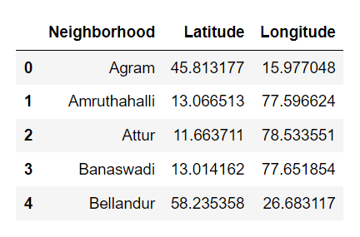

**3. Methodology**

**3.1 Geo-coordinates of Bangalore**

Initially I have collected the co-ordinates of Bangalore city in general and mapped the neighborhoods with some Circle Marker. These Circle Marker displays the each and every neighborhood with it’s corresponding latitude and longitude values.

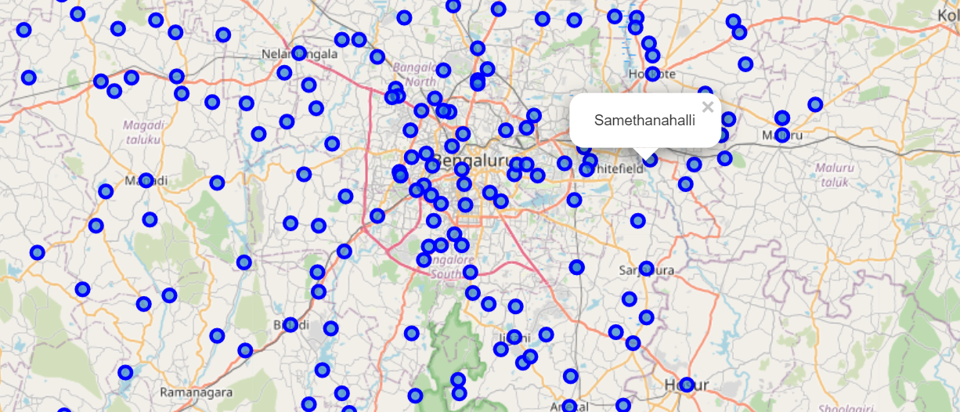

**3.2 Explore one neighborhood from the dataset**

From the dataset I have taken the first neighborhood and I wanted to know the famous venues/sites surrounding the venue. For this I have used the Foursquare Location data. This technique resulted me giving all the specific, loved, famous venues surrounding that particular neighborhood with a certain radius specified by me. But still I haven’t listed the venues orderly in terms of familiarity and most used.

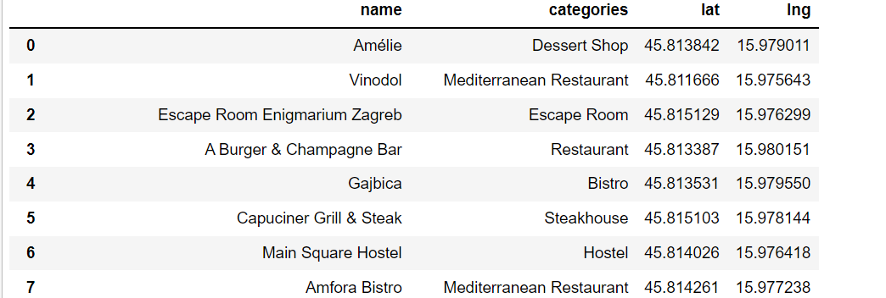

The above data is like for only one neighborhood in a big city Bangalore. The categories field will really help me to guide customers the area in which they could start.

**3.3 Exploring all the neighborhoods from the dataset**

Now that I have listed the venues for only one neighborhood. There are many areas in Bangalore where people can start the business. But having the insights for all the neighborhoods would be a wise thing, so that anybody who wish to start a business in a particular area of Bangalore, these venue details could help them greatly. So, for each neighborhood based on the familiarity of the neighborhood, corresponding venues and its categories are listed along with their latitude and longitude values.

**3.4 Performing One Hot Encoding over Venue Category**

Now, I have performed One Hot Encoding over the venue category so the categorical names are transferred to 0’s and 1’s. It is then normalized by taking the mean of each neighborhood value. This is helpful for determining the frequency of category that is mostly in use in the particular area. With this frequency you can also find the top-most categories in a particular venue.

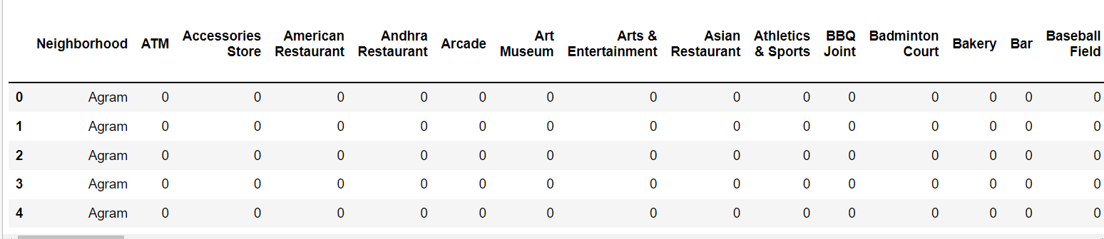

**4. Results**

After performing the One Hot Encoding Analysis, I have listed the top 10 Categories in each venue. So, if someone would like to start a small-scale business in a particular area in Bangalore and he has not idea about what people in that area are most fond off. This Result could help them to start their business. Having known the area, I have the results for top most venue categories in that area. So, based on the ability of the person he could choose any one category among the top most categories listed and start business related to that venue.

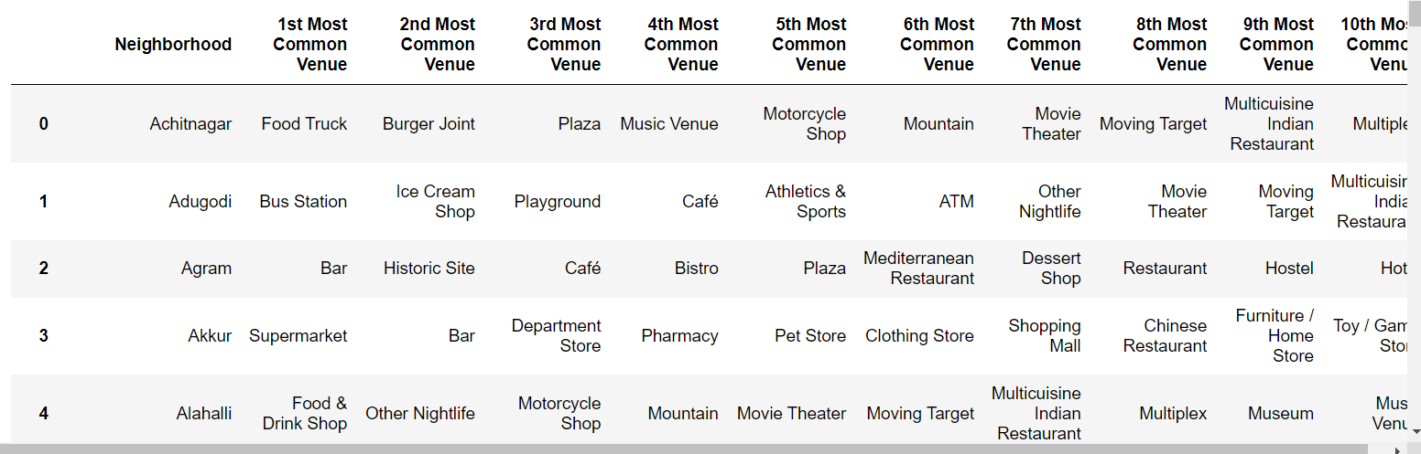

So, if the person would like to start his business in “Akkur” locality, I would suggest him to head start a “Super Market” business or relative to that.

**5. Discussion**

Going one step ahead, I have used clustering algorithm to find out similar neighborhoods across Bangalore. This data could help people to know that similar kind of neighborhoods are located in these areas. So, instead of travelling all the way to one particular area, they could do the same business in multiple area knowing where similar neighborhoods are located. This helps to improve their business.

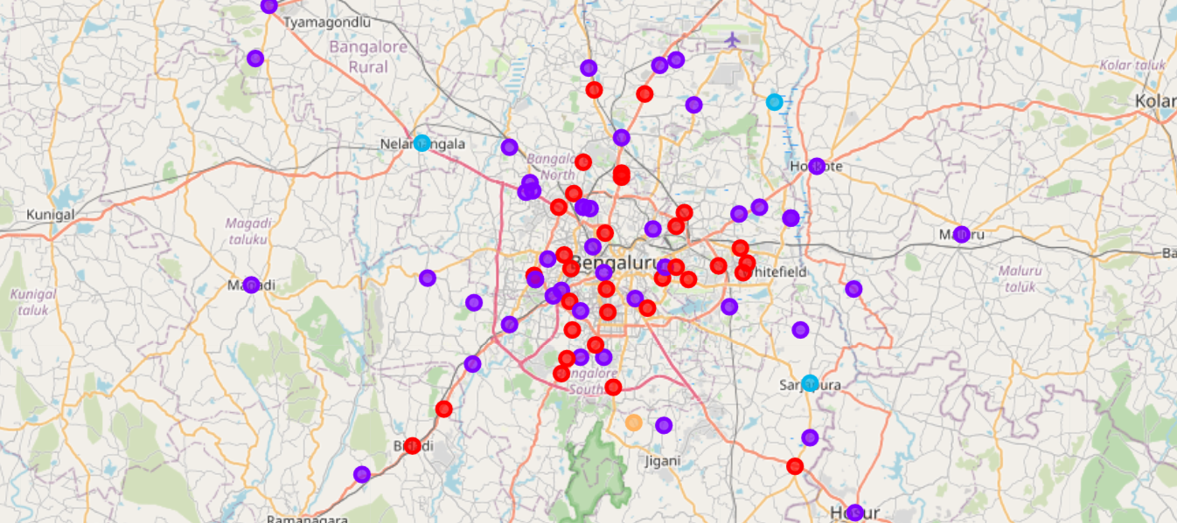

The similar neighborhoods are grouped into clusters. From this visualization, one can easily identify similar neighborhoods and start doing business in multiple areas.

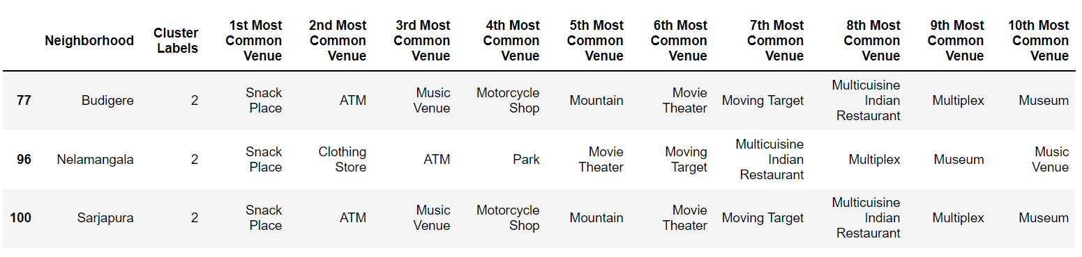

If you are starting a Snacks shop in Budigere, you can also start the same kind of shop in other localities also as shown above. This is how the clustering algorithm plays a great role in this project for enhancing the business

**6. Conclusion**

This project deals with great way for starting a small-scale business in Bangalore. The top common venues, top categories in those venues, the cluster data etc. could help anybody to choose the right path to start up their business not only in one particular area but also in multiple areas. The clustering algorithm used would really be helpful in enhancing the business.