**STOCK PRICE PREDICTION USING SUPERVISED MACHINE MODELS**

Table of Contents

1. Project Title 3

Team Members 3

2. Goals and Objectives: 3

• Motivation 3

• Significance 3

• Objectives 4

• Features 4

3. Related Work (Background) 4

4. Dataset 4

5. Detail design of Features 5

6. Analysis 6

7. Implementation 6

8. Preliminary Results 6

9. Project Management 6

10. Implementation status reports 7

11. Work completed: 7

12. Description 7

13. Responsibility (Task, Person) 7

14. Contributions (members/percentage) 8

15. Work to be completed 8

16. Description 8

17. Responsibility (Task, Person) 8

18. Issues/Concerns 9

References 10

# 1. Project Title

Stock Price Prediction Using Supervised Machine Models.

# 2. Goals and Objectives:

Predicting the ongoing “stock market value” is the most extensive challenge nowadays. It made many different fields such as business, economics, and computational fields gather and work together in this matter. The main goal of this particular document is to create a specific portfolio to forecast further changes in the current stock market price using machine learning methods.

## • Motivation

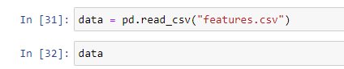

**Figure 1: Dataset loading**

(Source: Achieved from Jupyter notebook)

The valuation of the current stock market pricing is very changeable and fragile for making any predictions as it contains complicated types of different metrics. As per the view of Ahmed *et al.* (2019), the continuously developing technology makes essential techniques for making better forecasting methods for predicting stock market valuations. In this regard, “Machine learning” models are one the most versatile technologies for finding the essential indicators for making initial forecasts about the stock market.

## • Significance

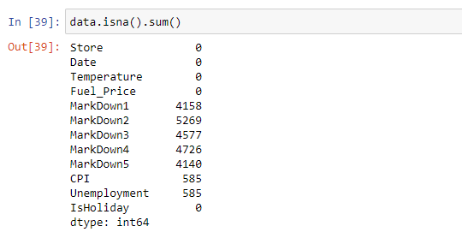

**Figure 2: Data pre processing**

(Source: Achieved from Jupyter notebook)

In this study, the stock market prediction method has been analyzed with the help of machine learning models. As per the view of Nikou *et al.* (2019), machine models help to make initial accuracy for predicting the current stock market pricing. As a result, stock market prediction helps various business professionals to use their “assets” more usually and also reduces the mistakes of the trades in a more effective way.

## • Objectives

The main objective of predicting stock market prices is to reduce the initial risks of investments by traders or any financial investor. By closely analyzing the jumbled dataset of the past, an improved forecast of the stock market using the machine learning method can be produced.

## • Features

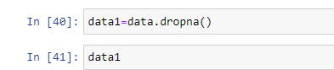

**Figure 3: Remove null values**

(Source: Achieved from Jupyter notebook)

The initial features of this implementation documentation are:

Analyzing different machine learning models

Helps financial professionals to raise capital

Finds indications for the state's economical situation

Helps investors with more growing potentiality

Cleaning and analyzing jumbled data

Current Twitter statements and analyzation

Normalization of data

# 3. Related Work (Background)

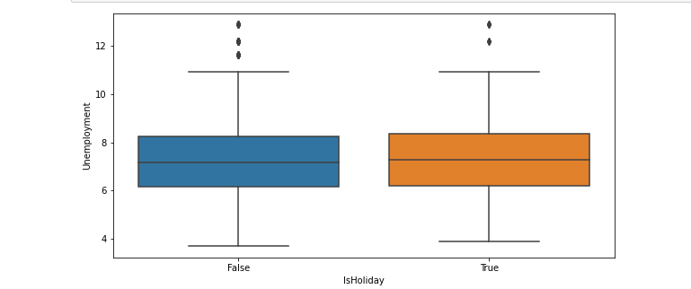

**Figure 4: Boxplot**

(Source: Achieved from Jupyter notebook)

Predicting the current stock market pricing is not an easy task to pursue. In this regard, different types of models have already been implemented previously for making a better forecasting method. As per the view of Nabipour*et al.* (2020), previously a model was built by Kim and Han combining the “Artificial Neural Networks” and the “Genetic Algorithms” making further discretization programs for making initial predictions of a stock price index.

# 4. Dataset

In this documentation, the prediction of the sales market of “Walmart Retail Company” has been implemented through machine models. Walmart is an American “multinational retail company”.

The initial dataset of Walmart has been attached below:

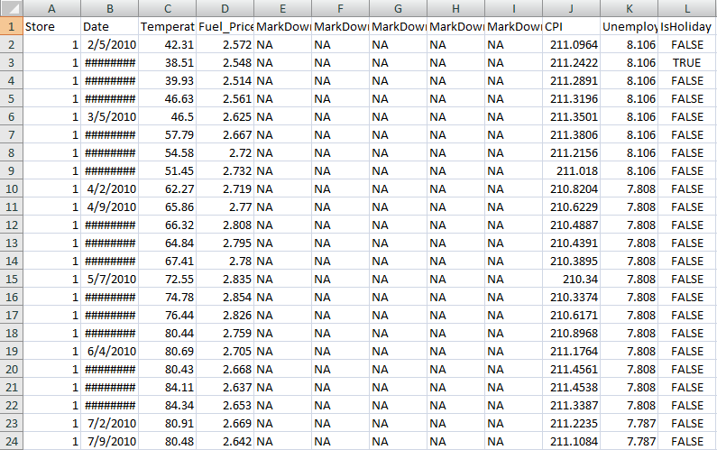

**Figure 5: Stock Sales Dataset**

(Source: Acquired from Kaggle)

In this above figure, the initial dataset of its marketing sales price from 2010 to 2013 has been gathered for predicting further forecasts about the stock market price of the retail company. The dataset has been collected from: https://www.kaggle.com/datasets/aslanahmedov/walmart-sales-forecast.

# 5. Detail design of Features

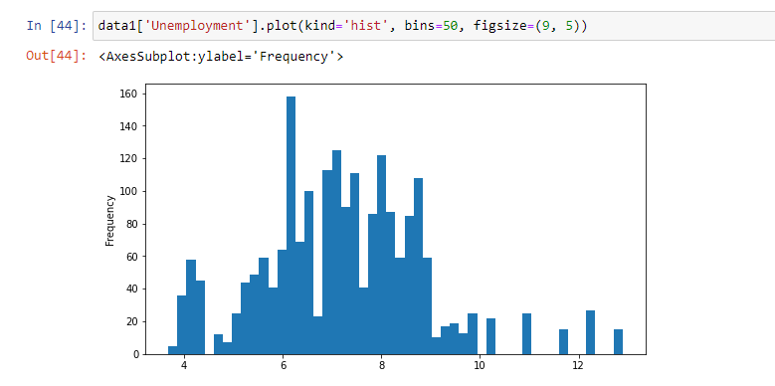

**Figure 6: Data visualization**

(Source: Achieved from Jupyter notebook)

The overall features of the machine learning model have been designed in such a way that a more vivid portfolio of the different stock prices of a variety of stocks has been built. The features of Walmart Retail Company have been customized by tagging the fuel price and markdown records in different categories individually. All the details of individual store value and their size have been featured in the model as well.

# 6. Analysis

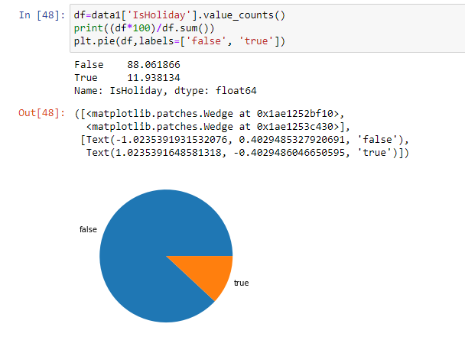

**Figure 7: Sentiment analysis**

(Source: Achieved from Jupyter notebook)

In this documentation, the initial dataset of “Walmart Retail Company” has been selected for further implementation for forecasting the stock market price of the company using machine learning. In this regard, an ongoing implementation project has taken place.

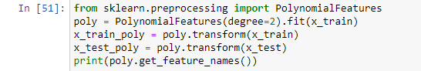

**Figure 8: Feature extraction**

(Source: Achieved from Jupyter notebook)

Many initiatives have been chosen such as: reducing the problematic formula of the dataset, past data gathering of the company, data exploration and discovering jumbled datasets, structuring further datasets, and data cleansing.

# 7. Implementation

A list of implementations has already been done using the machine model system in this whole project of predicting the stock market price of Walmart Retail Company. In the first step, the initial sales per week have been categorized in order to overcome the stocking price issues.

# 8. Preliminary Results

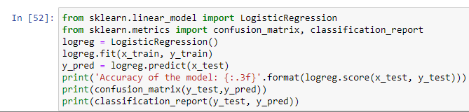

**Figure 9: Logistic regression model**

(Source: Achieved from Jupyter notebook)

In the primary results, all the initial outcomes have been shown with the help of machine learning models. By this model, the initial sales per week have been found for further implementation .In this section, the significant rise in sales has been predicted initially using the past details of different sales stores of the retail company. A primary model of structuring the sales of the company has been gathered as the outcome.

# 9. Project Management

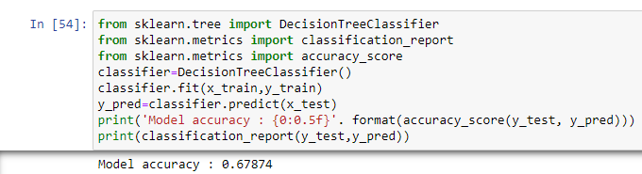

**Figure 10: Decision tree model**

(Source: Achieved from Jupyter notebook)

This project aims to build a specific model with the help of a machine learning process to gather essential data of Walmart Retail Company” for making future plans for its sales management. As per the view of Kalamara*et al.* (2022), the project, an initial calculation of the ongoing revenue of the company has been issued that will help the retailer make decisions about investing further.

# 10. Implementation status reports

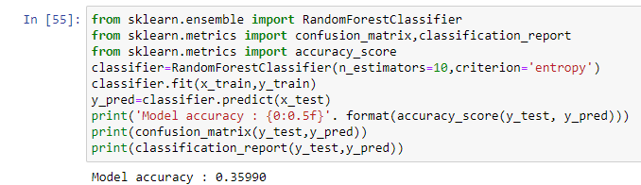

**Figure 11: Random Forest model**

(Source: Achieved from Jupyter notebook)

The initial implementation of the completed works has been reported to the owners of Walmart Retail Company. The organization has taken the essential initiative for going through the initial implementation plans of the project.

# 11. Work completed:

A list of works of this project has already been completed using the machine learning models for the betterment of forecasting the sales prediction of the Walmart Sales department.

# 12. Description

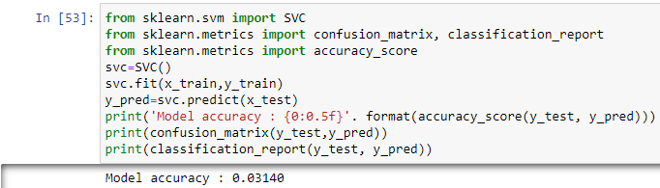

**Figure 12: SVM classification model**

(Source: Achieved from Jupyter notebook)

The dataset of Walmart Retail Company has been gathered from Kaggle. The detailed information from the year 2010 to 2013 of the sales department of various different stores of the company has been categorized in the dataset. In the later section, the preprocessing of the dataset, checking null values, and the process of erasing the null values was done accordingly.

# 14. Contributions

I am the only member of this project I was aware of all the issues that might have to face accordingly with the progression of the project.

# 15. Work to be completed

There are also some works that are in progress and will be completed within the given time to complete the project.

# 16. Description

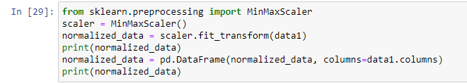

**Figure 13: Data normalization**

The data visualization part is indeed a very significant part to visualize the current sales record of the company. Based on the visualization, further improvements in predicting the upcoming plans will be easy to establish. The visualization part of this project will be described thoroughly via different types of diagrams such as data statistics, data splitting, train tests, model implementations, etc.

# 17. Responsibility (Task, Person)

The progressive responsibilities of the tasks have been done by myself

# 18. Issues/Concerns

The general concern that can arise while modeling the whole project is the sudden crash of the machine learning model (Jiang, 2021). The insufficient parameters of the model can also be a reason for concern. The issues can be found with the help of discussing the dataset from python.

# References

Ahmed, U., Mumtaz, R., Anwar, H., Shah, A.A., Irfan, R. and García-Nieto, J., 2019. Efficient water quality prediction using supervised machine learning. *Water*, *11*(11), p.2210.

<https://www.mdpi.com/559376>

Nikou, M., Mansourfar, G. and Bagherzadeh, J., 2019. Stock price prediction using DEEP learning algorithm and its comparison with machine learning algorithms. *Intelligent Systems in Accounting, Finance and Management*, *26*(4), pp.164-174.

<https://onlinelibrary.wiley.com/doi/abs/10.1002/isaf.1459>

Nabipour, M., Nayyeri, P., Jabani, H., Shahab, S. and Mosavi, A., 2020. Predicting stock market trends using machine learning and deep learning algorithms via continuous and binary data; a comparative analysis. *IEEE Access*, *8*, pp.150199-150212.

<https://ieeexplore.ieee.org/abstract/document/9165760/>

Shah, D., Isah, H. and Zulkernine, F., 2019. Stock market analysis: A review and taxonomy of prediction techniques. *International Journal of Financial Studies*, *7*(2), p.26.

<https://www.mdpi.com/469480>

Kalamara, E., Turrell, A., Redl, C., Kapetanios, G. and Kapadia, S., 2022. Making text count: economic forecasting using newspaper text. *Journal of Applied Econometrics*, *37*(5), pp.896-919.

<https://onlinelibrary.wiley.com/doi/abs/10.1002/jae.2907>

Jiang, W., 2021. Applications of deep learning in stock market prediction: recent progress. *Expert Systems with Applications*, *184*, p.115537.

<https://www.sciencedirect.com/science/article/pii/S0957417421009441>