
Stock Prediction using supervised machine models



https://github.com/Prasaadreddy/-Stock-Price-Prediction-using-Supervised-Machine-Models

Table of Contents
Title | Page No.
- Introduction | 3
- Background (Related work) | 4
- Your Model | 5
3.1 Architecture Diagram | 5
3.2 Workflow Diagram | 6
- Dataset | 8
4.1 Detailed description of Dataset | 8
4.2 Detail design of Features with diagram | 9
- Analysis of data | 11
- Implementation | 14
- Results | 18
- Project Management | 19
8.1 Work Description | 19
8.1.1 Description | 19
8.1.2 Responsibility (Task, Person) | 19
8.1.3 Contributions (members/percentage) | 19
8.1.4 Issues/Concerns | 19
- References/Bibliography | 20

Table of Figures

Figure Name. | Page No.
- Architecture | 5
- Workflow Diagram | 6
- Description Diagram | 8
- Features | 9
- Histogram | 11
- Pairplots | 12
- Confusion Marix | 13

- Introduction

Predicting future sales based on historical sales data is of great significance for merchants. Accurate forecasts can help businesses adjust sales strategies and optimize investment plans in a timely manner. Sales forecast in many scenarios will be used, regardless of the enterprise size, the number of sales staff sales forecasting affects including planning, budgeting and other aspects of the work. Although sales forecasts are very important, making high-quality sales forecasts not an easy task. Relying only on experience to predict sales is very prone to deviation. However, with the advancement of algorithms, I can extract valuable information from big data to achieve more accurate sales forecasts.

- Background (Related work)

For regression problems such as predicting sales, regression models can generally be used. First, the model is used to fit the relationship in the historical data to obtain a model with a higher degree of fit, and then the data that needs to be predicted is input into the model to predict future sales data. There are many models for prediction, such as the traditional linear regression model, Support Vector Machine (SVM). Many GBDT-based implementations, including XGBoost, sklearn, also have good predictive capabilities.

In [1], The libsvm open-source library is introduced in detail, and SVM is introduced in detail on the functions and parameters of the SVM kernel. In [2], Support vector machine was formally proposed. The ideas presented in this article have brought tremendous changes and have brought a lot of inspiration to researchers. [3] [10] are important achievement in the early stage of machine learning. The decision tree proposed in the paper is simple, practical and easy to explain, and has good results for some specific data analysis. [4][5] is the theoretical elaboration of data analysis and statistics in machine learning. It puts forward statistical learning theory and principal component analysis respectively, which has made great contributions to the improvement of dimensionality reduction algorithms. In[6],The method of applying support vector machines in the pattern is elaborated. [7][8][9] Introduced very classic machine learning methods, among which the linear regression, logistic regression and random forest methods mentioned in paper have very good performance and interpretability, and their application scenarios are also very good.

- Your Model
    - Architecture Diagram

Fig1. Architecture

Data Aquistion :- This involves data collection, preparing and segregating the case scenarios based on certain features involved with the decision making cycle and forwarding the data to the processing unit for carrying out further categorization. This stage is sometimes called the data preprocessing stage.
Data Processing :-
The received data in the data acquisition layer is then sent forward to the data processing layer where it is subjected to advanced integration and processing and involves normalization of the data, data cleaning, transformation, and encoding.
Model Engineering :-
This layer of the architecture involves the selection of different algorithms that might adapt the system to address the problem for which the learning is being devised, These algorithms are being evolved or being inherited from a set of libraries. The algorithms are used to model the data accordingly, this makes the system ready for the execution step.
Excusion :-
This stage in machine learning is where the experimentation is done, testing is involved and tunings are performed. The general goal behind being to optimize the algorithm in order to extract the required machine outcome and maximize the system performance, The output of the step is a refined solution capable of providing the required data for the machine to make decisions.
Deployment :-
Like any other software output, ML outputs need to be operationalized or be forwarded for further exploratory processing. The output can be considered as a non-deterministic query which needs to be further deployed into the decision-making system.
    - Workflow Diagram

Dataset

Training Data
Training Model
Testing
Testing Data
Data Pre-processing

Deploy

Fig2. DataFlow Diagram

- Dataset :- dataset collected from Kaggle website
- Data prepocessing :- In this step we perfom EDA , Data cleaning , removing outlier.
Then we split data into Two part training and testing data.
- Training Data :-Training Data is used for training purpose and perfoming hyperparameter tunning.
- Testing Data :- Testing Data is used for testing purpose and evaluation.
- Train Model:- In this we can train a data using machin learning model are Logistic regreesion, Descision tree, Random Forest, Xgboost and out of them Xgboost get high accuracy i.e. 100%
- Testing :- In this we compaired all model and tested by using test dataset.
- Deploy :- Findout well perform model and finalize that.

- Dataset

    - Detailed description of Dataset

Datasets are collected from Kaggle website. It contains 8 different feature. Dataset it related to Walmart requiremet- Stored Sales Forecasting. the prediction of the sales market of “Walmart Retail Company” has been implemented through machine models. Walmart is an American “multinational retail company. In 7 are independent variable and 1 dependent variable i.e. IsHoliday . Independent features will predict IsHoliday i.e. True or False.

Fig3. Description Diagram

    - Detail design of Features with diagram
Fig4. Features

- Store - the store number
- Date - the week
- Temperature - average temperature in the region
- Fuel_Price - cost of fuel in the region
- MarkDown1-5 - anonymized data related to promotional markdowns that Walmart is running. MarkDown data is only available after Nov 2011, and is not available for all stores all the time. Any missing value is marked with an NA.
- CPI - the consumer price index
- Unemployment - the unemployment rate
- IsHoliday - whether the week is a special holiday week

- Analysis of data

Histograms :- It show data is distributed in well shape and no more outliers.
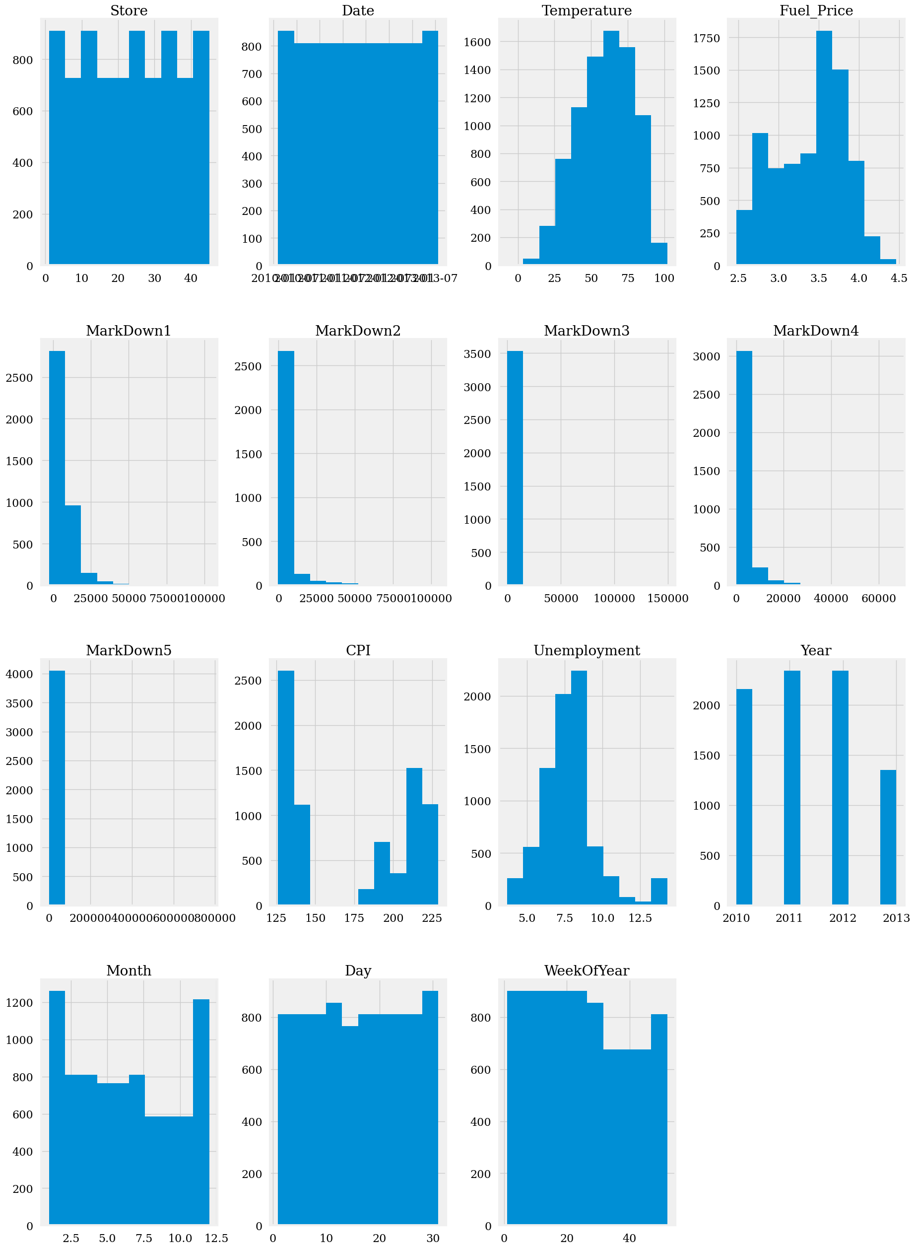
Fig5. Histogram

Pairplots :- It show correlation between all feature in datasets by ploting scatter plot.

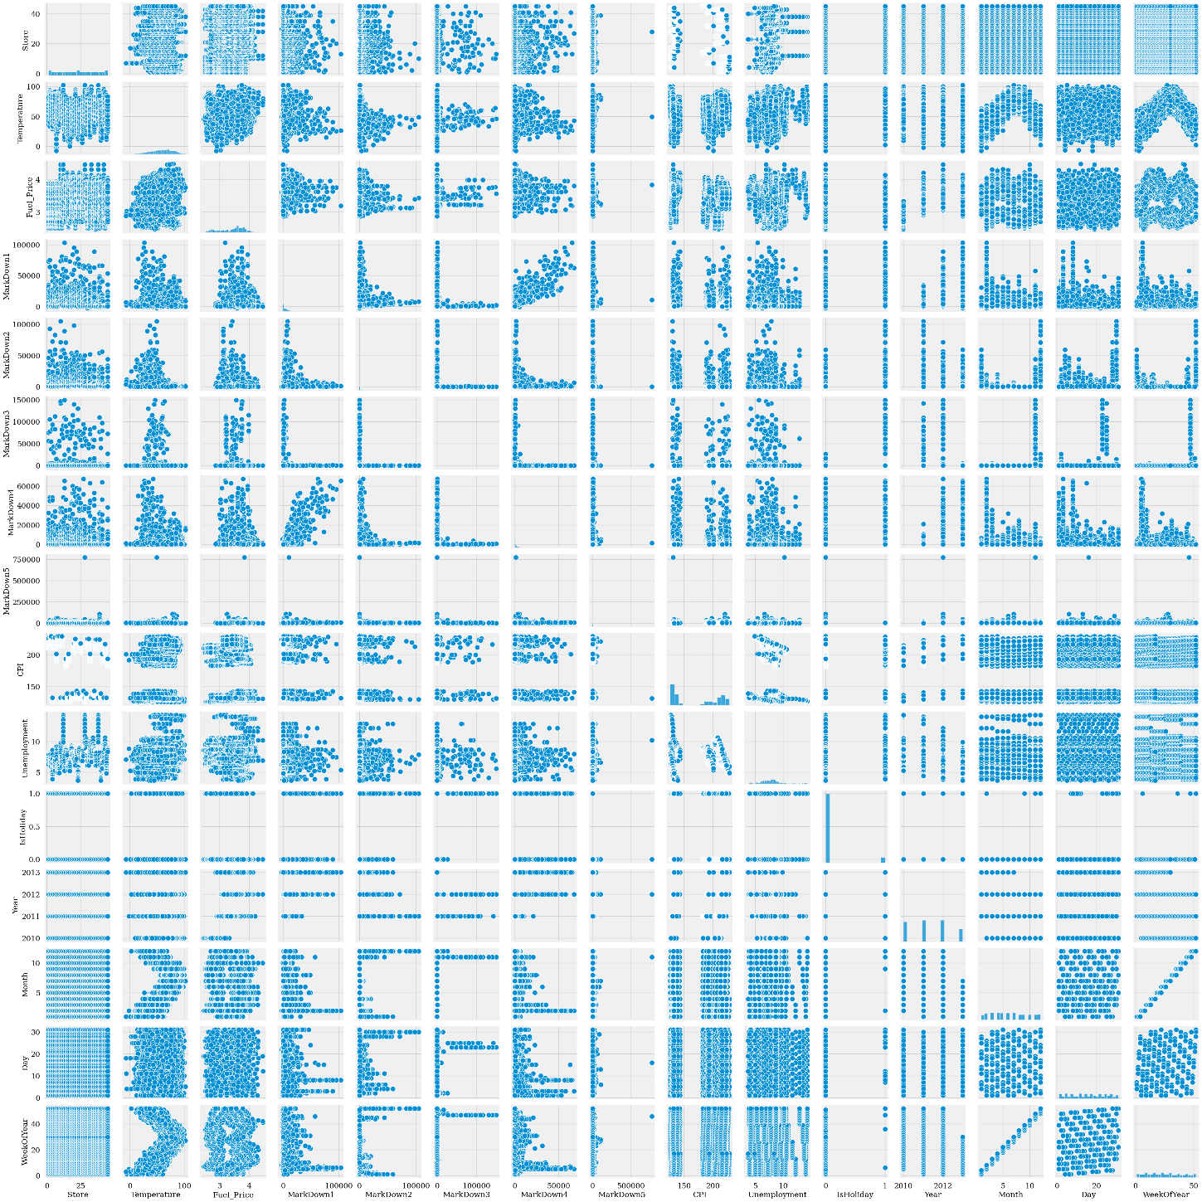

Fig6. Pairplots

Heatmap :-

Markdown1-5 have very weak correlation with the weekly sales, so we will leave these columns out

Temperature. Fuel price, CPI and Unemployment are very weakly coorelated with the weekly sales, so these columns will also be dropped out .

IsHoliday will be considered for the further analysis as the sales in the holiday weeks are higher than in the non-holiday week.

We will also leave out Month and Day as this information is already contained in the WeekOfYear

- Its shows correlation between the daatsets
- Strong Correlation :-
- Markdown 3 - Isholiday - 0.45
- year - Fuel_Price - 0.66
- Markdown1 - Markdown4 = 0.81

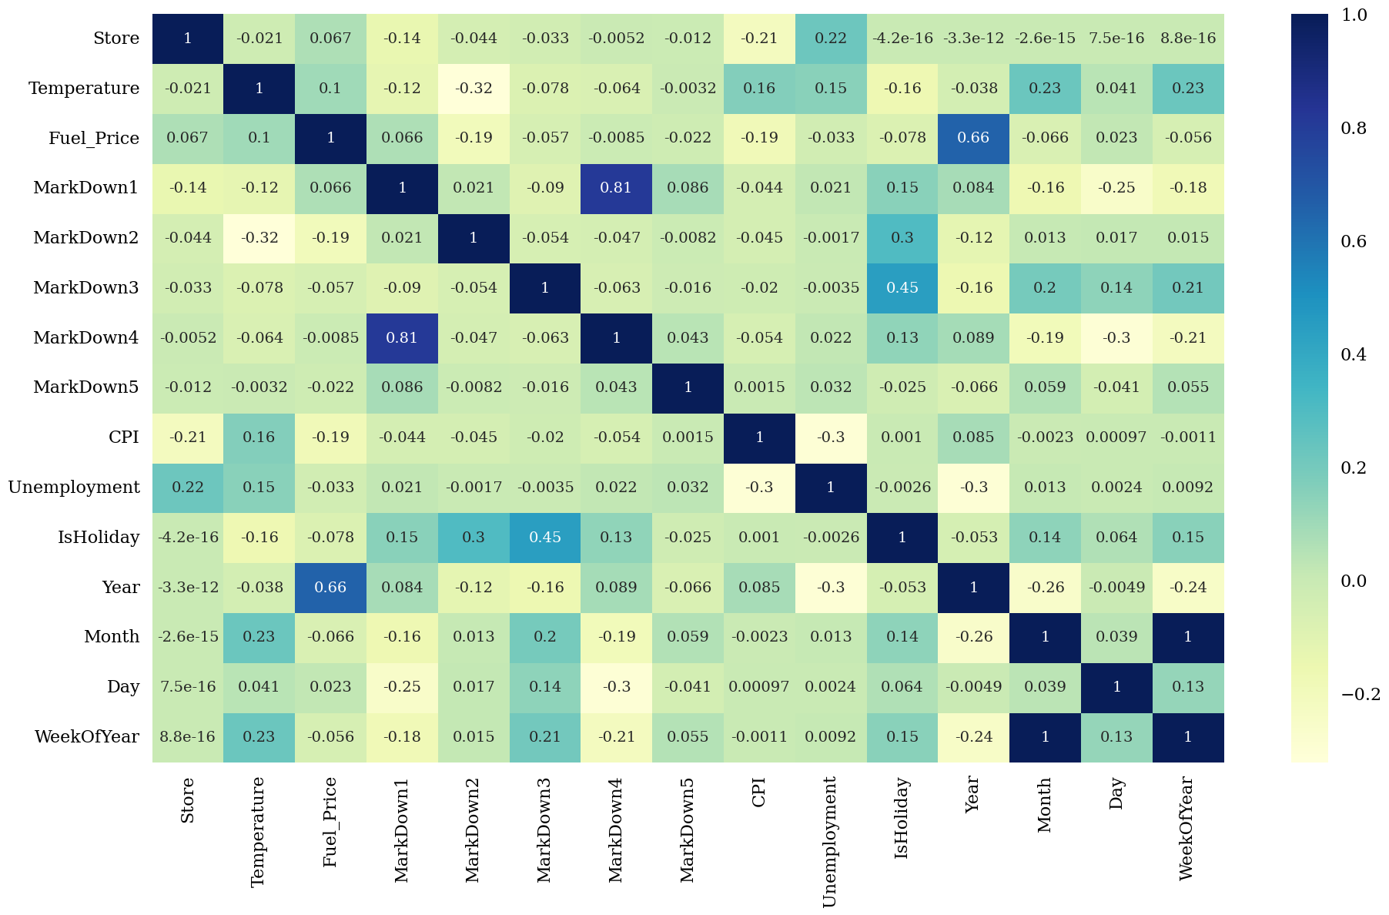

Fig7. Confusion Matrix

- Implementation

Importing Libraries:-

Data preprocessing :-
Exploratory Data Analysis :-

Fill Missing values :-

Data Encoding :-

Model Training :-
Random Forest and Xgboost classifier perform well ang get 100 % accuracy . and also Logistic Regression preform good and it well get 94% accuracy.

Final model:-

- Result

I propose a sales forecasting method based on the Xgboost or Random Forest model. I first preprocessed the initial data set, and then compared the effects of the three prediction models, and found that compared with traditional Logistic regreesion , Descision tree, Random Forest and Xgboost model has better prediction capabilities. Therefore, I finally choose the model with the highest accuracy to make predictions i.e Xgboost and it will get 100% accuracy.

- Project Management

  - Description :-

Firstly we collected dataset from Kaggle website and then draw architecture and workflow diagram of this project on the basis of that I implemented all task.

  - Responsibility (Task, Person):-

The progressive responsibilities of the tasks have been done by myself.

  - Contribution:-

Whole Implementation and documentation are created by me.

  - Issues/Concerns:-

The general concern that can arise while modeling the whole project is the sudden crash of the machine learning model (Jiang, 2021). The insufficient parameters of the model can also be a reason for concern. The issues can be found with the help of discussing the dataset from python.

- References/Bibliography

[1] C.-C. Chang and C.-J. Lin. LIBSVM: a Library for Support Vector Machines. ACM TIST, 2:27:1-27:27, 2011.
[2] Cortes, C. and Vapnik, V. Support vector networks. Machine Learning, 20, 273-297, 1995.
[3] J. Ross Quinlan. C4.5: Programs for Machine Learning. Morgan Kaufmann, San Francisco, CA, 1993.
[4] An overview of statistical learning theory. VN Vapnik - IEEE transactions on neural networks.
[5] Ian T. Jolliffe. Principal Component Analysis. Springer Verlag, New York, 1986.
[6] Burges JC. A tutorial on support vector machines for pattern recognition. Bell Laboratories, Lucent Technologies, 1997
[7] Breiman, Leo. Random Forests. Machine Learning 45 (1), 5-32, 2001.
[8] David W Hosmer, Stanley Lemeshow. Applied logistic regression. Technometrics. 2000.
[9] Breiman, L., Friedman, J. Olshen, R. and Stone C. Classification and Regression Trees, Wadsworth, 1984.
[10] J. Ross Quinlan. Induction of decision trees. Machine Learnin, 1(1): 81- 106, 1986.
[11] dataset link :- Walmart Recruiting - Store Sales Forecasting | Kaggle

