AI-Powered Intelligent BRD Generator
Automated Business Requirement Document & SOP Generation Using AI and NLP
System Analysis, Module Description & System Design
Name: [Student Name]
Roll No: [Roll Number]
Course: [Your Course / Programme]
Course Code: [Course Code]
Guide: [Guide Name]

1. Existing System
In most organizations, Business Requirement Documents (BRDs) are created manually by Business Analysts (BAs) through a series of client interactions, stakeholder meetings, and requirement-gathering sessions. The BA collects information through interviews, workshops, emails, and rough notes, and then consolidates this scattered information into a formal document using word processors such as Microsoft Word. This process is entirely dependent on the analyst's individual understanding, writing style, and domain expertise, which introduces a high degree of variability in the quality and structure of the final document.
The manual process typically follows a fixed sequence: conducting requirement-gathering meetings with stakeholders, taking handwritten or digital notes, interpreting and organizing these notes, drafting the BRD section by section (business objectives, functional requirements, non-functional requirements, assumptions, constraints, and risks), circulating the draft for review, and revising it multiple times based on stakeholder feedback. Each of these steps is performed manually, with little to no automated support, making the overall cycle time-consuming and prone to errors.
Because the process relies heavily on manual interpretation, requirements are often recorded ambiguously or incompletely. Analysts may unintentionally omit details, misinterpret a stakeholder's intent, or use inconsistent terminology across sections of the same document. In addition, since there is no standardized template enforced across teams, different analysts may structure BRDs differently, making it difficult for stakeholders and developers to compare or cross-reference documents across projects.
- Significant time is consumed in listening, note-taking, and manually drafting each section of the BRD.
- Documentation is inconsistent, as different analysts follow different formats, styles, and levels of detail.
- Requirements captured from discussions are often ambiguous, vague, or open to multiple interpretations.
- Manual transcription and drafting introduce human errors such as missing requirements or incorrect details.
- There is a lack of standardization, since no automated template or validation mechanism is enforced.
- The same manual effort of collecting, organizing, and formatting information is repeated for every new project.
- Cross-checking a BRD for completeness (objectives, stakeholders, functional and non-functional requirements, risks) is done manually and is easy to overlook.
- Version control and traceability of changing requirements are difficult to maintain in manually edited documents.

2. Proposed System
The proposed system is an AI-Powered Intelligent BRD Generator that automates the creation of Business Requirement Documents directly from raw business requirements, meeting notes, or uploaded documents. Instead of manually drafting a BRD, the user provides input in the form of typed text or an uploaded file (PDF, DOCX, or TXT), and the system uses Artificial Intelligence and Natural Language Processing (NLP) to understand, structure, and validate the content before generating a fully formatted BRD and an accompanying Standard Operating Procedure (SOP) document.
The system works by first extracting and cleaning the raw textual content, after which an AI/NLP-based Requirement Analyzer processes the text using a Large Language Model to identify key elements such as business objectives, stakeholders, functional requirements, non-functional requirements, business rules, assumptions, constraints, and risks. This information is organized into a structured JSON format. A validation layer then checks this structured data for completeness, flags missing or ambiguous requirements, and suggests clarification questions where necessary. Once validated, the finalized structured data is passed to document-generation modules that produce a standardized BRD and a corresponding SOP, both of which can be exported as DOCX or PDF files.
By automating the interpretation and structuring of requirements, the proposed system significantly reduces the manual workload of Business Analysts, enforces a consistent document structure across projects, and minimizes the risk of missing or ambiguous requirements through built-in validation. This results in faster turnaround time, higher documentation quality, and a standardized, reusable process for requirement documentation.

Advantages of the Proposed System
- Automates the end-to-end process of converting raw requirements into a structured BRD.
- Ensures consistent formatting and structure across all generated documents.
- Significantly reduces the manual effort and time required by Business Analysts.
- Validates extracted requirements and highlights missing or ambiguous information before finalization.
- Generates both a BRD and an SOP from the same validated requirement data.
- Supports multiple input formats, including plain text, PDF, and DOCX.
- Reduces human error through AI-assisted extraction and structuring of information.
- Produces exportable, ready-to-share documents in DOCX and PDF formats.

3. Module Description
The system is divided into six functional modules, each responsible for a distinct stage of the requirement-to-document pipeline. Together, these modules form a continuous workflow that begins with raw requirement input and ends with the generation of a finalized BRD and SOP.

Module 1 – Requirement Collection Module
Purpose: To capture raw business requirements from the user in a flexible manner, either as direct text input or as an uploaded file.
Input: Manually typed requirement text, or an uploaded PDF, DOCX, or TXT file containing meeting notes or requirement details.
Processing: Accepts and validates the input type, and for uploaded files, extracts the raw textual content using appropriate file-parsing libraries.
Output: Raw, unformatted requirement text ready for preprocessing.
Technologies Used: React.js (file upload interface), FastAPI (input handling endpoint), PyMuPDF (PDF text extraction), python-docx (DOCX text extraction).

Module 2 – Requirement Preprocessing Module
Purpose: To clean and standardize the extracted raw text so that it can be reliably processed by the AI Requirement Analyzer.
Input: Raw requirement text obtained from the Requirement Collection Module.
Processing: Removes unnecessary formatting, extra whitespace, special characters, and noise; performs basic text normalization such as sentence segmentation and tokenization to prepare clean, structured input text.
Output: Cleaned and organized requirement text ready for AI-based analysis.
Technologies Used: Python, NLP preprocessing libraries (for tokenization, cleaning, and normalization).

Module 3 – AI Requirement Analyzer Module
Purpose: To intelligently analyze the preprocessed requirement text and extract structured requirement information using NLP and a Large Language Model.
Input: Cleaned requirement text from the Requirement Preprocessing Module.
Processing: Applies NLP techniques and prompts a Large Language Model (LLM) to identify and extract Business Objectives, Stakeholders, Functional Requirements, Non-Functional Requirements, Business Rules, Assumptions, Constraints, and Risks from the text.
Output: A structured JSON object containing all identified requirement categories.
Technologies Used: Python, NLP libraries, Large Language Model API (Gemini / OpenAI / Hugging Face), FastAPI.

Module 4 – Requirement Validation Module
Purpose: To verify the completeness and clarity of the extracted requirement data before it is used for document generation.
Input: Structured JSON output produced by the AI Requirement Analyzer Module.
Processing: Checks each requirement category for missing or incomplete information, detects ambiguous statements, and automatically generates clarification questions for any gaps identified.
Output: A validated (and, where needed, flagged or annotated) JSON structure, along with a list of clarification questions if applicable.
Technologies Used: Python, rule-based validation logic, LLM-assisted ambiguity detection.

Module 5 – BRD Generation Module
Purpose: To convert the validated, structured requirement data into a formally formatted Business Requirement Document.
Input: Finalized and validated structured requirement JSON data.
Processing: Maps each JSON field to its corresponding section in a predefined BRD template (objectives, stakeholders, functional and non-functional requirements, business rules, assumptions, constraints, and risks) and applies consistent formatting.
Output: A complete, professionally formatted BRD, exportable as a DOCX or PDF file.
Technologies Used: Python, python-docx (DOCX generation), ReportLab (PDF generation), FastAPI.

Module 6 – SOP Generation Module
Purpose: To automatically generate a Standard Operating Procedure document describing the operational steps derived from the finalized business requirements.
Input: Finalized structured requirement data (the same validated JSON used for BRD generation).
Processing: Analyzes the functional requirements and business rules to derive a logical sequence of operational steps, and formats them into a clear, step-by-step SOP structure.
Output: A structured SOP document, exportable as a DOCX or PDF file.
Technologies Used: Python, python-docx / ReportLab, FastAPI.

4. Technology Stack
The following table summarizes the core technologies used in the development of the AI-Powered Intelligent BRD Generator, along with the purpose and justification for selecting each one.
Technology | Purpose | Reason for Selection
React.js | Frontend framework used to build the user interface for requirement input, review, and document download. | Component-based architecture enables a responsive, interactive UI with efficient state management for a multi-step workflow.
Tailwind CSS | Utility-first CSS framework used for styling the frontend interface. | Enables rapid, consistent, and maintainable UI styling without writing extensive custom CSS.
FastAPI | Backend framework used to build REST API endpoints for file upload, processing, and document generation. | High performance, native asynchronous support, and automatic API documentation make it well-suited for AI-integrated backends.
Python | Core programming language used across backend, NLP, and document-generation logic. | Extensive ecosystem of libraries for NLP, file processing, and document generation, with strong AI/LLM integration support.
NLP | Used for text preprocessing, tokenization, and assisting in requirement extraction. | Essential for cleaning and structuring unstructured requirement text before AI-based analysis.
Large Language Model (Gemini / OpenAI / Hugging Face) | Performs intelligent requirement analysis, extraction, and classification into structured categories. | Provides advanced language understanding needed to accurately interpret varied and unstructured business requirement text.
PyMuPDF | Extracts text content from uploaded PDF files. | Provides fast and reliable text extraction from PDF documents, including multi-page files.
python-docx | Extracts text from uploaded DOCX files and generates the final BRD/SOP DOCX output. | Native support for reading and creating Word documents with full formatting control.
JSON | Intermediate data format for storing structured requirement information. | Lightweight, structured, and easily exchanged between backend modules and the frontend.
MongoDB (optional) | Optionally stores requirement sessions, generated documents, and user history. | Flexible, schema-less document storage that naturally fits JSON-based requirement data.
ReportLab | Generates the BRD and SOP documents in PDF format. | Provides fine-grained control over PDF layout, making it suitable for professional document export.

5. System Workflow Design
The diagram below illustrates the end-to-end workflow of the AI-Powered Intelligent BRD Generator, from initial requirement input by the user to the final generation and export of the BRD and SOP documents.
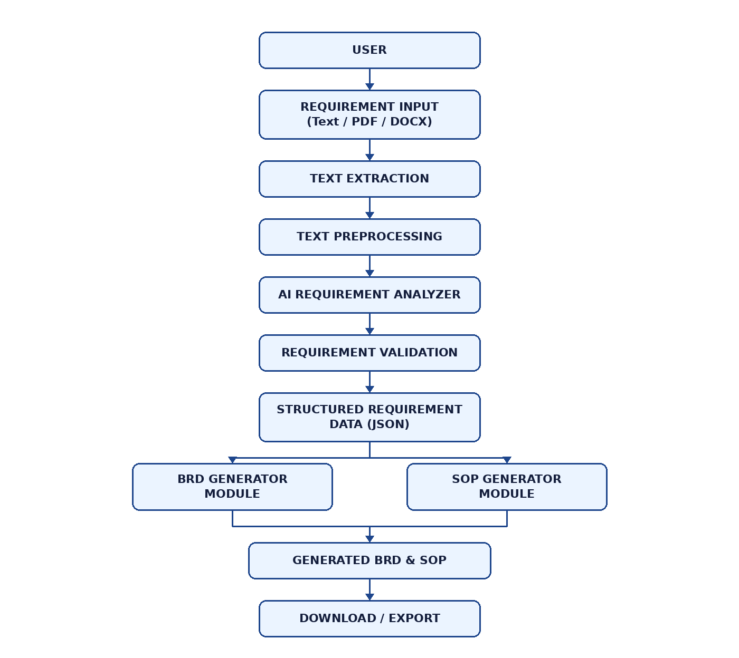

Explanation of Workflow Steps
- User: The Business Analyst or end user initiates the process by accessing the system.
- Requirement Input (Text / PDF / DOCX): The user submits business requirements either by typing text directly or uploading a PDF or DOCX file.
- Text Extraction: The system extracts raw textual content from the uploaded file, or accepts the typed text as-is.
- Text Preprocessing: The extracted text is cleaned, normalized, and formatted to remove noise before analysis.
- AI Requirement Analyzer: An NLP/LLM-based module analyzes the preprocessed text to identify business objectives, stakeholders, functional and non-functional requirements, business rules, assumptions, constraints, and risks.
- Requirement Validation: The extracted information is validated for completeness; missing or ambiguous requirements are flagged, and clarification questions are suggested where needed.
- Structured Requirement Data (JSON): Once validated, the finalized requirement information is stored in a structured JSON format that serves as the single source of truth for document generation.
- BRD Generator / SOP Generator: The structured data is passed in parallel to the BRD Generation Module and the SOP Generation Module, each of which formats the information into its respective document type.
- Generated BRD & SOP: The outputs of both generator modules are combined, producing a complete Business Requirement Document and Standard Operating Procedure.
- Download / Export: The final BRD and SOP documents are made available to the user for download in DOCX or PDF format.

