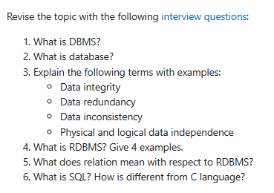

**1. What is DBMS?** A DBMS is software that manages and organizes data in a structured manner. It provides tools for creating, storing, retrieving, and updating data efficiently.

**2. What is database?** A database is a collection of interrelated data stored and organized in a structured way. It serves as a central repository for information, enabling efficient management and retrieval.

**3. Explain the following terms with examples:**

* **Data integrity:** Ensuring data accuracy and consistency. For example, preventing a customer's age from being entered as a negative number.
* **Data redundancy:** Storing the same data in multiple places. For example, having a customer's address in both the customer table and the order table.
* **Data inconsistency:** When data varies across different locations or systems. For example, a customer's phone number being listed differently in two separate databases.
* **Physical and logical data independence:** Physical data independence allows changes to the physical storage without affecting the application, while logical data independence allows changes to the data structure without affecting the application's view.

**4. What is RDBMS? Give 4 examples.** RDBMS (Relational Database Management System) is a type of DBMS that organizes data into tables, rows, and columns. Examples include MySQL, PostgreSQL, Oracle, and SQL Server.

**5. What does relation mean with respect to RDBMS?** In RDBMS, a relation refers to a table that represents a set of related entities. Each row in a relation represents a record or instance of the entity.

**6. What is SQL? How is it different from C language?** SQL (Structured Query Language) is a specialized language used to interact with databases. It is designed for querying, manipulating, and managing data within a relational database. Unlike C, which is a general-purpose programming language, SQL is specifically tailored for database operations.