travel

pedia

***Table of Contents***

***1. Introduction: 3***

***2. Home Page: 4***

***3. Login Or Signup Page: 5***

***4. Package Details Page: 6***

***5. Checkout Page: 7***

***6. Contact Us Page: 8***

1. **INTRODUCTION**:

Our website is an interactive travel package booking site that allows passengers to research packages and book travel with itinerary, where the passengers can add a list of activities of his choice available at each destination. Based on the subscription (standard, gold, premium) taken by the passenger, he has a cash balance which is used for registration of activities available at each destination.

The set of offers provided by us are listed below

* A premium passenger can sign up for all the activities at free of cost.
* A gold passenger can avail 10% discount on selected activities.
* A standard passenger gets no discount
  1. **INITIAL SETUP:**

To create the database on the system local storage to maintain various data objects we need to make a few changes to code.

1. Create a user on the user login page as mentioned in the sections below
2. Go to home.js in the parent folder
3. Go to line number 546
4. You can see that some code is commented from 546 - 553 (purposefully – do not delete). Remove the comment tags for the mentioned lines.
5. Add comments tag to the code lines 555 – 581, 586-592 and 598-606
6. Now run the program as explained in the sections below once (till booking and payment).
7. This will create required fields to maintain data on the localstorage.
8. Undo the steps ***D*** and ***E***
9. Now you can run the code smoothly

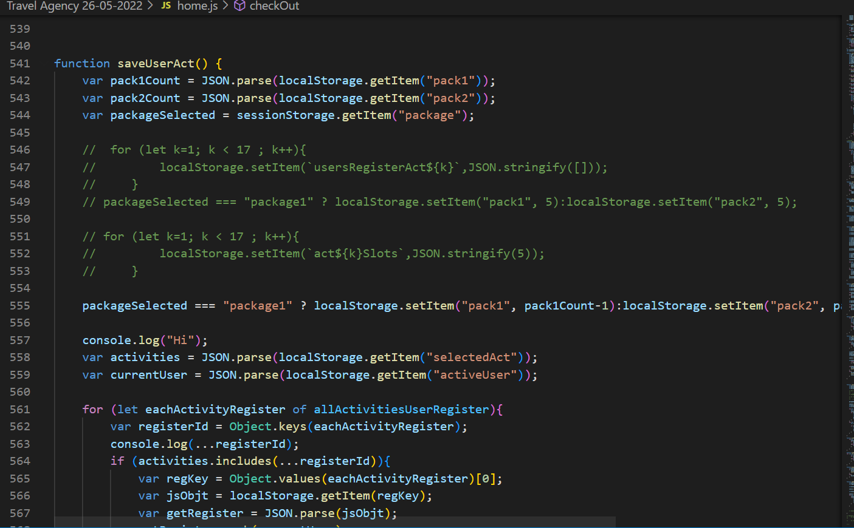

**Figure 1 Initial Code setup**

1. **HOME PAGE:**

Below is the home page of our website with Bootstrap navigation bar which can extend or collapse, depending on the screen size. Based on the screen size the menu would be either in Hamburger layout or extended layout. In the navigation bar we are providing the following options:

* **Login** which allows the passenger to logon or Register. Post successful login, the cash balance of the passenger is maintained throughout the website which would be updated based on the activities selected by the user at selected package itinerary.
* **Contact Us** section there is scope to add various mainstream social media addresses with which the passenger can communicate with the firm.
* **Logout** to get logged out of our website.

The home page also contains the list of available travel packages with capacity it can accommodate. Here the passenger can go through the package details and itinerary of any of the available packages by clicking on ***View Details*** Button.

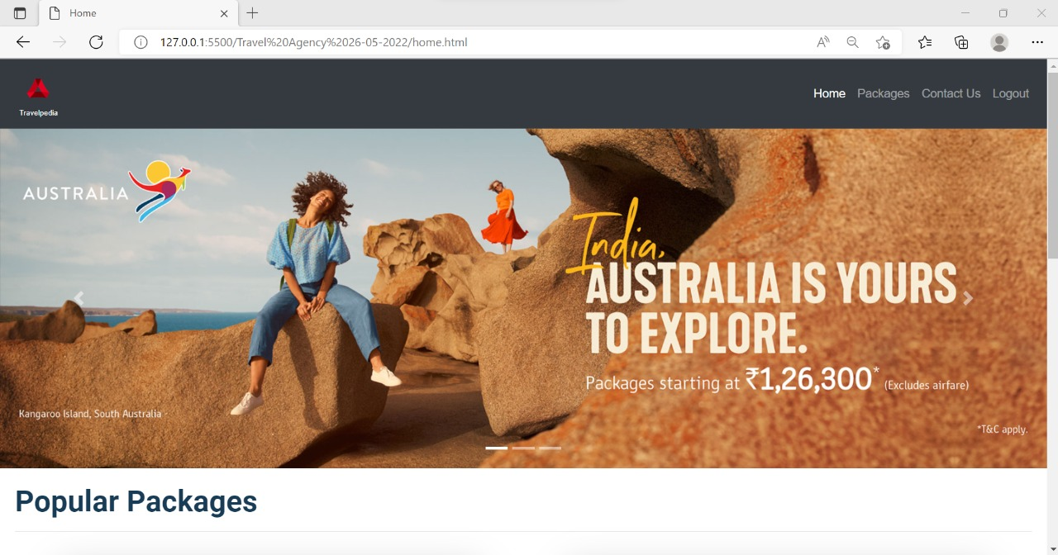

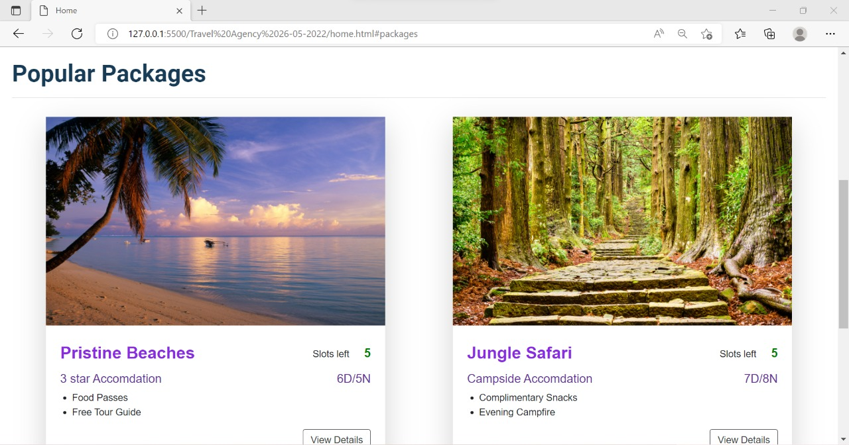

**Figure 1: Home page with nav bar and available packages**

1. **LOGIN OR SIGNUP PAGE:**

The website contains the login and register pages where the user can input his credentials to access various pages of website or he can register with necessary details as follows:

* A proper email id and user name.
* A password- must be of at least 6 characters which must contain a lowercase letter, an uppercase letter, a number or special character.
* The subscription type in order to avail the offers provided by the website.

After the completion of successful registration, the passenger would be able to logon to website and can logout on any page throughout the website.

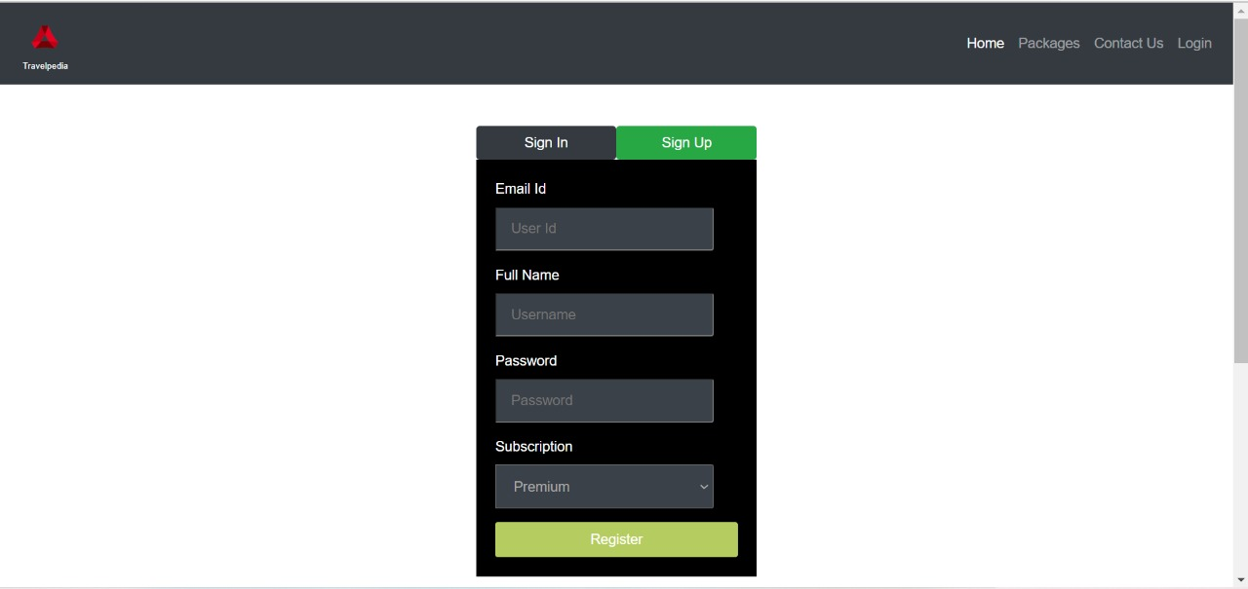

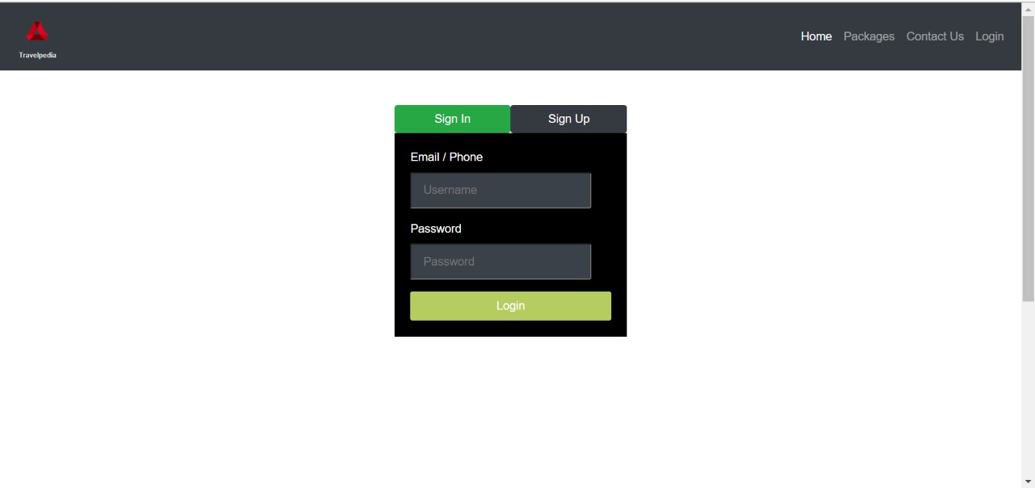

**Figure 2: Signup and Login**

1. **PACKAGE DETAILS PAGE:**

This page contains a navigation bar at top of the page which would allow the passenger to navigate across the website. Based on the selected package in home page it displays the list of destinations under that package dynamically. And upon clicking ***View Activities***button under each destination, the passenger would be able to see the list of activities available with capacity and fares applicable for it. He can register for either zero or more activities of his choice at each destination based on the available capacity using ***Add*** button and can remove the activity from his cart using ***Remove*** button. If the activity capacity has reached to maximum limit, then the ***Add*** button won’t be available for selection for passenger to add activities to cart.

After choosing the activities he can go for a checkout by clicking ***Proceed to Checkout*** buttonand if there is no current user login session then proceed to checkout button won’t be visible for further action**.**

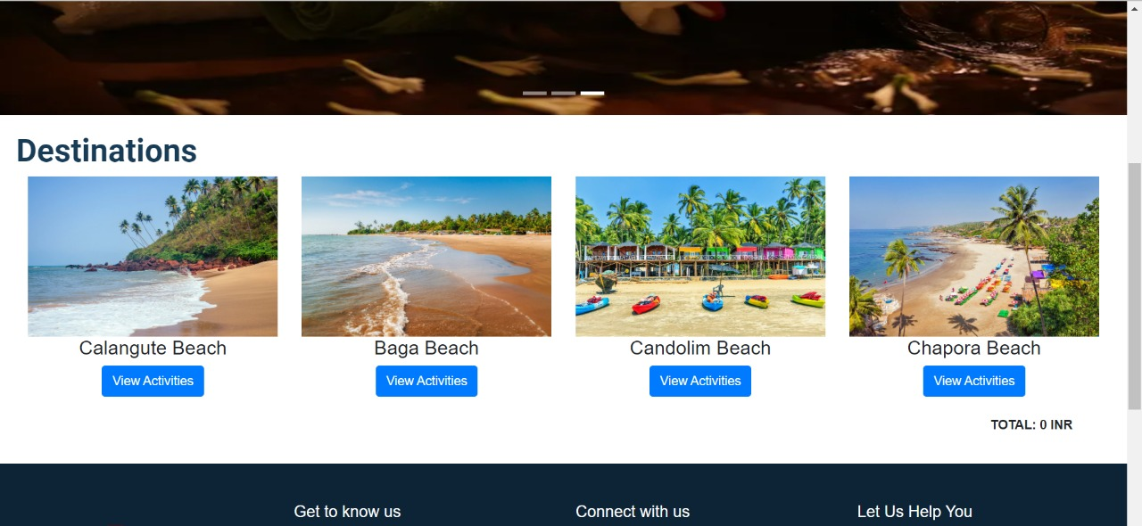

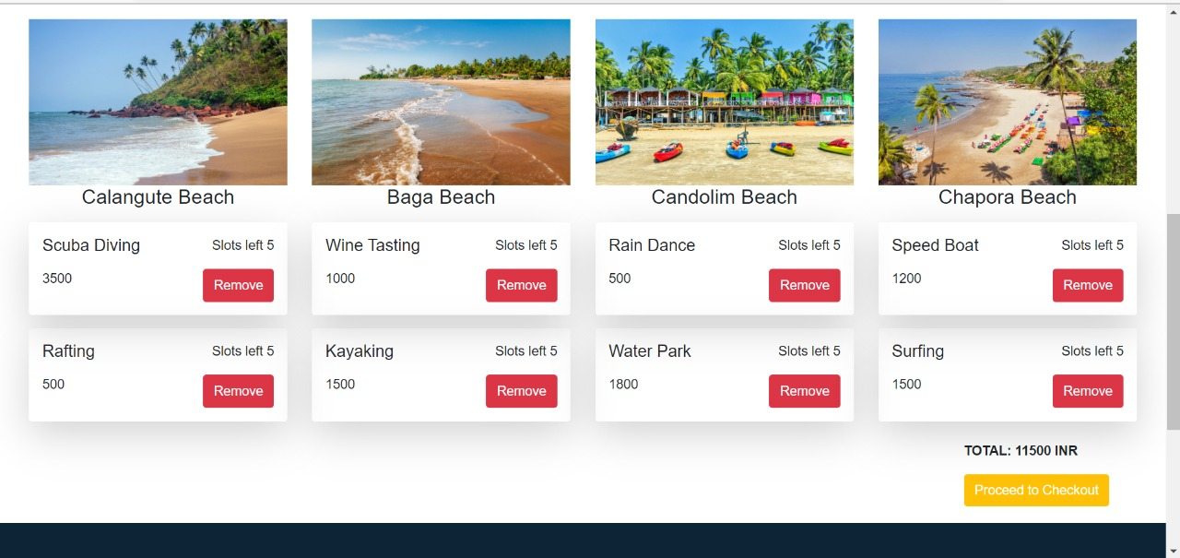

**Figure 3: Viewing activities under destinations and adding them to cart**

1. **CHECKOUT PAGE:**

This page contains a navigation bar at top of the page which would allow the passenger to navigate across the website. It contains the selected activities of the passenger and the final fares applicable based on the subscription taken by the passenger. The passenger can proceed to payment by clicking on ***Pay*** button. As we mentioned earlier, a premium passenger can sign up for all the activities at free of cost based on the activity’s capacity.

A gold passenger can proceed for payment if he has a sufficient balance and also can avail 10% discount on registered activities. The final fare after discount will be deducted from his cash balance.

A standard passenger can proceed for payment if he has a sufficient balance and his cash balance will be updated.

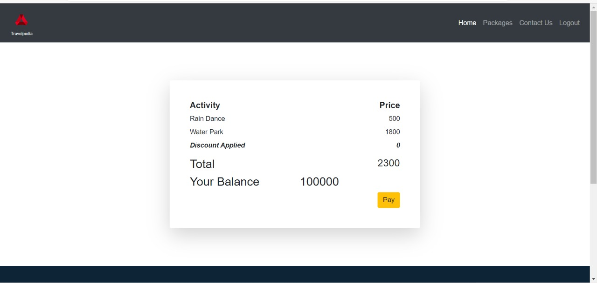

**Figure 5: Cart Payment with payment option**

1. **CONTACT US PAGE:**

This section is purely representational and doesn’t hold any functionality nor does it affect the website in anyway. But there is scope to add various mainstream social media addresses with which the passenger can communicate with the firm.

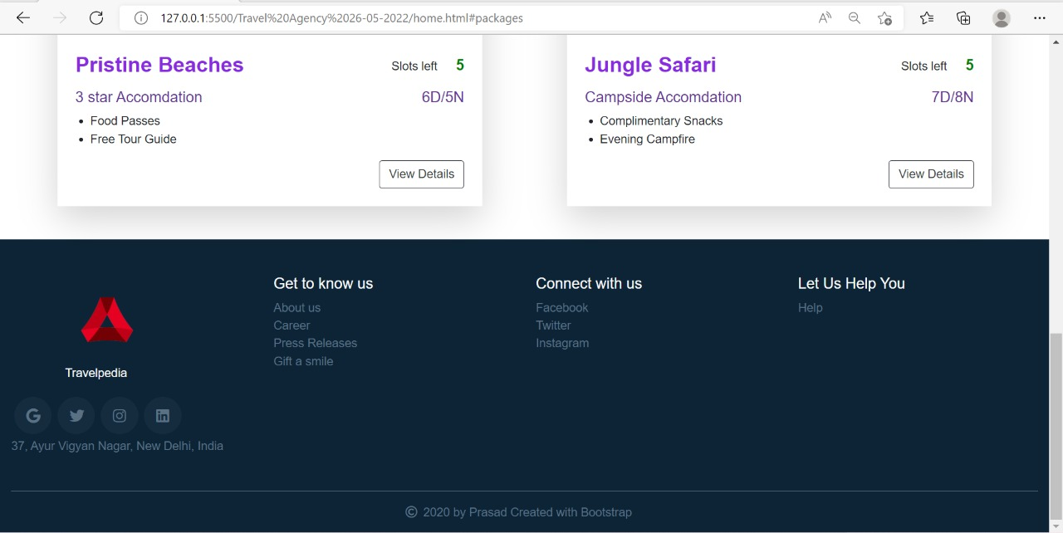

**Figure 6: Contact us section**

***End of the document***