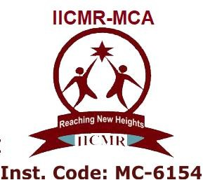

**ATSS**

**Institute of Industrial and Computer Management and Research**

**Academic Year 2023-2024 MCA IV**

**“ PROJECT SYNOPSIS”**

* **Title of the Project**:- **Dairy Dome**
* **Company / Client Name & Contact Details (if any**):- **Dudh Utpadak Sahkari Sanstha Maryadit Advihir [R.N :- 297]**

|  |  |
| --- | --- |
| **Name of Team Member** | Prasad Ravindra Patil |
| **Roll Number** | 32 |
| **Contact Number** | 9604126194 |
| **E-mail ID** | [**prasadpatil24212@gmail.com**](mailto:prasadpatil24212@gmail.com) |
| **Project Guide** | **Mrs. Swati Kirange** |
| **Division** | Technocrats |

1. **Existing System :**

* An existing system provides manual paperwork or an excel sheet to track the buying and selling product details.
* The customer has to go to the medical shop where the customer can get the required dairy products. Most of the time customer does not get required product which him/her looking the products at different locations. Which results in wasting a lot time in it.
* In the existing system, you cannot provide feedback of the service provided to the admin (shopkeeper) directly.

1. **Need of System:**

* The new system is totally Web based application. Nowadays, there is dairy shop management which benefits customers greatly.
* A new system provides features like time efficiency to show product details and whatever the customer will give the feedback to the admin(shopkeeper).
* This system provides various types of dairy products.
* The buying of product is done easily by customer

1. **Scope of System: -**

* The Dairy shop management to keep detailed records of both the dairy products and the customers.
* The system will be mainly design for small shops that sell dairy products to customers.
* The application will have the ability to carry out a transaction.
* This system will automate the process of buying and selling the products

1. **Objective of the Proposed System :-**

* Top of Form
  + **Easy Access:** Let customers easily browse and buy dairy products online.
  + **Save Time:** Make it quick for customers to see product details and for the shopkeeper to get feedback.
  + **Offer Variety:** Provide lots of different dairy products for customers to choose from.
  + **Simple Buying:** Make it easy for customers to pick what they want and buy it without any hassle.
  + **-231** Allow customers to share their thoughts easily so the shopkeeper can improve the service based on their feedback.

1. **Technology Description for Management:-**

**5.1 Hardware Requirements:**

* Processor : i5
* Hard Disk : 28 GB or more
* RAM : 4 GB or more
* Operating System : Any

**5.2 Software Requirements:**

* Any Operating System
* VS Code
* Any web browser

**5.3 Technology Used: -**

* **Java script:-**
* JavaScript is a script-based programming language developed by Netscape Communication Corporation.
* JavaScript originally called Live Script and renamed as JavaScript to indicate its relationship with Java.
* **HTML:-**
* HTML, an initialize of Hypertext Markup Language, is the predominant markup language for web pages.
* It provides a means to describe the structure of text-based information in a document.
* **CSS:-**
* Cascading Style Sheets is a style sheet language used for describing the presentation of a document written in a markup language such as HTML.
* CSS is a cornerstone technology of the World Wide Web, alongside HTML and JavaScript.
* **BOOTSTRAP4 :-**
* Bootstrap is a free and open-source CSS framework directed at responsive, mobile-first frontend web development.
* It contains CSS- and JavaScript-based design templates for typography, forms, buttons, navigation, and other interface components.
* **MySQLite:-**
* SQLite is a C-language library that implements a small, fast, self-contained, high-reliability, fullfeatured, SQL database engine. SQLite is the most used database engine in the world.
* SQLite is built into all mobile phones and most computers and comes bundled inside countless other applications that people use every day.
* **Python:-**
* Python has a simple syntax similar to the English language.
* Python has syntax that allows developers to write programs with fewer lines than some other programming languages.
* Python runs on an interpreter system, meaning that code can be executed as soon as it is written
* **Django:-**
* Django is a high-level Python web framework that encourages rapid development and clean, pragmatic design.
* It follows the model-view-template (MVT) architectural pattern, which is similar to the model-view-controller (MVC) pattern. Django emphasizes reusability and "pluggability" of components, making it efficient for developers to build web applications.
* It includes built-in features for authentication, URL routing, database management (using ORM), template rendering, and more, reducing the need for external libraries.
* Django is widely used for developing complex web applications due to its scalability, security features, and extensive documentation.

1. **Expected GUI Screens : -**

* **Home Page :-**

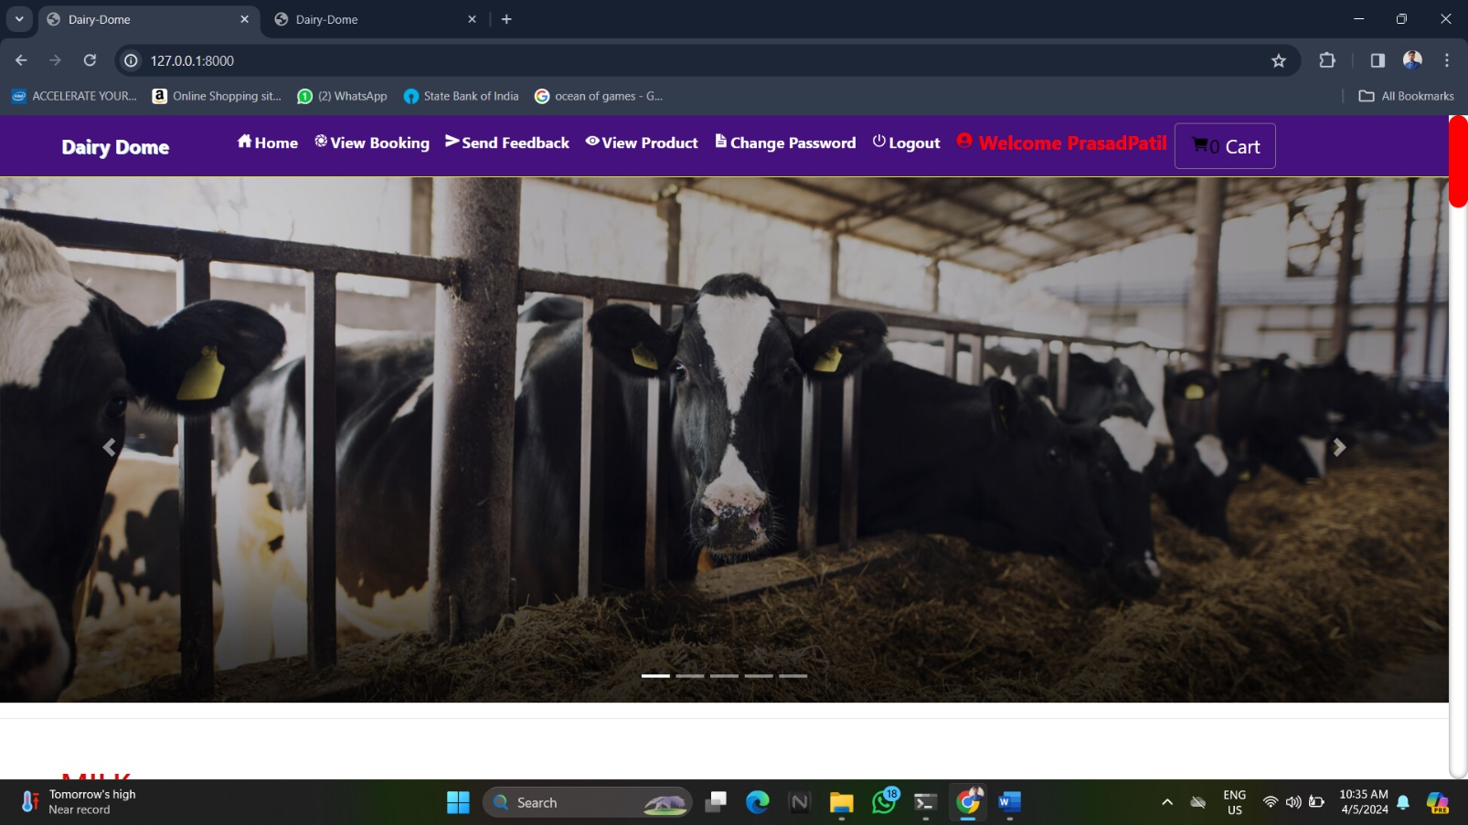

* **Admin Page :-**

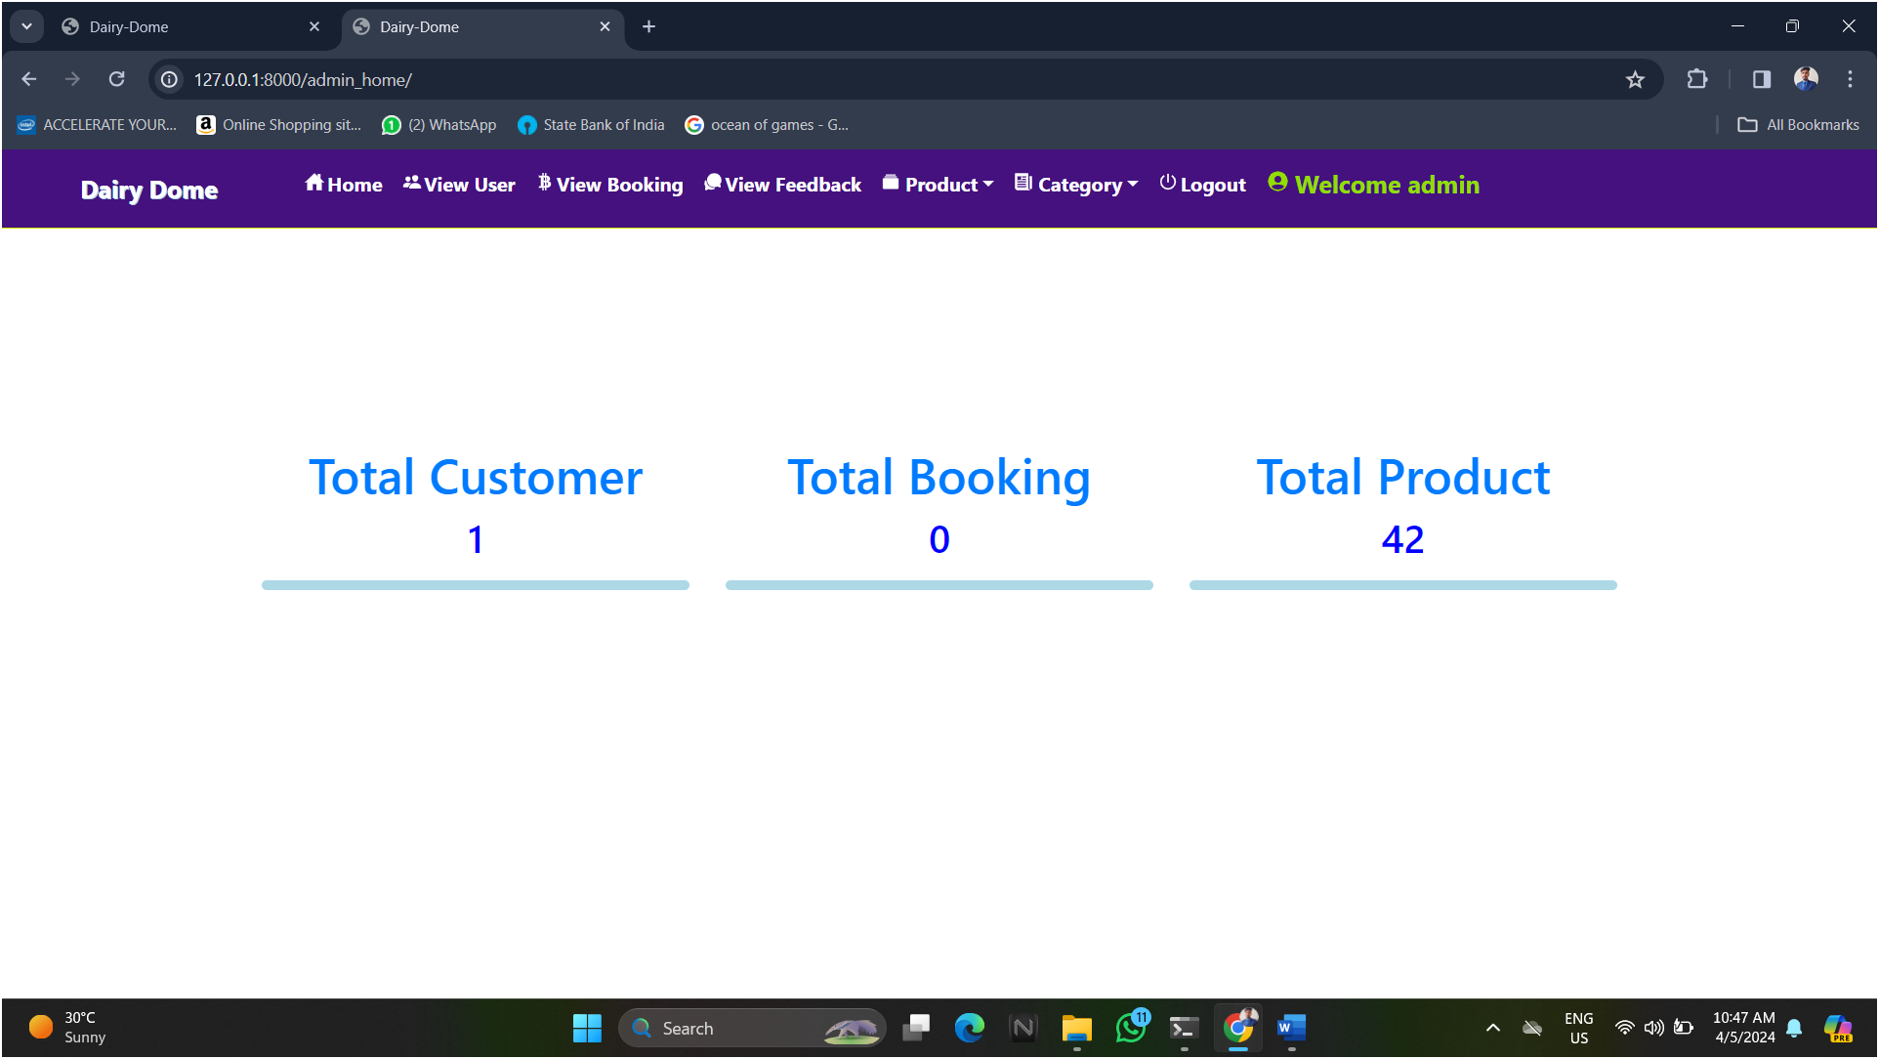

* **Add product :-**

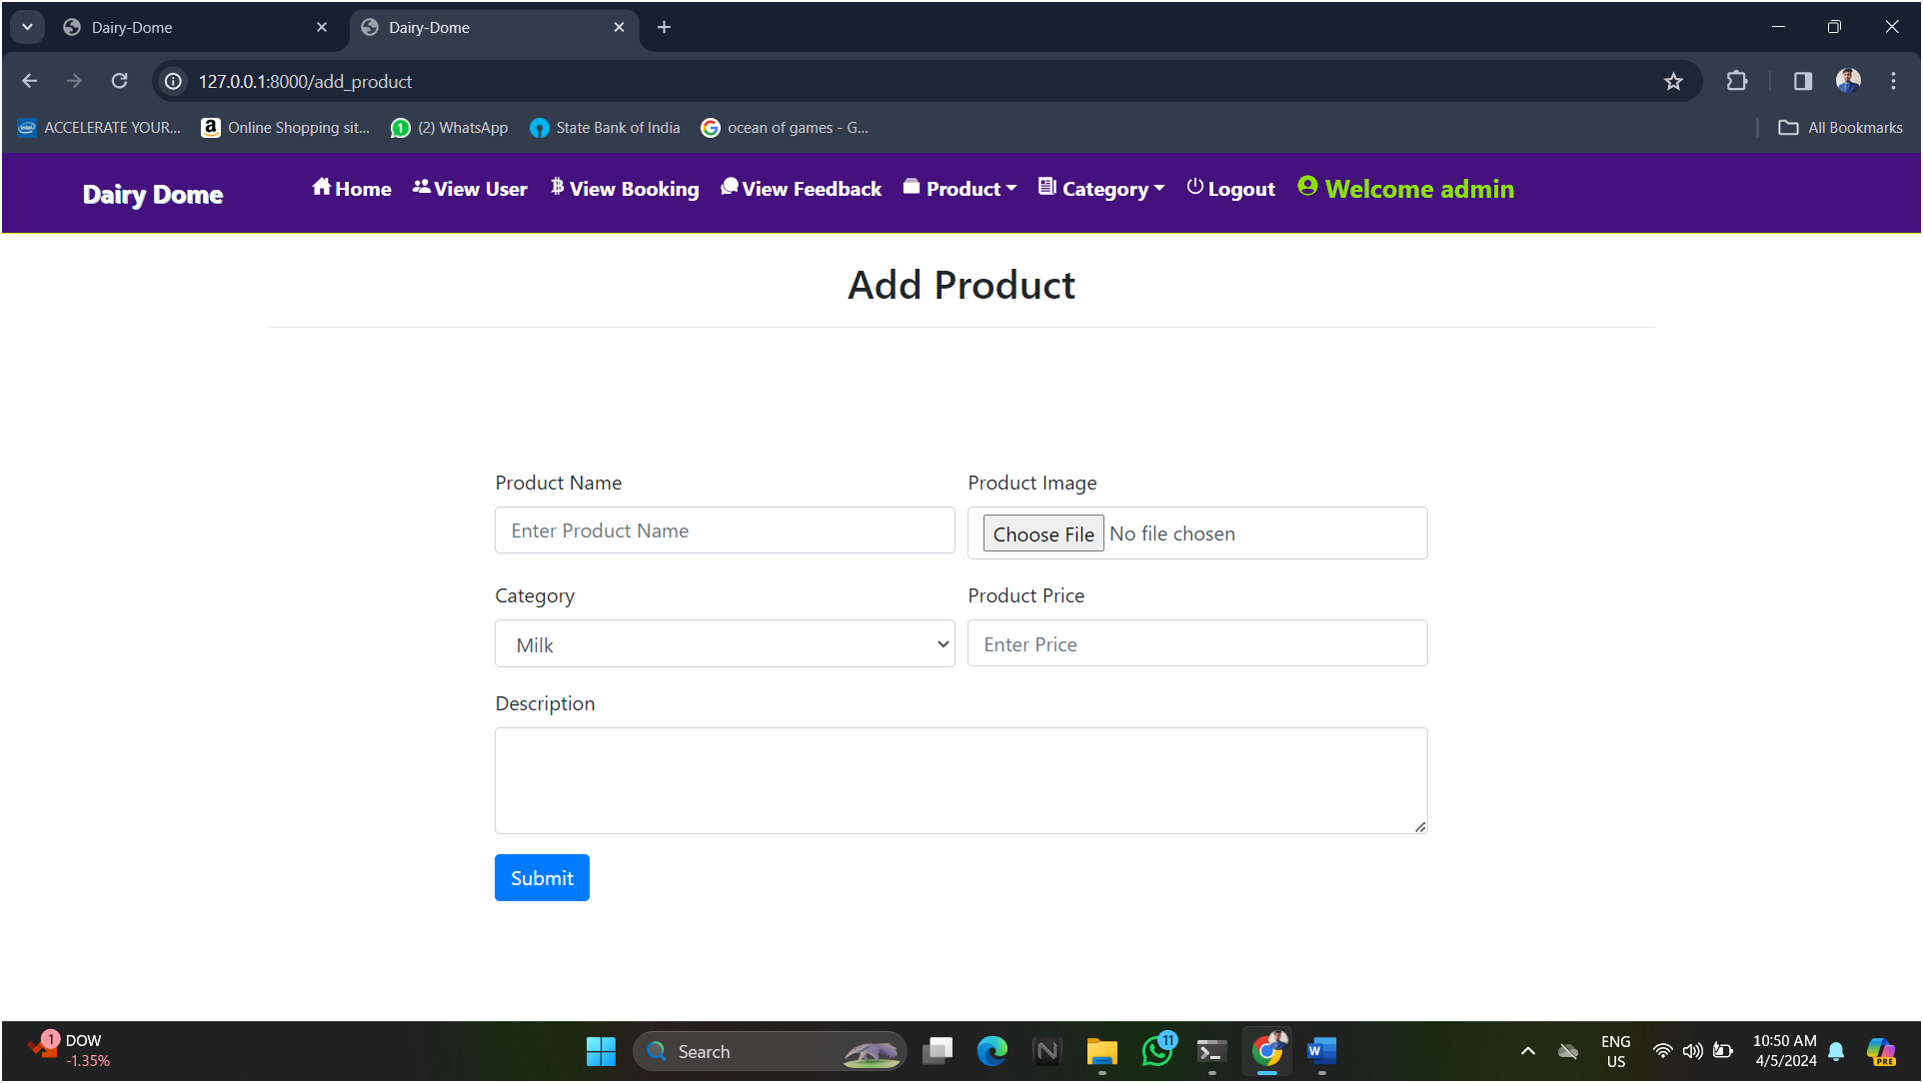

* 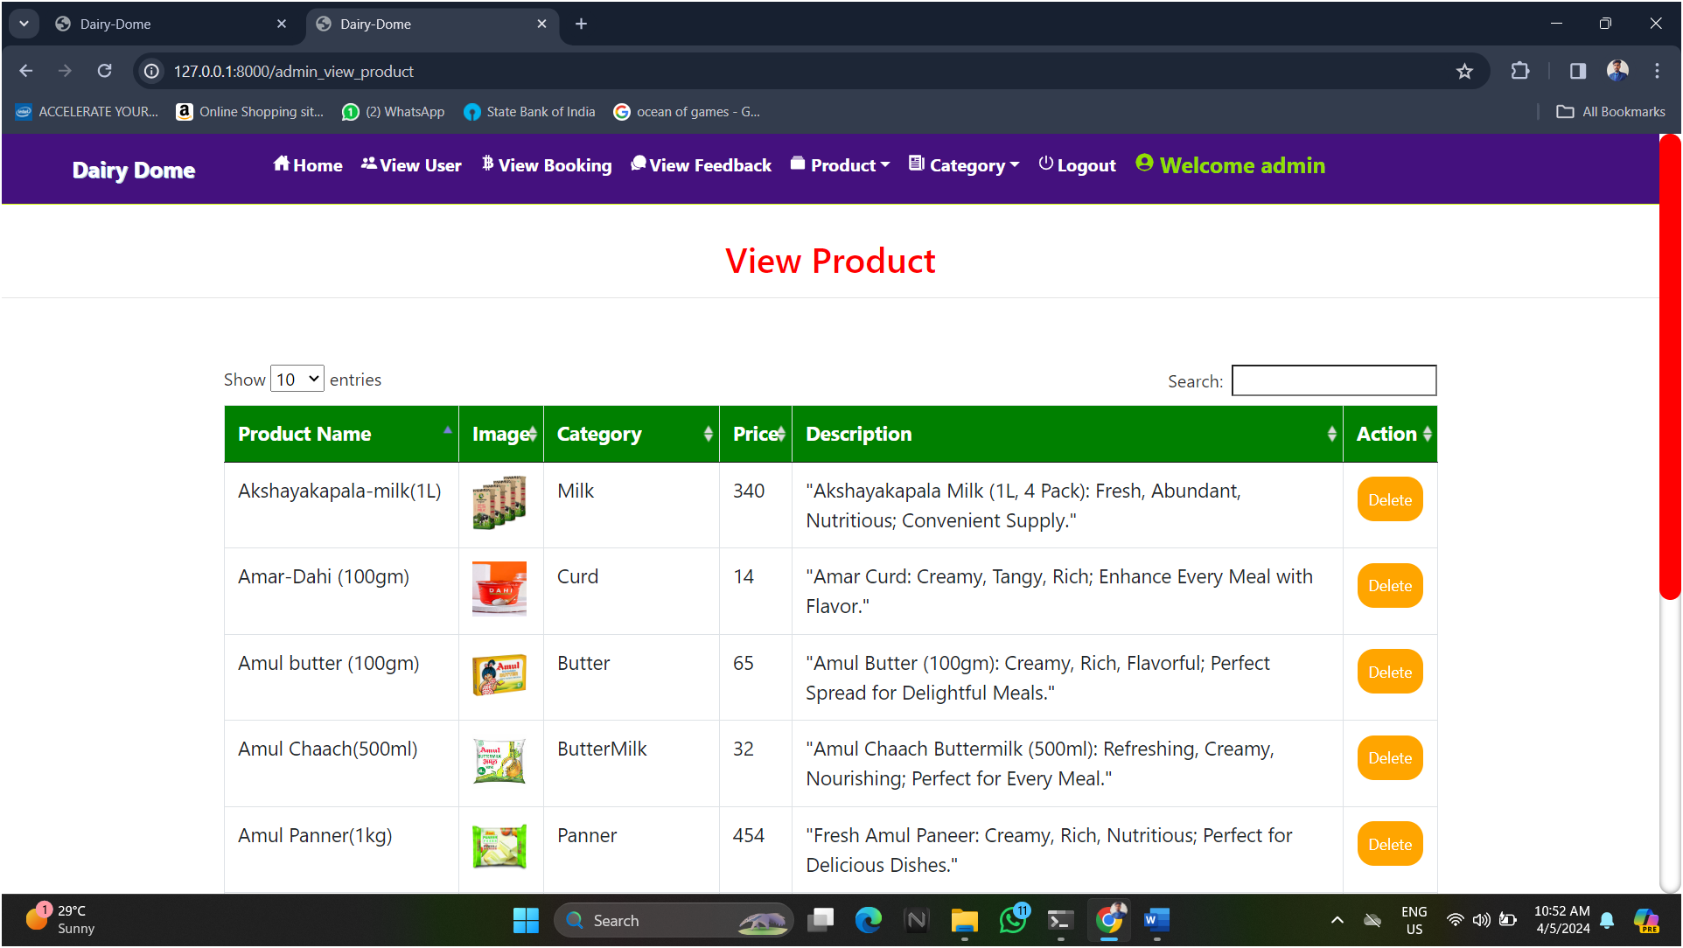**View product:-**
* **Add category:-**

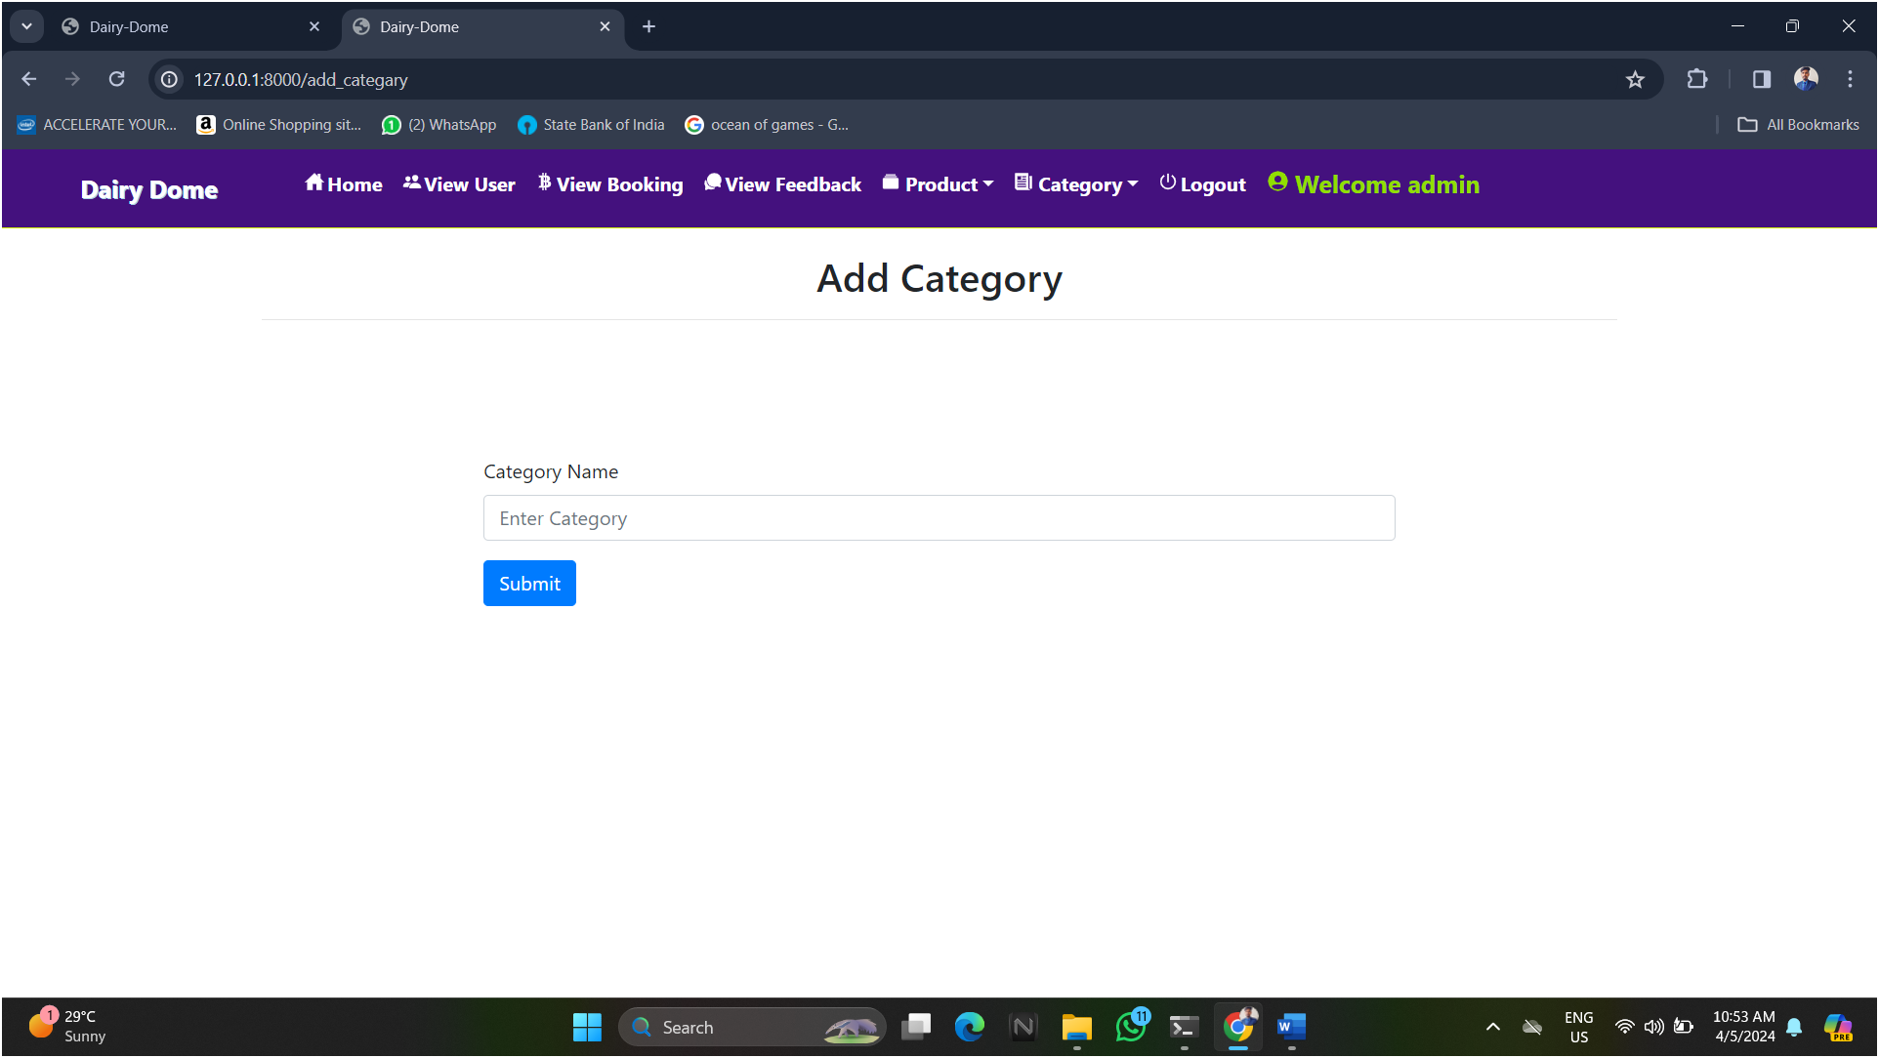

* **View category:-**

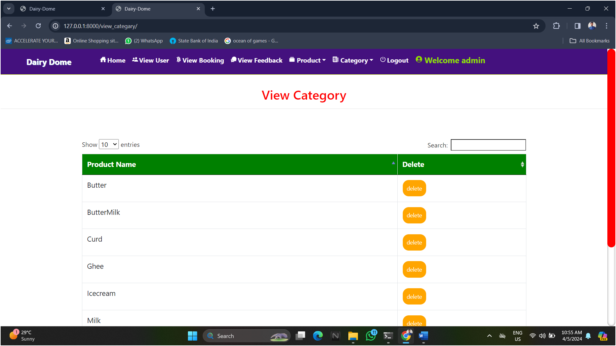

* 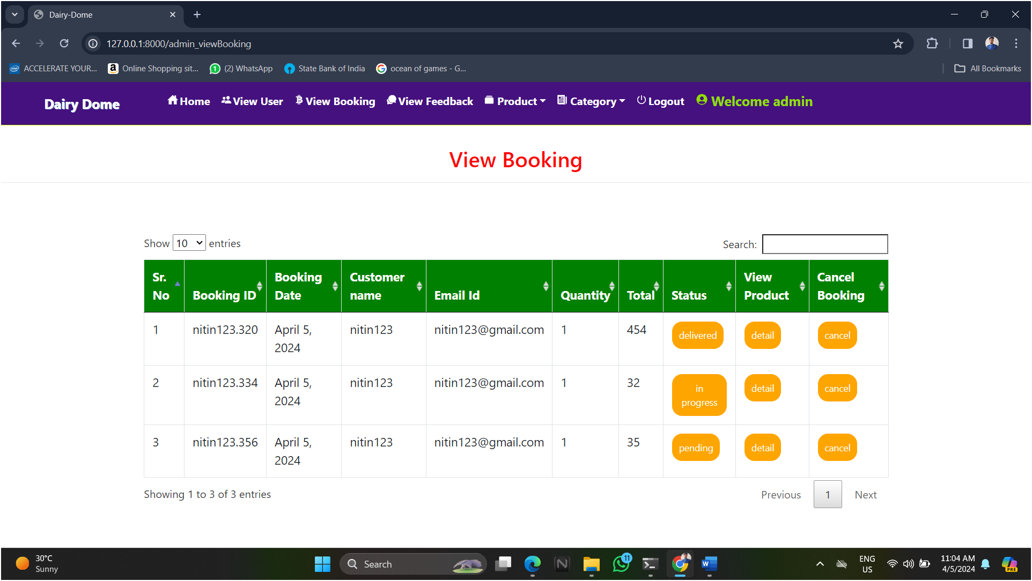**View booking:-**
* **View feedback :-**

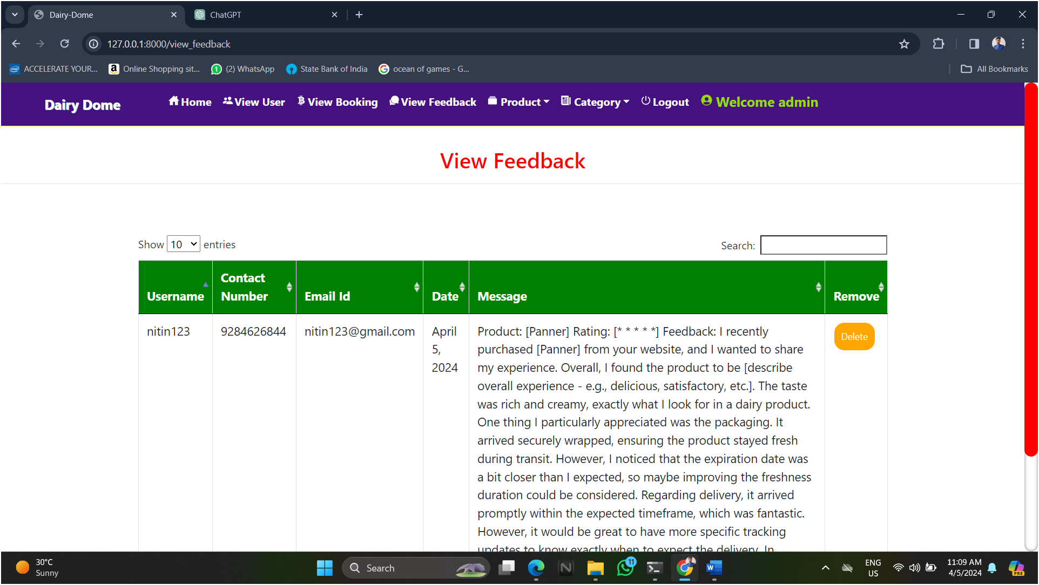

* 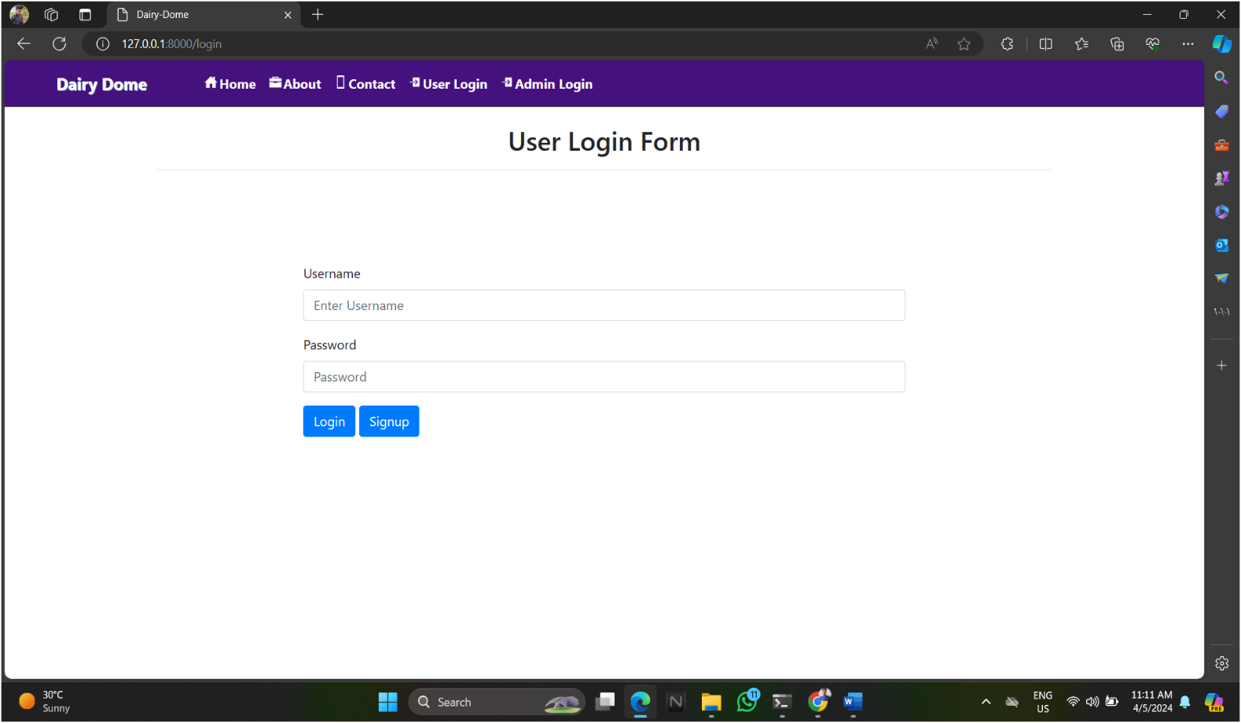**User login :-**
* **Registration Form :-**

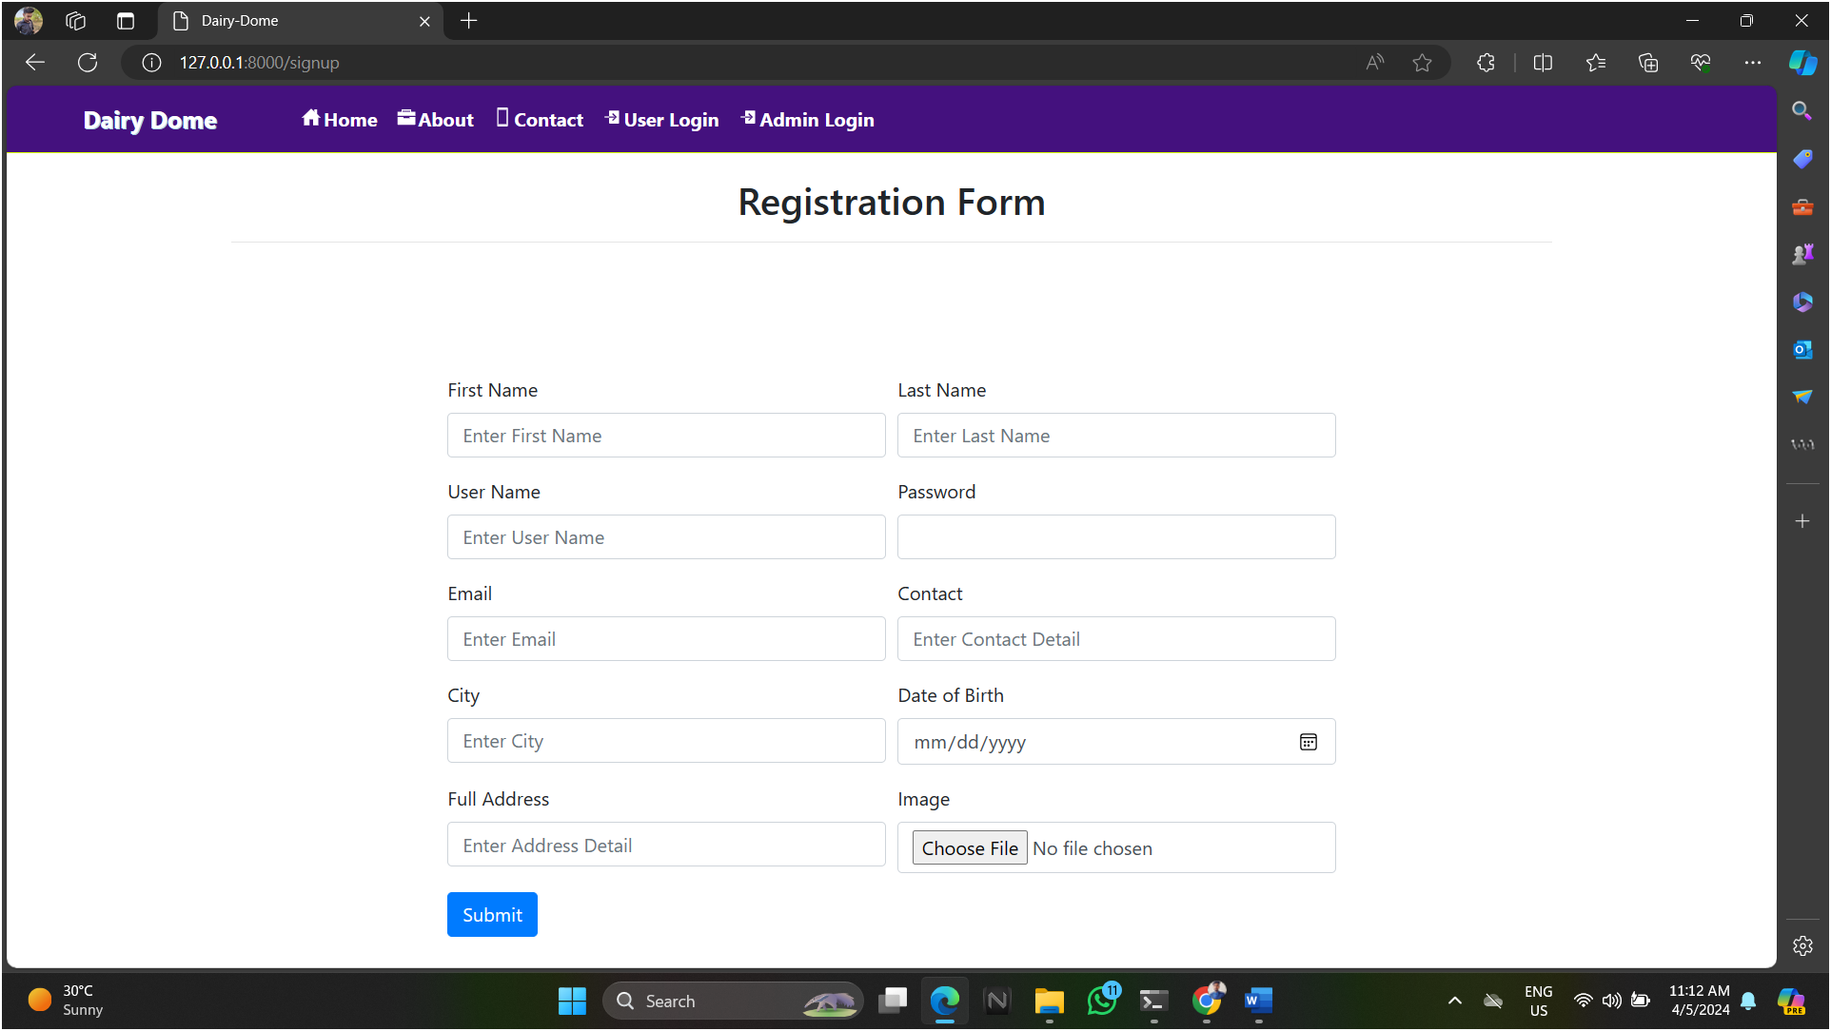

* 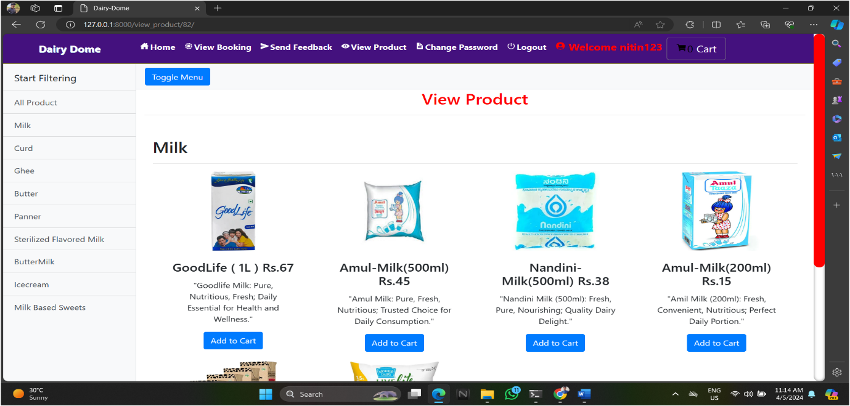**View product :-**

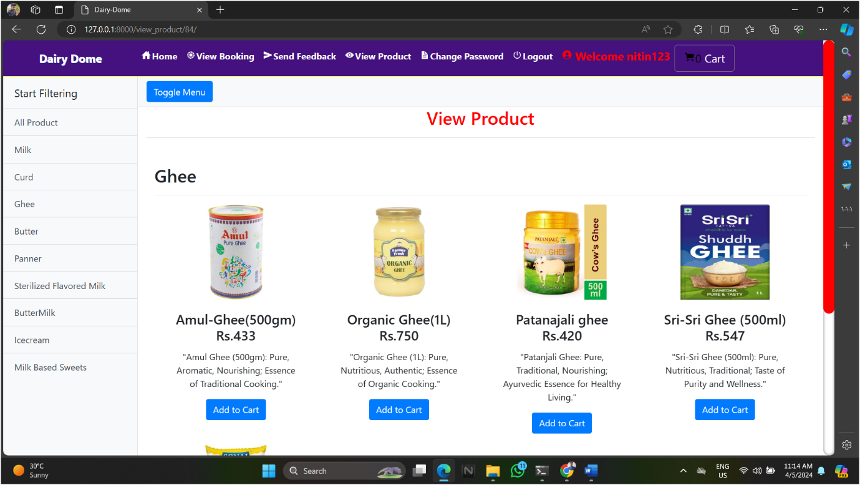

* 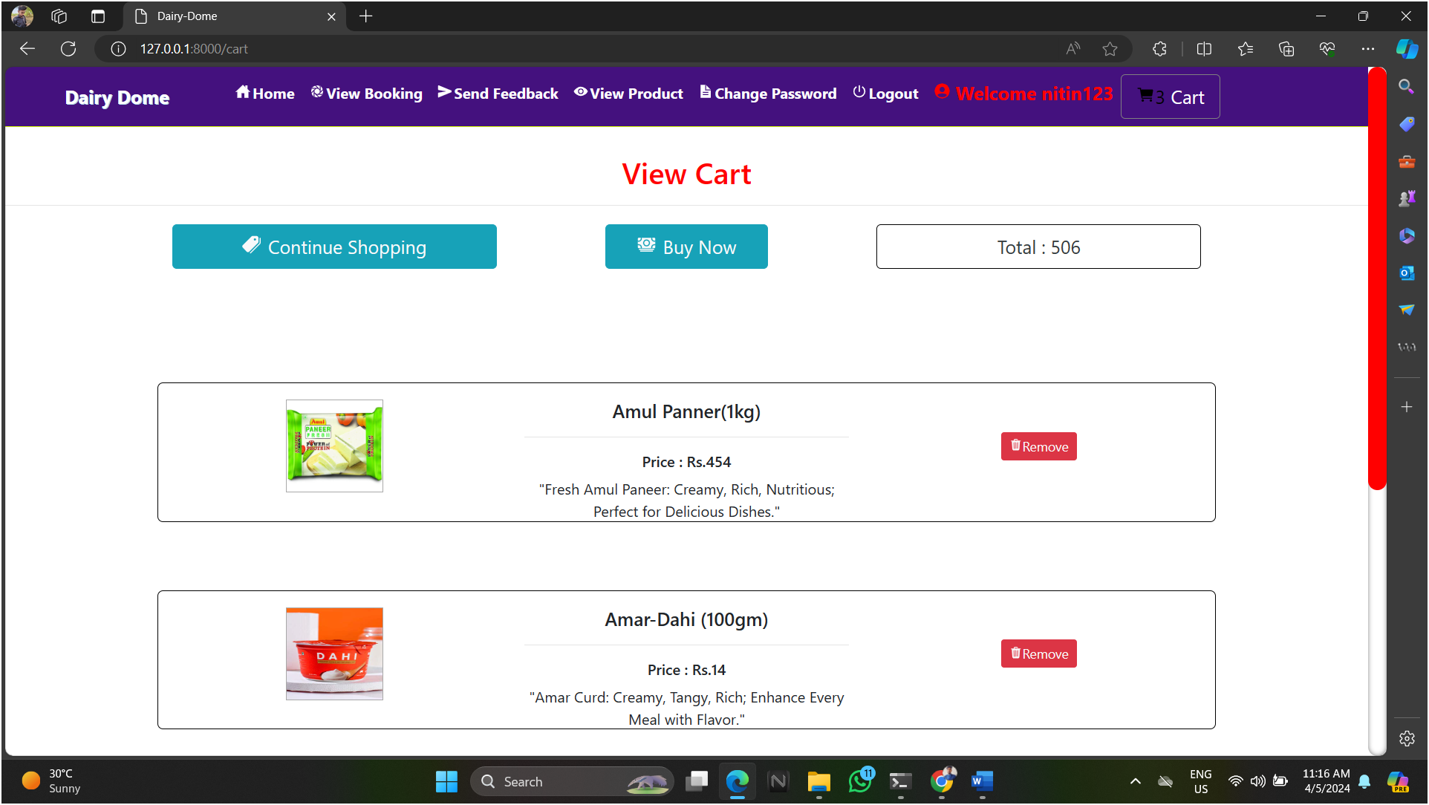**View cart :-**
* 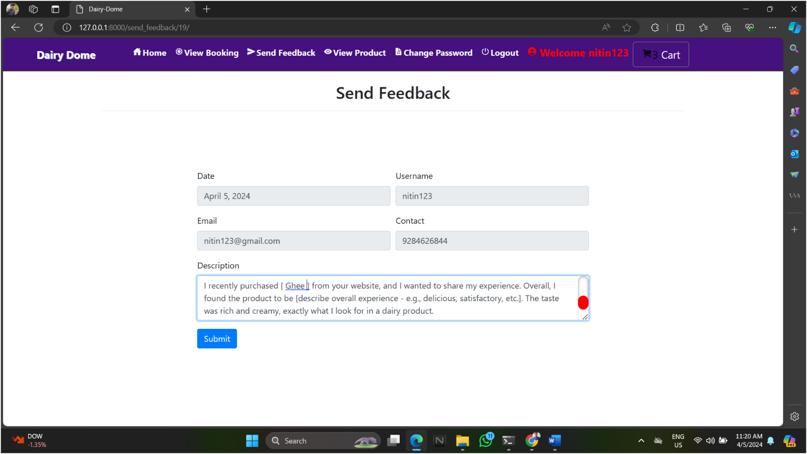**Send feedback :-**