# Entity Relationship Diagram: -

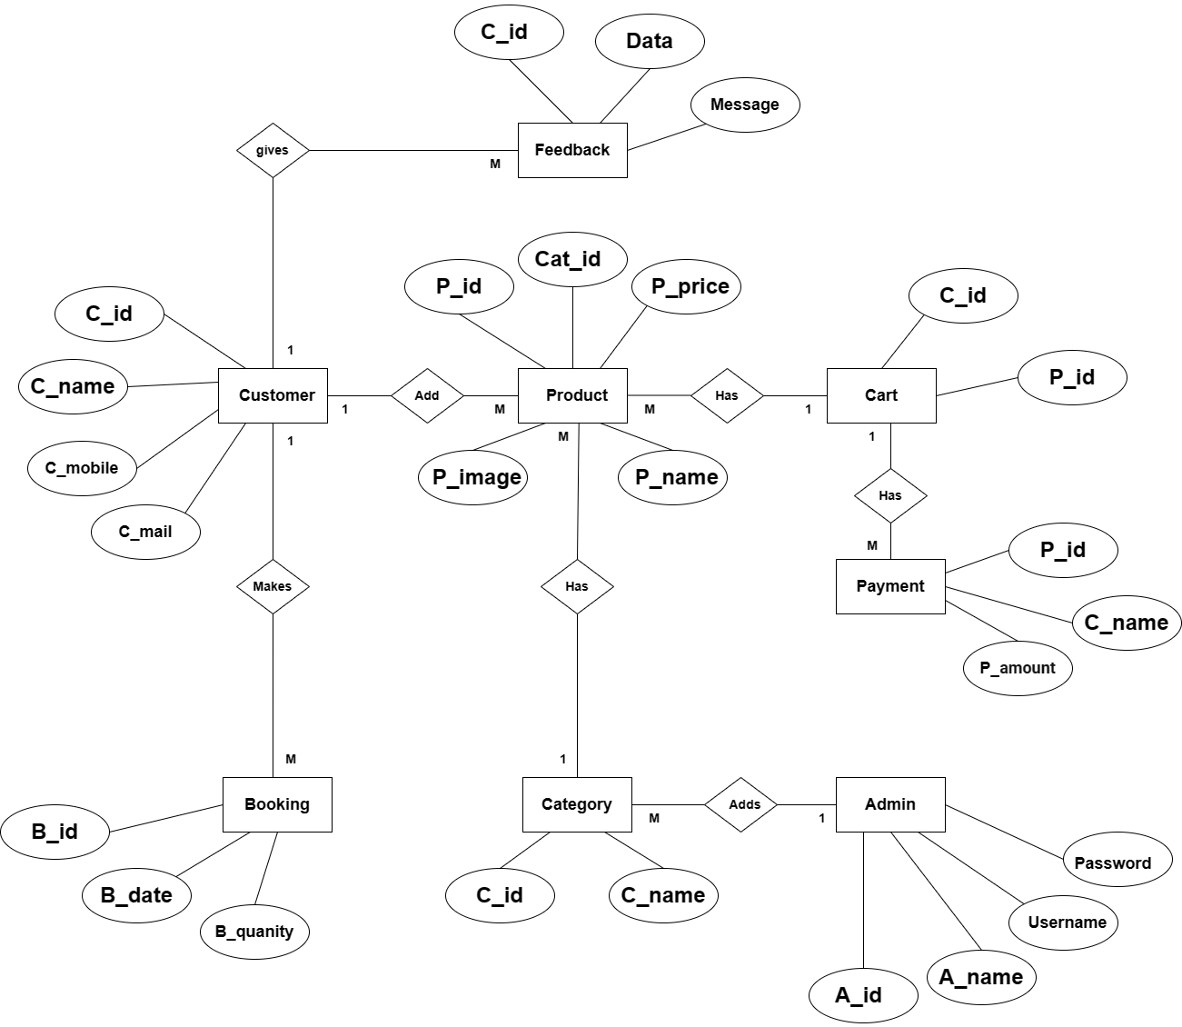

# Use Case Diagram: -

# 

**Class Diagram: -**

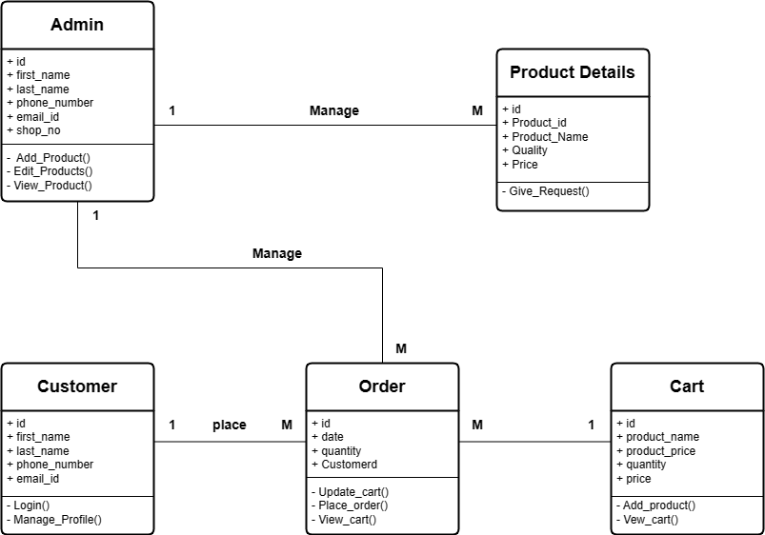

# Activity Diagram: -

1. Order Management Customer Side:

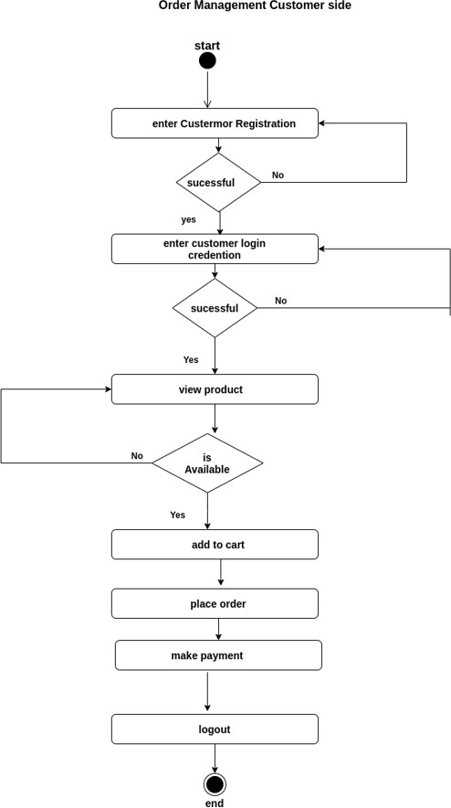

**Product Management :-**

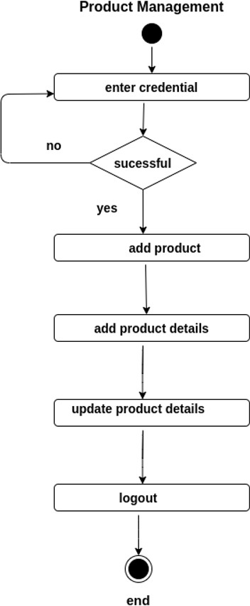

# Order Management Admin side:

# 

# Deployment Diagram: -

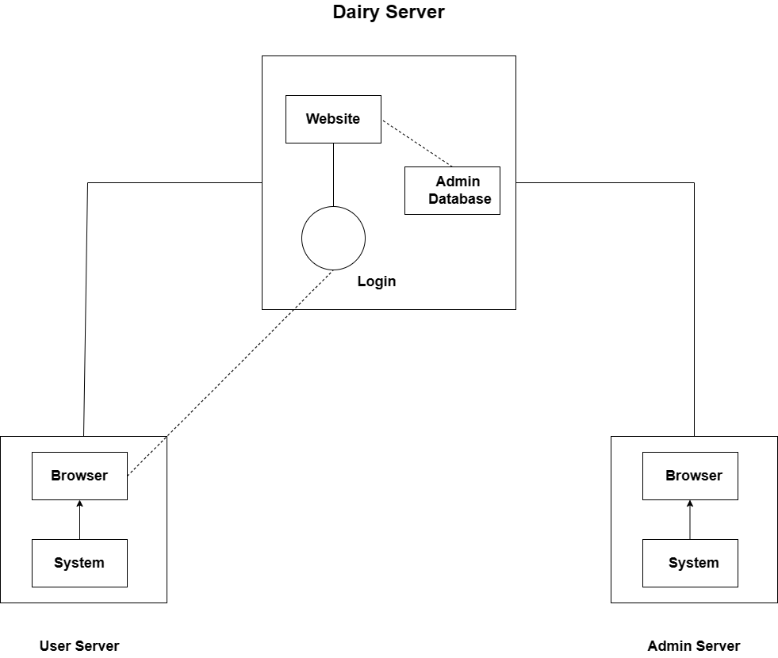

**Module Hierarchy Diagram: -**

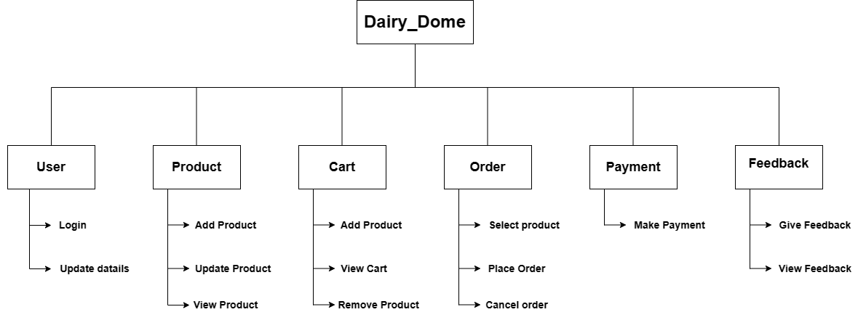

**DataBase Table:-**

* 1. **Table Structure: -**

1. **Customer(login)**

|  |  |  |  |
| --- | --- | --- | --- |
| Name | Type | Null | Constraints |
| id | int(10) | No | Primary Key |
| UserName | varchar(30) | No | - |
| Password | varchar(128) | No | - |

1. **product**

|  |  |  |  |
| --- | --- | --- | --- |
| Name | Type | Null | Constraints |
| id | Int | No | Primary key |
| image | varchar(100) | No | - |
| name | varchar(30) | No | - |
| price | Int | No | - |
| desc | Text | No | - |
| category_id | Int | No | Foreign Key |

1. **category**

|  |  |  |  |
| --- | --- | --- | --- |
| Name | Type | Null | Constraints |
| id | Int | No | Primary key |
| name | varchar(30) | No | - |

1. **booking**

|  |  |  |  |
| --- | --- | --- | --- |
| Name | Type | Null | Constraints |
| Product id | Int | No | Foreign Key |
| book | varchar(30) | No | - |
| total | Int | Yes | - |
| booking_id | varchar(20) | Yes | Primary key |
| profile_id | Integer | Yes | Foreign Key |
| quality | varchar(100) | No | - |
| status_id | Integer | No | - |

1. **cart**

|  |  |  |  |
| --- | --- | --- | --- |
| Name | Type | Null | Constraints |
| id | Int | No | Primary key |
| product_id | Int | Yes | Foreign Key |
| profile_id | Int | Yes | Foreign Key |

1. **profile(customer registration)**

|  |  |  |  |
| --- | --- | --- | --- |
| Name | Type | Null | Constraints |
| id | Int | No | Primary key |
| password | varchar(128) | Yes | - |
| username | varchar(50) | Yes | - |
| last_name | varchar(50) | Yes | - |
| email | varchar(50) | Yes | - |
| first_name | varchar(50) | Yes | - |

1. **feedback**

|  |  |  |  |
| --- | --- | --- | --- |
| Name | Type | Null | Constraints |
| Id | Int | No | Primary key |
| Message | Text | No | - |
| Date | varchar(30) | No | - |
| profile_id | Int | No | Foreign Key |