1.What are the two values of the Boolean data type? How do you write them?

Ans:- Two values of the Boolean data type is True and False. Boolean expressions use relational and logical operators. The result of a Boolean expression is either true or false.

2. What are the three different types of Boolean operators?

Ans:- There are three basic Boolean search commands: AND, OR and NOT.

3. Make a list of each Boolean operator's truth tables (i.e. every possible combination of Boolean values for the operator and what it evaluate ).

Ans:-

**Truth Table for AND**

True and True is True.

True and False is False.

False and True is False.

False and False is False.

**Truth Table for OR**

True or True is True.

True or False is True.

False or True is True.

False or False is False.

**Truth Table for NOT**

not True is False.

not False is True.

4. What are the values of the following expressions?

(5 > 4) and (3 == 5)

not (5 > 4)

(5 > 4) or (3 == 5)

not ((5 > 4) or (3 == 5))

(True and True) and (True == False)

(not False) or (not True)

Ans:-

False

False

True

False

False

True

5. What are the six comparison operators?

Ans:- ==, !=, <, >, <=, and >=

6. How do you tell the difference between the equal to and assignment operators?Describe a condition and when you would use one.

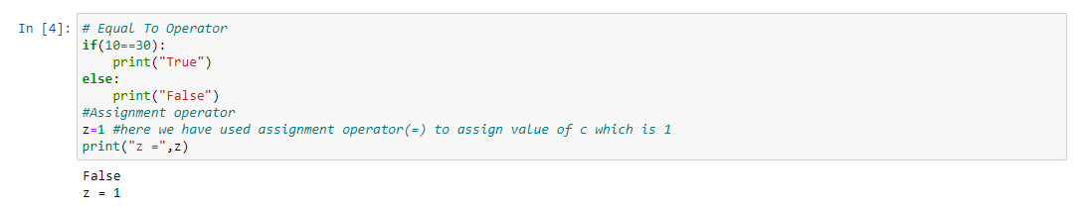

7. Identify the three blocks in this code:

spam = 0

if spam == 10:

print('eggs')

if spam > 5:

print('bacon')

else:

print('ham')

print('spam')

print('spam')

Ans:-

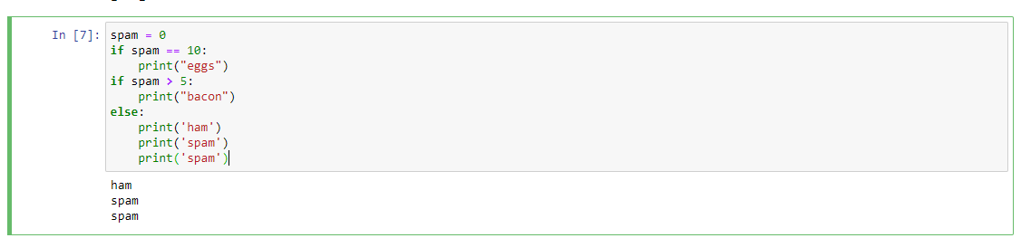

8. Write code that prints Hello if 1 is stored in spam, prints Howdy if 2 is stored in spam, and prints Greetings! if anything else is stored in spam.

Ans:- If program is stuck in endless loop we will press ctrl+c.

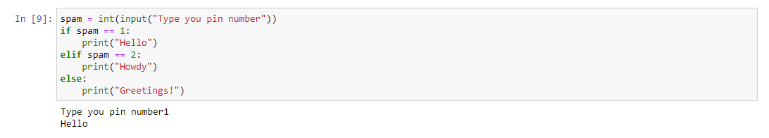

9.If your programme is stuck in an endless loop, what keys you’ll press?

Ans:- If program is stuck in endless loop we will press ctrl+c.

10. How can you tell the difference between break and continue?

Ans:-

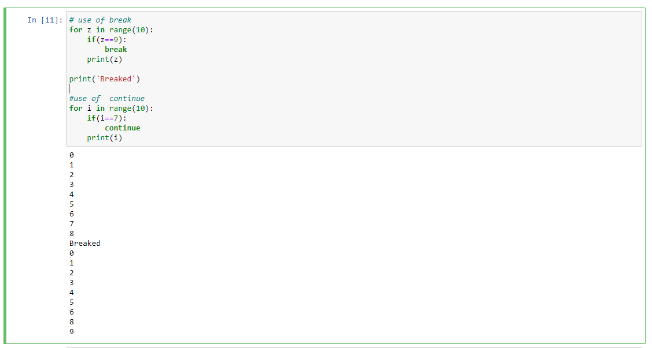

The Python break statement stops the loop in which the statement is placed. A Python continue statement skips a single iteration in a loop.

11. In a for loop, what is the difference between range(10), range(0, 10), and range(0, 10, 1)?

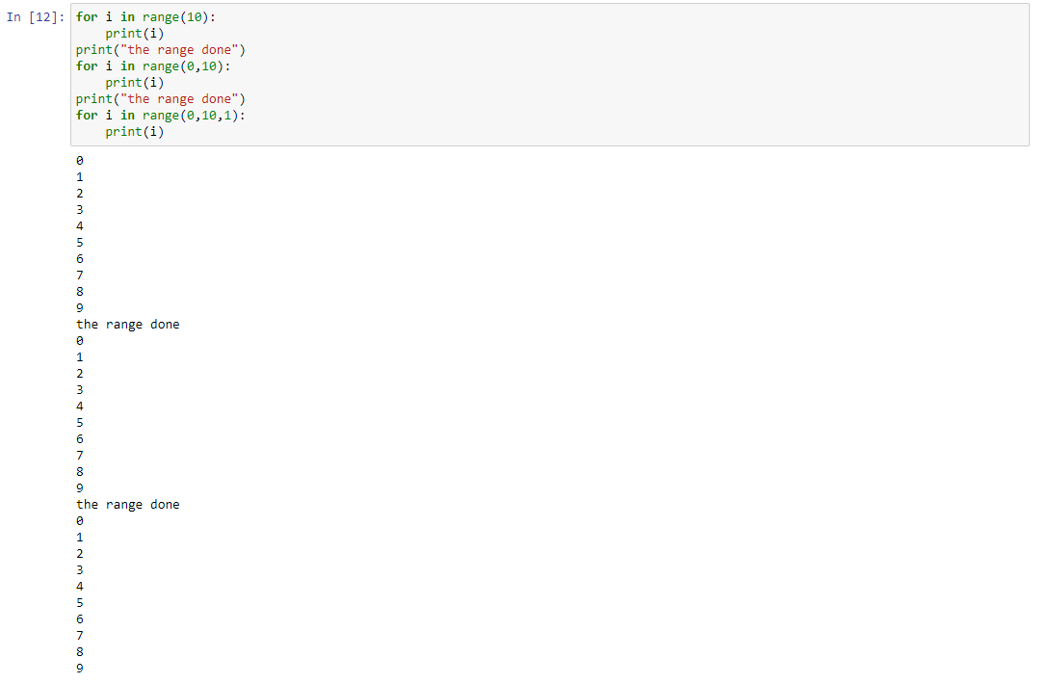

12. Write a short program that prints the numbers 1 to 10 using a for loop. Then write an equivalent program that prints the numbers 1 to 10 using a while loop.

Ans:-

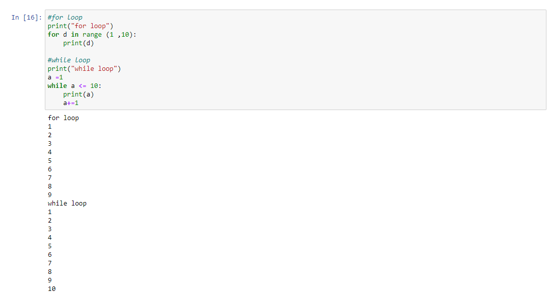

13. If you had a function named bacon() inside a module named spam, how would you call it after importing spam?

Ans:- This function can be called with spam.bacon().