AML Project Report

*On*

GoT-Wiki

*by*

| Name | Exam seat no. | Roll no. |
| --- | --- | --- |
| Prasad Jagadale | 22110189 | 322029 |
| Abhishek Katare | 22110477 | 322034 |
| Ankita Mandhare | 22110173 | 322040 |
| Sachin Nakate | 22110381 | 322046 |



Department of Computer Engineering

VIIT

**2023-2024**

**Contents**

| **Sr. No.** | **Topic** | | | **Page No.** |
| --- | --- | --- | --- | --- |
| **Chapter-1** | **Introduction** | | | 1 |
|  | 1.1 | | Introduction | 1 |
|  | 1.2 | | Motivation | 1 |
|  | 1.3 | | Problem Definition | 2 |
| **Chapter-2** | **Literature Survey** | | | 3 |
| **Chapter-3** | **Software Requirements Specification** | | | 4 |
|  | 3.2 | Functional Requirements | | 4 |
|  | 3.3 | Non-functional Requirements | | 5 |
| **Chapter-4** | **Analysis Models: SDLC Model to be applied** | | | 7 |
| **Chapter-5** | **System implementation plan** | | | 9 |
|  | 5.1 | System Design | | 10 |
|  | 5.2 | System Architecture | | 10 |
|  | 5.3 | Data Flow Diagrams | | 11 |
|  | 5.4 | Entity Relationship Diagrams | | 12 |
|  | 5.5 | UML diagram | | 13 |
| **Chapter-6** |  | **Observations** | | 14 |
| **Chapter-7** | **Conclusion** | | | 16 |
|  | **References** | | | 17 |

**ABSTRACT**

In the realm of Westeros, where digital connectivity intertwines with the pursuit of knowledge, web series enthusiasts are seeking innovative means to enrich user experiences on their websites. This project introduces the implementation of Conversational AI to revolutionize GoT-themed websites. The primary aim is to streamline access to comprehensive lore, improve navigation, and offer personalized assistance to fans, historians, and other website visitors.

The project involves developing and integrating Conversational AI into GoT-themed websites, leveraging natural language processing and machine learning techniques. The AI serves as a virtual assistant, capable of addressing common inquiries, guiding users through the website's vast archives, and providing real-time support. It's designed to adapt and learn from user interactions, ensuring enhanced responses and user satisfaction with each engagement.

The benefits of Conversational AI for GoT-themed websites include 24/7 availability, easing the workload on website administrators, deepening user engagement, and ultimately enriching the overall user experience within the realm of Westeros. Through this innovative project, we aim to provide a powerful tool for Got fans to connect with their online audience, offer efficient support, and remain at the forefront of technological advancements in disseminating Westeros lore. Conversational AI for GoT-themed websites represents a significant stride in transforming the accessibility and exploration of historical knowledge in the digital age of Westeros.

* **Introduction**
  1. **Introduction**

Conversational AI is fundamentally altering the landscape of human-computer interaction, heralding a new era of intuitive engagement. By employing natural language processing, this technology facilitates seamless, real-time conversations between users and computer systems. In the realm of Westeros, the "GOT-Wiki" project epitomizes this transformation, offering users the opportunity to engage in dialogue akin to consulting a knowledgeable maester of the Citadel. Through this innovative platform, users can effortlessly navigate the rich tapestry of Westeros history, inquire about intricate alliances, and seek guidance, all with the convenience of interacting in a natural, conversational manner.

GOT-Wiki's Conversational AI not only provides instant support and information but also cultivates a deeper connection between users and the vast repository of Westeros knowledge. Much like the maesters meticulously curate scrolls of wisdom, these intelligent systems comprehend and respond to user inquiries, enhancing the overall user experience. As technology continues to evolve, GOT-Wiki stands at the forefront, revolutionizing the way individuals interact with the expansive lore of the Seven Kingdoms, ushering in a new era of digital enlightenment.

* 1. **Motivation**

There are several reasons to implement Conversational ai in for Game Of Thrones Bot:

* Deepen Engagement:

Enhance viewer immersion with personalized responses, enriching the Game of Thrones experience.

* Uninterrupted Access:

Provide 24/7 support for fans, ensuring assistance and information availability anytime, anywhere.

* Immediate Assistance:

Deliver instant answers, mirroring the series' fast-paced intrigue for fans' inquiries.

Building a Game of Thrones (GoT) bot, or "GOT-Wiki," could be motivated by engaging fans in immersive experiences, educating users about the show's rich lore, and promoting merchandise or upcoming episodes. It could also serve to build and strengthen the GoT fan community by facilitating discussions and events. Additionally, developing such a bot would showcase innovative technologies like conversational AI and natural language processing, demonstrating their capabilities in creating interactive user experiences. Overall, the motivation behind building a GoT bot lies in providing entertainment, education, promotion, community-building, and technological innovation within the expansive universe of Game of Thrones

* 1. **Problem Definition**

Developing a Conversational AI bot for Game of Thrones, such as "GOT-Wiki," tackles the challenge faced by fans in accessing comprehensive and accurate series information efficiently. With the vast and intricate world of Westeros, including numerous characters, plotlines, and historical events, fans often struggle to find reliable details amidst the vast array of sources.

The bot aims to bridge this gap by offering users instant access to reliable and up-to-date information on various aspects of the series. Users can simply ask the bot questions about characters, plotlines, or trivia, and receive accurate responses in real-time. This not only saves time and effort for fans but also ensures that they can trust the information they receive.

By enhancing user experience and satisfaction within the GoT fan community, the Conversational AI bot contributes to a deeper engagement with the series. Fans can delve into discussions, debates, and analyses with confidence, knowing that they have access to a reliable source of information. Ultimately, the bot serves as a valuable resource for fans to explore and enjoy the rich and immersive world of Game of Thrones.

* **Literature Survey**

1. The literature review emphasizes how chatbots are becoming more and more common in a variety of settings, especially in the workplace, where they function as virtual assistants to improve customer service effectiveness and handle several user interactions at once. The need for chatbot performance optimization is highlighted, which led to the solution suggested in this paper. The chatbot uses Artificial Intelligence Markup Language (AIML) to provide accurate answers based on a dataset of Frequently Asked Questions (FAQs) for template-based and general queries. Furthermore, Latent Semantic Analysis (LSA) integration is presented to handle service-specific queries, guaranteeing precision and effectiveness in responding to user inquiries. The goal of the research paper is to advance the field by presenting a design that effectively makes use of both AIML and LSA, offering an engaging and fulfilling experience for users, specifically tailored for university settings to address the curiosity of students through an intelligent FAQ system. [1]
2. The literature review highlights how intelligent chatbots are being integrated into a wide range of industries, which represents a major change toward automated online help and guidance. The paper highlights the complementary applications of machine learning and natural language processing in the field of artificial intelligence and notes the growing advantages of chatbots. The survey highlights the current obstacles and restrictions in their use, despite their growing popularity. The goal of the paper is to present a thorough understanding of the changing field of chatbot technology by examining recent developments in it. Furthermore, the survey outlines the limitations and challenges that have been identified, providing a basis for suggesting directions for future research endeavors. This research paper endeavors to contribute to the ongoing discourse by offering insights into the current state of chatbot technology and proposing directions for overcoming existing constraints and advancing the field. [2]
3. This study explores the field of Conversational AI, which is a branch of Artificial Intelligence that aims to develop text- or speech-based agents that can automate and simulate conversations. Conversational AI agents, like voice assistants and chatbots, have become more commonplace due to developments in Machine Learning and Deep Learning, which have been made possible by growing research interest and increased processing power from GPUs and TPUs. These agents' built-in natural language interface makes them adaptable to a variety of industries, including e-commerce, healthcare, customer service, and education. The study introduces newer and more sophisticated models for Conversational AI architecture's fundamental components, highlighting the field's accelerated rate of innovation. It seeks to clarify the most recent findings in this field, highlighting advancements over more conventional counterparts and pointing out future directions for research The paper contributes to the continuous development of this dynamic field by offering a thorough overview and laying the groundwork for future research and innovation in conversational artificial intelligence. [5]

* **Software requirement specifications**

**3.1. Introduction**

**3.1.1 Purpose**

The purpose of this document is to provide a comprehensive outline of the software requirements for the development of Conversational AI for GOT-Wiki website. This system is aimed at improving user experience, engagement, and accessibility on website.

**3.1.2 Scope**

The Conversational AI system will include a chatbot that interacts with website users, answers queries, guides users, and offers real-time assistance. The scope covers the system's functional and non-functional requirements, user interactions, and system behavior.

**3.2. Functional Requirements**

**3.2.1 User Interaction**

**3.2.1.1 User Query Handling**

* The system should interpret and respond to user queries.
* It should be able to handle text-based inputs in natural language.

**3.2.1.2 Guided Responses**

* In the Game of Thrones context, the Conversational AI system guides users to relevant sections of the "GOT-Wiki" based on their inquiries. For example, questions about House Stark lead to information on their history and notable members. Similarly, inquiries about events like the Red Wedding prompt details on their significance within the series. This ensures a smooth and informative experience for fans seeking specific information about the Game of Thrones universe.

**3.2.1.3 Personalization**

* The system should learn from user interactions to provide personalized responses over time.
* It should recognize user preferences and adapt its responses accordingly.

**3.2.2 Administrative Interface**

**3.2.2.1 Content Management**

There should be an administrative interface to manage chatbot responses, frequently asked questions, and conversational content.

**3.2.2.2 Analytics**

* The system should collect data on user interactions and provide analytics to administrators.
* It should track usage patterns, common queries, and user feedback.

**3.3. Non-Functional Requirements**

**3.3.1 Performance**

**3.3.1.1 Response Time**

* The system should respond to user queries within seconds.
* It should handle multiple user interactions simultaneously without performance degradation.

**3.3.2 Security**

**3.3.2.1 Data Security**

* User data, including queries and interactions, should be securely stored and protected.
* Compliance with relevant data protection regulations (e.g., GDPR) is mandatory.

**3.3.3 Scalability**

**3.3.3.1 Scalability**

* The system should be able to handle a growing number of users and interactions.
* It should scale both vertically and horizontally to meet demand.

**3.3.4 User Interface**

**3.3.4.1 User-Friendly Interface**

* The chatbot's interface should be user-friendly, with clear instructions and easy-to-understand responses.

**3.3.5 Technology Stack**

**3.3.5.1 Technology Requirements**

* The system should be developed using modern AI and natural language processing technologies.

**3.4. Constraints**

**3.4.1 Compatibility**

The system should be compatible with common web browsers and devices, including desktop and mobile.

**3.4.2 Budget**

The project should adhere to budget constraints as specified.

**3.5. Conclusion**

This Software Requirements Specification outlines the essential functional and non-functional requirements for the development of the Conversational AI system for GOT-Wiki website. Adherence to these requirements will ensure the successful implementation and deployment of the system to improve user experiences and engagement on websites.

* **Analysis Models: SDLC Model to be applied**

Agile Software Development Life Cycle (SDLC) model is well-suited to the dynamic and iterative nature of the project requirements. Agile emphasizes flexibility, collaboration, and customer feedback throughout the development process. Here's how Agile can be applied to the given project:

**Iterative Development:**

Explanation: Agile promotes iterative development cycles, allowing for the continuous improvement and refinement of the system.

Application: Each iteration can focus on specific functionalities of the Conversational AI, ensuring that the development team can incorporate feedback and make adjustments as needed.

**Customer Collaboration:**

Explanation: Agile encourages regular interaction with stakeholders, including end-users and administrators, to understand their needs and expectations.

Application: Regular sprint reviews and feedback sessions will be conducted to involve stakeholders in the decision-making process and validate the system's alignment with their requirements.

**Adaptability to Changes:**

Explanation: Agile embraces changes in requirements, even late in the development process, to respond effectively to evolving needs.

Application: As the project progresses, new insights and requirements may emerge. Agile allows the team to accommodate these changes without disrupting the overall development flow.

**Cross-functional Teams:**

Explanation: Agile encourages collaboration among cross-functional teams, including developers, testers, and subject matter experts.

Application: The project team will consist of members with expertise in AI, natural language processing, and web development. Cross-functional collaboration ensures a holistic approach to the system's development.

**Continuous Delivery:**

Explanation: Agile promotes delivering functional increments of the software at the end of each iteration.

Application: Working increments of the Conversational AI system will be delivered at the end of each sprint, allowing stakeholders to experience and provide feedback on the evolving product.

Emphasis on Individuals and Interactions:

Explanation: Agile places importance on direct communication and face-to-face interactions among team members.

Application: Daily stand-up meetings and regular communication channels will be established to foster real-time collaboration, address challenges, and maintain a shared understanding of project goals.

**Prioritization and Backlog Management:**

Explanation: Agile relies on a prioritized backlog of user stories and features.

Application: The product backlog will be continuously refined, and sprint planning sessions will involve selecting the highest-priority items for each iteration based on stakeholder and team input.

**Regular Reflection and Improvement:**

Explanation: Agile encourages regular retrospectives to reflect on the team's performance and identify areas for improvement.

Application: Sprint retrospectives will be conducted to evaluate what went well, what could be improved, and to implement adjustments for continuous enhancement.

By applying the Agile SDLC model to the project, the development team can adapt to changing requirements, deliver incremental value, and maintain a high level of collaboration with stakeholders, ultimately contributing to the successful development and deployment of the Conversational AI for GOT-Wiki Website.

**5.System implementation plan**

**User Input Processing:**

Project Mapping: Equivalent to the "Requirements Gathering and Analysis" phase in a system implementation plan. It involves understanding and preprocessing the user's input, including tasks like tokenization, stemming, and lemmatization.

**Intent Recognition and System Interaction:**

Project Mapping: Similar to the "System Design" phase. In this stage, the system determines the user's intent and initiates the appropriate response. This phase is crucial for designing the architecture and interaction flow of the conversational AI.

**Data Collection and Model Training:**

Project Mapping: Integrated into the "Development and Testing" phase. Before deploying the system, it involves collecting relevant data to train the underlying models. This phase ensures that the conversational AI can learn from historical interactions and improve its performance.

**Response Generation:**

Project Mapping: Aligns with the "Development and Testing" phase. The response generation stage involves creating the actual responses based on the user's input. It may utilize templates or machine learning models for generating text responses.

**Knowledge Retrieval:**

Project Mapping: Corresponds to the "Development and Testing" phase. Information retrieval is vital during the system's development, where it retrieves relevant data from a knowledge base or database to support accurate responses.

**Database Management:**

Project Mapping: Relates to the "Deployment and Maintenance" phase. The database stage involves storing and managing information used by the system. This phase is critical for ongoing maintenance, updates, and ensuring the availability of up-to-date data.

**5.Designs and Diagrams**

System Design

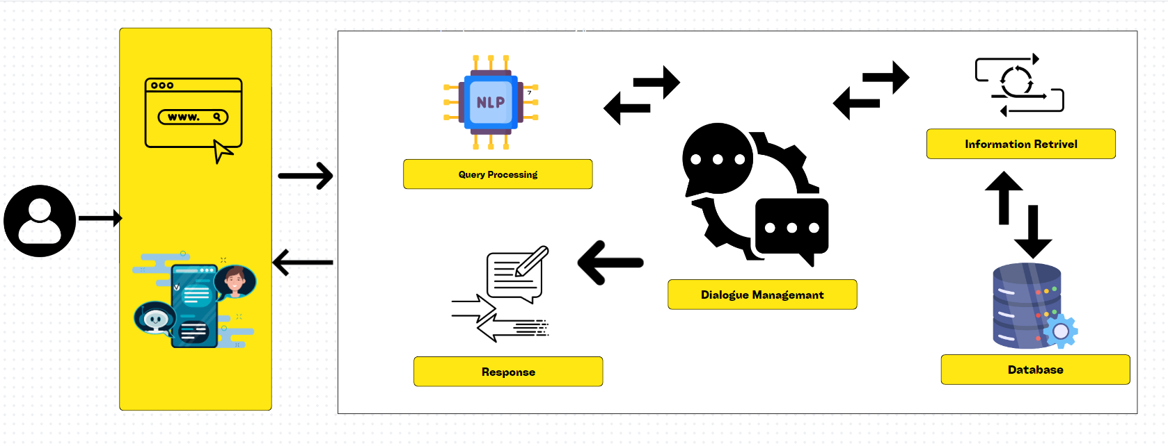

System Architecture

Deployment Model

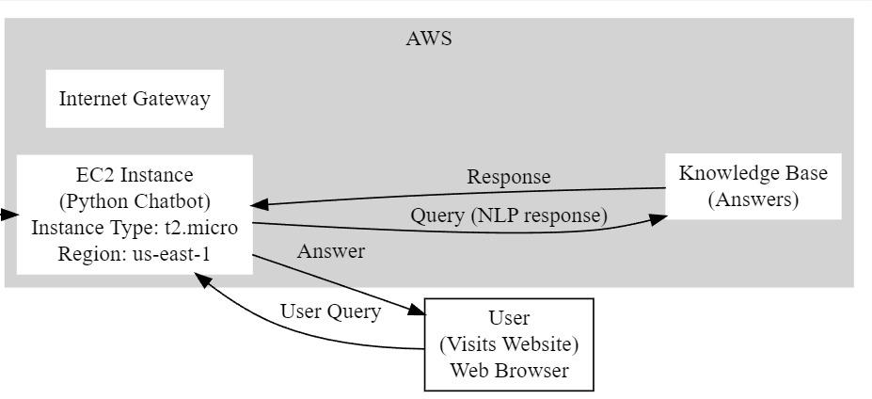

Data-Flow Diagram

ER Diagram

Activity Diagram

Use Case Diagram

**Observations**

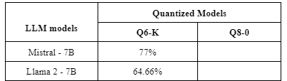

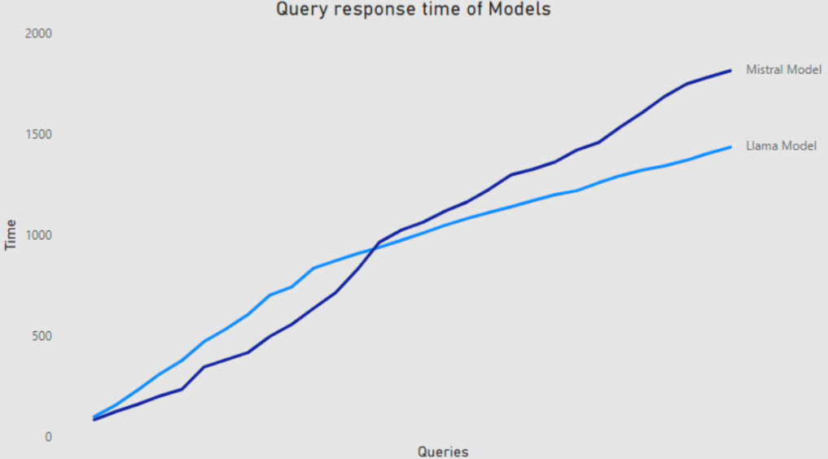

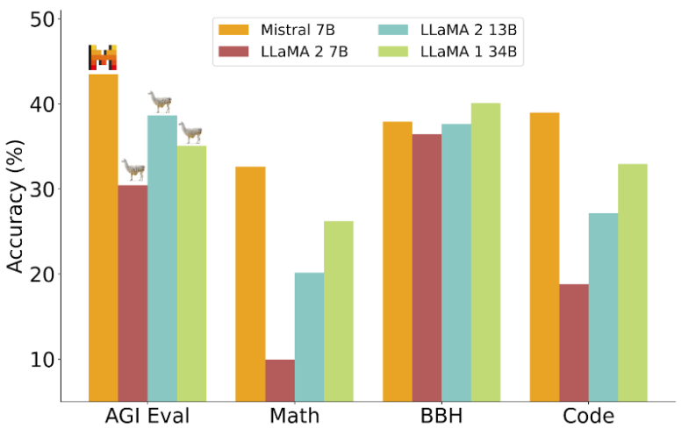

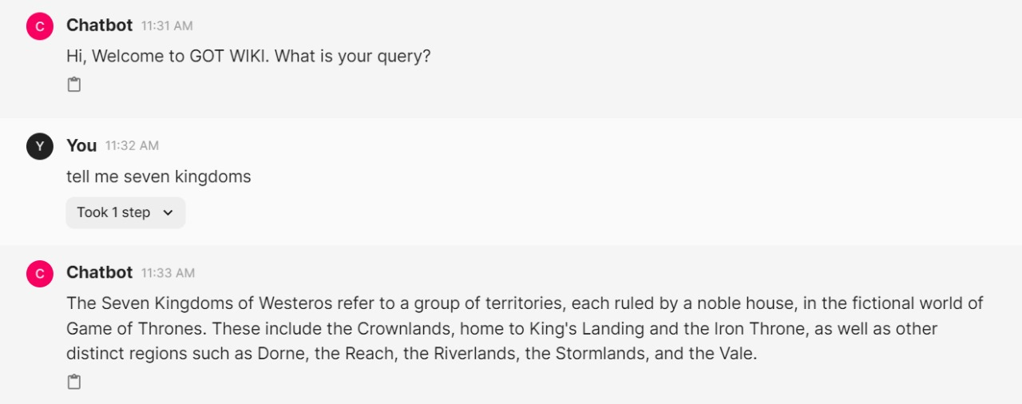

**Conclusion**

In conclusion, the "Conversational AI for Game of Thrones Websites" project stands as a groundbreaking endeavor, leveraging advanced artificial intelligence to enrich user experiences within the realm of Westeros. The introduction of Conversational AI brings forth a sophisticated virtual assistant capable of not only answering inquiries but also guiding users through the website and offering real-time support.

The motivation behind this project lies in meeting the dynamic expectations of website visitors, including fans, enthusiasts, and curious minds eager to explore the intricate world of Game of Thrones. By incorporating Conversational AI, the project aims to ensure 24/7 availability, reduce administrative burdens, enhance user engagement, and deliver personalized assistance tailored to the diverse needs of the GoT fan community.

Drawing insights from existing research and successful projects like GOT-Wiki Bot, the project underscores the practical applications and advantages of implementing Conversational AI in entertainment environments. A detailed software requirements specification outlines the functional and non-functional necessities crucial for seamless development, including user interactions, administrative interfaces, and integration with GoT databases, all while adhering to stringent security and scalability standards.

Adopting an Agile Software Development Life Cycle (SDLC) model ensures iterative and adaptive development, facilitating effective project management and timely delivery. The implementation plan, complemented by design diagrams, provides a comprehensive blueprint for development and deployment, ensuring a smooth transition from concept to reality.

In summary, the "Conversational AI for Game of Thrones Websites" project not only contributes to the digital evolution of entertainment platforms but also pioneers the innovative use of Conversational AI as a powerful tool for engaging with online audiences, providing efficient support, and staying at the forefront of technological advancements within the realm of Westeros. The project team extends gratitude to all contributors and looks forward to the continued evolution and impactful integration of Conversational AI in entertainment settings.

**References**

1. B. R. Ranoliya, N. Raghuwanshi and S. Singh, "Chatbot for university related FAQs," 2017 International Conference on Advances in Computing, Communications and Informatics (ICACCI), Udupi, 2017
2. Guendalina Caldarini, Sardar Jaf, Kenneth McGarry, "A Literature Survey of Recent Advances in Chatbots", 15 January 2022
3. Tarun Lalwani, Shashank Bhalotia, Ashish Pal, Shreya Bisen, Vasundhara Rathod, "Implementation of a Chatbot System using AI and NLP ", International Journal of Innovative Research in Computer Science & Technology (IJIRCST), Volume-6, Issue-3, May 2018
4. Mir Murtaza, Yamna Ahmed, Mariam Usman, "AI-Based Personalized E-Learning Systems: Issues, Challenges, and Solutions", Published in IEEE Access 2022
5. Pradnya Kulkarni, Ameya Mahabaleshwarkar, Mrunalini Kulkarni, Nachiket Sirsikar, Kunal Gadgil, "Conversational AI: An Overview of Methodologies, Applications & Future Scope", International Conference On Computing, Communication, Control And Automation 2019
6. Emanuela Haller, Traian Rebedea, “Designing a Chat-bot that Simulates an Historical Figure”, IEEE Conference Publications, July 2013.