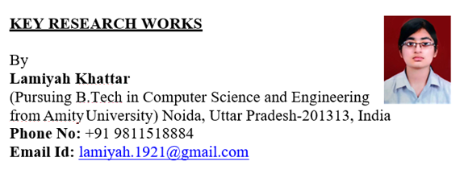

# Projects:

**Multipurpose Discord bot:** A multipurpose discord bot in javascript with aspects of machine learning which helped it possess a profanity filter and other features such as kicking people,banning people,editing roles,weather forecasting etc.

# Research Papers

Accepted for Publication:

**Analysis and Applications of systems of Online Grocery Recommendation:** The paper focused on using reorders as the basis of recommendation and applying the criteria on different recommendation system models to observe the results obtained.

**Analysis of Human Activity Recognition Using Deep Learning :** The paper focuses on drawing a comparison between the usage and accuracy of different Human Activity Recognition models. The discussion mainly focuses on two models- 2-D Convolutional Neural Network and Long-Short term Memory**.**

# Term Papers:

**Data Science :** A beginners guide to data science. Its co variants, branches, applications and affect have also been highlighted in the paper

**Cancer Analysis :** A detailed paper on the analysis of occurrence of cancer based on age, gender and type of cancer

1. **Work Experience**
2. Interned at MyCaptain for the duration of 1 month and got experience in Business Development, Marketing and Sales
3. Learnt work at Galentic Technologies Private Limited focusing on the area of Manual

testing.

1. Research Internship under Dr. Geetika Munjal and wrote a report paper on Grocery Recommender Systems,their uniqueness and most effective system

# Experiences and Achievements:

1. **Study Abroad Program** : Visited London for 6 weeks (Nov –December 2019) as a part of University Study Abroad Program. Attended Birkbeck University and wrote a Term Paper on prediction of cancer in different people based on age and gender.
2. **GRE Score**: 314, 162 in Quantitaive,152 in Verbal.
3. **Confluence 2020 and 2019:** Contributed in organizing the 9th and 10th International Conference “Confluence 2020” and “Confluence 2019” on the theme: “Cloud Computing, Data Science and Engineering”.
4. **Data Science Training:** Passed six weeks Internshala Summer “Data Science” Training with a score of 100% in the year 2019
5. **Google Analytics for Beginners:** Completed online google certified course on google analytics for beginners
6. **Ethical Hacking Workshop**: Participated in 3 days workshop for ethical hacking, certified by CETPA and Microsoft
7. **Class Representative** : Class Representative since the year 2017.
8. **Active IET Member** : Member of IET since the year 2017. Was active in many events and workshops that have been organized
9. **French Language:** Studied French Language for a total of 9 years

# Technical skills

Excellence in programming languages like C++, C and python and fine knowledge of other languages as well including PHP, HTML and Java. Worked on various projects in the field of machine learning and data science while also being experienced in SQL,DBMS and UFT.

# Soft skills:

1. Hard working and dedicated
2. Good Orator
3. Consistent
4. Excellent with people
5. Sharp memory power
6. **Extra Curriculars**

a) Diploma Prarambhik (Fine Arts) – from Shri Shankar Kala Mandir in the years 2011-13 with first division in both years

1. Diploma Bhushan (Fine Arts) – from Shri Shankar Kala Mandir in the years 2013-15 with first division in both years
2. Participated in various interschool painting, designing and project proposal competitions with positive results : 2010-17
3. Semi Finalist in St. Xavier’s - Personality Contest in the year 2015-16
4. Participated in various interclass and few interschool debates