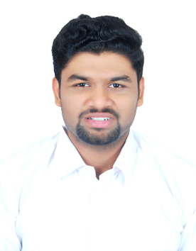

PRASAD DESAI

Personal details

**Contact #:** +91 9321063591 / 9324249312

**E-mail:** [prasad.desai3101@gmail.com](mailto:prasad.desai3101@gmail.com)

**Address**: 204, Sai-Ganesh CHS Ltd; Near Bhoir Gymkhana, Off. Mahatma Phule Road, Bhoirwadi, Dombivli (west), Maharashtra, India, 421202

**LinkedIn:** <https://www.linkedin.com/in/prasad-desai-3aab69124/>

Objective

To associate myself with an organization to prove my innovative skills and to work in a position where my skills and knowledge of Information Technology are utilized in the best possible way, which provides me with an opportunity for growth in my professional career and also contribute to the growth of the organization.

Credentials

|  |  |  |  |
| --- | --- | --- | --- |
| **Degree** | **Academic Year** | **Board** | **Percentage** |
| MBA (IT) | 2019-2021 | SIU | Pursuing |
| B.Sc. (IT) | 2018-2019 | Mumbai | 7.78 SGPI |
| HSC | 2015-2016 | Maharashtra | 57.23% |

achievements

* Certified by **NIIT** for successfully completing **Programming in Java** & Currently **appearing** for **DT (Digital Transformation) Course** conducted by NIIT.
* Completed the course in **Data Analytics using Excel**.
* Was the **Core Member** of **Students Council** for **two consecutive years** **(2016-2017 & 2017-2018).**
* Achieved **First Prize** in **Android Development** Competition held by **Asterix Solutions.**
* Completed the course in **Advance Google Analytics** from **Google Analytics Academy**.
* Participated in **Developers Weekend** held at **SIES Graduate School of Technology**.

* Completed the course of **Microsoft Analysis and Dashboard Reporting.**

Techinical Skills

* Data Analytics using Python
* Data visualization using Tableau
* Data visualization using Power BI
* MySQL
* Java
* HTML
* Computer Skills

Strength

* Communication
* Team Building & Leadership
* Ability to work under pressure
* Presentation skills
* Creativity

Projects

* **SIA-TECHLINK:** -

Selected for Developing and Building Business Logic of college/industry projects in 2018

i.e. **E-Ticketing** project using STRUTS & with JSP as Frontend and MYSQL as the Backend. The objective of this system was we can file a complaint or any problems online i.e. the online grievance box.

HOBBIES

* Endurance Sports
* Community group involvement
* Hiking
* Watching Movies & Listening Music

Personal Particulars

* Date of Birth : January 31, 1999
* Languages Known : English, Hindi, Marathi, Kannada
* Nationality : Indian
* Marital Status : Unmarried
* Passport valid till : January 02, 2027

Declaration

I hereby declare that the above-mentioned information is true to the best of my knowledge.