Processing update package. Check dmpdownloader.log for details.

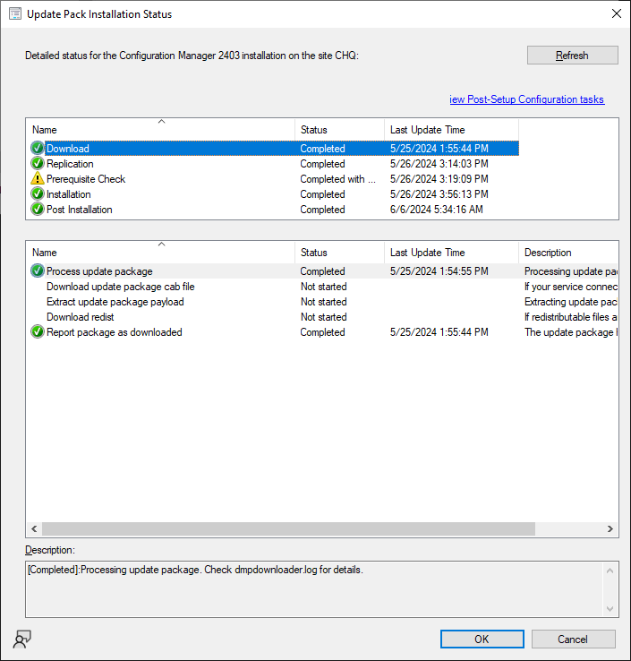

Creating or updating Configuration Manager Update Package. Check hman.log for details.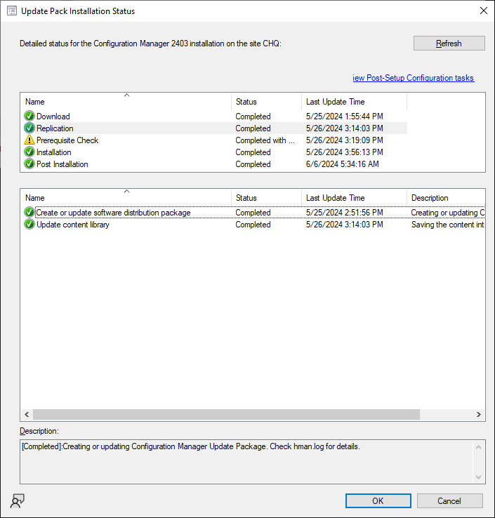

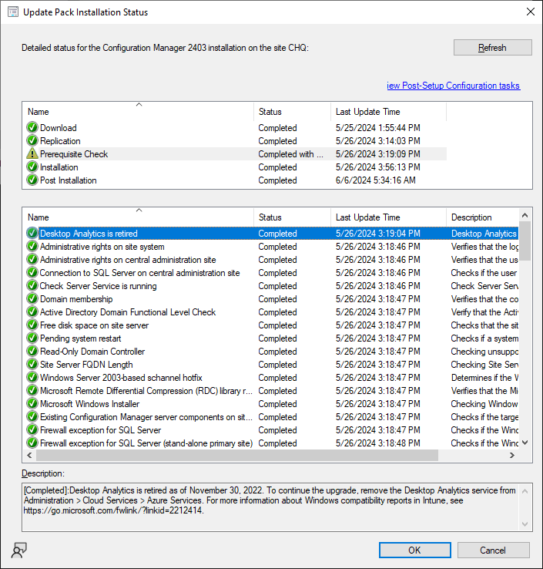

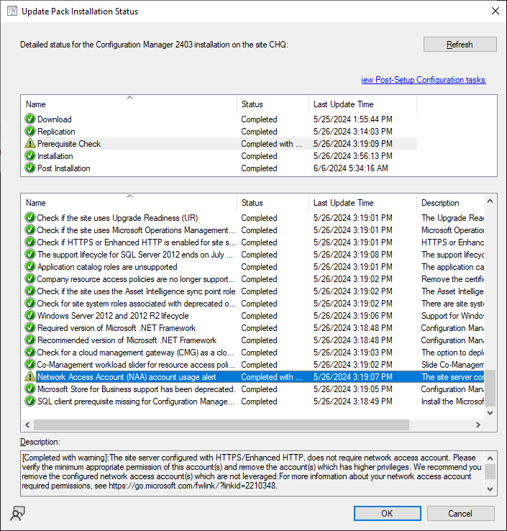

[Completed with warning]:The site server configured with HTTPS/Enhanced HTTP, does not require network access account. Please verify the minimum appropriate permission of this account(s) and remove the account(s) which has higher privileges. We recommend you remove the configured network access account(s) which are not leveraged.For more information about your network access account required permissions, see <https://go.microsoft.com/fwlink/?linkid=2210348>.