

The script “CopyOSDLogs.ps1” can be run anywhere in an OSD TS but is most often used in the Error Section, thus

only run in case of a failed deployment.

For more info. on how to set up error handling in a non-MDT Task Sequence please check this post by my colleague @ccmexec: <http://ccmexec.com/2016/12/error-handling-in-ts-without-mdt-using-osdbackground/>

There are a couple of pre-requisites to make it work:

* Powershell Optional Component in Boot image.
* We need a location (file share) to save the logs.
* A TS Variable holding the UNC path to the share.
* The “First” Network Access Account must be granted “Modify” permissions on the share.

The script will use the Network Access Account for authentication; making it work also in the event of a failure during Windows PE, where we cannot use the computer account, as the machine is not yet domain joined

Check the name of your “first” NAA, if you have several it should be the one on top.

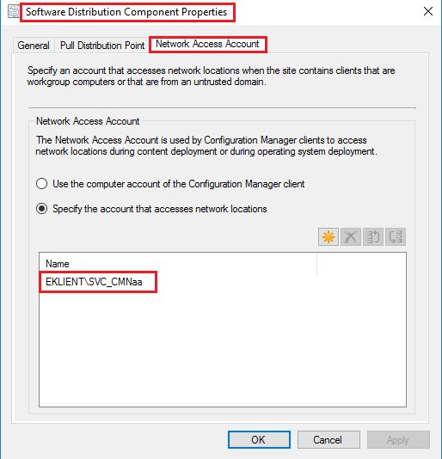

Make sure the Account has been granted "Modify" permissions on your log share:

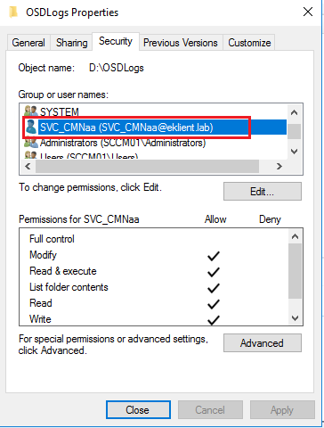

Create a TS Variable "SLShare" and assign it the UNC-Path to your log share:

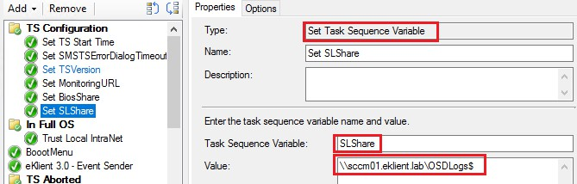

Create a Package (without program) or put the script in an existings scripts package, incorporate in TS as:

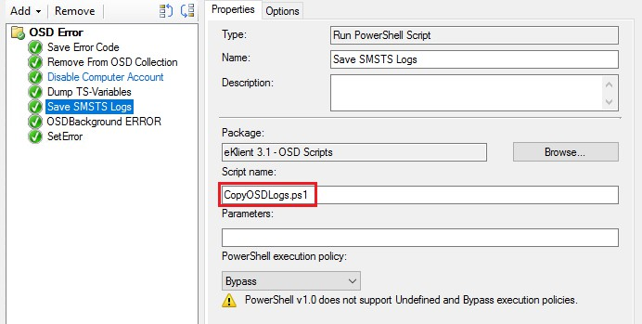

In the event of a failure the SMSTSLogs folder will now get zipped and stored as a single file on your log share:

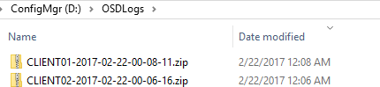

Happy Deployment!