Business Interpretation Report – Employee Attrition
What the models tell HR leadership, and what to do about it
DATA NOTE: the figures in this report were produced on a synthetic dataset that has the same schema as the IBM HR Analytics file (the real file could not be downloaded in the build environment). Re-run the notebook with the real file in data/ and then `python src/build_reports.py` to refresh every number and chart.

1. Executive summary
About 16% of employees in the dataset left. Our best model (Logistic Regression) ranks employees by leaving-risk with a ROC-AUC of 0.78 on unseen data and flags roughly 59% of actual leavers. The strongest, most actionable drivers are pay level, overtime, job satisfaction and tenure/management stability. Employees working overtime left at 29.4% versus 10.5% for those who do not – nearly 2.8× the rate.

2. What drives attrition
Ranked by permutation importance (how much predictive power is lost when the feature is shuffled):
- MonthlyIncome (importance 0.154)
- OverTime (importance 0.057)
- JobSatisfaction (importance 0.020)
- YearsWithCurrManager (importance 0.018)
- Age (importance 0.016)
- StockOptionLevel (importance 0.012)
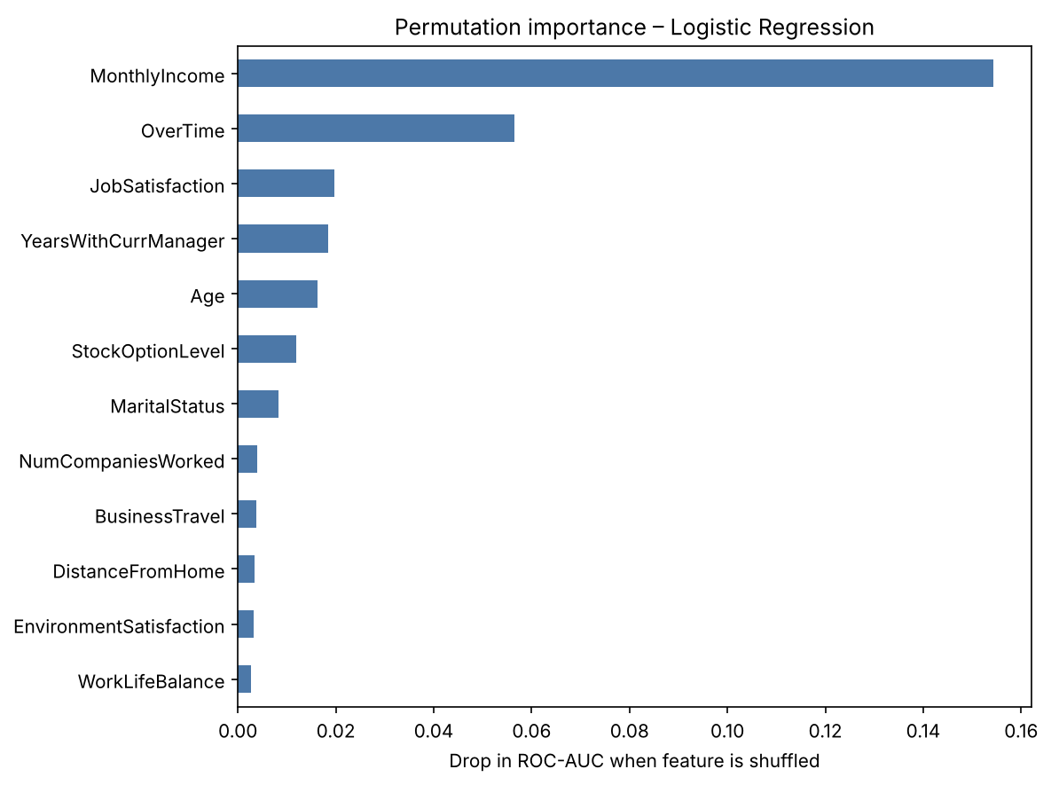
Figure 1 – Top drivers of attrition risk.
Direction of effect (logistic regression, standardised coefficients):
- Raises risk: OverTime_Yes, BusinessTravel_Travel_Frequently, MaritalStatus_Single, JobRole_Sales Representative, EducationField_Other
- Lowers risk: MonthlyIncome, OverTime_No, BusinessTravel_Non-Travel, EducationField_Technical Degree, MaritalStatus_Divorced
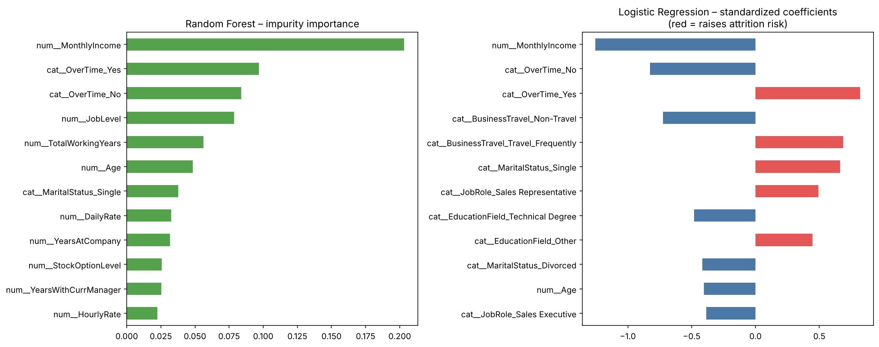
Figure 2 – Importance and direction of effect.

3. Business interpretation
- Compensation: lower monthly income is the single strongest warning sign; low-paid staff in early job levels are the most mobile.
- Workload: overtime is the clearest controllable lever – overworked employees leave at a much higher rate.
- Engagement: low job satisfaction and poor work-life balance raise risk, but satisfaction itself could not be predicted from HR fields (R² ≈ 0), so it must be measured directly via surveys.
- Career stability: short tenure with the current manager, many previous employers and no stock options all point to flight risk.
- Profile: single employees and frequent business travellers show higher attrition.

4. Recommendations
- Run a pay-equity / market-benchmark review for low-income, junior roles first; targeted raises are cheaper than replacement.
- Cap and monitor overtime; flag teams where a large share of staff work overtime and rebalance headcount or deadlines.
- Extend stock-option / retention-bonus eligibility to high-risk, high-performing staff.
- Add stay-interviews and a pulse survey (job satisfaction, work-life balance) for employees in the top risk decile.
- Strengthen manager continuity: avoid unnecessary manager reassignments; coach managers of high-risk teams.
- Review travel-heavy roles for travel reduction or compensation.

5. How HR should use the model
- Score the workforce monthly and review the top 10–15 % highest-risk employees with their manager.
- Use it as a conversation starter, not a decision about an individual; never use it for firing, pay-cuts or promotion decisions.
- Check fairness regularly (age, gender, marital status) – these attributes are correlated with outcomes and must not drive unequal treatment.
- Retrain every 6–12 months and track whether interventions actually reduce attrition (A/B or matched-group comparison).

6. Caveats
- Predictive ≠ causal: reducing overtime is expected to help, but it should be piloted and measured.
- Precision is modest (many flagged employees would have stayed), so interventions should be low-cost and supportive.
- Small dataset; results should be validated on the company's own, larger and more recent data.

