Evaluation Report – Employee Attrition Prediction Models
Classification of employee attrition with Logistic Regression, Decision Tree, Random Forest and XGBoost
DATA NOTE: the figures in this report were produced on a synthetic dataset that has the same schema as the IBM HR Analytics file (the real file could not be downloaded in the build environment). Re-run the notebook with the real file in data/ and then `python src/build_reports.py` to refresh every number and chart.

1. Objective
Predict whether an employee will leave the company (Attrition = Yes) using HR records, compare four classification algorithms, improve them with cross-validation and hyper-parameter tuning, and identify the features that drive attrition.

2. Data
Source: synthetic stand-in (IBM schema). 1470 employees, 30 predictor columns (after dropping constant/ID columns). Attrition rate = 15.7%, i.e. the classes are imbalanced (about 1 leaver per 5 stayers).
Preprocessing: stratified 80/20 train/test split (random_state=42); numeric features standardised, categorical features one-hot encoded, all inside a scikit-learn Pipeline to avoid leakage. Class imbalance handled with class weights (scale_pos_weight for XGBoost).
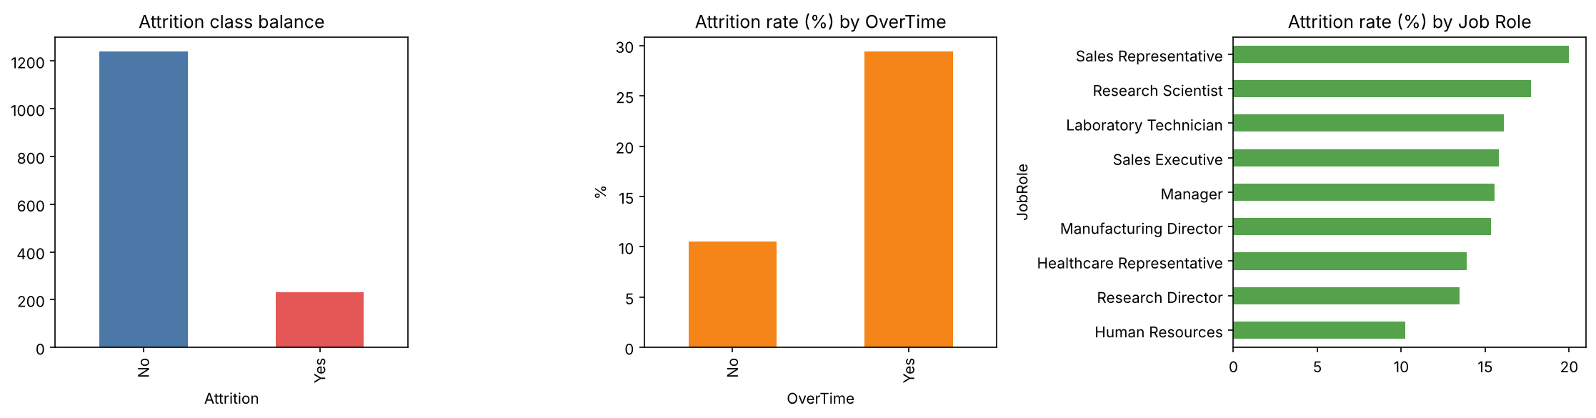
Figure 1 – Class balance and attrition rate by OverTime / Job Role.

3. Methodology
- Metrics: Accuracy, Precision, Recall, F1, ROC-AUC (positive class = leaver).
- Cross-validation: 5-fold stratified CV on the training set for every model.
- Tuning: RandomizedSearchCV (20 candidates, 5-fold CV, scoring = ROC-AUC) per model.
- Final scores: tuned models evaluated once on the untouched 20 % test set.
- Interpretation: permutation importance, random-forest importance and logistic-regression coefficients.

4. Results

4.1 Baseline models (test set)
Model | Accuracy | Precision | Recall | F1 | ROC-AUC
Logistic Regression | 0.735 | 0.314 | 0.587 | 0.409 | 0.771
Decision Tree | 0.660 | 0.240 | 0.543 | 0.333 | 0.668
Random Forest | 0.837 | 0.458 | 0.239 | 0.314 | 0.739
XGBoost* | 0.786 | 0.319 | 0.326 | 0.323 | 0.731

4.2 5-fold cross-validation (training set, mean ± std)
Model | Accuracy | Precision | Recall | F1 | ROC-AUC
Logistic Regression | 0.748 ± 0.026 | 0.349 ± 0.044 | 0.697 ± 0.106 | 0.465 ± 0.062 | 0.816 ± 0.053
Decision Tree | 0.698 ± 0.055 | 0.297 ± 0.042 | 0.632 ± 0.063 | 0.401 ± 0.034 | 0.697 ± 0.031
Random Forest | 0.852 ± 0.010 | 0.545 ± 0.053 | 0.357 ± 0.096 | 0.426 ± 0.071 | 0.792 ± 0.035
XGBoost* | 0.820 ± 0.026 | 0.442 ± 0.067 | 0.541 ± 0.070 | 0.486 ± 0.068 | 0.769 ± 0.032

4.3 Tuned models (test set)
Model | Accuracy | Precision | Recall | F1 | ROC-AUC | CV ROC-AUC (best)
Logistic Regression | 0.745 | 0.325 | 0.587 | 0.419 | 0.776 | 0.817
Decision Tree | 0.684 | 0.272 | 0.609 | 0.376 | 0.688 | 0.724
Random Forest | 0.786 | 0.369 | 0.522 | 0.432 | 0.764 | 0.795
XGBoost* | 0.748 | 0.325 | 0.565 | 0.413 | 0.754 | 0.804

* NOTE: in this run the xgboost package was unavailable, so the XGBoost row is a gradient-boosted-tree fallback (sklearn HistGradientBoosting). Re-running the notebook with `pip install xgboost` replaces it with true XGBoost.

4.4 Best hyper-parameters
- Logistic Regression: {'penalty': 'l2', 'C': 0.23357214690901212}
- Decision Tree: {'min_samples_leaf': 40, 'max_depth': 4, 'criterion': 'entropy'}
- Random Forest: {'n_estimators': 200, 'min_samples_leaf': 10, 'max_features': 'sqrt', 'max_depth': 6}
- XGBoost: {'min_samples_leaf': 20, 'max_iter': 100, 'max_depth': 2, 'learning_rate': 0.05, 'l2_regularization': 1.0}
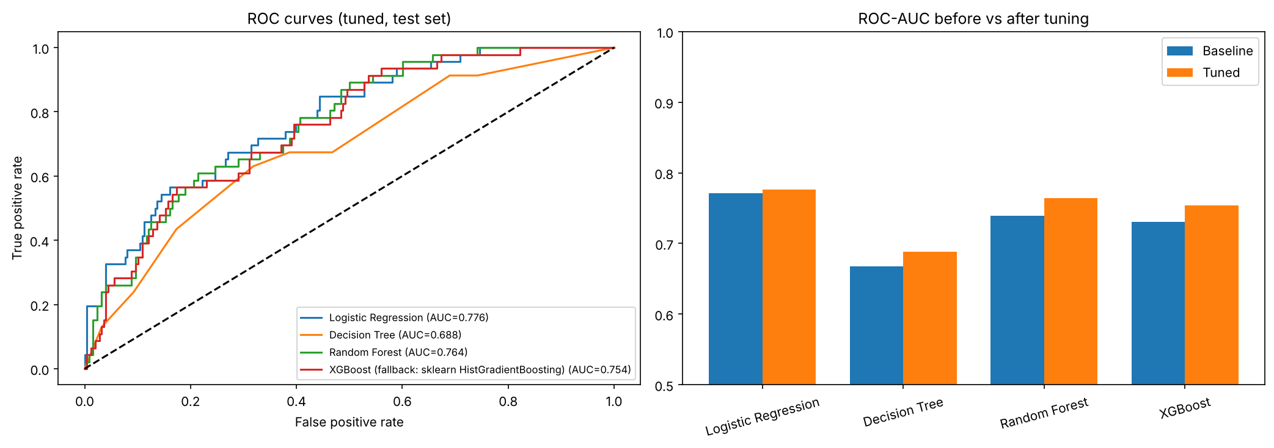
Figure 2 – ROC curves of the tuned models and ROC-AUC before vs after tuning.
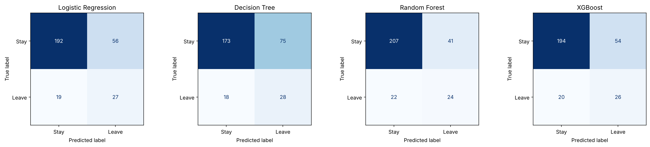
Figure 3 – Confusion matrices (tuned models, test set).

5. Feature importance
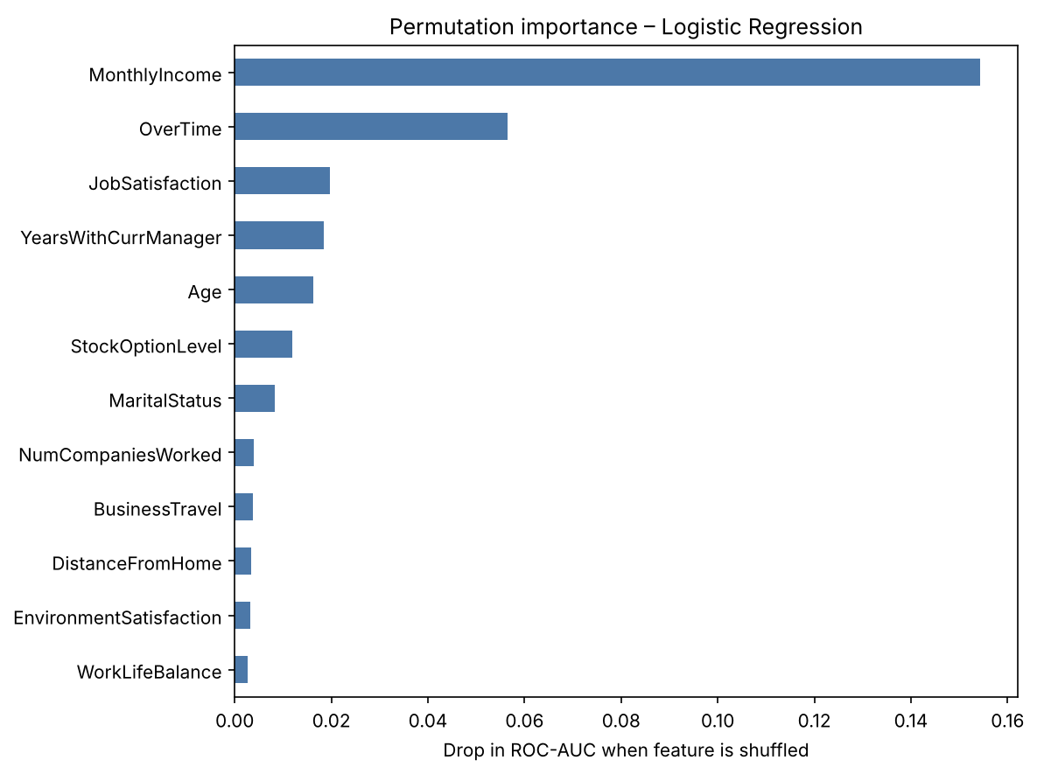
Figure 4 – Permutation importance for the best model (Logistic Regression).
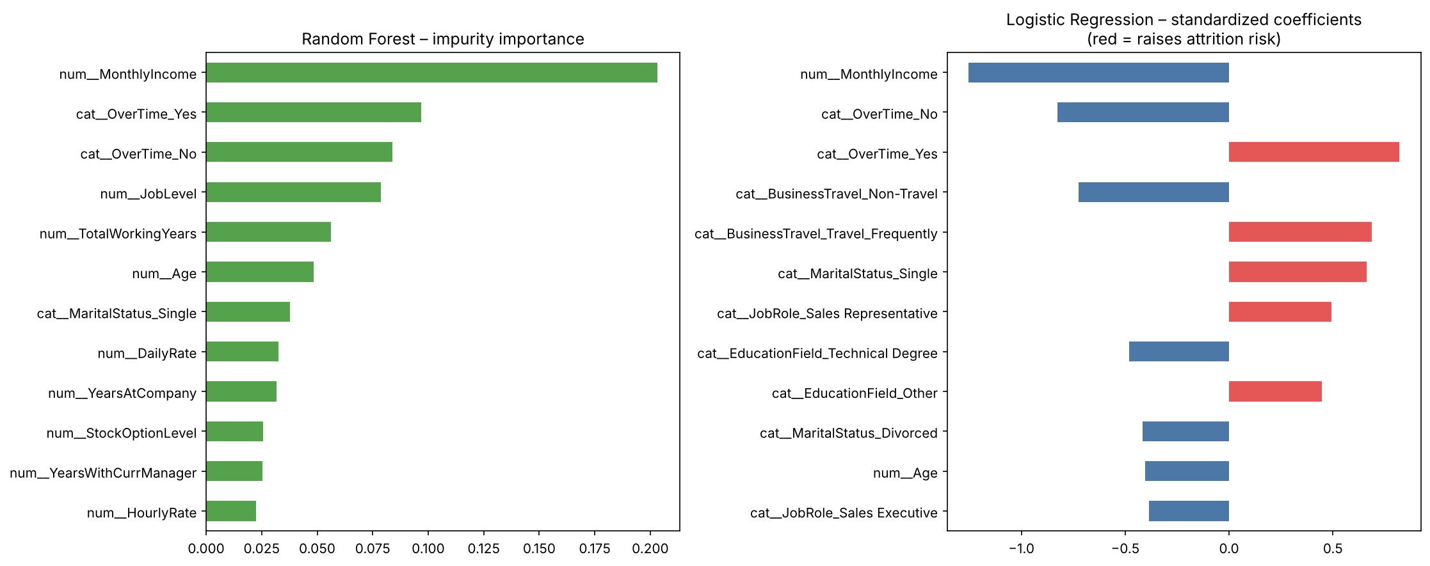
Figure 5 – Random Forest importance and Logistic Regression coefficients.

6. Optional regression task – predicting Job Satisfaction
Model | MAE | RMSE | R2
Linear Regression | 0.939 | 1.104 | -0.072
Random Forest Regressor | 0.936 | 1.096 | -0.057
Baseline (predict mean) | 0.920 | 1.066 | 0.000

Job satisfaction (1–4) is only weakly predictable from the HR record: both regressors barely improve on predicting the mean (R² ≈ 0). Conclusion: satisfaction needs survey/engagement data; it should be collected rather than modelled from HR fields.

7. Discussion
- Best ROC-AUC on the test set: Logistic Regression (0.776). Highest recall: Decision Tree (0.609).
- Accuracy is misleading here: a model that always predicts 'stay' would score about 84%. Recall, F1 and ROC-AUC are the relevant measures.
- Tuning and class weighting improved recall/F1 for most models, at the cost of some precision – an acceptable trade-off, because missing a leaver is costlier than a retention conversation with someone who would have stayed.
- Simple, regularised linear models are competitive with ensembles on this small tabular dataset (≈1.5k rows); ensembles need more data to pull ahead.
- Single decision trees are the weakest and most unstable; they are useful only as an easy-to-read rule set.

8. Limitations
- Small dataset (1,470 rows, ~230 leavers) → wide confidence intervals (see ± in CV table).
- Features are a snapshot; no time dimension, so attrition cannot be forecast by month.
- Associations are not causal; model outputs should support, not replace, manager judgement.
- Probability threshold fixed at 0.5; HR could choose a lower threshold to catch more leavers.

