**Q1) Pull any image from the docker hub, create its container, and execute it showing the output.**

Docker is a software platform to create, test and deploy applications in an isolated environment. Docker uses container to package up an application with all of the parts it needs including, libraries and dependencies.

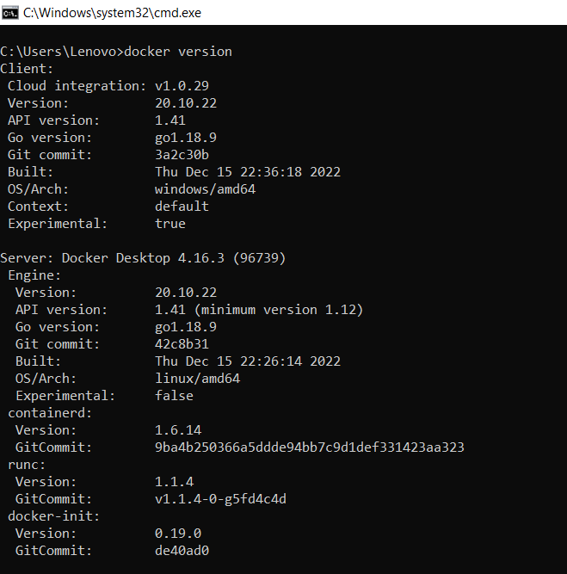

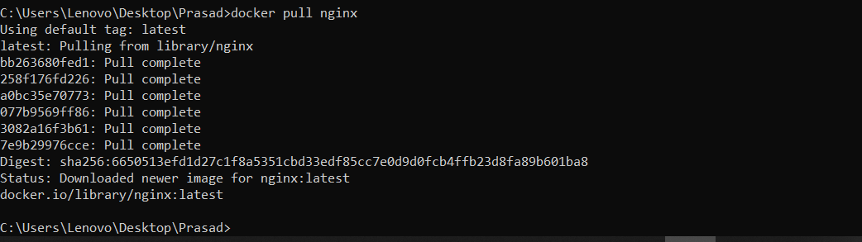



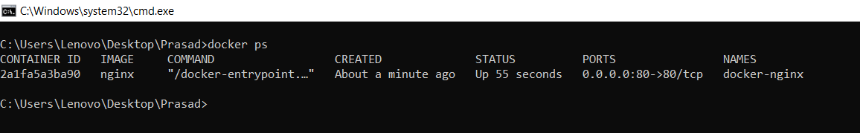

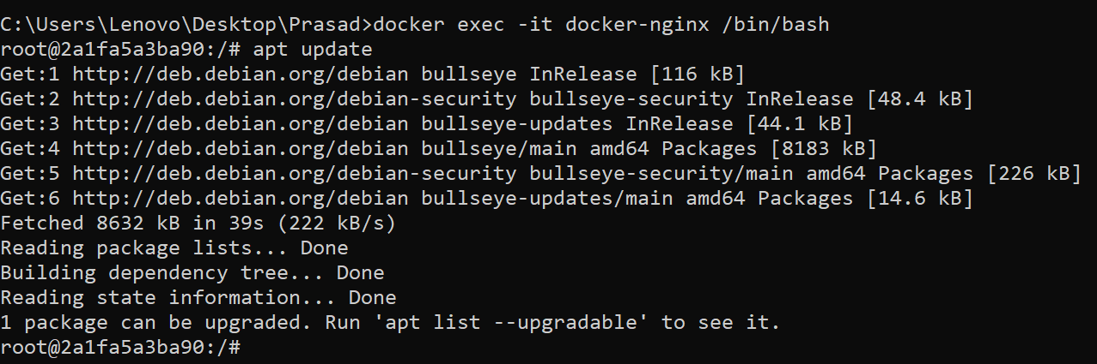

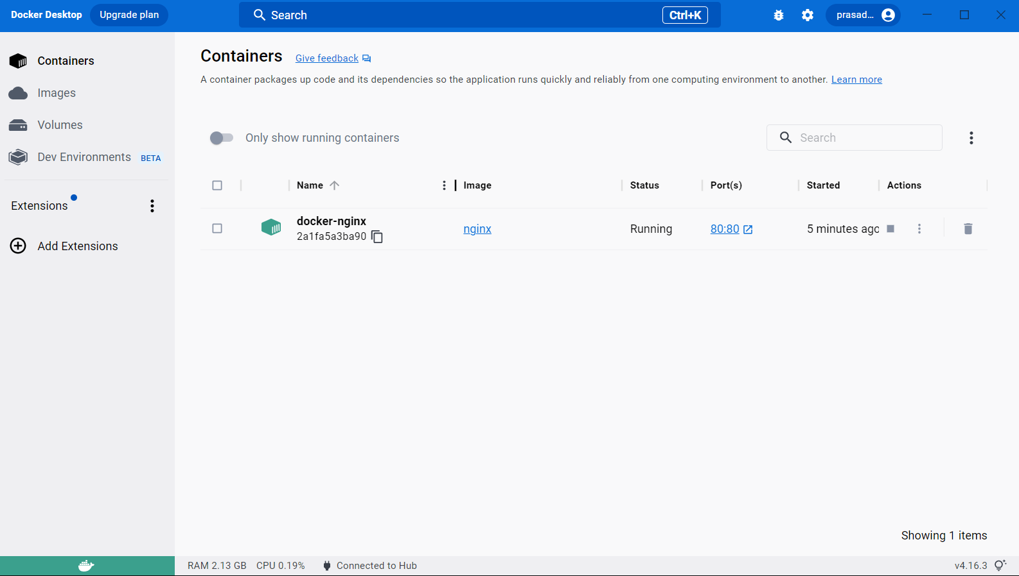

**Q2) Create the basic java application, generate its image with necessary files, and execute it with docker**.

Creation of basic java application

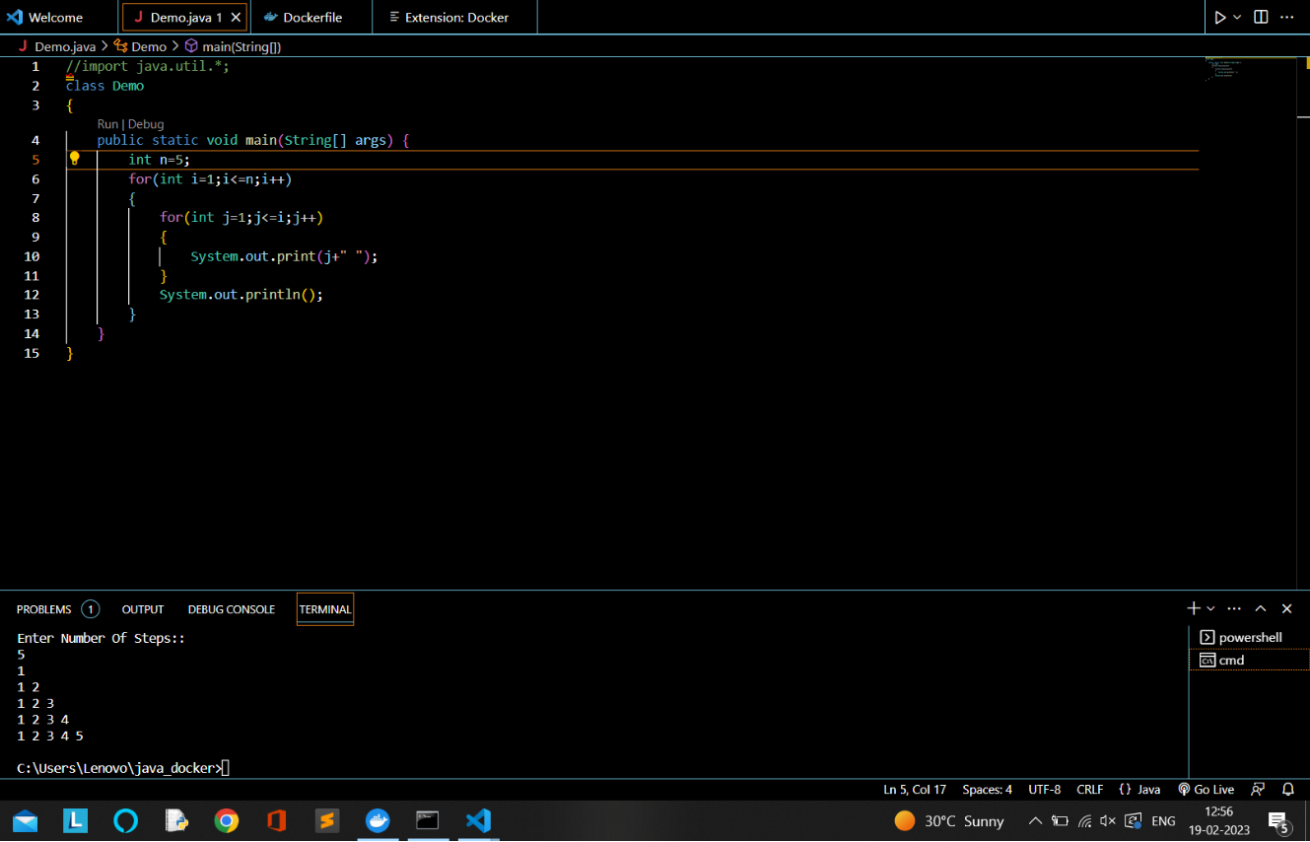

Docker file:

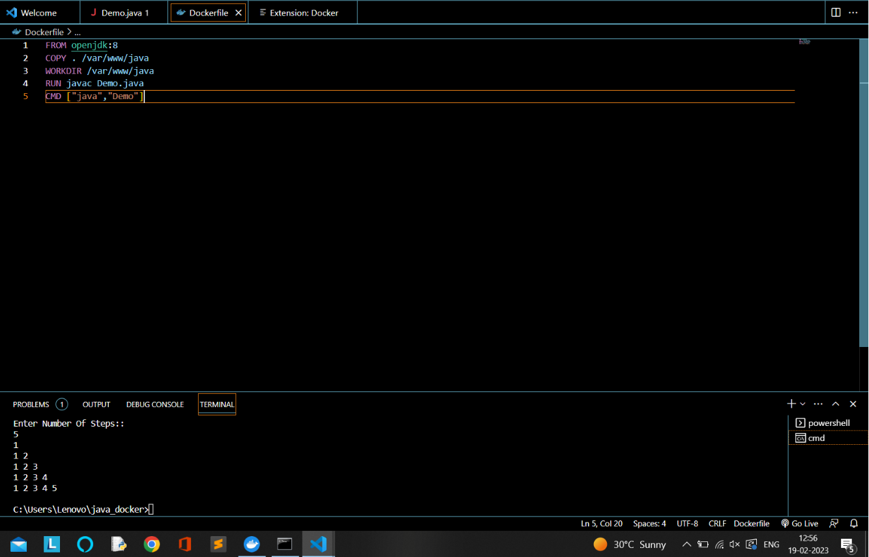

create an image by following below command.we must login as root in order to create a image.In the following command ,java-app is name of the image.We can have any name for our docker image.

