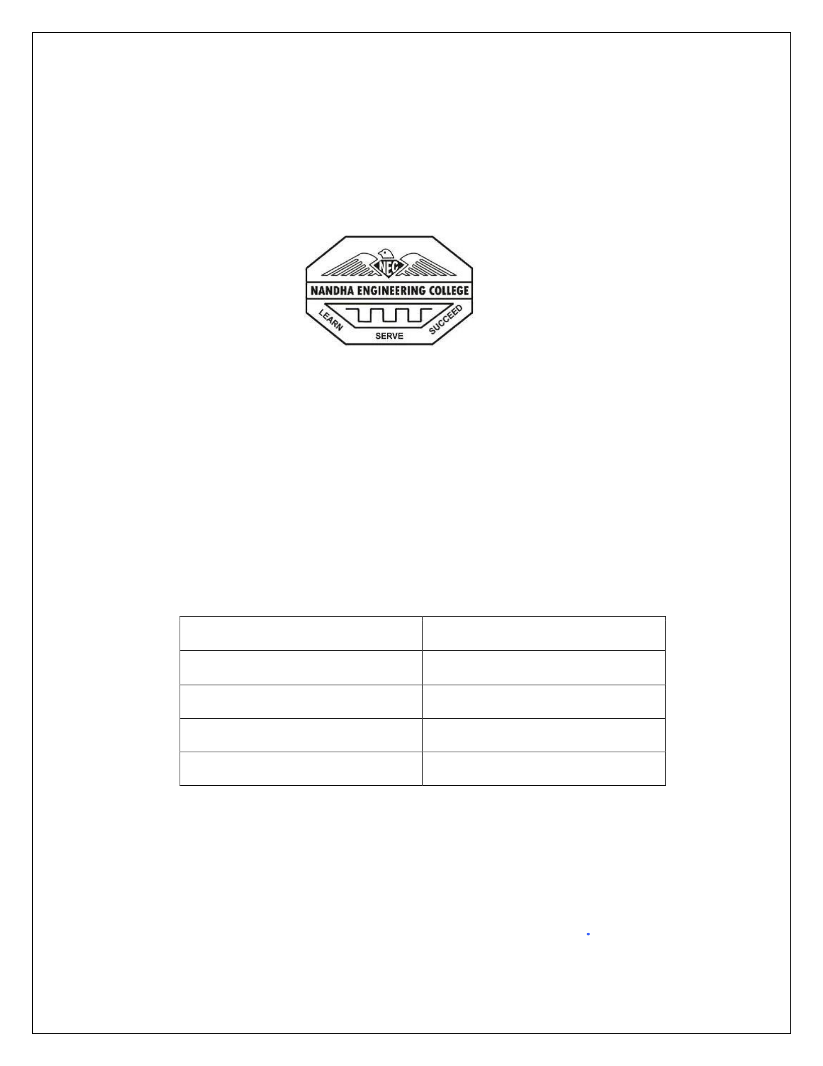
NANDHA ENGINEERING COLLEGE ERODE–638052 (Autonomous)
(Affiliated to Anna University, Chennai)
DEPARTMENT OF ARTIFICIAL INTELLIGENCE AND DATA SCIENCE
PROJECT CHRONOSYNC
PBL REPORT
22AIC09 – DATABASE DESIGN MANAGEMENT Submitted by
REGISTER NUMBER | NAME
22AI009 | DEEPAKKUMAR M
22AI036 | PRANESH E R
22AI037 | PRASAD R S
22AI052 | TAMILMUHILAN B
in partial fulfillment for the award of the degree of
BACHELOR OF TECHNOLOGY
IN
ARTIFICIAL INTELLIGENCE AND DATA SCIENCE

NANDHA ENGINEERING COLLEGE
(An Autonomous Institution, Affiliated to Anna University, Chennai)
BONAFIDE CERTIFICATE
This is to certify that the project work entitled “CHRONOSYNC” is the bonafide work of
DEEPAKKUMAR M (22AI009), PRANESH E R (22AI036), PRASAD R S (22AI037),
TAMILMUHILAN B (22AI052) who carried out the work under my supervision.
Signature of the SupervisorSignature of the HOD
Ms.S. SHANMUGA PRIYA, Ms.M.PARVATHI,
Assistant Professor, Assistant Professor and Head ,
Department of AI&DS, Department of AI&DS,
Nandha Engineering College, Nandha Engineering College,
Erode-638052. Erode-638052.
Submitted for End semester PBL review held on

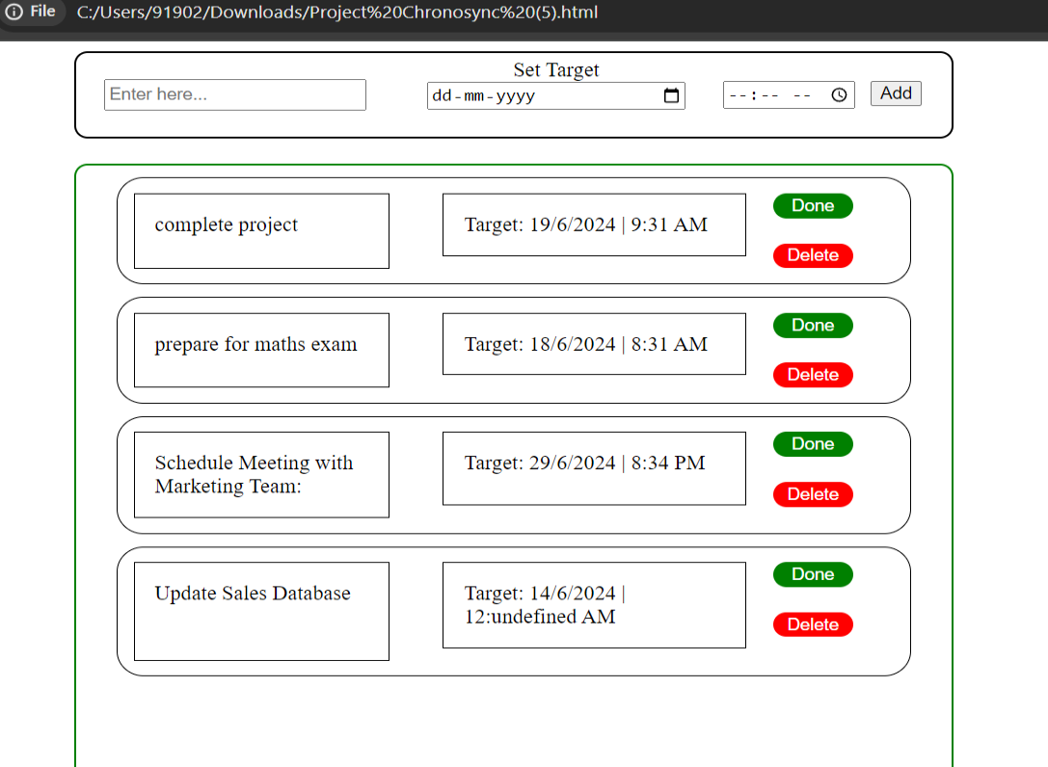
After Set Goals / Tasks
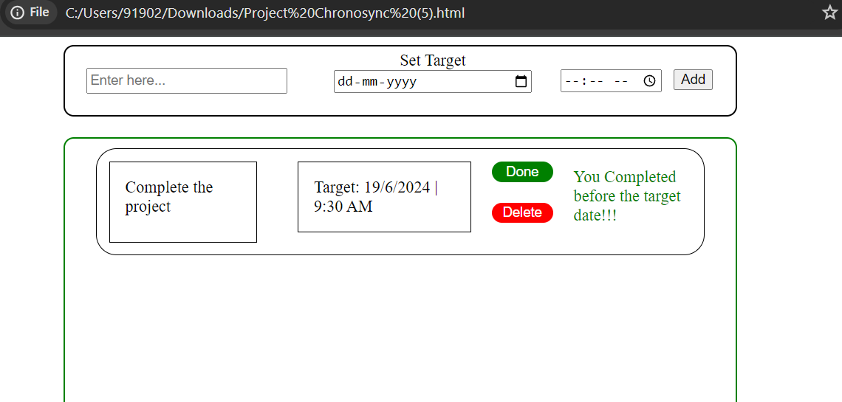
Complete the Task
41

CONCLUSION
As the project progresses, there are several avenues for future development that could significantly enhance the application's capabilities and user experience. One key area of focus should be the implementation of robust reminder notifications. By integrating intelligent reminders, users can stay on top of upcoming deadlines, meetings, and task due dates, ensuring better time management and productivity. This feature could leverage machine learning algorithms to provide personalized reminders based on user behavior and preferences, further improving its effectiveness.
Another important aspect to explore is the integration of advanced collaboration tools for team-based projects. Enabling seamless file sharing, real-time document editing, and secure communication channels would foster better teamwork and facilitate the successful completion of complex, multi-stakeholder initiatives. Integrating the application with popular calendar applications, such as Google Calendar or Microsoft Outlook, would further streamline the user experience by allowing for easy scheduling and synchronization of project-related events.
Enhancing the data visualization capabilities of the application is another crucial area for future development. By providing users with intuitive and customizable
dashboards, they can gain deeper insights into their productivity, task progress, and resource utilization. This could include features like Gantt charts, burndown charts, and
42

interactive visualizations that help users identify trends, bottlenecks, and opportunities
for optimization. Incorporating machine learning-powered predictive analytics could
also enable users to anticipate potential issues and make more informed decisions.
REFERENCES
Website Referred:
• http://www.dreamincode.net/
•
•
•
•
•
43

