Express js
Express setup:npm i express

1.Web server and Page handling with 404 error

const express = require('express')
const app = express ()
const path = require('path')
const PORT = process.env.PORT || 3500

app.get('^/$|index(.html)?' , (req , res) =>
{
// res.send('Hi Prasanth')
res.sendFile(path.join(__dirname,'index.html'))
})

app.get('/new-page(.html)?' , (req , res) =>
{
// res.send('Hi Prasanth')
res.sendFile(path.join(__dirname,'new-page.html'))
})

app.get('/old-page(.html)?' , (req , res) =>
{
res.redirect(301 , 'new-page.html')
})

app.get('/hello' , (req,res,next) =>
{
console.log('Loading Hello...')
next()
}, (req,res) =>
{
res.send('Hi hello')
})

app.get('/*' , (req,res) =>
{
res.status(404).send('404 page not found !')
})
app.listen( PORT ,() => console.log('Server is running on',PORT))

2.Chain Functions
const express = require('express')
const app = express ()
const path = require('path')
const PORT = process.env.PORT || 3500

app.get('^/$|index(.html)?' , (req,res) =>
{
res.sendFile(path.join(__dirname,'index.html'))
})

app.get('/new(.html)?' , (req,res) =>
{
res.sendFile(path.join(__dirname,'new-page.html'))
})

app.get('/hello' , (req,res,next) =>
{
console.log('Loading Hello ')
next()
},(req,res) =>
{
res.send('Hello ')
})

const one = (req,res,next) =>
{
console.log('One')
next()
}
const two = (req,res,next) =>
{
console.log('Two')
next()
}
const three = (req,res) =>
{
console.log('three')
res.send('Finished')
}

app.get('/chain' , [one,two,three])

app.get('/*', (req,res) =>
{
res.status(404).send('404 Page not found')
})

app.listen( PORT , () =>
{
console.log('Server running on ',PORT)
})

3.Middleware
const express = require('express')
const app = express ()
const path = require('path')
const PORT = process.env.PORT || 3500

app.use(express.urlencoded({extended:false}))
app.use(express.json())
app.use(express.static(path.join(__dirname,'/public')))

app.get('^/$|index(.html)?' , (req,res) =>
{
res.sendFile(path.join(__dirname,'index.html'))
})

app.get('/new(.html)?' , (req,res) =>
{
res.sendFile(path.join(__dirname,'new-page.html'))
})

app.get('/hello' , (req,res,next) =>
{
console.log('Loading Hello ')
next()
},(req,res) =>
{
res.send('Hello ')
})

const one = (req,res,next) =>
{
console.log('One')
next()
}
const two = (req,res,next) =>
{
console.log('Two')
next()
}
const three = (req,res) =>
{
console.log('three')
res.send('Finished')
}

app.get('/chain' , [one,two,three])

app.get('/*', (req,res) =>
{
res.status(404).send('404 Page not found')
})

app.listen( PORT , () =>
{
console.log('Server running on ',PORT)
})
OUTPUT:
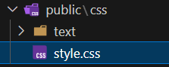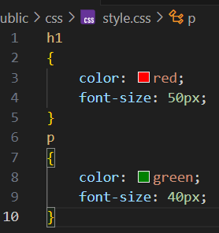

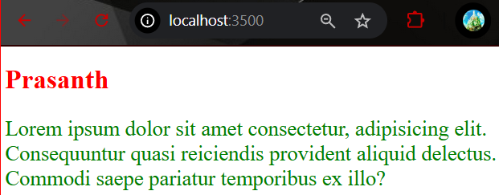

app.use(express.json())

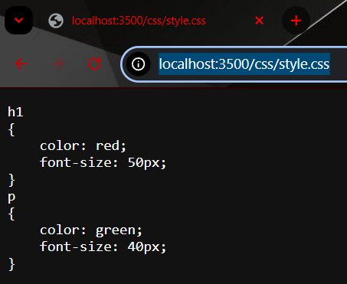

Method and Path :

const express = require('express')
const path = require('path')
const app = express ()
const PORT = process.env.PORT || 3500

//Ena ena files lam use panniruku nu paakurathuku use:
app.use( (req,res,next) => // next ah use panna adhu middle ware
{
console.log( `${req.method} | ${req.path}`)
next()
})

app.use(express.urlencoded({extended:false}))
app.use(express.json())

app.use(express.static(path.join(__dirname,'public'))) //File Access (important Line)

app.get('^/$|index(.html)?' , (req,res) =>
{
res.sendFile(path.join(__dirname,'index.html'))
})

app.get('/new-page(.html)?' , (req,res) =>
{
res.sendFile(path.join(__dirname,'new-page.html'))
})

app.listen( PORT ,() =>
{
console.log('Server is running on',PORT)
})

app.get('/*', (req,res) =>
{
res.status(404).send('404 Page not found')
})

OUTPUT:
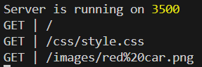
Middleware and Logs:
Step 1: Create the path and the logEvents file
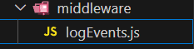

logEvents.js:
const { format } = require('date-fns')
const { v4 : uuid} = require('uuid')

const fs = require('fs')
const fsPromises = require('fs').promises
const path = require('path')

const logEvents = async(message,filename) =>
{
const datetime = format(new Date(), 'dd/MM/yyyy\tHH:mm:ss')
const logItem = `${datetime}\t${uuid()}\t${message}\n`

try
{
if(!fs.existsSync(path.join(__dirname,'Logs')))
{
await fsPromises.mkdir(path.join(__dirname,'Logs'))
await fsPromises.appendFile(path.join(__dirname,'Logs',filename),' Date Time uID Message\n')
}
await fsPromises.appendFile(path.join(__dirname,'Logs',filename), logItem)
}
catch(err)
{
console.error(err)
}
}

module.exports = logEvents

web_server.js:
const express = require('express')
const logEvents = require('./middleware/logEvents')
const path = require('path')
const app = express ()
const PORT = process.env.PORT || 3500
//Ena ena files lam use panniruku nu paakurathuku use:
app.use( (req,res,next) => //use next as a middleware
{
logEvents(`${req.method}|${req.url}`,'reqlogs.txt')
next()
})

app.use(express.urlencoded({extended:false}))
app.use(express.json())

app.use(express.static(path.join(__dirname,'public'))) //File Access (important Line)

app.get('^/$|index(.html)?' , (req,res) =>
{
res.sendFile(path.join(__dirname,'index.html'))
})

app.get('/new-page(.html)?' , (req,res) =>
{
res.sendFile(path.join(__dirname,'new-page.html'))
})

app.listen( PORT ,() =>
{
console.log('Server is running on',PORT)
})

app.get('/*', (req,res) =>
{
res.status(404).send('404 Page not found')
})
After Refresh:::::::::::::::::::::
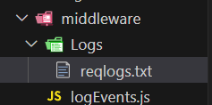

Reqlogs.txt
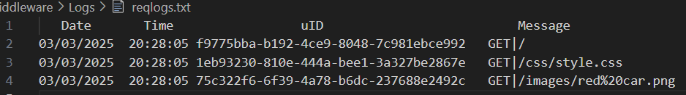
Middleware and Logger:
logEvents.js

const { format } = require('date-fns')
const { v4 : uuid} = require('uuid')

const fs = require('fs')
const fsPromises = require('fs').promises
const path = require('path')

const logEvents = async(message,filename) =>
{
const datetime = format(new Date(), 'dd/MM/yyyy\tHH:mm:ss')
const logItem = `${datetime}\t${uuid()}\t${message}\n`

try
{
if(!fs.existsSync(path.join(__dirname,'Logs')))
{
await fsPromises.mkdir(path.join(__dirname,'Logs'))
await fsPromises.appendFile(path.join(__dirname,'Logs',filename),' Date Time uID Message\n')
}
await fsPromises.appendFile(path.join(__dirname,'Logs',filename), logItem)
}
catch(err)
{
console.error(err)
}
}

const logger = (req,res,next) => //use next as a middleware
{
logEvents(`${req.method}|${req.url}`,'reqlogs.txt')
next()
}

module.exports = {logEvents,logger}

web_server.js

//======================Middle ware + Logger======================
const express = require('express')
const {logger} = require('./middleware/logEvents')
const path = require('path')
const app = express ()
const PORT = process.env.PORT || 3500

//Ena ena files lam use panniruku nu paakurathuku use:
app.use(logger)
……………
……………

Third-party- Middle ware:
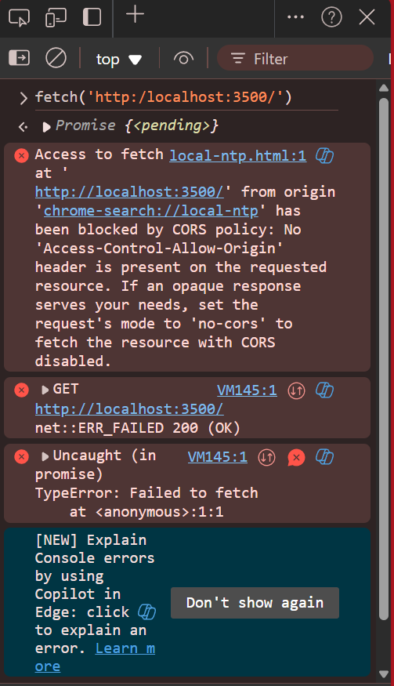

To avoid this error: install cors:
npm i cors
web_server.js
//======================Middle ware + Logger + cors======================
const express = require('express')
const {logger} = require('./middleware/logEvents')
const cors = require('cors')
const path = require('path')
const app = express ()
const PORT = process.env.PORT || 3500

//Ena ena files lam use panniruku nu paakurathuku use:
app.use(logger)
app.use(cors())
app.use(express.urlencoded({extended:false}))
app.use(express.json())

After using the cors in our code:
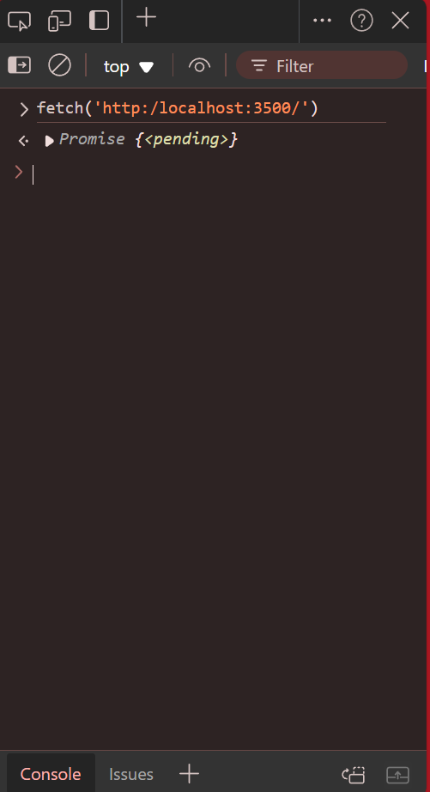

Cors Access and Deny:
web_server.js
//==================Cors Policy Access and Deny============

const express = require('express')
const app = express()
const path = require('path')
const PORT = process.env.PORT || 3500
const {logEvents,logger} = require('./middleware/logEvents')
const cors = require('cors')

//Custom Middleware
app.use(logger)

//Cors access giving and declining
const whitelist = ['https://www.google.com','http://127.0.0.1:5500','http://localhost:3500']
const corsOptions = {
origin : (origin,callback) =>
{
if(whitelist.includes(origin))
{
callback(null,true)
}
else
{
callback(new Error('Blocked due to cors policy'))
}
},
optionsSuccessStatus : 200
}

app.use(cors(corsOptions))

app.use(express.urlencoded({extended:false})) // built-in middleware
app.use(express.json())
app.use(express.static(path.join(__dirname,'/public')))

app.get('^/$|/index(.html)?' , (req,res) =>
{
res.sendFile(path.join(__dirname,'index.html'))
})

app.get('/new' , (req,res) =>
{
res.sendFile(path.join(__dirname,'new-page.html')
)
})

app.get('/hello' , (req,res) =>
{
res.send('Hello...')
})

app.listen( PORT , () =>
{
console.log('Server is running on',PORT)
})

app.get('/*' , (req,res) =>
{
res.sendFile(path.join(__dirname,'404.html'))
})

OUTPUT:
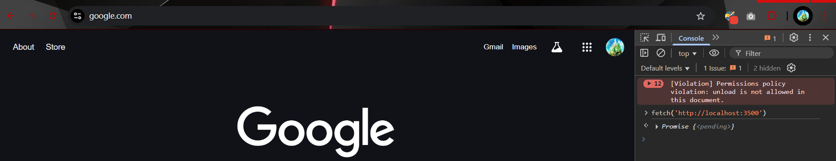
To Solve this Clearly ::
web_server.js:
const express = require('express')
const app = express()
const path = require('path')
const PORT = process.env.PORT || 3500
const {logEvents,logger} = require('./middleware/logEvents')
const cors = require('cors')
const errorHandler = require('./middleware/errorHandler')
//Custom Middleware
app.use(logger)

//Cors access giving and declining
const whitelist = ['https://www.goo.com', 'http://127.0.0.1:5500','http://localhost:3500']
const corsOptions = {
origin : (origin,callback) =>
{
if(whitelist.includes(origin) || !origin)//!origin –production apa thevaila
{
callback(null,true)
}
else
{
callback(new Error('Blocked Due to Cross Policy !'))
}
},
optionsSuccessStatus : 200
}
app.use(cors(corsOptions))
app.use(express.urlencoded({extended:false})) // built-in middleware
app.use(express.json())
app.use(express.static(path.join(__dirname,'/public')))
app.get('^/$|/index(.html)?' , (req,res) =>
{
res.sendFile(path.join(__dirname,'index.html'))
})
app.get('/new' , (req,res) =>
{
res.sendFile(path.join(__dirname,'new-page.html')
)
})
app.get('/hello' , (req,res) =>
{
res.send('Hello...')
})
app.get('/*' , (req,res) =>
{
res.sendFile(path.join(__dirname,'404.html'))
})
app.use(errorHandler)

app.listen( PORT , () =>
{
console.log('Server is running on',PORT)
})

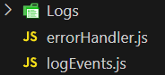

errorHandler.js
const {logEvents} = require('./logEvents')

const errorHandler = (err,req,res,next) =>
{
logEvents(`${err.name} ${err.message}`,'errLog.txt')
res.status(500).send(err.message)
next()
}

module.exports = errorHandler

logEvents.js:
const { format } = require('date-fns')
const { v4 : uuid} = require('uuid')
const fs = require('fs')
const fsPromises = require('fs').promises
const path = require('path')
const logEvents = async(message,file_name) =>
{
const datetime = format(new Date(), 'dd/MM/yyyy\tHH:mm:ss')
const logItem = `${datetime}\t${uuid()}\t${message}\n`
try
{
if(!fs.existsSync(path.join(__dirname,'..','Logs')))
{
await fsPromises.mkdir(path.join(__dirname,'..','Logs'))
await fsPromises.appendFile(path.join(__dirname,'..','Logs',file_name),' Date Time uID Method Message Path\n')
}
await fsPromises.appendFile(path.join(__dirname,'..','Logs',file_name), logItem)
}
catch(err){
console.error(err)
}
}
const logger = (req,res,next) =>
{
logEvents(`${req.method}\t${req.headers.origin}\t${req.url}`,'req_log.txt')
console.log(`${req.method} ${req.path}`)
next()
}
module.exports = {logger,logEvents}

Middlewere all :
app.all('*' , (req,res) =>
{
if(req.accepts('html'))
{
res.sendFile(path.join(__dirname,'404.html'))
}
else if(req.accepts('json'))
{
res.json({'error':'404 json error'})
}
else
{
res.type('txt').send('404 type error')
}
})

Routing:
Oru sub directories la irukura files ku epadi access kudukurathu ? adhan routing la learn panna porom.
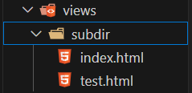
Showing wrong file when searching the files in the sub directory folder.

To Solve this follow the steps

Step 1: Create a Routes Folder and make a file called subdir.js
Routes>subdir.js:
const express = require('express')
const router = express.Router()
const path = require('path')

router.get( '^/$|index(.html)?' , (req,res) =>
{
res.sendFile(path.join(__dirname,'..','views','subdir','index.html'))
})

router.get( '/test(.html)?' , (req,res) =>
{
res.sendFile(path.join(__dirname,'..','views','subdir','test.html'))
})

module.exports = router

Step 2: use the router app in web_server.js:
const express = require('express')
const app = express()
const path = require('path')
const PORT = process.env.PORT || 3500
const {logEvents,logger} = require('./middleware/logEvents')
const cors = require('cors')
const errorHandler = require('./middleware/errorHandler')

//Custom Middleware
app.use(logger)

//Cors access giving and declining
const whitelist = ['https://www.goo.com', 'http://127.0.0.1:5500','http://localhost:3500']
const corsOptions = {
origin : (origin,callback) =>
{
if(whitelist.includes(origin) || !origin)
{
callback(null,true)
}
else
{
callback(new Error('Blocked Due to Cross Policy !'))
}
},
optionsSuccessStatus : 200
}
app.use(cors(corsOptions))

app.use(express.urlencoded({extended:false})) // built-in middleware
app.use(express.json())
app.use(express.static(path.join(__dirname,'/public')))

app.use('/subdir', require('./Routes/subdir'))

app.get('^/$|/index(.html)?' , (req,res) =>
{
res.sendFile(path.join(__dirname,'views','index.html'))
})

app.get('/new' , (req,res) =>
{
res.sendFile(path.join(__dirname,'views','new-page.html')
)
})

app.get('/hello' , (req,res) =>
{
res.send('Hello...')
})

app.all('*' , (req,res) =>
{
if(req.accepts('html'))
{
res.sendFile(path.join(__dirname,'views','404.html'))
}
else if(req.accepts('json'))
{
res.json({'error':'404 json error'})
}
else
{
res.type('txt').send('404 type error')
}
})

app.use(errorHandler)

app.listen( PORT , () =>
{
console.log('Server is running on',PORT)
})

Result:
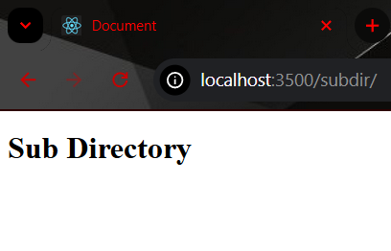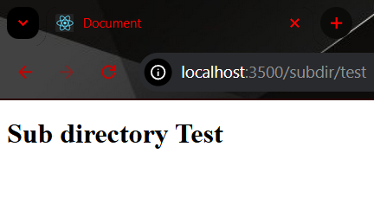

Another try:: (important)

web_server.js:
//=========================Make Another root===========================
const express = require('express')
const app = express()
const path = require('path')
const PORT = process.env.PORT || 3500
const {logEvents,logger} = require('./middleware/logEvents')
const cors = require('cors')
const errorHandler = require('./middleware/errorHandler')

//Custom Middleware
app.use(logger)

//Cors access giving and declining
const whitelist = ['https://www.goo.com', 'http://127.0.0.1:5500','http://localhost:3500']
const corsOptions = {
origin : (origin,callback) =>
{
if(whitelist.includes(origin) || !origin)
{
callback(null,true)
}
else
{
callback(new Error('Blocked Due to Cross Policy !'))
}
},
optionsSuccessStatus : 200
}
app.use(cors(corsOptions))

app.use(express.urlencoded({extended:false})) // built-in middleware
app.use(express.json())
app.use(express.static(path.join(__dirname,'/public')))

app.use('/subdir', require('./Routes/subdir'))

app.use('/',require('./Routes/root'))

app.use(errorHandler)

app.listen( PORT , () =>
{
console.log('Server is running on',PORT)
})

Routes/root.js:
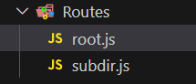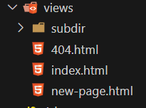
const express = require('express')
const router = express.Router()
const path = require('path')

router.get('^/$|/index(.html)?' , (req,res) =>
{
res.sendFile(path.join(__dirname,'..','views','index.html'))
})

router.get('/new' , (req,res) =>
{
res.sendFile(path.join(__dirname,'..','views','new-page.html')
)
})

router.get('/hello' , (req,res) =>
{
res.send('Hello...')
})

router.all('*' , (req,res) =>
{
if(req.accepts('html'))
{
res.sendFile(path.join(__dirname,'..','views','404.html'))
}
else if(req.accepts('json'))
{
res.json({'error':'404 json error'})
}
else
{
res.type('txt').send('404 type error')
}
})

module.exports = router

Adhigapresengithanam successfully done:

web_server.js:

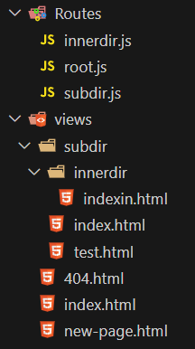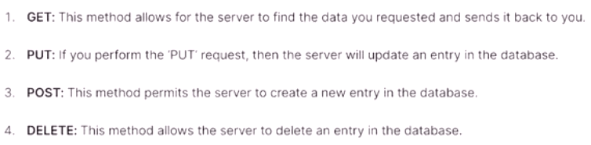

//=========================Make Another root adhukulla another innerdir===========================
const express = require('express')
const app = express()
const path = require('path')
const PORT = process.env.PORT || 3500
const {logEvents,logger} = require('./middleware/logEvents')
const cors = require('cors')
const errorHandler = require('./middleware/errorHandler')

//Custom Middleware
app.use(logger)

//Cors access giving and declining
const whitelist = ['https://www.goo.com', 'http://127.0.0.1:5500','http://localhost:3500']
const corsOptions = {
origin : (origin,callback) =>
{
if(whitelist.includes(origin) || !origin)
{
callback(null,true)
}
else
{
callback(new Error('Blocked Due to Cross Policy !'))
}
},
optionsSuccessStatus : 200
}
app.use(cors(corsOptions))

app.use(express.urlencoded({extended:false})) // built-in middleware
app.use(express.json())
app.use(express.static(path.join(__dirname,'/public')))

app.use('/subdir',express.static(path.join(__dirname,'/public')))
app.use('/subdir/innerdir',express.static(path.join(__dirname,'/public')))

app.use('/subdir',require('./Routes/subdir'))
app.use('/subdir/innerdir',require('./Routes/innerdir'))

app.use('/',require('./Routes/root'))

app.use(errorHandler)

app.listen( PORT , () =>
{
console.log('Server is running on',PORT)
})

API
Step 1: Create Data json
Create a data Folder and a file employees.json
data>employees.json
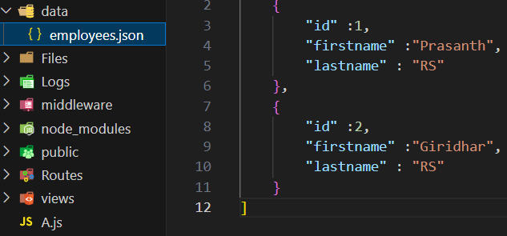

Step 2: Create a api folder then create a file employees.js
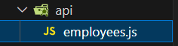

api>employees.js:
const express = require('express')
const path = require('path')
const router = express.Router()

data = {}
data.employees = require('../data/employees.json')

router.route('/')
.get((req,res)=>
{
res.json(data.employees)
})
.post((req,res)=>
{
res.json(
{
"firstname" : req.body.firstname,
"lastname" : req.body.lastname
}
)
})
.put((req,res)=>
{
res.json(
{
"firstname" : req.body.firstname,
"lastname" : req.body.lastname
}
)
})
.delete((req,res)=>
{
res.json({"id":req.body.id})
})

//id
router.route('/:id')
.get((req,res)=>
{
res.json(
{"id":req.params,
"firstname" : req.query.firstname || 'NOT PROVIDED',
"lastname" : req.query.lastname || 'NOT PROVIDED'
}
)
})

module.exports = router

Step 3: Install a extension called ‘REST Client’ in vs code to act as a frontend giving a request

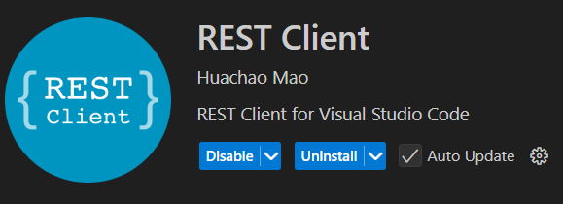
Step 4: Add the hilighted line in web_server.js
const express = require('express')
const app = express()
const path = require('path')
const PORT = process.env.PORT || 3500
const {logEvents,logger} = require('./middleware/logEvents')
const cors = require('cors')
const errorHandler = require('./middleware/errorHandler')
//Custom Middleware
app.use(logger)
//Cors access giving and declining
const whitelist = ['https://www.goo.com', 'http://127.0.0.1:5500','http://localhost:3500']
const corsOptions = {
origin : (origin,callback) =>
{
if(whitelist.includes(origin) || !origin){
callback(null,true)
}
else{
callback(new Error('Blocked Due to Cross Policy !'))
}
},
optionsSuccessStatus : 200
}
app.use(cors(corsOptions))
app.use(express.urlencoded({extended:false})) // built-in middleware
app.use(express.json())
app.use(express.static(path.join(__dirname,'/public')))

app.use('/employees',require('./api/employees'))

app.use('/subdir',express.static(path.join(__dirname,'/public')))
app.use('/subdir/innerdir',express.static(path.join(__dirname,'/public')))

app.use('/subdir',require('./Routes/subdir'))
app.use('/subdir/innerdir',require('./Routes/innerdir'))

app.use('/',require('./Routes/root'))

app.use(errorHandler)

app.listen( PORT , () =>
{
console.log('Server is running on',PORT)
})

Step 5: create a file globally called ‘route.rest’


When tap on send request the Results will be ::
GET :
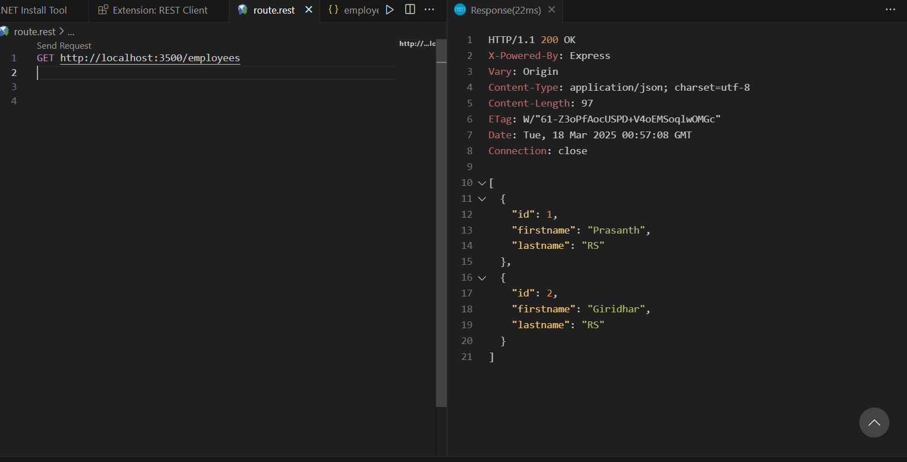

GET + id :
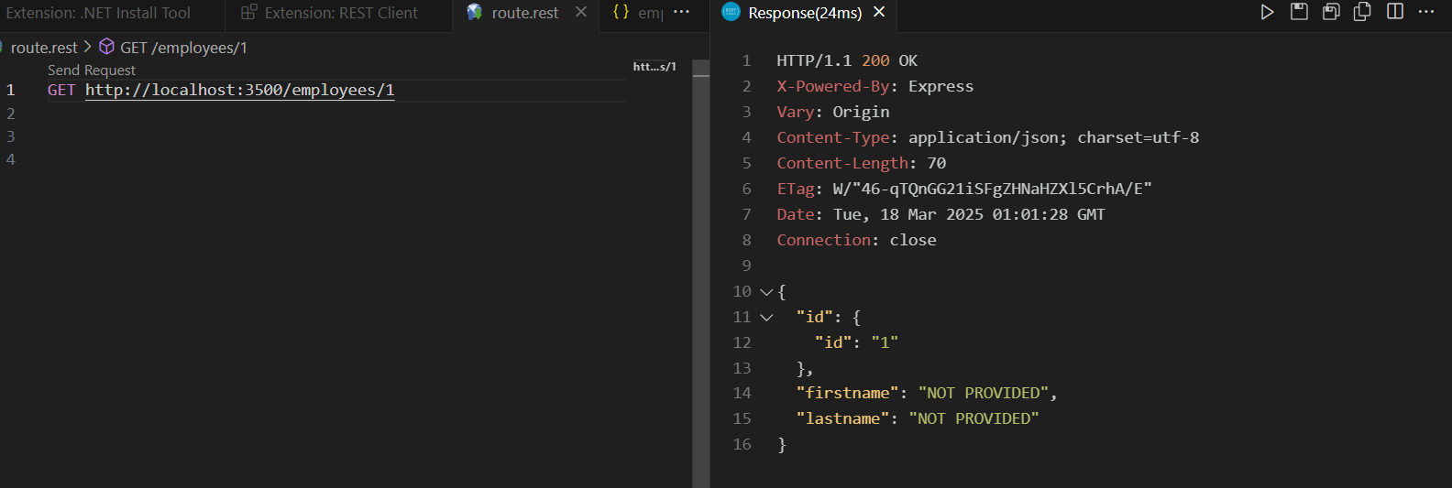

POST:
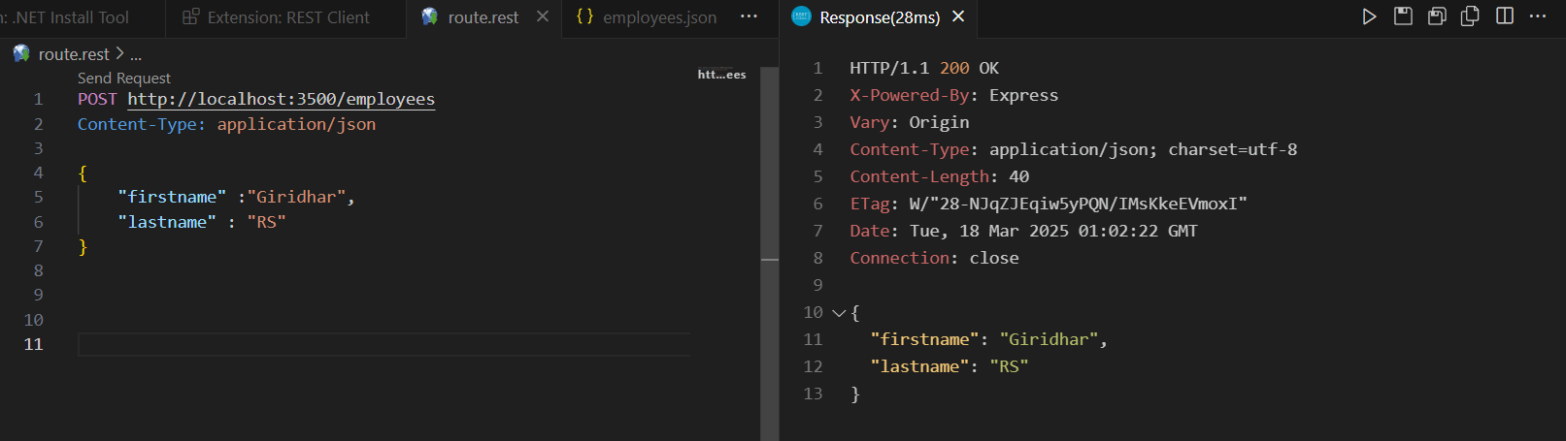
MVC:
Files and floder apm allocation epadi venaalum pannalaam in Express.js , Adha confusion ah sari panna than oru c procedure than MVC.

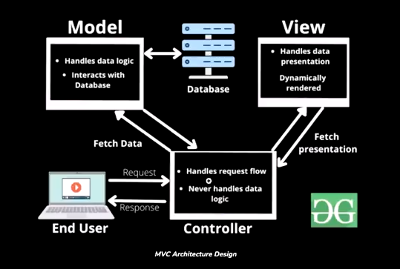

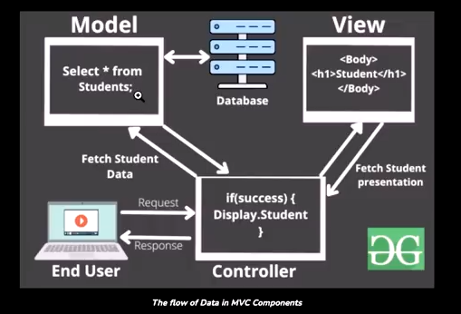
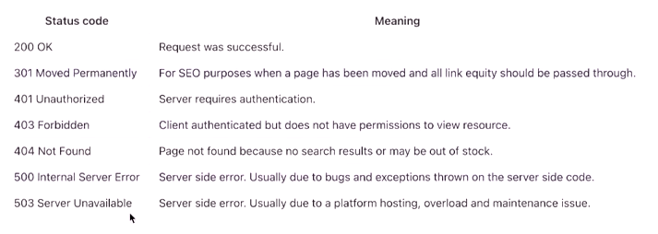

Impotant ::::::::::::::::::::::::::::::::::::::::::::::::::::::::::::::::::::::::::::::::::::::

Step 1 : Create a folder called controllers and create a file for controlling
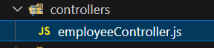

employeeController.js:
const data = {
employees : require('../model/employees.json'),
setEmployees : function(data) {this.employees = data}
}

const getAllEmployees = (req,res)=>
{
res.json(data.employees)
}

const createNewEmployee = (req,res)=>
{
const newEmployee =
{
id : data.employees?.length? data.employees[data.employees.length -1].id + 1 : 1,
firstname : req.body.firstname,
lastname : req.body.lastname
}

if(!newEmployee.firstname || !newEmployee.lastname)
{
res.status(400).json({"message":"Provide both firstname and Lastname"})
}

data.setEmployees([...data.employees,newEmployee])
res.status(201).json(data.employees)
}

const updateEmployee = (req,res)=>
{
const employee = data.employees.find(emp => emp.id === parseInt(req.body.id))

if(!employee)
{
res.status(400).json({"message":`Employee with id ${req.body.id} is not found!`})
}

if(req.body.firstname) employee.firstname = req.body.firstname
if(req.body.lastname) employee.lastname = req.body.lastname

const filteredArray = data.employees.filter(emp => emp.id !== parseInt(req.body.id))

const unsortedArray = [...filteredArray,employee]
data.setEmployees(unsortedArray.sort((a,b) => a.id > b.id ? 1 : a.id < b.id ? -1:0))
res.json(data.employees)
}

const deleteEmployee = (req,res)=>
{
const employee = data.employees.find(emp => emp.id === parseInt(req.body.id))

if(!employee)
{
res.status(400).json({"message":`Employee with id ${req.body.id} is not found!`})
}

const filteredArray = data.employees.filter(emp => emp.id !== parseInt(req.body.id))

data.setEmployees([...filteredArray])

res.status(201).json(data.employees)

}

const getEmployee = (req,res)=>
{
const employee = data.employees.find(emp => emp.id === parseInt(req.body.id))

if(!employee)
{
res.status(400).json({"message":`Employee with id ${req.body.id} is not found!`})
}

res.status(201).json(employee)

}

module.exports = {getAllEmployees,createNewEmployee,updateEmployee,deleteEmployee,getEmployee}

Step 2: Create a model folder for data storage (JSON)
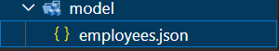

employees.json:

[
{
"id" :1,
"firstname" :"Prasanth",
"lastname" : "RS"
},
{
"id" :2,
"firstname" :"Giridhar",
"lastname" : "RS"
}
]

corsOptions.js:
//Cors access giving and declining
const whitelist = ['https://www.goo.com', 'http://127.0.0.1:5500','http://localhost:3500']
const corsOptions = {
origin : (origin,callback) =>
{
if(whitelist.includes(origin) || !origin)
{
callback(null,true)
}
else
{
callback(new Error('Blocked Due to Cross Policy !'))
}
},
optionsSuccessStatus : 200
}

Step 3: Alter the web_server.js based on the files and directories

//=========================MVC===========================
const express = require('express')
const app = express()
const path = require('path')
const PORT = process.env.PORT || 3500
const {logEvents,logger} = require('./middleware/logEvents')
const cors = require('cors')
const errorHandler = require('./middleware/errorHandler')

const corsOptions = require('./corsOptions')

//Custom Middleware
app.use(logger)

app.use(cors(corsOptions))

app.use(express.urlencoded({extended:false})) // built-in middleware
app.use(express.json())
app.use(express.static(path.join(__dirname,'/public')))

app.use('/employees',require('./api/employees'))

app.use('/subdir',express.static(path.join(__dirname,'/public')))
app.use('/subdir/innerdir',express.static(path.join(__dirname,'/public')))

app.use('/subdir',require('./Routes/subdir'))
app.use('/subdir/innerdir',require('./Routes/innerdir'))

app.use('/',require('./Routes/root'))

app.use(errorHandler)

app.listen( PORT , () =>
{
console.log('Server is running on',PORT)
})

