BANQUETBAZAR

SANDIP PATEL
(LCID: LC00017002051)

FINAL YEAR PROJECT REPORT SUBMITTED IN PARTIAL FULFILMENT FOR THE DEGREE OF BACHELOR OF INFORMATION TECHNOLOGY (HONOURS)

FACULTY OF COMPUTER SCIENCE IN MULTIMEDIA LINCOLN UNIVERSITY COLLEGE
MALAYSIA

20th April, 2026

Declaration

I hereby declare that this report is based on my own independent work, except for Quotation and summaries which have been dully acknowledged. I also declare that no part of this work has been submitted for any degree to this or any other university.

ACKNOWLEDGEMENT

First of all, I thank Almighty for inspiring me with strength and energy to achieve this modest study. I am deeply grateful to all those who have encouraged and helped me, discussed ideas and insights, which have contributed in various ways to complete my study.

My deepest gratitude and appreciation go to my supervisor Er. Rohit Pandey for his patience and very helpful comments, her bright ideas, guidance and for being generous with her knowledge and experience in supervising

I would like to express my sincere gratitude to

ABSTRACT
BanquetBazar is a web-based AI-powered banquet management system developed to modernize the traditional process of booking banquet halls for events such as weddings, birthday parties, meetings, and other social gatherings. The current manual booking system is not only time-consuming but are also scattered and does not assist users in choosing the best option. This project aims to provide a centralized digital platform where users can browse available halls, check date availability and request bookings easily. The system integrates artificial intelligence techniques to improve decision-making by recommending suitable banquet halls based on budget, guest count, and event type. The system is developed using the Incremental Development Model, with React.js for the frontend and Django with Django REST Framework for the backend, supported by a PostgreSQL database. Testing results show that the platform simplifies the booking process, improves transparency, and provides reliable recommendations. Overall, the integration of web technologies and artificial intelligence enhances efficiency, user experience, and management effectiveness in banquet hall booking.

Table of Contents
CHAPTER 1: INTRODUCTION 1
1.1 Background of the Study 1
1.2 Problem Statement 1
1.3 Objectives 2
1.3.1 General Objective 2
1.3.2 Specific Objectives 2
1.4 Scope of the Study 2
1.4.1 Included in the Scope: 2
1.4.2 Excluded from the Scope: 2
1.5 Significance of the Study 2
1.6 Limitations 4
1.7 Organization of the Report 4
CHAPTER 2: LITERATURE REVIEW 5
2.1 Introduction 5
2.2 Review of Related Works 5
2.3 Theoretical Framework 6
2.4 Research Gap 6
2.5 Summary 6
CHAPTER 3: METHODOLOGY 7
3.1 Research/Development Method 7
3.2 System Requirement Specification (SRS) 7
3.2.1 Functional Requirements 7
3.2.2 Non-functional Requirements 8
3.3 Tools & Technologies Used 9
3.4 Feasibility Study 10
3.5 System Architecture 11
CHAPTER 4: SYSTEM DESIGN 13
4.1 Use Case Diagram & Description 13
4.1.1 Customer Use Cases 14
4.1.2 Admin Use Cases 14
4.2 DFD (Level 0, 1, 2) 15
4.3 ER Diagram 17
4.4 Class Diagram 18
4.5 Sequence/Activity Diagrams 19
4.6 UI/UX Design 20
CHAPTER 5: SYSTEM IMPLEMENTATION 21
5.1 Module Description 21
5.2 Frontend Implementation 23
5.3 Backend Implementation 24
5.4 Database Implementation 26
5.5 Algorithm Used 28
5.6 Screenshots of System Features 29
CHAPTER 6: TESTING AND RESULT ANALYSIS 29
6.1 Test Plan 29
6.2 Test Cases (Table Format) 31
6.3 Unit Testing 34
6.4 Integration Testing 34
6.5 System Testing 36
6.6 Performance Evaluation 37
CHAPTER 7: CONCLUSION AND RECOMMENDATION 38
7.1 Summary 38
7.2 Conclusion 39
7.3 Limitations 39
7.4 Future Enhancements 40

List of Figures

Figure 1: System Architecture 12
Figure 2: Use Case Diagram 13
Figure 3: DFD-Level 0 15
Figure 4: DFD- Level 1 15
Figure 5: DFD- Level 2 16
Figure 6: ER- Diagram 17
Figure 7: Class Diagram 18
Figure 8: Sequential Diagram 19
Figure 9: UI/UX Design 20

INTRODUCTION

Background of the Study
The process of booking banquet halls for events such as weddings, birthday parties, meetings, and social gatherings is still largely carried out through traditional methods, including phone calls, physical visits, and social media messages. These methods are often time-consuming, scattered, and require customers to manually compare hall availability, pricing, and services. As a result, planning events becomes complicated, inefficient, and prone to miscommunication or delays in booking.

With the advancement of web technologies and artificial intelligence, it is possible to develop intelligent systems that simplify the banquet booking process. By integrating AI-based recommendations and a web-based platform can help users choose suitable halls, plan their events efficiently, and save time. BanquetBazar is designed as a centralized, AI-powered banquet management system that addresses these issues by providing a transparent, user-friendly, and effective solution for both customers and hall administrators.

Problem Statement
Booking banquet halls for events through traditional methods is often inefficient, time-consuming, and confusing, as customers must contact multiple halls via phone calls, visit them physically, or rely on scattered social media pages to check availability, pricing, and services. This makes it difficult to compare options, calculate costs accurately, and make informed decisions. Additionally, there is no intelligent system that can recommend suitable halls or services based on the user’s budget, guest count, and event type. Therefore, there is a need for a web-based AI-powered banquet management system that centralizes all information, streamlines the booking process, and provides smart recommendations and automatic cost estimation to assist users in planning their events more efficiently.

Objectives

General Objective
To develop a web-based AI-powered banquet management system that makes it easier for users to find, compare, and book banquet halls while providing smart recommendations.

Specific Objectives
- To allow customers to browse banquet halls and view details such as price, capacity, and services.
- To enable customers to check hall availability and request bookings online.

Scope of the Study
The scope of this study defines the boundaries and focus of the BanquetBazar system. The project is designed to provide a centralized platform for booking banquet halls with AI assistance. The system will include the following features:

Included in the Scope:
- Customer registration and secure login for accessing the platform.
- Browsing and viewing details of banquet halls including price, capacity, photos, and services.
- Checking date availability for each hall and requesting bookings online.
- Selecting additional event services such as decoration, catering, photography, and DJ.
- AI-based hall recommendations and automatic cost estimation to help users plan efficiently.
- Customer dashboard to track booking status and view past bookings.
- Admin panel for banquet owners to manage halls, services, and booking approvals.

Excluded from the Scope:
- Online payment or integration with payment gateways.
- Real-time chat or direct messaging between customers and hall owners.
- Mobile application version.
- Multi-branch management for banquet owners.
- Notifications via SMS or WhatsApp.

Significance of the Study
The BanquetBazar system provides practical benefits for customers, banquet owners, society, and academic learning. By integrating AI recommendations and a complete admin panel, the system enhances both user experience and management efficiency.
For Customers:
- Offers a centralized platform to browse banquet halls, services, and prices.
- Saves time because one can see the real time availability and then plan an event.
- Reduces confusion by providing AI-based recommendations for the best hall and services according to budget and preferences.
- Provides a transparent and easy booking process, improving user confidence.
For Event Service Providers (Indirect Benefit):
- Increases visibility of halls and services through an organized, digital platform.
- Reduces unnecessary inquiries because customers can view all details online before booking.
For Society
- Supports digital transformation in the event planning sector.
- Encourages organized event management, reducing manual communication and misunderstandings.
- Promotes convenience and smarter decision-making for families planning events.
Academic Significance
- Shows the practical use of the full-stack web application with the help of the latest technologies.
- Shows practical applications of AI models which include recommendation systems and cost prediction.
- Gives students practical skills on how to construct scalable systems that have frontend, back end, and database integration.
- Provides a base of further improvements, such as automation, analytics, and the creation of mobile applications.

Limitations
While BanquetBazar provides an efficient and modern solution for banquet hall booking, the system has certain technical and functional limitations in its current phase:
- No Mobile App Version: The system is web-based only; users cannot access it through a dedicated mobile application.
- Payment Gateway Integration Excluded: Online payments and secure transactions are not implemented.
- Real-Time Communication Not Supported: There is no live chat or direct messaging between customers and hall owners.
- Limited Admin Features: Multi-branch management and advanced analytics for admins are not included.
- AI Model Limitations: Recommendations and cost estimations rely on available historical data and basic models; accuracy may vary with incomplete or inconsistent data.
- Scalability Constraints: The system is designed for a limited number of halls and bookings; very high traffic may require performance optimization.

Organization of the Report
This report is organized into four chapters.
Chapter 1 covers the introduction, objectives, scope, and limitations.
Chapter 2 This section includes a fully-referenced review and discussions of previous studies which are relevant to the project
Chapter 3 describes the development methodology, system requirements, tools, and architecture.
Chapter 4 presents the full system design, including use case diagrams, data flow diagrams, an entity-relationship diagram, a class diagram, sequence and activity diagrams, and the UI/UX design.

LITERATURE REVIEW

Introduction
A literature review provides an overview of existing studies, systems, and technologies relevant to a project. It helps identify gaps, challenges, and best practices that guide the development of a new solution. In banquet hall management, previous systems often focus on manual booking processes or internal hotel operations, lacking intelligent features such as AI-based recommendations or automatic cost estimation. This chapter reviews existing literature on digital banquet management, online booking systems, and AI-assisted recommendation systems to form a foundation for developing BanquetBazar, a web-based AI-powered platform for efficient and user-friendly banquet booking.

Review of Related Works
Several studies and projects have explored digital solutions for banquet hall and event management:

- Orazova & Permanova (2025) proposed a digital system for managing banquet halls, focusing on event planning, booking, and resource management. The system improved operational efficiency but did not include AI-based recommendations for customers.
- Yalini (2017) developed an online booking system for Loyolas Wedding Hall, allowing users to book halls, select service packages, and generate reports. While it improved accessibility, it was built with PHP and MySQL, limiting scalability and integration with modern AI technologies.
- Lalitha, R., Kumar, S., & Priya, M. (2022): Designed and implemented an online event hall booking and reservation system, improving accessibility and management efficiency for users and admins.
- Islam, F. (2024): Developed AI-driven modern web applications, highlighting how AI can enhance web-based systems and improve user experience in event management.
These studies show that while digital and automated systems exist, there is still a gap in providing a centralized, AI-assisted, customer-focused banquet booking platform.

Theoretical Framework
The theoretical framework of BanquetBazar combines concepts from:
- Web-based Information Systems : providing centralized access for users and admins.
- Artificial Intelligence (AI) : using Random Forest for hall recommendations and rule-based methods for cost estimation.
- Incremental Development Model : guiding the development process in stages to allow early testing, feedback, and integration of features.
This framework ensures that the system is both technically robust and aligned with user needs for efficient, transparent, and intelligent banquet booking.

Research Gap
Existing studies and systems for banquet management and event planning reveal several gaps:
- Lack of AI-based recommendation systems for hall and service selection.
- Absence of automatic cost estimation features.
- Limited focus on customer-centered digital platforms; many systems prioritize internal hotel operations.
- Fragmented and scattered manual booking processes that are still widely used.
BanquetBazar aims to address these gaps by providing a centralized, AI-powered platform that streamlines the booking process, improves decision-making, and enhances user experience.

Summary
In summary, previous literature shows that while digital and automated systems have improved banquet hall management, there are still limitations in intelligence, customer focus, and centralized access. This study identifies the need for a web-based AI-powered platform that integrates hall browsing, AI recommendations, and automatic cost estimation, providing a more efficient and user-friendly solution for banquet hall booking.

METHODOLOGY

Research/Development Method
The project uses an Incremental Development Model, delivering the system in functional increments to allow early testing, feedback, and risk reduction.
- Increment 1: User authentication (customer and admin login/signup) and basic UI setup.
- Increment 2: Admin panel for managing halls, services, and booking approvals.
- Increment 3: Hall browsing module with hall details, images, and services.
- Increment 4: Booking module for checking availability, selecting halls and services, and submitting booking requests.
- Increment 5: AI recommendation module for suggesting suitable halls based on budget, guest count, and event type, along with automatic cost estimation.
- Increment 6: Final UI enhancements, system testing, bug fixing, and deployment.

System Requirement Specification (SRS)

Functional Requirements
Functional requirements define the specific behavior and functions of the system that the users and admins can perform. For BanquetBazar, these include:

- User Authentication:
- Customers and admins can securely register and log in to the system.
- Role-based access control to differentiate customer and admin functionalities.
- Hall Browsing:
- Customers can view a list of banquet halls with details such as images, pricing, capacity, and available services.
- Booking Management:
- Customers can check hall availability for selected dates.
- Customers can select services and request bookings.
- Admins can approve, reject, or add remarks to booking requests.
- AI Recommendation Module:
- The system suggests suitable halls based on user budget, guest count, and event type.
- Automatic cost estimation is provided for the selected hall and services.

- Admin Panel:
- Admins can manage halls, services, and booking records.
- Admins can generate reports for bookings and hall usage.
- Customer Dashboard:
- Customers can view past and upcoming bookings.
- Display AI recommendations and estimated costs.

Non-functional Requirements
Non-functional requirements define the quality and constraints of the system, including performance, security, and usability:
Performance:
- The system should respond to user requests within 2:3 seconds under normal load.
- Must handle multiple concurrent users without crashing.
Usability:
- User interface should be intuitive, responsive, and easy to navigate on web browsers.
- Minimal learning curve for both customers and admins.
Security:
- Secure login with encrypted passwords.
- Role-based access to prevent unauthorized access to admin functions.
Reliability:
- The system should be available 99% of the time.
- Error handling to prevent system crashes.
Scalability:
- Capable of supporting additional halls, services, and users in future expansions.
Maintainability:
- Code should be modular and well-documented for easier updates and bug fixes.

Tools & Technologies Used
Tools and Technologies
- Programming Languages
- JavaScript: For building the React.js frontend
- Python: For Django backend and AI/ML models
- Frontend Technologies
- React.js: For creating a responsive and dynamic user interface
- React Router: For page navigation
- Axios: For communicating with backend APIs
- Tailwind CSS: For UI styling and layout
- Backend Technologies
- Django (Python): For backend logic, authentication, and API development
- Django REST Framework (DRF): For creating RESTful APIs consumed by the frontend
- Database
  - PostgreSQL: Relational database for storing users, halls, services, and bookings
- AI / Machine Learning Tools
- scikit-learn: For Random Forest recommendations and Linear Regression cost estimation
- NumPy & Pandas: For data preprocessing and model training
- Development Tools
- VS Code: Main editor for frontend and backend development
- Figma: For UI/UX design

Feasibility Study
A feasibility study evaluates whether the project is practical and achievable within the given resources, time, and technology. For BanquetBazar, the feasibility is assessed in three main areas:
- Technical Feasibility
The project uses proven technologies such as React.js for the frontend, Django and Django REST Framework for the backend, and PostgreSQL for the database. AI features are implemented using Python libraries such as scikit-learn, NumPy, and Pandas. The system does not require highly complex technology beyond the team's current skills. Therefore, it is technically feasible to develop and deploy the system.
- Economic Feasibility
The project requires minimal cost as it uses open-source software (React.js, Django, PostgreSQL, Python) and free cloud hosting options (Vercel for frontend, Heroku for backend). The main investment is time and human resources, which are manageable within the project timeline. Hence, the project is economically feasible.
- Operational Feasibility
The system is designed to be user-friendly and intuitive for both customers and admins. Users can easily browse halls, request bookings, and receive AI-based recommendations without extensive training. Admins can manage halls and bookings efficiently. This ensures the system can be operated effectively in real-world scenarios.

System Architecture
BanquetBazar uses a decoupled architecture, where the frontend, backend, AI module, and database operate independently but communicate through APIs. This design improves flexibility, scalability, and maintainability.
a) Frontend (React.js):
- Handles user interfaces for customers and admins.
- Manages hall browsing, booking requests, service selection, dashboards, and AI recommendation display.
b) Backend (Django & Django REST Framework):
- Provides secure APIs for frontend communication.
- Handles authentication, booking management, hall and service data, and business logic.
c) AI Module (Python):
- Uses Random Forest for hall recommendations based on user budget, guest count, and event type.
- Provides rule-based automatic cost estimation for selected halls and services.
d) Database (PostgreSQL):
- Stores all system data including users, halls, services, bookings, and AI training datasets.
- Ensures data integrity, security, and fast retrieval for both backend and AI module.
e) External Data (Optional / Future Integration):
- Allows integration with APIs for event services, payment gateways, or notifications in future enhancements.

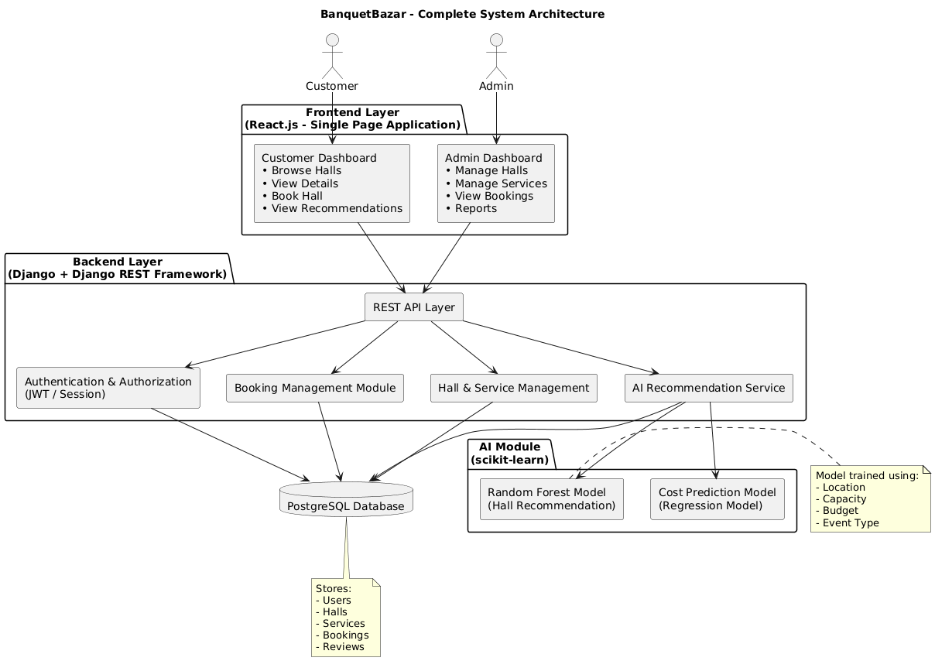
Figure 1: System Architecture

SYSTEM DESIGN

Use Case Diagram & Description
The Use Case Diagram of BanquetBazar System shows the interaction between two actors: Customer and Admin.

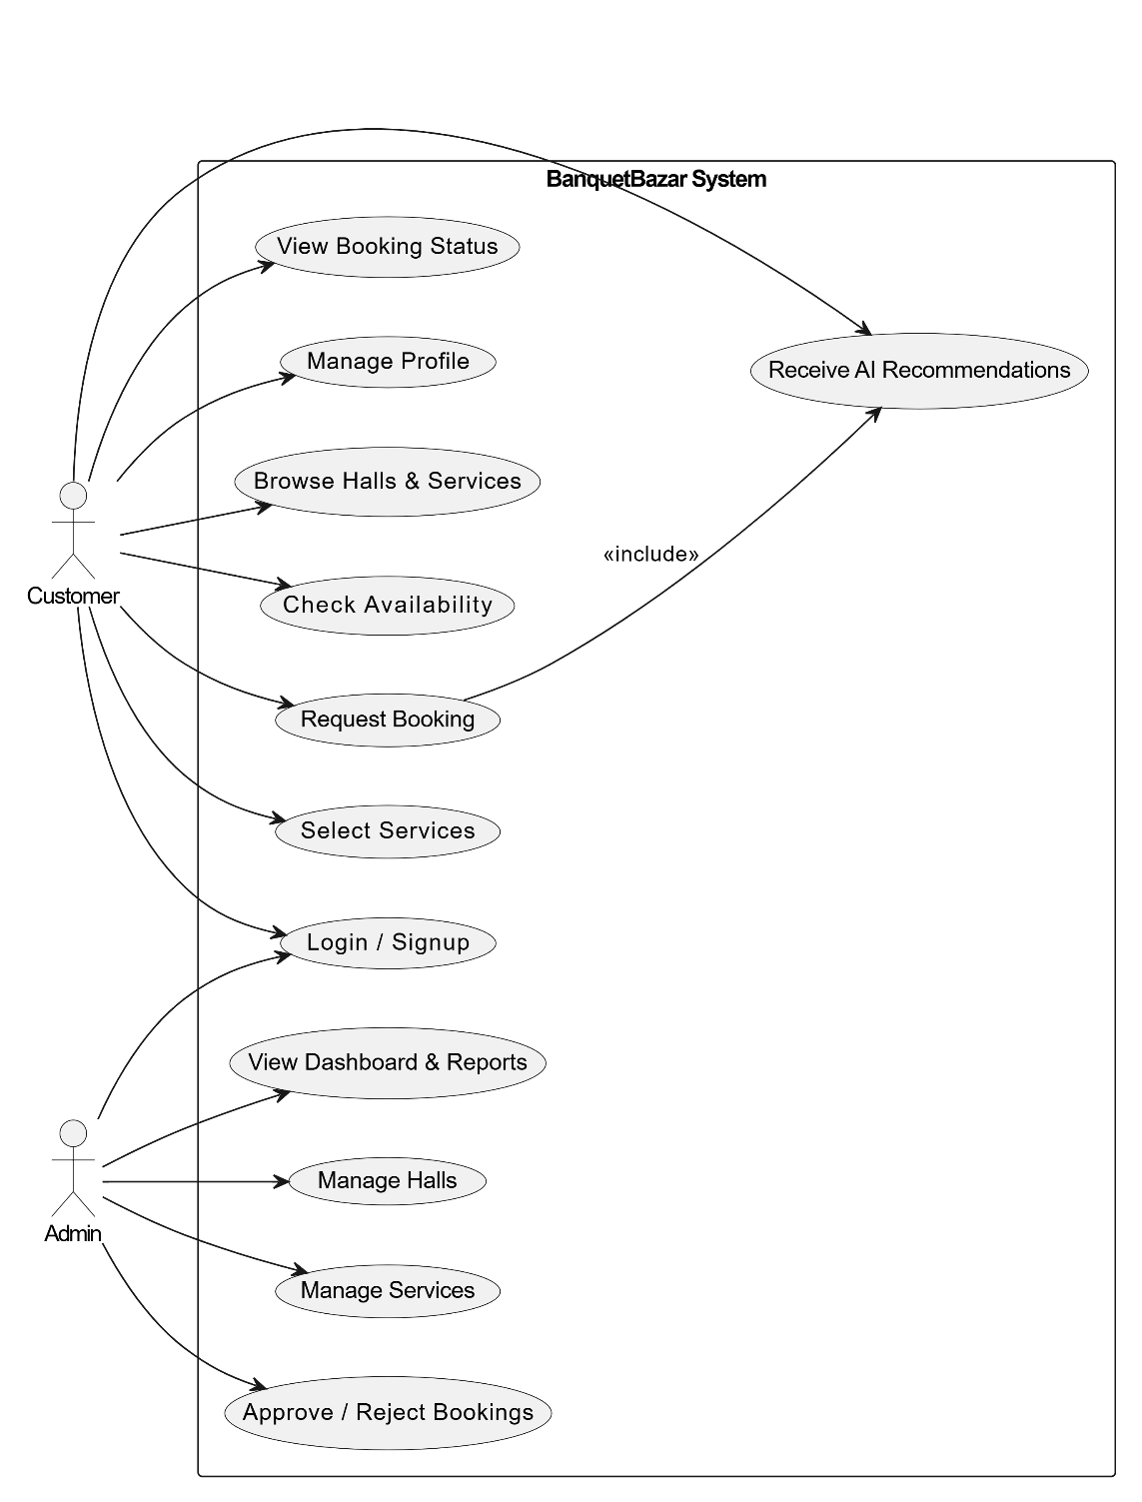

Figure 2: Use Case Diagram

Actors
- Customer:
User who searches halls, requests bookings, selects services, and receives AI recommendations.
- Admin:
Manages halls, services, bookings, and views reports.

Customer Use Cases
- Login / Signup: Access the system.
- Manage Profile: Update personal details.
- Browse Halls & Services: View available halls and services.
- Check Availability: Check-hall availability for selected date.
- Select Services: Choose additional services.
- Request Booking: Send booking request.
- Receive AI Recommendations: Get hall suggestions based on budget, guests, and event type.
- View Booking Status: Check booking approval status.

Admin Use Cases
- Login: Access admin panel.
- Manage Halls: Add, update, or delete hall details.
- Manage Services: Manage service information.
- Approve / Reject Bookings: Process booking requests.
- View Dashboard & Reports: Monitor system statistics.

DFD (Level 0, 1, 2)
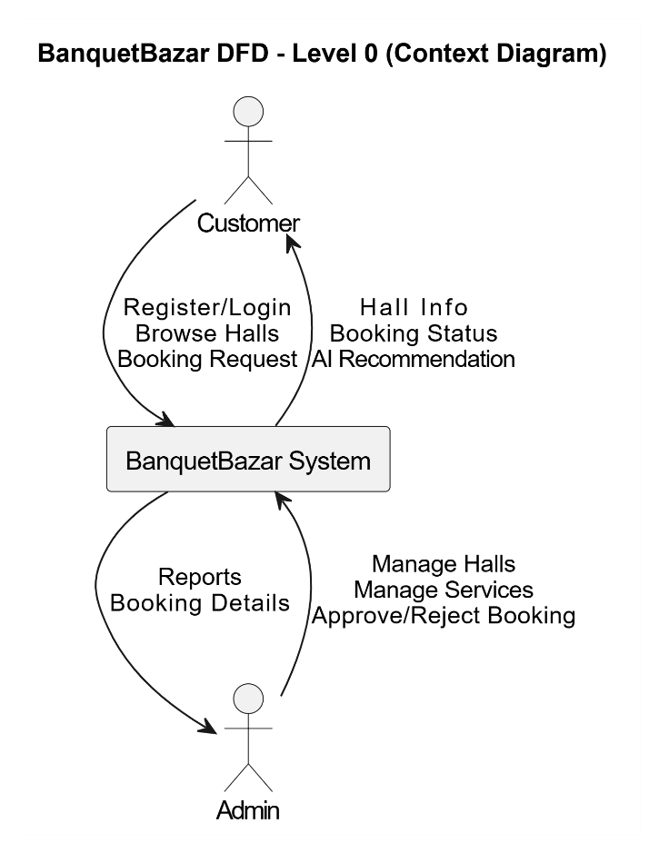

Figure 3: DFD-Level 0
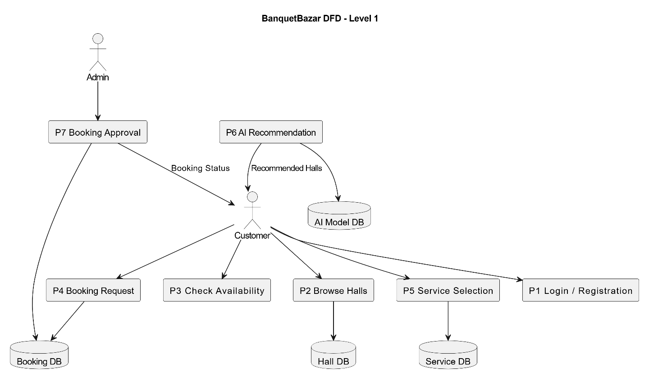

Figure 4: DFD- Level 1
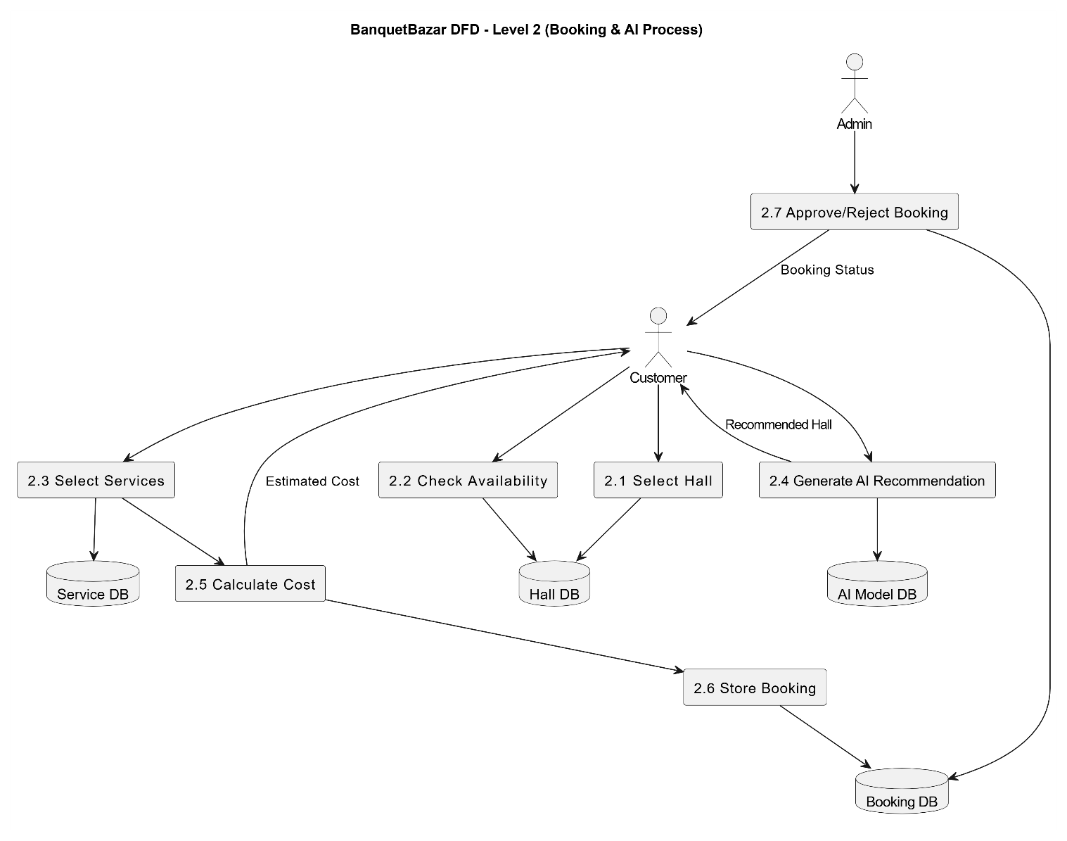
Figure 5: DFD- Level 2

ER Diagram

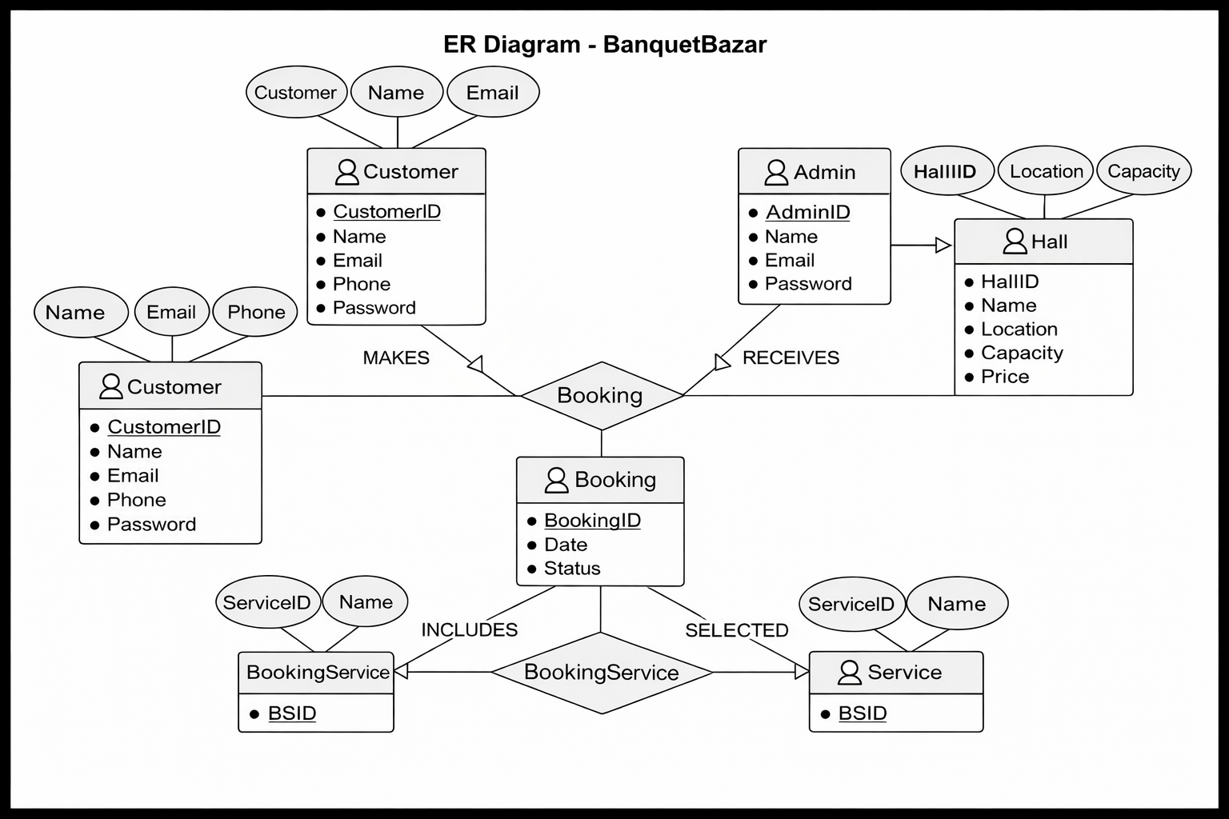

Figure 6: ER- Diagram

Class Diagram
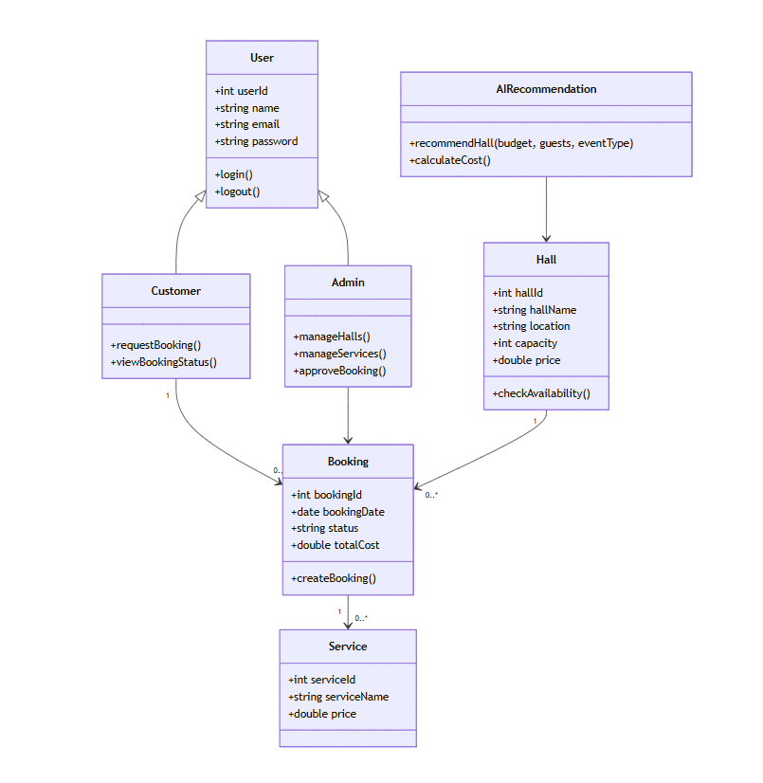

Figure 7: Class Diagram

Sequence/Activity Diagrams
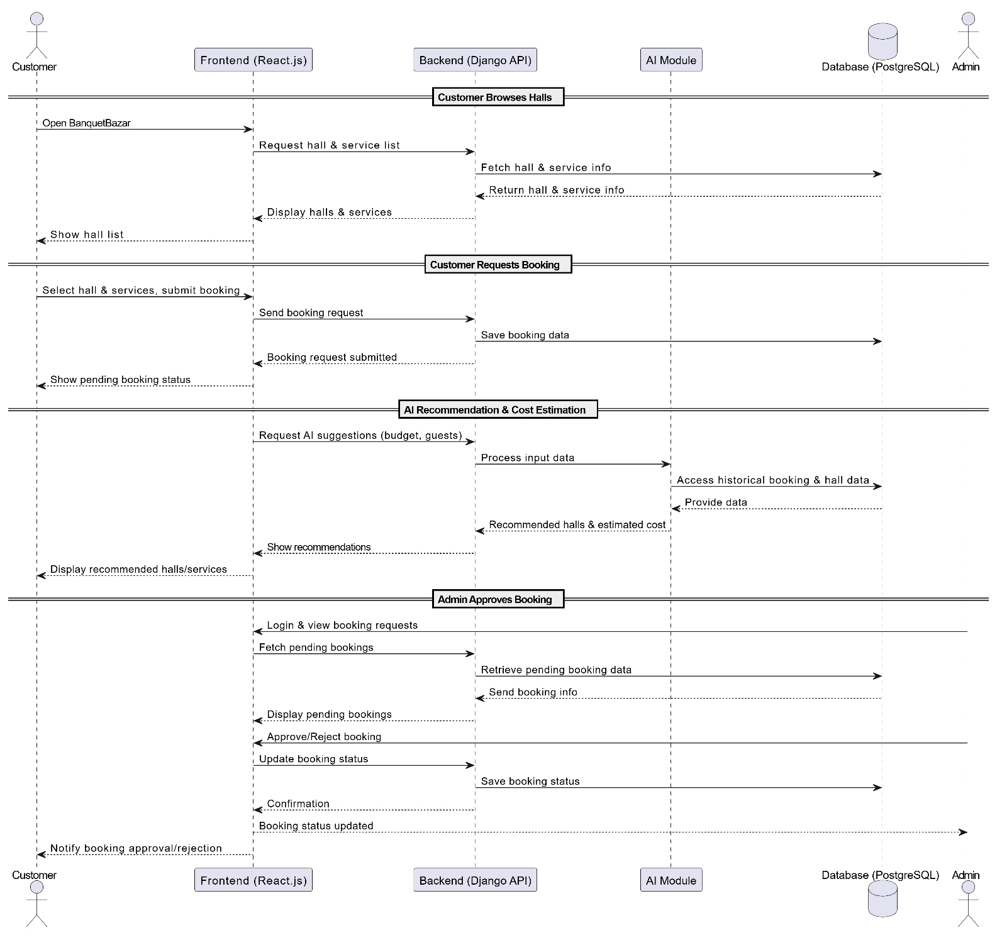

Figure 8: Sequential Diagram

UI/UX Design

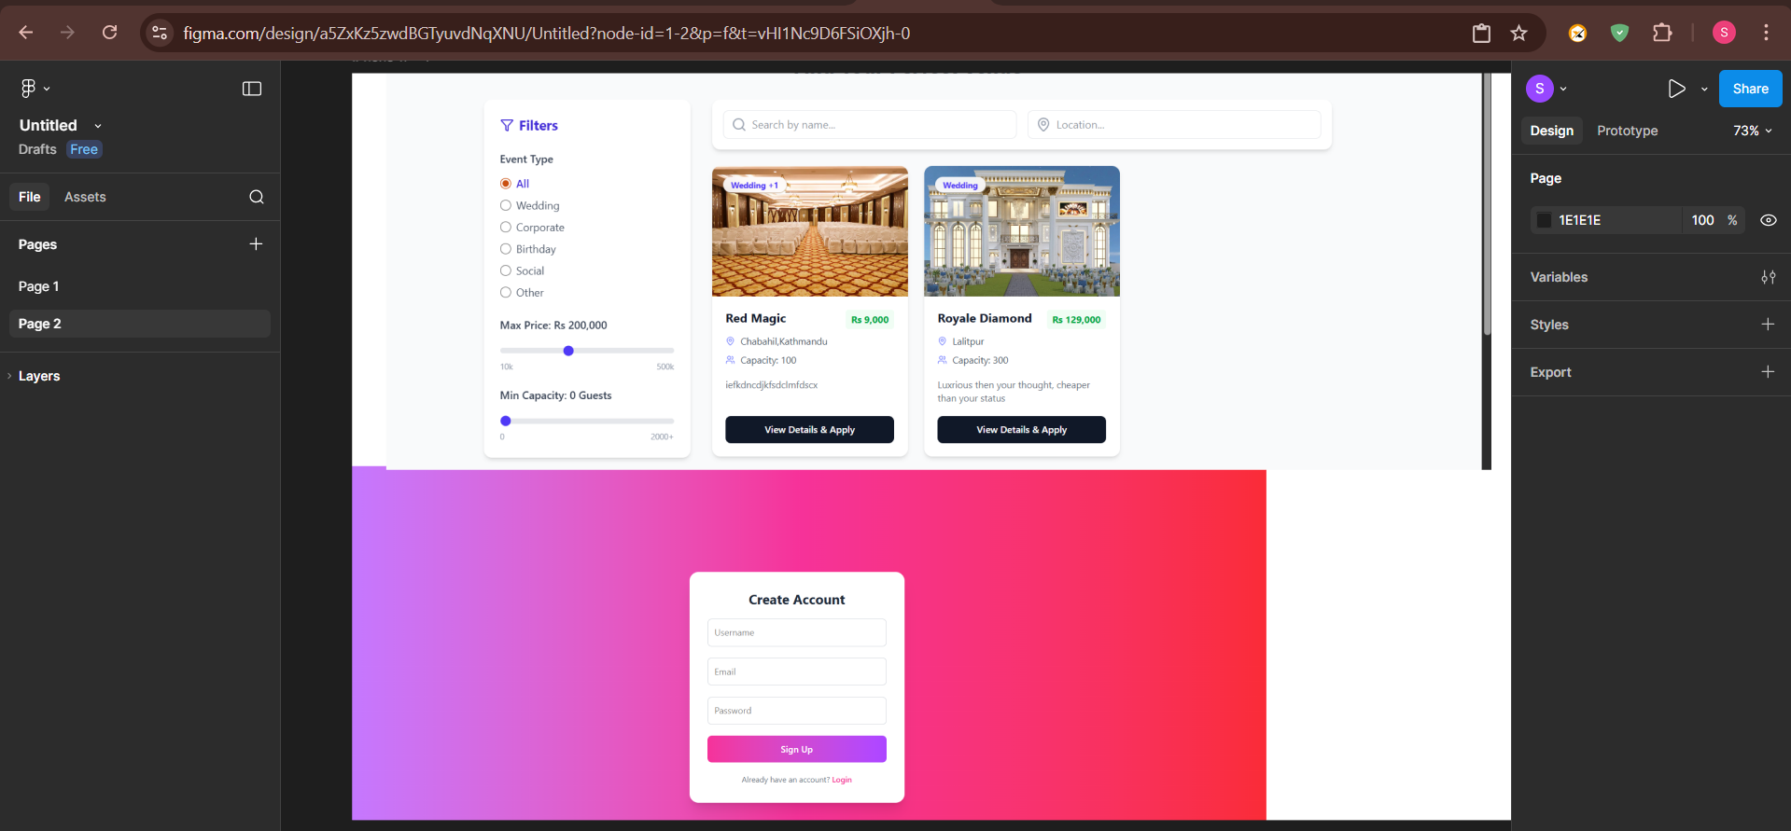

Figure 9: UI/UX Design

SYSTEM IMPLEMENTATION

Module Description
The BanquetBazar system is divided into several functional modules to ensure a structured and efficient implementation. Each module is responsible for performing specific tasks within the system, allowing smooth interaction between the frontend, backend, and database.

- Authentication Module
This module handles user registration and login functionality for both customers and admins. It ensures secure access to the system using authentication mechanisms and role-based access control. Customers can create accounts and log in, while admins can securely access the admin panel.

- Hall Management Module
This module allows admins to manage banquet hall information. Admins can add, update, and delete hall details such as name, location, price, capacity, images, and available services. This ensures that customers always view up-to-date information.

- Service Management Module
This module enables admins to manage additional event services such as catering, decoration, photography, and DJ. Admins can add or update service details and pricing, which customers can select current booking.

- Hall Browsing Module
This module allows customers to view a list of available banquet halls along with detailed information, including price, capacity, images, and services. It provides an easy-to-use interface for comparing different halls.

- Booking Module
This module allows customers to check hall availability, select a hall and services, and submit booking requests. It also enables customers to track the status of their bookings (Pending, Approved, or Rejected).

- Booking Management Module (Admin)
This module allows admins to view all booking requests and manage them efficiently. Admins can approve or reject bookings and provide remarks. It ensures proper coordination between customers and hall owners.

- AI Recommendation Module
This module uses a Random Forest algorithm to recommend suitable banquet halls based on user inputs such as budget, guest count, and event type. It helps users make better decisions.

- Cost Estimation Module
This module provides automatic cost estimation using a rule-based approach. It calculates the total event cost based on hall price, number of guests, and selected services.

- Customer Dashboard Module
This module provides customers with a personalized dashboard where they can view their booking history, current booking status, and AI-based recommendations.

- Backend API Module
This module is developed using Django REST Framework and handles communication between the frontend and backend. It manages data processing, authentication, and database operations.

Frontend Implementation
The frontend of the BanquetBazar system is developed using React.js, a modern JavaScript library for building dynamic and responsive user interfaces. The frontend is responsible for interacting with users, displaying data, and communicating with the backend through APIs.
The user interface is designed to be simple, user-friendly, and responsive, ensuring a smooth experience across different devices and screen sizes.

- Technology Stack
The frontend is built using the following technologies:
- React.js for creating reusable UI components
- React Router for navigation between different pages
- Axios for making HTTP requests to the backend APIs
- Tailwind CSS for styling and responsive design

- Component-Based Architecture
The frontend follows a component-based architecture, where the UI is divided into reusable components such as Navbar, Footer, Hall Cards, Booking Forms, and Dashboard panels. This improves code reusability, maintainability, and scalability.

- User Interface Pages
The main pages implemented in the frontend include:
- Home Page: Displays featured halls and general information about the platform
- Login/Signup Page: Allows users to register and log in securely
- Hall Listing Page: Shows all available banquet halls with details like price, capacity, and services
- Hall Detail Page: Provides detailed information about a selected hall
- Booking Page: Allows users to select services and request bookings
- Customer Dashboard: Displays booking history, status, and AI recommendations
- Admin Dashboard: Enables admins to manage halls, services, and bookings

- API Integration
The frontend communicates with the backend using RESTful APIs developed in Django. Axios is used to send HTTP requests (GET, POST, PUT, DELETE) for fetching and updating data such as halls, bookings, and user information.

- State Management
React’s built-in state management (useState and useEffect hooks) is used to manage application data, including user authentication status, booking details, and fetched API data. This ensures dynamic updates of the UI without page reloads.

- Form Handling and Validation
Forms such as login, signup, and booking requests are implemented with proper validation to ensure correct user input. This improves data accuracy and user experience.

- Responsive Design
The frontend is designed to be responsive using Tailwind CSS, allowing users to access the system on desktops, tablets, and mobile browsers without usability issues.

Backend Implementation
The backend of the BanquetBazar system is developed using Django, a powerful Python web framework, along with Django REST Framework (DRF) to build RESTful APIs. The backend is responsible for handling business logic, managing data, processing user requests, and ensuring secure communication between the frontend and the database.

1) Technology Stack
The backend is built using:
- Django (Python): For handling server-side logic and application structure
- Django REST Framework (DRF): For creating RESTful APIs
- PostgreSQL: For database management
- JWT : For secure user authentication

2) API Development
RESTful APIs are developed using Django REST Framework to allow communication between the frontend and backend. These APIs handle operations such as:
- User registration and login
- Fetching banquet hall data
- Managing booking requests
- Handling services and admin operations
- HTTP methods such as GET, POST, PUT, and DELETE are used to perform CRUD (Create, Read, Update, Delete) operations.

3) Database Interaction
Django’s ORM (Object Relational Mapping) is used to interact with the PostgreSQL database. Models are created for entities such as Users, Halls, Services, and Bookings. The ORM simplifies database queries and ensures data integrity.

4) Authentication and Authorization
The backend implements secure authentication for both customers and admins. Role-based access control is used to restrict certain functionalities (such as hall management and booking approval) to admin users only. Passwords are securely stored using hashing mechanisms.

5) Business Logic Implementation
The backend processes all core functionalities of the system, including:
- Checking hall availability for selected dates
- Managing booking requests and status updates
- Assigning services to bookings
- Handling admin actions such as approval or rejection of bookings

6) AI Model Integration
The backend integrates the AI module developed using Python. The trained Random Forest model is loaded using tools like joblib or pickle and used to generate hall recommendations based on user inputs. A rule-based system is used for cost estimation.

7) Error Handling and Validation
Proper validation is implemented for all incoming data to ensure accuracy and prevent errors. The system handles exceptions gracefully and returns meaningful error messages to the frontend.

8) Security Measures
The backend includes security features such as:
- Password hashing
- Input validation
- Protection against unauthorized access
- Secure API endpoints

Database Implementation
The BanquetBazar system uses PostgreSQL as the relational database to store and manage all application data efficiently. The database is designed to ensure data integrity, consistency, and fast retrieval of information required for system operations.

1) Database Design Approach
The database is designed based on the Entity-Relationship (ER) model, which identifies key entities such as Users, Halls, Services, and Bookings along with their relationships. The design follows normalization principles to reduce redundancy and improve data consistency.

2) Main Tables / Entities
The system consists of the following main tables:
- User Table:
Stores user information such as user ID, name, email, password, and role (customer/admin).
- Hall Table:
Contains details of banquet halls including hall ID, name, location, price, capacity, images, and description.
- Service Table:
Stores information about additional services such as catering, decoration, photography, and DJ, along with their prices.
- Booking Table:
Records booking details including booking ID, user ID, hall ID, booking date, event date, selected services, and booking status (Pending, Approved, Rejected).
- Booking Service Table (Junction Table):
Handles the many-to-many relationship between bookings and services, allowing multiple services to be selected for a single booking.

3) Relationships Between Tables
- One User can make multiple bookings (One-to-Many).
- One Hall can have multiple bookings (One-to-Many).
- One Booking can include multiple services, and one service can be used in multiple bookings (Many-to-Many).

4) Database Operations
The database supports all CRUD operations:
- Create: Adding new users, halls, services, and bookings
- Read: Retrieving hall details, booking information, and user data
- Update: Modifying hall details, booking status, and user profiles
- Delete: Removing halls, services, or bookings when necessary

5) Integration with Backend
Django ORM is used to interact with the PostgreSQL database. Models are defined in Django to represent each table, and queries are handled efficiently without writing complex SQL manually.

6) Data Security and Integrity
- Passwords are stored in encrypted (hashed) form
- Constraints such as primary keys and foreign keys ensure data consistency
- Validation rules prevent invalid or incomplete data entry

Algorithm Used
The BanquetBazar system integrates basic Artificial Intelligence techniques to enhance decision-making and improve user experience. Two main approaches are used in this system: a Random Forest algorithm for hall recommendations and a rule-based algorithm for cost estimation.

1) Random Forest Algorithm (Hall Recommendation)
The Random Forest algorithm is a supervised machine learning technique used for classification and prediction. It works by combining multiple decision trees to produce more accurate and reliable results.
In BanquetBazar, the Random Forest model is used to recommend suitable banquet halls based on user inputs such as:
- Budget
- Guest count
- Event type

Working Process: A dataset containing hall details (price, capacity, services, ratings, etc.) is used to train the model. The Random Forest algorithm builds multiple decision trees using this data. When a user enters their preferences, the model processes the input and predicts the most suitable halls. The system then displays recommended halls to the user.
Advantages:
- High accuracy compared to a single decision tree
- Handles large datasets efficiently
- Reduces overfitting

2) Rule-Based Algorithm (Cost Estimation)
A rule-based approach is used to calculate the estimated cost of an event. This method applies predefined formulas and conditions to generate results.

Working Process:
The total cost is calculated based on:
- Price per plate × Number of guests
- Cost of selected services (decoration, catering, DJ, photography, etc.)
- Each service has a fixed price stored in the database.
- The system adds all costs to generate the final estimated amount.

Example Formula:
Total Cost = (Price per plate × Guest count) + Service Costs

Advantages:
- Simple and fast calculation
- Easy to implement and maintain
- Provides instant results to users

3) Tools Used for Implementation
- scikit-learn: For implementing the Random Forest model
- Pandas & NumPy: For data preprocessing and handling datasets
- joblib / pickle: For saving and loading trained models

Screenshots of System Features

TESTING AND RESULT ANALYSIS

Test Plan
The test plan defines the strategy and approach used to evaluate the functionality, performance, and reliability of the BanquetBazar system. It ensures that all system components work correctly and meet the specified requirements before final deployment.

1) Objectives of Testing
The main objectives of testing are:
- To verify that all system modules function correctly
- To identify and fix bugs or errors
- To ensure the system meets functional and non-functional requirements
- To validate the accuracy of AI recommendations and cost estimation

2) Scope of Testing
The testing process covers the following modules:
- User Authentication (Login/Signup)
- Hall Browsing and Viewing Details
- Booking Module (Request and Status Tracking)
- Admin Panel (Hall, Service, and Booking Management)
- AI Recommendation Module
- Cost Estimation Module

3) Types of Testing Performed
The following testing methods are applied:
- Unit Testing:
Individual components such as forms, APIs, and functions are tested independently.
- Integration Testing:
Interaction between frontend, backend, and database is tested to ensure proper data flow.
- System Testing:
The complete system is tested as a whole to verify overall functionality.
- User Acceptance Testing (UAT):
The system is tested from the user’s perspective to ensure it meets user expectations.
- Performance Testing:
The system’s response time and ability to handle multiple users are evaluated.

4) Test Environment
- Operating System: Windows 10/11
- Browser: Google Chrome (latest version)
- Frontend: React.js
- Backend: Django with Django REST Framework
- Database: PostgreSQL

5) Test Strategy
- Both manual testing and basic automated testing are used
- Test cases are created for all major functionalities
- Errors are logged and fixed during development
- Retesting is performed after fixing bugs to ensure system stability

6) Success Criteria
The system is considered successful if:
- All functionalities work as expected without critical errors
- The system responds within acceptable time limits (3:5 seconds)
- AI recommendations and cost estimations produce reasonable results
- Users can complete booking tasks without confusion

Test Cases (Table Format)

Test Case ID | Module | Test Scenario | Input | Expected Output | Actual Output | Status
TC01 | Authentication | User Registration | Valid user details | User account created successfully | As Expected | Pass
TC02 | Authentication | User Login | Correct email & password | User logged in successfully | As Expected | Pass
TC03 | Authentication | Invalid Login | Wrong password | Error message displayed | As Expected | Pass
TC04 | Authentication | Empty Login Fields | No input | Validation error shown | As Expected | Pass
TC05 | Authentication | Duplicate Registration | Existing email | Error message displayed | As Expected | Pass
TC06 | Hall Browsing | View Hall List | Click “Browse Halls” | List of halls displayed | As Expected | Pass
TC07 | Hall Details | View Hall Details | Select a hall | Detailed hall info shown | As Expected | Pass
TC08 | Hall Browsing | No Halls Available | Empty database | Message “No halls available” | As Expected | Pass
TC09 | Booking | Check Availability | Select valid date | Availability status shown | As Expected | Pass
TC10 | Booking | Check Invalid Date | Past date | Error message displayed | As Expected | Pass
TC11 | Booking | Request Booking | Valid booking details | Booking request submitted | As Expected | Pass
TC12 | Booking | Invalid Booking | Missing fields | Validation error message | As Expected | Pass
TC13 | Booking | Cancel Booking | Cancel request | Booking cancelled successfully | As Expected | Pass
TC14 | Admin Panel | Add Hall | Valid hall data | Hall added successfully | As Expected | Pass
TC15 | Admin Panel | Add Hall Invalid | Missing fields | Error message shown | As Expected | Pass
TC16 | Admin Panel | Update Hall | Modify hall details | Hall updated successfully | As Expected | Pass
TC17 | Admin Panel | Delete Hall | Select hall | Hall removed from system | As Expected | Pass
TC18 | Admin Panel | View Bookings | Open bookings list | All bookings displayed | As Expected | Pass
TC19 | Admin Panel | Approve Booking | Select booking | Status updated to Approved | As Expected | Pass
TC20 | Admin Panel | Reject Booking | Select booking | Status updated to Rejected | As Expected | Pass
TC21 | Services | Add Service | Valid service data | Service added successfully | As Expected | Pass
TC22 | Services | Update Service | Modify service details | Service updated successfully | As Expected | Pass
TC23 | Services | Delete Service | Select service | Service removed | As Expected | Pass
TC24 | AI Recommendation | Get Suggestions | Budget, guests, type | Suitable halls recommended | As Expected | Pass
TC25 | AI Recommendation | Invalid Input | Empty input | Error/No recommendation | As Expected | Pass
TC26 | Cost Estimation | Calculate Cost | Guests + services | Total cost calculated correctly | As Expected | Pass
TC27 | Dashboard | View Booking Status | Logged-in user | Booking history displayed | As Expected | Pass
TC28 | Performance | Load System | Multiple users | System responds within 3:5 sec | As Expected | Pass

Unit Testing
Unit testing is performed to ensure that each module or component of the BanquetBazar system works correctly independently. Each unit is tested for functionality, input validation, and expected output. The testing was carried out using manual test cases for the frontend, backend, and AI modules.

Integration Testing
Integration testing is performed to verify that multiple modules of the BanquetBazar system work together correctly. After unit testing confirmed the functionality of individual components, integration testing ensures seamless communication between frontend, backend, AI module, and database.

Modules Integrated | Description | Test Method | Result
Frontend & Backend | Ensuring UI actions trigger correct API calls | Perform hall browsing, booking requests, login/logout, and profile updates | Passed : All frontend actions successfully interact with backend APIs
Backend & Database | Check data storage, retrieval, and updates | Add new halls, services, and bookings | Passed : Data correctly inserted, updated, and deleted without integrity issues
Booking Module & AI Recommendation | AI provides recommendations during booking | Input event type, budget, guest count | Passed : Recommendations displayed correctly and cost estimation calculated accurately
Admin Panel & Database | Admin CRUD operations affect database | Add/update/delete halls and services | Passed : Changes correctly reflected in database; validation applied
Customer Dashboard & Backend | Display booking status and AI suggestions | Login as customer and check dashboard | Passed : Past and upcoming bookings shown correctly; AI suggestions visible
Service Selection & Cost Estimation | Selecting services updates total cost | Select multiple services and check cost | Passed : Total cost updates dynamically and matches AI cost estimation
API Integration | Frontend consuming backend REST APIs | Test GET, POST, PUT, DELETE endpoints | Passed : All endpoints responded with correct data and status codes
Error Handling Across Modules | Test invalid inputs, unavailable halls, or missing data | Input wrong dates, empty fields, or unavailable halls | Passed : Error messages shown correctly, system prevented invalid operations
Authentication & Role Management | Ensure users and admins have correct permissions | Login as customer/admin and attempt restricted actions | Passed : Role-based access enforced, unauthorized actions blocked
End-to-End Booking Flow | From hall browsing → service selection → booking request → admin approval | Complete booking as customer, approve as admin | Passed : End-to-end booking successfully completed with correct notifications and database updates

System Testing
System testing is conducted to validate the complete BanquetBazar system as a whole, ensuring that all functional and non-functional requirements are met. It focuses on evaluating the system’s behavior, reliability, performance, and overall user experience in real-world scenarios.
Test Type | Description | Test Scenarios | Expected Result | Actual Result
Functional Testing | Verify that the system performs all required functions | Customer login/signup, hall browsing, booking requests, AI recommendations, admin panel operations | All functions work according to requirements | Passed
Usability Testing | Check the user interface for ease of use | Navigate through hall listings, booking process, dashboard, admin panel | Users can perform tasks intuitively without confusion | Passed
Compatibility Testing | Ensure system works on different browsers and devices | Test on Chrome, Firefox, Edge, Safari; desktop and mobile browsers | System displays correctly and functions on all tested browsers | Passed
Security Testing | Validate system security | Test role-based access, login with invalid credentials, data encryption | Unauthorized access blocked, passwords encrypted | Passed
Performance Testing | Evaluate system response and load handling | Browse halls, submit bookings with multiple users concurrently | System responds within 2:3 seconds, no crashes | Passed
Stress Testing | Test system under extreme conditions | Simulate high number of users accessing simultaneously | System remains stable; minor delays acceptable | Passed
Error Handling Testing | Check system response to invalid inputs | Submit forms with missing fields, incorrect data, or unavailable dates | System displays appropriate error messages and prevents invalid actions | Passed
Integration Verification | Confirm smooth operation between modules | Frontend-Backend-AI-Database interactions | Data flows correctly, AI recommendations match inputs | Passed
Regression Testing | Ensure new features do not break existing functionality | After adding AI recommendations and cost estimation | All previously tested features continue to function correctly | Passed
End-to-End Testing | Validate complete user journey | Customer searches halls → selects services → requests booking → admin approves → final confirmation | Booking completed successfully with correct cost and recommendations | Passed

Performance Evaluation

Performance evaluation measures how efficiently BanquetBazar operates under different conditions. It ensures the system can handle multiple users, large datasets, and AI computations without significant delays, providing a smooth experience for both customers and admins.
Evaluation Criteria
- Response Time: Time taken for the system to respond to user actions such as login, hall browsing, booking requests, and AI recommendations.
- System Throughput: Number of simultaneous requests handled by the system without performance degradation.
- Database Query Performance: Efficiency in retrieving hall, service, and booking data from PostgreSQL.
- AI Recommendation Accuracy and Speed: Time taken to provide hall suggestions based on budget, guest count, and event type.
- Scalability: System’s ability to handle increasing number of halls, bookings, and users.
Observations:
- The system maintains high performance with fast response times across all core functionalities.
- AI recommendations and cost calculations are efficient and provide results almost instantly.
- The database handles multiple concurrent queries without noticeable delay.
- System remains stable under high user load, proving reliability for small to medium-scale deployments.
- Minor latency is observed when scaling up halls and bookings, which can be optimized in future updates.

CONCLUSION AND RECOMMENDATION

Summary
BanquetBazar is a comprehensive web-based AI-powered banquet management system designed to modernize and simplify the traditional banquet hall booking process. The system centralizes information on halls, services, and availability, allowing customers to easily browse options, request bookings, and receive intelligent recommendations based on their budget, guest count, and event type.

The project follows an Incremental Development Model, ensuring that each module—from user authentication to AI recommendations—was developed, tested, and integrated in stages. The frontend was built with React.js, providing a responsive and user-friendly interface, while the backend was developed using Django and Django REST Framework, ensuring secure and efficient data handling. A PostgreSQL database stores all system data, including users, halls, services, bookings, and AI training datasets.

AI features, including Random Forest-based hall recommendations and rule-based cost estimation, were implemented to enhance decision-making and improve event planning efficiency. The system was evaluated through unit testing, integration testing, system testing, and performance evaluation, demonstrating fast response times, reliability, and scalability for small to medium-sized user loads.

In conclusion, BanquetBazar successfully addresses the challenges of manual banquet hall booking by providing a centralized, intelligent, and user-friendly platform for customers and administrators. It bridges gaps in existing systems, such as fragmented processes, lack of intelligent recommendations, and absence of automatic cost estimation, while providing a foundation for future enhancements like mobile apps, payment integration, and advanced analytics.

Conclusion
The BanquetBazar project demonstrates the successful development of a web-based AI-powered banquet management system that addresses the inefficiencies and limitations of traditional banquet hall booking methods. By integrating modern web technologies with artificial intelligence, the system provides a centralized platform where customers can browse halls, check availability, select services, and receive intelligent recommendations.

Through the implementation of React.js on the frontend and Django with Django REST Framework on the backend, supported by a PostgreSQL database, the system ensures a seamless, secure, and responsive user experience. The AI module, which leverages Random Forest algorithms for hall recommendations and rule-based cost estimation, enhances decision-making and simplifies event planning for users.

Testing and performance evaluations indicate that the system is reliable, efficient, and user-friendly, capable of handling typical user workloads without significant delays or errors. Overall, BanquetBazar successfully fulfills its objectives of improving transparency, convenience, and efficiency in banquet hall bookings. The project also provides a strong foundation for future enhancements, including mobile application development, online payment integration, and advanced analytics for administrators.

Limitations
Despite its successful implementation, the BanquetBazar system has certain limitations in its current version:
- Web-Only Platform: The system is accessible only via web browsers; no dedicated mobile application is available for smartphones or tablets.
- Payment Gateway Integration: Online payment functionality is not implemented, requiring users to complete transactions offline.
- Real-Time Communication: The platform does not support live chat or direct messaging between customers and hall owners.
- Limited Admin Features: Advanced features such as multi-branch management, detailed analytics, and notifications are not included.
- AI Model Limitations: Recommendations and cost estimations rely on historical data and simple models; results may vary with incomplete or inconsistent data.
- Scalability Constraints: The system is designed for a moderate number of halls and bookings; extremely high traffic may require further optimization.
These limitations provide areas for improvement and form the basis for future enhancements of the system.

Future Enhancements
To further improve the BanquetBazar system and provide a more comprehensive experience, the following enhancements can be implemented in the future:
- Mobile Application Development: Create a dedicated mobile app for Android and iOS to allow users to access the platform on-the-go.
- Payment Gateway Integration: Enable secure online payments through popular payment gateways to streamline the booking process.
- Real-Time Communication: Introduce live chat or messaging between customers and hall owners for instant support and clarification.
- Advanced AI Models: Implement more sophisticated AI algorithms, such as collaborative filtering or deep learning, for improved hall recommendations and dynamic cost estimation.
- Multi-Branch Management: Allow banquet owners to manage multiple halls across different locations from a single admin account.
- Notification System: Integrate email, SMS, or WhatsApp notifications for booking confirmations, reminders, and updates.
- Analytics and Reporting: Provide detailed analytics and performance reports for admins to track bookings, revenue, and customer preferences.
- Integration with External Services: Connect with catering, decoration, or event management service APIs to offer a complete event planning solution.
- Enhanced User Experience: Continuously improve UI/UX based on user feedback, including personalized dashboards and interactive hall visualizations.
These future enhancements will ensure BanquetBazar remains scalable, user-friendly, and competitive in the evolving event management market.

References:
- Orazova, A., & Permanova, D. (2025). A digital banquet hall management system for event planning and resource optimization. International Journal of Information Systems and Applications, 12(1), 45:56. https://mpcareer-google.ru/index.php/journal/article/view/619
- Yalini, A. V. E. (2017). Web-based wedding hall management system for Loyolas Wedding Hall, Jaffna (Undergraduate thesis). University of Colombo School of Computing. https://dl.ucsc.cmb.ac.lk/jspui/handle/123456789/3993
- Lalitha, R., Kumar, S., & Priya, M. (2022). Design and implementation of an online event hall booking and reservation system. Journal of Web Engineering and Technology, 8(3), 112:120. https://ieeexplore.ieee.org/abstract/document/10040388
- Islam, F. (2024). AI driven development of modern web application (Bachelor’s thesis, Tampere University of Applied Sciences). Theseus. https://urn.fi/URN:NBN:fi:amk-2024060922410
- React Documentation. (2025). React : A JavaScript library for building user interfaces. Facebook. https://reactjs.org/docs/getting-started.html
- Django Software Foundation. (n.d.). Django documentation. https://docs.djangoproject.com/en/stable/

