**Installation and Configuration of the Manim Engine**

**Steps to Install Manim on Windows:**

1. **Install Python**:
   * Download and install Python from the official website.
   * Ensure you check the box to add Python to your PATH during installation.
2. **Install Dependencies**:
   * Open a command prompt and install the required dependencies:
   * pip install manim

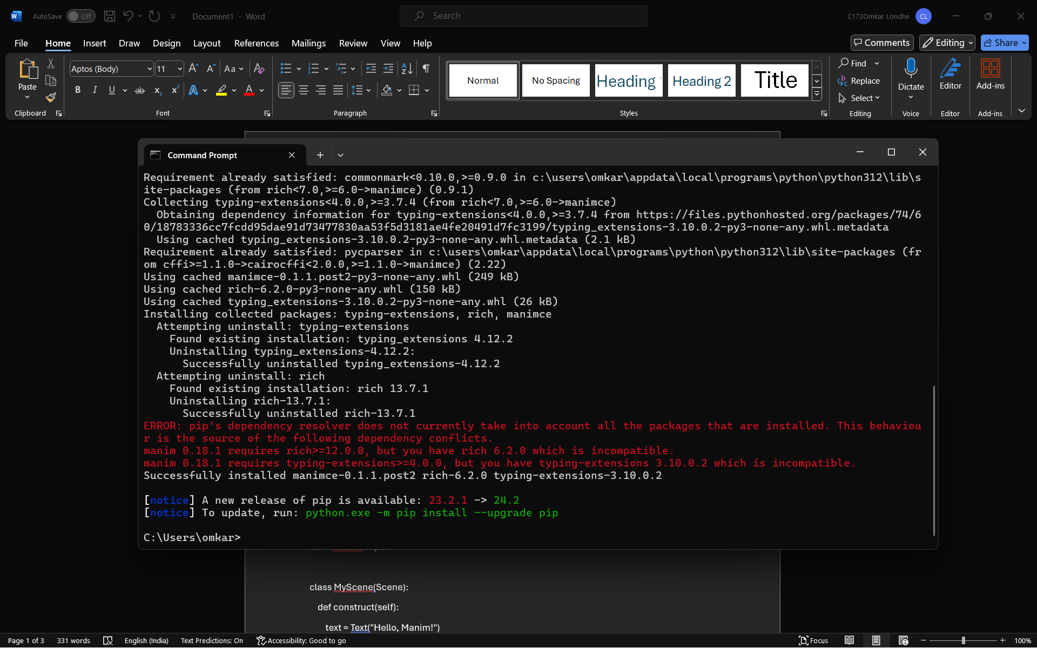

1. **Install FFmpeg**:
   * Download FFmpeg from FFmpeg’s official site.
   * Extract the files and add the bin directory to your system’s PATH.
2. **Verify Installation**:
   * Run the following command to check if Manim is installed correctly:
   * manim --version

**Structural Overview of a Manim Script**

A basic Manim script has a simple structure. Here’s an example:

**Python**

from manim import *

class MyScene(Scene):

def construct(self):

text = Text("Hello, Manim!")

self.play(Write(text))

self.wait(2)

AI-generated code. Review and use carefully.

**Key Components:**

1. **Import Manim**:
   * from manim import * imports all necessary classes and functions.
2. **Define a Scene**:
   * Create a class that inherits from Scene.
   * Define the construct method where you build your animation.
3. **Create and Animate Mobjects**:
   * Mobjects (Mathematical Objects) are the building blocks of Manim animations.
   * Use methods like self.play() to animate mobjects.
4. **Render the Scene**:
   * Save the script as my_scene.py.
   * Run the script using the command:
   * manim -pql my_scene.py MyScene

**Crafting Basic Scenes and Animations**

Let’s create a simple animation where a circle transforms into a square:

**Python**

from manim import *

class TransformShape(Scene):

def construct(self):

circle = Circle()

square = Square()

self.play(Create(circle))

self.wait(1)

self.play(Transform(circle, square))

self.wait(1)

AI-generated code. Review and use carefully.

**Explanation:**

1. **Create Mobjects**:
   * Circle() and Square() create the respective shapes.
2. **Animate Mobjects**:
   * self.play(Create(circle)) draws the circle.
   * self.play(Transform(circle, square)) transforms the circle into a square.
3. **Wait**:
   * self.wait(1) pauses the animation for 1 second.

**Running the Script:**

Save the script as transform_shape.py and run it with:

manim -pql transform_shape.py TransformShape

This will render the animation and open it in your default video player.