8/2/2020

By Team:

AzmuthStar

**AzmuthStar**

User Manual

1. **SOFTWARE SYSTEM REQUIREMENTS:**

• Windows 10, Linux, MAC(platform independent)

• 64-bits operating system

• 8 GB of RAM available

• An Internet connection

1. **PREREQUISITES:**
   1. GDAL must be configured on your local system, you can install it from below link

<https://drive.google.com/drive/folders/1DpwzJTsoUSpkvOVBPJw0tyI8PI8qKIae?usp=sharing>

* 1. Python version 3.6
  2. Required python packages mentioned in “requirements.txt” on git hub repository
  3. Yolov3.weights, yolov3.cfg, you can download this files from below link
  4. Shape file of ocean, you can download this file using below link

1. **How to use *AzmuthStar* software:**

***Step 1: Run “main.py” using python IDE or command line.***

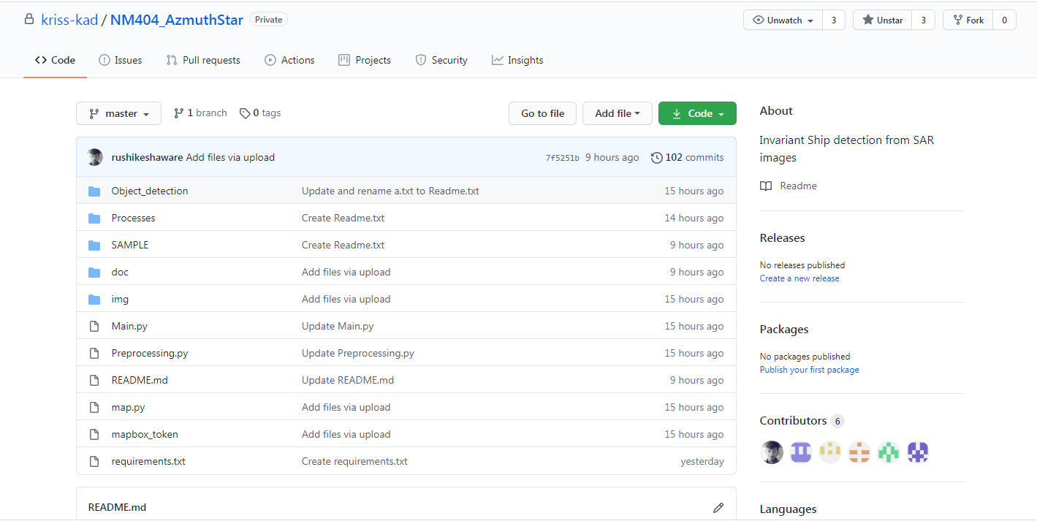

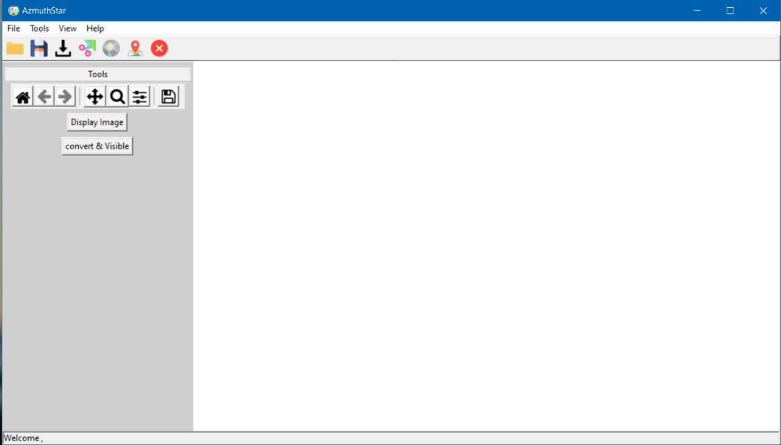

***Step 2: Now you can see the GUI of AzmuthStar as displayed below.***

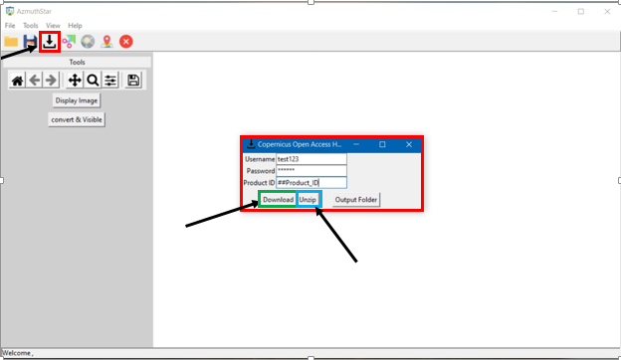

***Step 3:***

***3.1 To initialize the AzmuthStar Ship Application first of all we need to Login in SAR API by passing Username, Password and Product id for this click on the download button***  ***and the pop up will appear.***

***3.2 Login in SAR API and press download button***

***3.3 Click on unzip button provided in SAR API pop up window and Unzip the downloaded dataset.***

***3.4 3.3 After pressing unzip button the data is going to store at ‘Processes/Download/Unzip’.***

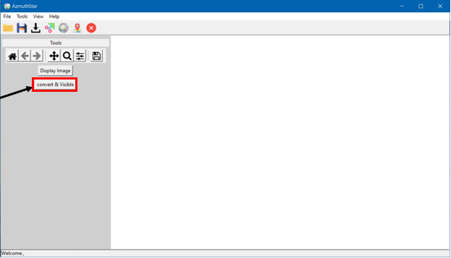

***Step 4: To visualize the downloaded image from unzip folder click on “convert and visible button” on the GUI.***

***4.1 The visualize image will be saved in Processes/Visible/.***

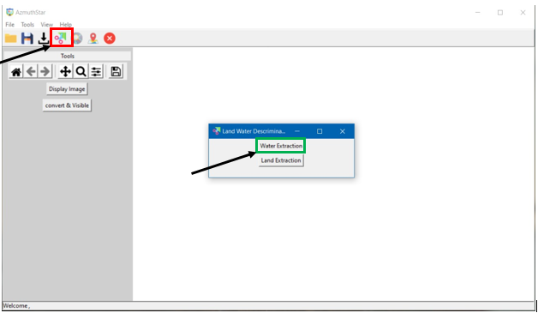

***Step 5: To perform Land water discrimination click on*** ***.***

***5.1 A pop up window will appear providing two buttons, one for Land Extraction and another for Water Extraction.***

***5.2 For Ocean part click on Water Extraction.***

***5.3 The extracted ocean part will be saved in the folder “/Processes/Ocean/”.***

***Step 6: To display the click on “Display Image” button on the GUI.***

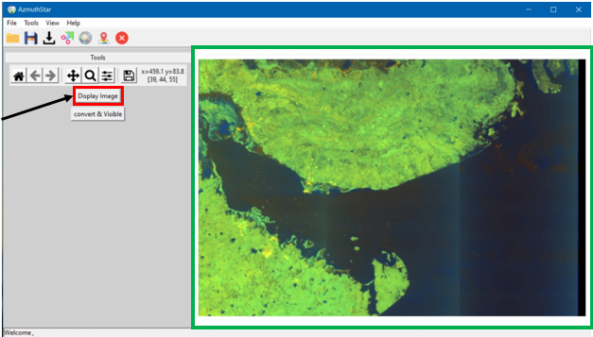

***Step 7: For detecting the ships on the extracted ocean part click on C:\Users\CC-19\Desktop\search.png.***

***‘’ After clicking on the button three operations start simultaneously, first is the ocean gridding, second is contouring and the then the object detection.”***



***Step 7: To plot the All the detected ships click on C:\Users\CC-19\Desktop\location.png.***

