|  |  |
| --- | --- |
| Roll No | A-75 |
| Student Name | Prasad Kashid |
| Subject | IP |
| Date of Experiment |  |
| Date of Submission |  |

# EXPERIMENT NO1

**Aim:** Installation of VS Code and configuration of libraries

# Lab Objective: Lab Outcome:

**Theory:**

Visual Studio Code combines the simplicity of a source code editor

with powerful developer tooling, like IntelliSense code completion and debugging. First and foremost, it is an editor that gets out of your way. The delightfully frictionless edit-build-debug cycle means less time fiddling with your environment, and more time executing on your ideas.

Visual Studio Code supports macOS, Linux, and Windows - so you can hit the ground running, no matter the platform

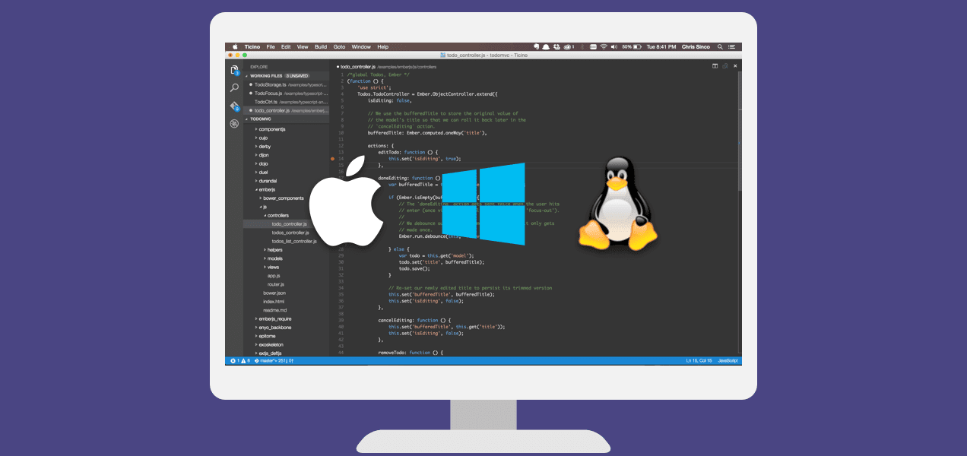

Visual Studio Code features a lightning-fast source code editor, perfect for day-to-day use. With support for hundreds of languages, VS Code helps you be instantly productive with syntax highlighting, bracket-matching, auto- indentation, box-selection, snippets, and more. Intuitive keyboard shortcuts, easy customization and community-contributed keyboard shortcut mappings let you navigate your code with ease. VS Code also integrates with build and

scripting tools to perform common tasks making everyday workflows faster. VS Code has support for Git so you can work with source control without leaving the editor including viewing pending changes diffs.

VS Code includes enriched built-in support for Node.js development with JavaScript and TypeScript, powered by the same underlying technologies that drive Visual Studio. VS Code also includes great tooling for web technologies such as JSX/React, HTML, CSS, SCSS, Less, and JSON.

Installation of VS Code

## Step1

Download Visual Studio code from below URL: <https://code.visualstudio.com/download> **Step2:**

## Install Visual Studio Code on Windows Step3:

Thirdly, click on "create a desktop icon" so that it can be accessed from desktop and click on Next.

## Step4:

After that, click on the install button.

## Step5:

Finally, after installation completes, click on the finish button, and the visual studio code will get open.

## USER INTERFACE:

**Configuration of libraries in VS Code**

## Install python library for extension

## 

1. **Install php library for extension**

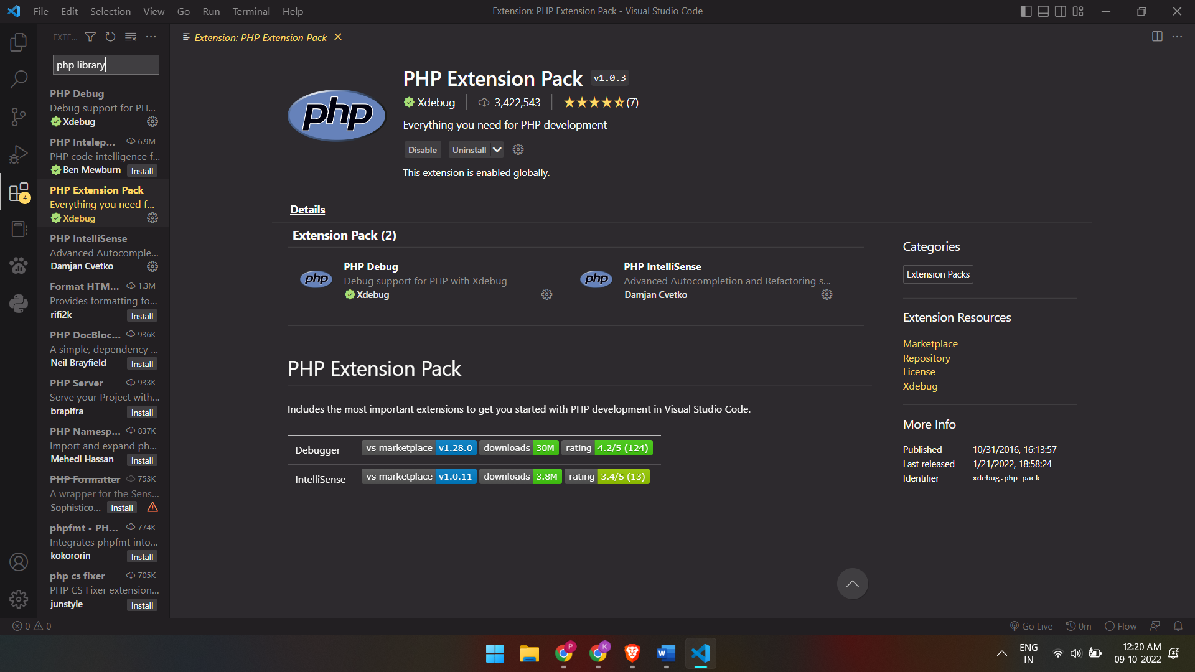

## Install html5 library

## 

1. **Install json library**

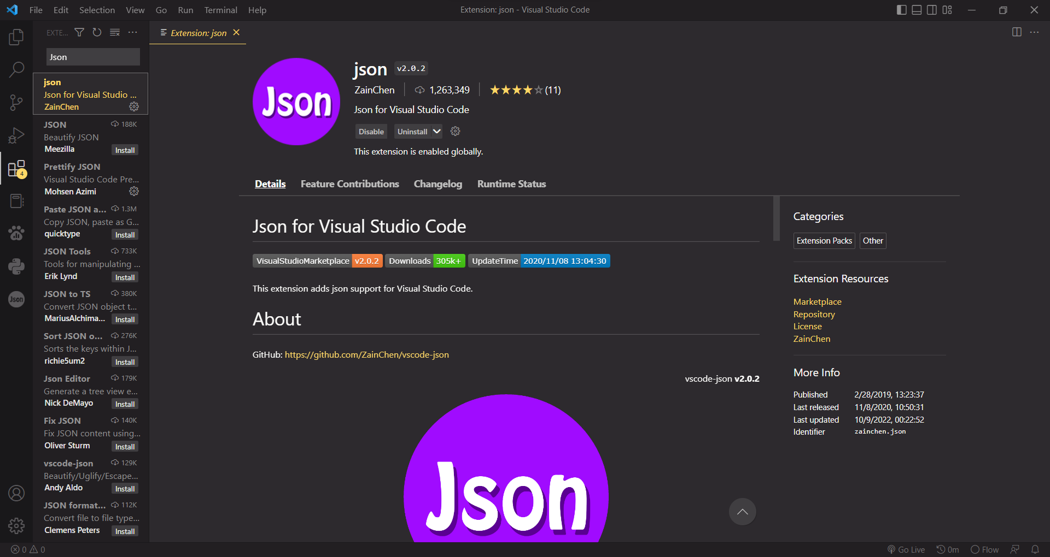

1. **Install json library**



**Conclusion:** Hence we successfully installed VS code and configuration of some libraries in VS code.