|  |  |
| --- | --- |
| Roll No. | A-75 |
| Student Name | Prasad Kashid |
| Subject | Internet Programming |
| Date Of Experiment |  |
| Date Of Submission |  |

# SUBJECT: INTERNET PROGRAMMING EXPERIMENT NO. 3

**AIM:** Create styles for Facebook login webpage using CSS.

**OBJECTIVE:** To orient student to CSS for making Webpages.

**LAB OUTCOMES:** LO1 & LO2

**LO1:** Identify and apply the appropriate HTML tags to develop a webpage.

**LO2**: Identify and apply the appropriate CSS tags to format data on webpage.

**THEORY:**

# CSS:

Cascading Style Sheets, fondly referred to as CSS, is a simple design language intended to simplify the process of making web pages presentable. CSS stands for Cascading Style Sheets. It describes how HTML elements are to be displayed on screen, paper, or in other media. CSS saves a lot of work. It can control the layout of multiple web pages all at once. External stylesheets are stored in CSS files.

# Advantage of CSS

* **Create Stunning Web site:** CSS handles the look and feel part of a web page. Using CSS, you can control the color of the text, the style of fonts, the spacing between paragraphs, how columns are sized and laid out, what background images or colors are used, layout designs, variations in display for different devices and screen sizes as well as a variety of other effects.
* **Become a web designer:** If you want to start a career as a professional web designer, HTML and CSS designing is a must skill.
* **Control web:** CSS is easy to learn and understand but it provides powerful control over the presentation of an HTML document. Most commonly, CSS is combined with the markup languages HTML or XHTML.

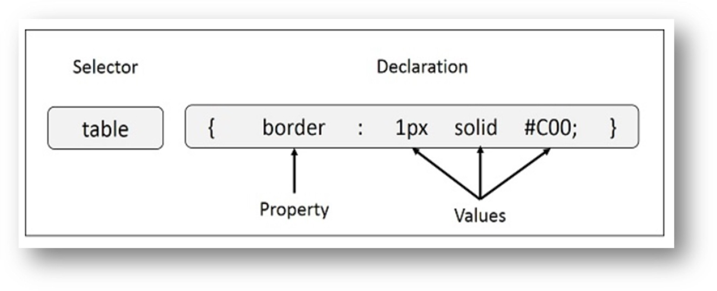

# CSS Syntax

You can put CSS Style Rule Syntax as follows

selector { property: value }

* + The selector points to the HTML element you want to style.
  + The declaration block contains one or more declarations separated by semicolons.
  + Each declaration includes a CSS property name and a value, separated by a colon.
  + Multiple CSS declarations are separated with semicolons, and declaration blocks are surrounded by curly braces.

# Example

In this example all <p> elements will be center-aligned, with a red text editor.

p {

color: red;

text-align: center;

}

# CSS Selectors

CSS selectors are used to "find" (or select) the HTML elements you want to style. We can divide CSS selectors into five categories:

* + Simple selectors (select elements based on name, id, class)
  + Combinator selectors (select elements based on a specific relationship between them)
  + Pseudo-class selectors (select elements based on a certain state)
  + Pseudo-elements selectors (select and style a part of an element)
  + Attribute selectors (select elements based on an attribute or attribute value)

# Three Ways to Insert CSS:

There are three ways of inserting a style sheet:

## External CSS:

Each HTML page must include a reference to the external style sheet file inside the

<link> element, inside the head section.

External styles are defined within the <link> element, inside the <head> section of an HTML page:

<link rel="stylesheet" href= "mystyle.css">

## Internal CSS:

An internal style sheet may be used if one single HTML page has a unique style. The internal style is defined inside the <style> element, inside the head section.

Internal styles are defined within the <style> element, inside the <head> section of an HTML

<style>

body {

}

</style>

background-color: linen;

## Inline CSS

An inline style may be used to apply a unique style for a single element.

To use inline styles, add the style attribute to the relevant element. The style attribute can contain any CSS property.

Inline styles are defined within the "style" attribute of the relevant element:

<h1 style="color:blue;text-align:center;">This is a heading</h1>

## CSS Border Style

The border-style property specifies what kind of border to display. The following values are allowed:

* Dotted: Defines a dotted border
* Dashed: Defines a dashed border
* Solid: Defines a solid border
* Double: Defines a double border
* Groove: Defines a 3D grooved border. The effect depends on the border-color value
* Ridge: Defines a 3D ridged border. The effect depends on the border-color value
* Inset: Defines a 3D inset border. The effect depends on the border-color value
* Outset: Defines a 3D outset border. The effect depends on the border-color value
* None: Defines no border
* Hidden: Defines a hidden border

# CSS Box Model

In CSS, the term "box model" is used when talking about design and layout.

The CSS box model is essentially a box that wraps around every HTML element. It consists of: margins, borders, padding, and the actual content. The image below illustrates the box model:

Explanation of the different parts:

* + **Content:** The content of the box, where text and images appear
  + **Padding:** Clears an area around the content. The padding is transparent
  + **Border:** A border that goes around the padding and content
  + **Margin:** Clears an area outside the border. The margin is transparent

## Background properties:

* + The background-color property is used to set the background color of an element.
  + The background-image property is used to set the background image of an element.
  + The background-repeat property is used to control the repetition of an image in the background.
  + The background-position property is used to control the position of an image in the background.
  + The background-attachment property is used to control the scrolling of an image in the background.
  + The background property is used as shorthand to specify a number of other background properties.

# Font properties:

* + The font-family property is used to change the face of a font.
  + The font-style property is used to make a font italic or oblique.
  + The font-variant property is used to create a small-caps effect.
  + The font-weight property is used to increase or decrease how bold or light a font appears.
  + The font-size property is used to increase or decrease the size of a font.
  + The font property is used as shorthand to specify a number of other font properties.

# CSS-Dimension

* + The height property is used to set the height of a box.
  + The width property is used to set the width of a box.
  + The line-height property is used to set the height of a line of text.
  + The max-height property is used to set a maximum height that a box can be.
  + The min-height property is used to set the minimum height that a box can be.
  + The max-width property is used to set the maximum width that a box can be.
  + The min-width property is used to set the minimum width that a box can be.

## OUTCOMES:

**CODE:**

# index.html

<!DOCTYPE *html*>

<html *lang*="en">

<head>

<title>Facebook </title>

<meta *charset*="utf-8">

<meta *name*="viewport" *content*="width=device-width, initial-scale=1">

<link *rel*="stylesheet" *href*="exp3.css">

<link *href*='https://fonts.googleapis.com/css?family=Open+Sans:400,700' *rel*='stylesheet' *type*='text/css'>

</head>

<body>

<div *id*="navwrapper">

<div *id*="navbar"> <table *class*="tablewrapper">

<tr>

<td *class*="row1">Email or Phone</td>

<td *class*="row1">Password</td>

</tr>

<tr>

<td><input *type*="text" *class*="inputtext">

</td>

<td><input *type*="text" *class*="inputtext">

</td>

<td><div *id*="button">Log In</div></td>

</tr>

<tr>

<td>

<div *class*="row2"><input *type*="checkbox" *checked*>Keep me logged in</div></td>

<td *class*="row2 h">Forgot your password?</td>

</table>

<h1 *class*="logowrapper">facebook</h1>

</div>

</div>

<div *id*="contentwrapper">

<div *id*="content">

<div *id*="leftbod">

<div *class*="connect bolder">

Connect with friends and the

world around you on Facebook.</div>

<div *class*="leftbar">

<img *src*="img1.PNG" *alt*="img1" *class*="iconwrap fb1"/>

<div *class*="fb1">

<span *class*="rowtext">See photos and updates</span>

<span *class*="rowtext2 fb1">from friends in News Feed</span>

</div>

</div>

<div *class*="leftbar">

<img *src*="img2.PNG" *alt*="img2" *class*="iconwrap fb1"/>

<div *class*="fb1">

<span *class*="rowtext">Share what's new</span>

<span *class*="rowtext2 fb1">in your life on your timeline</span>

</div>

</div>

<div *class*="leftbar">

<img *src*="img3.png" *alt*="img3" *class*="iconwrap fb1"/>

<div *class*="fb1">

<span *class*="rowtext">Find more</span>

<span *class*="rowtext2 fb1">of what you're looking for with graph search</span>

</div>

</div>

</div>

<div *id*="rightbod">

<div *class*="signup bolder">Sign Up</div>

<div *class*="free bolder">It's free and always will be</div>

<div *class*="formbox">

<input *type*="text" *class*="inputbody in1" *placeholder*="First name">

<input *type*="text" *class*="inputbody in1 fr" *placeholder*="Last name">

</div>

<div *class*="formbox">

<input *type*="text" *class*="inputbody in2" *placeholder*="Email or mobile number">

</div>

<div *class*="formbox">

<input *type*="text" *class*="inputbody in2" *placeholder*="Re-enter email or mobile number">

</div>

<div *class*="formbox">

<input *type*="text" *class*="inputbody in2" *placeholder*="New password">

</div>

<div *class*="formbox">

<div *class*="bday">Birthday</div>

</div>

<div *class*="formbox">

<span *data-type*="selectors">

<span>

<select *title*="Month" *class*="selectbody f1">

<option *value*="0" *selected*="1">Month</option>

<option *value*="1">Jan</option>

<option *value*="2">Feb</option>

<option *value*="3">Mar</option>

<option *value*="4">Apr</option>

<option *value*="5">May</option>

<option *value*="6">Jun</option>

<option *value*="7">Jul</option>

<option *value*="8">Aug</option>

<option *value*="9">Sep</option>

<option *value*="10">Oct</option>

<option *value*="11">Nov</option>

<option *value*="12">Dec</option>

</select>

<select *title*="Day" *class*="selectbody fl">

<option *value*="0" *selected*="1">Day</option>

<option *value*="1">1</option>

<option *value*="2">2</option>

<option *value*="3">3</option>

<option *value*="4">4</option>

<option *value*="5">5</option>

<option *value*="6">6</option>

<option *value*="7">7</option>

<option *value*="8">8</option>

<option *value*="9">9</option>

<option *value*="10">10</option>

<option *value*="11">11</option>

<option *value*="12">12</option>

<option *value*="13">13</option>

<option *value*="14">14</option>

<option *value*="15">15</option>

<option *value*="16">16</option>

<option *value*="17">17</option>

<option *value*="18">18</option>

<option *value*="19">19</option>

<option *value*="20">20</option>

<option *value*="21">21</option>

<option *value*="22">22</option>

<option *value*="23">23</option>

<option *value*="24">24</option>

<option *value*="25">25</option>

<option *value*="26">26</option>

<option *value*="27">27</option>

<option *value*="28">28</option>

<option *value*="29">29</option>

<option *value*="30">30</option>

<option *value*="31">31</option></select>

<select *title*="Year" *class*="selectbody fl">

<option *value*="0" *selected*="1">Year</option>

<option *value*="2015">2021</option>

<option *value*="2015">2020</option>

<option *value*="2015">2019</option>

<option *value*="2015">2017</option>

<option *value*="2015">2016</option>

<option *value*="2015">2015</option>

<option *value*="2014">2014</option>

<option *value*="2013">2013</option>

<option *value*="2012">2012</option>

<option *value*="2011">2011</option>

<option *value*="2010">2010</option>

<option *value*="2009">2009</option>

<option *value*="2008">2008</option>

<option *value*="2007">2007</option>

<option *value*="2006">2006</option>

<option *value*="2005">2005</option>

<option *value*="2004">2004</option>

<option *value*="2003">2003</option>

<option *value*="2002">2002</option>

<option *value*="2001">2001</option>

<option *value*="2000">2000</option>

<option *value*="1999">1999</option>

<option *value*="1998">1998</option>

<option *value*="1997">1997</option>

<option *value*="1996">1996</option>

<option *value*="1995">1995</option>

<option *value*="1994">1994</option>

<option *value*="1993">1993</option>

<option *value*="1992">1992</option>

<option *value*="1991">1991</option>

<option *value*="1990">1990</option>

<option *value*="1989">1989</option>

<option *value*="1988">1988</option>

<option *value*="1987">1987</option>

<option *value*="1986">1986</option>

<option *value*="1985">1985</option>

<option *value*="1984">1984</option>

<option *value*="1983">1983</option>

<option *value*="1982">1982</option>

<option *value*="1981">1981</option>

<option *value*="1980">1980</option>

<option *value*="1979">1979</option>

<option *value*="1978">1978</option>

<option *value*="1977">1977</option>

<option *value*="1976">1976</option>

<option *value*="1975">1975</option>

<option *value*="1974">1974</option>

<option *value*="1973">1973</option>

<option *value*="1972">1972</option>

<option *value*="1971">1971</option>

<option *value*="1970">1970</option>

<option *value*="1969">1969</option>

<option *value*="1968">1968</option>

<option *value*="1967">1967</option>

<option *value*="1966">1966</option>

</select>

</span>

<div *class*="fb1 why h">Why do I need to provide my birthday?</div></div>

<div *class*="formbox mt1">

<span *data-type*="radio" *class*="spanpad">

<input *type*="radio" *id*="fem" *class*="m0">

<label *for*="fem" *class*="gender">Female

</label>

<input *type*="radio" *id*="male" *class*="m0">

<label *for*="male" *class*="gender">Male

</label>

</span>

</div>

<div *class*="formbox">

<div *class*="agree">

By clicking Sign Up, you agree to our <div *class*="link">Terms</div> and that you have read our <div *class*="link">Data Use Policy</div>, including our <div *class*="link">Cookie Use</div>.

</div>

</div>

<div *class*="formbox">

<button *type*="submit" *class*="signbut bolder">Sign Up</button>

</div>

<div *class*="formbox">

<div *class*="create"><div *class*="link h">Create a Page</div> for a celebrity, band or business.</div>

</div>

</div>

</div>

</div>

</body>

# styles.css:

*.body* {

  margin: 0;

  font-family: "Lucida Grande", tahoma, verdana, arial, sans-serif;

  line-height: 1.28;

}

*#navwrapper* {

  width: 100%;

  height: 82px;

  background-color: #3b5998;

}

*#navbar* {

  margin: 0 auto;

  width: 980px;

  height: 59px;

}

*#contentwrapper* {

  width: 100%;

  height: 606px;

  background-color: #edf0f5;

}

*#content* {

  margin: 0 auto;

  width: 980px;

  padding-top: 20px;

}

h1 {

  font-family: tahoma, verdana, arial, sans-serif;

  font-size: 38px;

  letter-spacing: 0.05px;

  margin: 0;

  color: #fff;

*-webkit-font-smoothing*: antialiased;

}

*.logowrapper* {

  display: block;

  padding: 30px 0;

}

*#button* {

  position: relative;

  width: 45px;

  height: 18px;

  background-color: #5b72a9;

  border: 1px solid #999;

  border-color: #8b9dc3 #2f477a #29447e #1a356e;

*-webkit-box-shadow*: 0 1px 0 rgba(0, 0, 0, 0.1);

  cursor: pointer;

  font-size: 11px;

  font-weight: bold;

  text-align: center;

  color: #fff;

}

*.tablewrapper* {

  float: right;

  margin-top: 15px;

}

*.row1* {

  color: #fff;

  font-size: 11px;

  width: 164px;

  cursor: pointer;

}

*.inputtext* {

  border-color: #1d2a5b;

  margin: 0;

  width: 142px;

  border: 1px solid #bdc7d8;

  margin: 0;

  padding: 3px;

  background-color: #faffbd;

}

*.row2* {

  color: #9daccb;

  font-size: 11px;

  width: 164px;

  cursor: pointer;

}

*#leftbod* {

  width: 565px;

  display: inline-block;

}

*.connect* {

  width: 409px;

  height: 72px;

  padding: 42px 0 24px;

  font-size: 26px;

  font-weight: 700;

  line-height: 36px;

  color: #333;

  display: inline-block;

}

*.leftbar* {

  padding-bottom: 10px;

  margin-top: 20px;

}

*.iconwrap* {

  margin-right: 20px;

  width: 55px;

}

*.rowtext* {

  font-size: 16px;

  font-weight: bold;

  color: #333;

}

*.fb1* {

  display: inline-block;

  vertical-align: middle;

}

*.rowtext2* {

  font-size: 15px;

  color: #666;

  margin-left: 10px;

}

*#rightbod* {

  display: inline-block;

  vertical-align: top;

  width: 399px;

  height: 200px;

  float: right;

}

*.signup* {

  font-size: 36px;

*-webkit-font-smoothing*: antialiased;

  font-weight: 700;

  margin-bottom: 5px;

}

*.bolder* {

  font-family: "Open Sans", sans-serif;

  text-rendering: optimizelegibility;

  color: #333;

}

*.free* {

  font-size: 19px;

  margin-bottom: 20px;

}

*.formbox* {

  display: inline-block;

  width: 399px;

}

*.inputbody* {

  display: inline-block;

  font-size: 18px;

  padding: 8px 10px;

  border: 1px solid #bdc7d8;

*-webkit-border-radius*: 5px;

  color: #333;

  margin-bottom: 10px;

}

*::-webkit-input-placeholder* {

  color: #999;

}

*::-moz-placeholder* {

  color: #999;

}

*:-ms-input-placeholder* {

  color: #999;

}

*.in1* {

  width: 172px;

}

*.in2* {

  width: 377px;

}

*.fr* {

  float: right;

}

*.fl* {

  float: left;

}

*.bday* {

  font-size: 19px;

  color: #141823;

*-webkit-font-smoothing*: antialiased;

  margin-bottom: 5px;

}

*.selectbody* {

  display: inline-block;

  height: 30px;

  font-size: 13px;

  border: 1px solid #bdc7d8;

*-webkit-border-radius*: 5px;

  color: #141823;

}

*.why* {

  font-size: 11px;

  color: #3b5998;

  width: 150px;

  margin-left: 10px;

  cursor: pointer;

}

*.h:hover* {

  text-decoration: underline;

}

*.gender* {

  font-size: 18px;

  color: #141823;

  cursor: pointer;

  padding: 0 10px 0 3px;

  margin-right: 4px;

  line-height: 18px;

  vertical-align: middle;

}

*.spanpad* {

  padding: 5px 0 5px 4px;

  display: inline-block;

}

*.mt1* {

  margin-top: 15px;

}

*.m0* {

  margin: 0;

}

*.agree* {

  font-size: 11px;

  color: #777;

  width: 316px;

  margin: 11px 0 11px;

}

*.link* {

  color: #3b5998;

  display: inline-block;

  cursor: pointer;

}

*.signbut* {

  font-size: 19px;

  font-weight: 700;

  letter-spacing: 1px;

  color: #fff;

  min-width: 194px;

  padding: 7px 20px;

  text-align: center;

*-webkit-border-radius*: 5px;

  background: -webkit-linear-gradient(#67ae55, #578843);

*-webkit-box-shadow*: inset 0 1px 1px #a4e388;

  border: 1px solid;

  border-color: #3b6e22 #3b6e22 #2c5115;

  margin-top: 10px;

  margin-bottom: 10px;

  text-shadow: 0 1px 2px rgba(0, 0, 0, 0.5);

  cursor: pointer;

}

*.signbut:hover* {

  background: -webkit-linear-gradient(#79bc64, #578843);

}

*.create* {

  border-top: 1px solid #a0a9c0;

  color: #666;

  font-size: 13px;

  font-weight: bold;

  margin-top: 10px;

  padding-top: 15px;

}

**OUTPUT:**

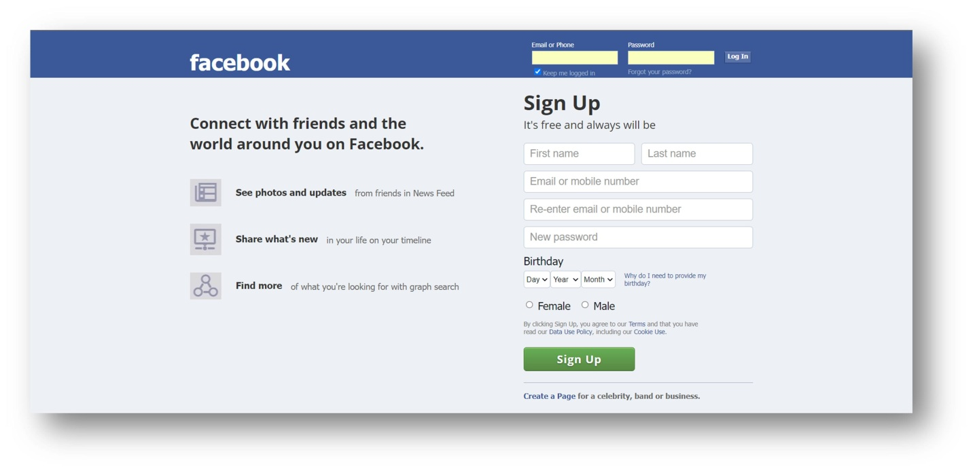

**CONCLUSION:** In the above experiment we studied about CSS and also implemented and created a basic webpage for facebook with the help of styling using CSS.