|  |  |
| --- | --- |
| Roll No | A-75 |
| Student Name | Prasad Kashid |
| Subject | IP |
| Date of Experiment |  |
| Date of Submission |  |

# EXPERIMENT NO. 4

**AIM:** Create responsive Web page using Bootstrap

**OBJECTIVE:** To orient students to boostrap to create responsive websites

# LABOUTCOMES:

LO1(Identify and apply the appropriate HTML tags to develop a webpage.)

LO2(Identify and apply the appropriate CSS tags to format data on webpage) LO3(Construct responsive websites using Bootstrap)

# THEORY:

**Bootstrap**

* Bootstrap is the most popular HTML, CSS and JavaScript framework for developing a responsive and mobile friendly website.
* It is absolutely free to download and use.
* It is a front-end framework used for easier and faster web development.
* It includes HTML and CSS based design templates for typography, forms, buttons, tables, navigation, modals, image carousels and many others.
* It can also use JavaScript plug-ins.
* It facilitates you to create responsive designs.

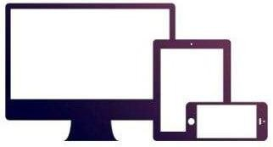

# History of Bootstrap

Bootstrap was developed by Mark Otto and Jacob Thornton at Twitter.It was released as an open source product in August 2011 on GitHub.

In June 2014 Bootstrap was the No.1 project on GitHub.

# Use of Bootstrap

Following are the main advantage of Bootstrap:

* It is very easy to use. Anybody having basic knowledge of HTML and CSS can use Bootstrap.
* It facilitates users to develop a responsive website.
* It is compatible on most of browsers like Chrome, Firefox, Internet Explorer, Safari and Opera etc.

# What is a responsive website

A website is called responsive website which can automatically adjust itself to look good on all devices, from smart phones to desktops etc.

# Bootstrap package contains

**Scaffolding:** Bootstrap provides a basic structure with Grid System, link styles, and background.

**CSS:** Bootstrap comes with the feature of global CSS settings, fundamental HTML elements style and an advanced grid system.

**Components**: Bootstrap contains a lot of reusable components built to provide iconography, dropdowns, navigation, alerts, pop-overs, and much more.

**JavaScript Plugins:** Bootstrap also contains a lot of custom jQuery plugins. You can easily include them all, or one by one.

**Customize:** Bootstrap components are customizable and you can customize Bootstrap's components, LESS variables, and jQuery plugins to get your own style.

# CODE:

<!DOCTYPE html>

<html lang="en">

<head>

<meta charset="utf-8">

<meta content="width=device-width, initial-scale=1.0" name="viewport">

<title>TERNA ENGINEERING COLLEGE</title>

<meta content="" name="description">

<meta content="" name="keywords">

<!-- Favicons -->

<link href="assets/img/favicon.png" rel="icon">

<link href="assets/img/apple-touch-icon.png" rel="apple-touch-icon">

<!-- Google Fonts -->

<link href="https://fonts.googleapis.com/css?family=Open+Sans:300,300i,400,400i,600,600i, 700,700i|Raleway:300,300i,400,400i,500,500i,600,600i,700,700i|Poppins:300,300i,400,

400i,500,500i,600,600i,700,700i" rel="stylesheet">

<!-- Vendor CSS Files -->

<link rel="stylesheet"

href="https://use.fontawesome.com/releases/v5.15.4/css/all.css" integrity="sha384-

DyZ88mC6Up2uqS4h/KRgHuoeGwBcD4Ng9SiP4dIRy0EXTlnuz47vAwmeGwVChigm" crossorigin="anonymous">

<link href="assets/vendor/aos/aos.css" rel="stylesheet">

<link href="assets/vendor/bootstrap/css/bootstrap.min.css" rel="stylesheet">

<link href="assets/vendor/bootstrap-icons/bootstrap-icons.css" rel="stylesheet">

<link href="assets/vendor/boxicons/css/boxicons.min.css" rel="stylesheet">

<link href="assets/vendor/glightbox/css/glightbox.min.css" rel="stylesheet">

<link href="assets/vendor/remixicon/remixicon.css" rel="stylesheet">

<link href="assets/vendor/swiper/swiper-bundle.min.css" rel="stylesheet">

<!-- Template Main CSS File -->

<link href="assets/css/style.css" rel="stylesheet">

</head>

<body>

<!-- ======= Header ======= -->

<header id="header" class="fixed-top">

<div class="container d-flex align-items-center justify-content-between">

<a href="index.html" class="logo"><img src="assets/img/Terna-Logo_COREL- cdr.png" alt="" class="img-fluid"></a>

<nav id="navbar" class="navbar">

<ul>

<li><a class="nav-link scrollto active" href="#hero">Home</a></li>

<li><a class="nav-link scrollto" href="#about">About Us</a></li>

<li><a class="nav-link scrollto" href="#testimonials">Testimonials</a></li>

<li><a class="nav-link scrollto o" href="#services">Departments</a></li>

<li><a class="nav-link scrollto" href="#contact">Contact</a></li>

<li><a class="getstarted scrollto" href="#about">Get Started</a></li>

</ul>

<i class="bi bi-list mobile-nav-toggle"></i>

</nav><!-- .navbar -->

</div>

</header><!-- End Header -->

<!-- ======= Hero Section ======= -->

<section id="hero" class="d-flex align-items-center">

<div class="container position-relative" data-aos="fade-up" data-aos-delay="100">

<div class="row justify-content-center">

<div class="col-xl-7 col-lg-9 text-center">

<h1>TERNA ENGINEERING COLLEGE</h1>

<h2>KNOWLEDGE TO EMPOWER</h2>

</div>

</div>

<div class="text-center">

<a href="#about" class="btn-get-started scrollto">Explore now</a>

</div>

<main id="main">

<!-- ======= About Section ======= -->

<section id="about" class="about">

<div class="container" data-aos="fade-up">

<div class="section-title">

<h2>About Us</h2>

</div>

<div class="row content">

<div class="col-lg-6">

<p>

Terna Engineering College is a private college of engineering in Nerul, Navi Mumbai, Maharashtra, India, affiliated to the University of Mumbai. It was established in 1991 and received approval from the All India Council for Technical Education in 1994. It offers bachelor's and master's degrees in various engineering subjects.

</p>

<ul>

<li><i class="ri-check-double-line"></i> Ranked 40th in the top private engineering college in India by Times Ranking 2020</li>

<li><i class="ri-check-double-line"></i> 1500 job offers in last four placement seasons.</li>

<li><i class="ri-check-double-line"></i> Terna Offers Education Of The Highest Quality With Its Curriculum of Exceptional Offerings In Engineering & Technology Studies.</li>

</ul>

</div>

<div class="col-lg-6 pt-4 pt-lg-0">

<p>

As per Maharashtra Public Universities Act, 2016 (Mah. Act No. VI of 2017) clause 97, a College Development Committee (CDC) has been established.

The Main Objective of College Development Committee is to provide a delegation to various stakeholders of institute for administration and development of institute.

</p>

<ul>

<li><i class="ri-check-double-line"></i> Terna Engineering College Is One Of The Well Known And Finest Technical Institution,With ‘A’ Grade From Maharashtra Government.</li>

<li><i class="ri-check-double-line"></i> 1st college to have MECHATRONICS Engineering Course</li>

<li><i class="ri-check-double-line"></i> Strong Entrepreneurship Cell, Incubated Startup, Counselling Center for Overseas Education.</li>

</ul>

</div>

</div>

</div>

</section><!-- End About Section -->

<!-- ======= Counts Section ======= -->

<section id="counts" class="counts section-bg">

<div class="container">

<div class="row justify-content-end">

<div class="col-lg-3 col-md-5 col-6 d-md-flex align-items-md-stretch">

<div class="count-box">

<span data-purecounter-start="0" data-purecounter-end="9" data-purecounter- duration="2" class="purecounter"></span>

<p>Departments</p>

</div>

</div>

<div class="col-lg-3 col-md-5 col-6 d-md-flex align-items-md-stretch">

<div class="count-box">

<span data-purecounter-start="0" data-purecounter-end="300" data- purecounter-duration="2" class="purecounter"></span>

<p>Placements</p>

</div>

</div>

<div class="col-lg-3 col-md-5 col-6 d-md-flex align-items-md-stretch">

<div class="count-box">

<span data-purecounter-start="0" data-purecounter-end="25" data- purecounter-duration="2" class="purecounter"></span>

<p>Years of experience</p>

</div>

</div>

<div class="col-lg-3 col-md-5 col-6 d-md-flex align-items-md-stretch">

<div class="count-box">

<span data-purecounter-start="0" data-purecounter-end="10" data- purecounter-duration="2" class="purecounter"></span>

<p>Awards</p>

</div>

</div>

</div>

</div>

</section><!-- End Counts Section -->

<!-- ======= Clients Section ======= -->

<section id="clients" class="clients section-bg">

<div class="container">

<div class="row">

<div class="col-lg-2 col-md-4 col-6 d-flex align-items-center justify-content-center" data-aos="zoom-in">

<img src="assets/img/clients/a.jpg" class="img-fluid" alt="">

</div>

<div class="col-lg-2 col-md-4 col-6 d-flex align-items-center justify-content-center" data-aos="zoom-in">

<img src="assets/img/clients/b.jpg" class="img-fluid" alt="">

</div>

<div class="col-lg-2 col-md-4 col-6 d-flex align-items-center justify-content-center" data-aos="zoom-in">

<img src="assets/img/clients/c.jpg" class="img-fluid" alt="">

</div>

<div class="col-lg-2 col-md-4 col-6 d-flex align-items-center justify-content-center" data-aos="zoom-in">

<img src="assets/img/clients/d.jfif" class="img-fluid" alt="">

</div>

<div class="col-lg-2 col-md-4 col-6 d-flex align-items-center justify-content-center" data-aos="zoom-in">

<img src="assets/img/clients/e.jfif" class="img-fluid" alt="">

</div>

<div class="col-lg-2 col-md-4 col-6 d-flex align-items-center justify-content-center" data-aos="zoom-in">

<img src="assets/img/clients/f.jpg" class="img-fluid" alt="">

</div>

</div>

</div>

</section><!-- End Clients Section -->

<!-- ======= Testimonials Section ======= -->

<section id="testimonials" class="testimonials">

<div class="container" data-aos="fade-up">

<div class="section-title">

<h2>Testimonials</h2>

</div>

<div class="testimonials-slider swiper" data-aos="fade-up" data-aos-delay="100">

<div class="swiper-wrapper">

<div class="swiper-slide">

<div class="testimonial-item">

<p>

<i class="bx bxs-quote-alt-left quote-icon-left"></i>

The infrastructure is nice and it is very near from nerul railways station (W). I’m in mech Branch so the faculties have good teaching experience and they try their best to explain you. They conduct lots of activities so that you can take part in.

<i class="bx bxs-quote-alt-right quote-icon-right"></i>

</p>

<img src="assets/img/testimonials/testimonials-1.jpg" class="testimonial-img"

alt="">

<h3>Saul Goodman</h3>

<h4>Student </h4>

</div>

</div><!-- End testimonial item -->

<div class="swiper-slide">

<div class="testimonial-item">

<p>

<i class="bx bxs-quote-alt-left quote-icon-left"></i>

Best college in Navi Mumbai.Experienced faculty, good infra structure,state of the art library,hostel facilities,Higher education cell for students.Nearer to railway station.

alt="">

<i class="bx bxs-quote-alt-right quote-icon-right"></i>

</p>

<img src="assets/img/testimonials/testimonials-2.jpg" class="testimonial-img"

<h3>Sara Wilsson</h3>

<h4>Student</h4>

</div>

</div><!-- End testimonial item -->

<div class="swiper-slide">

<div class="testimonial-item">

<p>

<i class="bx bxs-quote-alt-left quote-icon-left"></i>

A great college and the staffs. The atmosphere is very comfortable as responded by students I know. The HOD team and the other faculty members I met personally for my son were very co operative and supportive.

<i class="bx bxs-quote-alt-right quote-icon-right"></i>

</p>

<img src="assets/img/testimonials/testimonials-3.jpg" class="testimonial-img"

alt="">

<h3>Jena Karlis</h3>

<h4>Student</h4>

</div>

</div><!-- End testimonial item -->

<div class="swiper-slide">

<div class="testimonial-item">

<p>

<i class="bx bxs-quote-alt-left quote-icon-left"></i>

Just learnt today, amidst heavy rains they arranged hostel stay for mumbaikars staying away from college and stranded.

<i class="bx bxs-quote-alt-right quote-icon-right"></i>

</p>

<img src="assets/img/testimonials/testimonials-4.jpg" class="testimonial-img"

alt="">

<h3>Matt Brandon</h3>

<h4>Student</h4>

</div>

</div><!-- End testimonial item -->

<div class="swiper-slide">

<div class="testimonial-item">

<p>

<i class="bx bxs-quote-alt-left quote-icon-left"></i>

It is good place for the people who don’t really care much and are comfortable with self learning even though this statement mentioned there few fabulous and knowledgeable teachers college has good infrastructure,libary,grounds,enivorment and i am happy to be part of it

<i class="bx bxs-quote-alt-right quote-icon-right"></i>

</p>

alt="">

<img src="assets/img/testimonials/testimonials-5.jpg" class="testimonial-img"

<h3>John Larson</h3>

<h4>Student</h4>

</div>

</div><!-- End testimonial item -->

</div>

<div class="swiper-pagination"></div>

</div>

</div>

</section><!-- End Testimonials Section -->

<!-- ======= Services Section ======= -->

<section id="services" class="services section-bg">

<div class="container" data-aos="fade-up">

<div class="section-title">

<h2>Departments</h2>

</div>

<div class="row">

<div class="col-lg-4 col-md-6 d-flex align-items-stretch" data-aos="zoom-in" data- aos-delay="100">

<div class="icon-box iconbox-blue">

<div class="icon">

<svg width="100" height="100" viewBox="0 0 600 600" [xmlns="http://www.w3.org/2000/svg">](http://www.w3.org/2000/svg)

</svg>

<i class="fas fa-tv"></i>

</div>

<h4><a href="">INFORMATION TECHNOLOGY</a></h4>

<p>Terna Engineering College enriched IT Infrastructure for students to build IT skills, apply innovative ideas, implement real world projects</p>

</div>

</div>

<div class="col-lg-4 col-md-6 d-flex align-items-stretch mt-4 mt-md-0" data- aos="zoom-in" data-aos-delay="200">

<div class="icon-box iconbox-orange ">

<div class="icon">

<svg width="100" height="100" viewBox="0 0 600 600" [xmlns="http://www.w3.org/2000/svg">](http://www.w3.org/2000/svg)

</svg>

<i class="fas fa-laptop"></i>

</div>

<h4><a href="">COMPUTER SCIENCE</a></h4>

<p>The department of Computer Engineering was established in 1991 with initial intake of 60 to meet the demand of society and later it increased to 180</p>

</div>

</div>

<div class="col-lg-4 col-md-6 d-flex align-items-stretch mt-4 mt-lg-0" data- aos="zoom-in" data-aos-delay="300">

<div class="icon-box iconbox-pink">

<div class="icon">

<svg width="100" height="100" viewBox="0 0 600 600" [xmlns="http://www.w3.org/2000/svg">](http://www.w3.org/2000/svg)

</svg>

<i class="fas fa-tools"></i>

</div>

<h4><a href="">MECHANICAL </a></h4>

<p>Mechanical Engineering has been the very backbone of the industrial infrastructure. It is an area of study in which knowledge of mathematics and science

</p>

</div>

</div>

<div class="col-lg-4 col-md-6 d-flex align-items-stretch mt-4" data-aos="zoom-in" data-aos-delay="100">

<div class="icon-box iconbox-yellow">

<div class="icon">

<svg width="100" height="100" viewBox="0 0 600 600" [xmlns="http://www.w3.org/2000/svg">](http://www.w3.org/2000/svg)

</svg>

<i class="fas fa-building"></i>

</div>

<h4><a href="">CIVIL </a></h4>

<p>Civil engineers have one of the world’s greatest jobs. They build the quality of life, with technical and creative skills. </p>

</div>

</div>

<div class="col-lg-4 col-md-6 d-flex align-items-stretch mt-4" data-aos="zoom-in" data-aos-delay="200">

<div class="icon-box iconbox-red">

<div class="icon">

<svg width="100" height="100" viewBox="0 0 600 600" [xmlns="http://www.w3.org/2000/svg">](http://www.w3.org/2000/svg)

</svg>

<i class="fas fa-satellite-dish"></i>

</div>

<h4><a href="">Electronics & Telecommunication </a></h4>

<p>The Department is one of the most reputed in Mumbai University, well known for both its academic excellence and innovative approach.</p>

</div>

</div>

<div class="col-lg-4 col-md-6 d-flex align-items-stretch mt-4" data-aos="zoom-in" data-aos-delay="300">

<div class="icon-box iconbox-teal">

<div class="icon">

<svg width="100" height="100" viewBox="0 0 600 600" [xmlns="http://www.w3.org/2000/svg">](http://www.w3.org/2000/svg)

</svg>

<i class="fas fa-robot"></i>

</div>

<h4><a href="">MECHATRONICS </a></h4>

<p>A mechatronic system is a multidisciplinary system embodying a synergistic combination of the disciplines of electrical/electronics, mechanical and computer science / information technology.</p>

</div>

</div>

</div>

</div>

</section><!-- End Sevices Section -->

<!-- ======= Contact Section ======= -->

<section id="contact" class="contact">

<div class="container" data-aos="fade-up">

<div class="section-title">

<h2>Contact</h2>

</div>

<div>

<iframe style="border:0; width: 100%; height: 270px;" [src="https://www.google.com/maps/embed?pb=!1m14!1m8!1m3!1d12097.433213460](http://www.google.com/maps/embed?pb=!1m14!1m8!1m3!1d12097.433213460) 943!2d-

74.0062269!3d40.7101282!3m2!1i1024!2i768!4f13.1!3m3!1m2!1s0x0%3A0xb89d1fe6b

c499443!2sDowntown+Conference+Center!5e0!3m2!1smk!2sbg!4v1539943755621" frameborder="0" allowfullscreen></iframe>

</div>

<div class="row mt-5">

<div class="col-lg-4">

<div class="info">

<div class="address">

<i class="bi bi-geo-alt"></i>

<h4>Location:</h4>

<p>Plot No. 12, Sector-22, Opp. Nerul Railway Station, Phase-II, Nerul (W), Navi Mumbai 400706.</p>

</div>

<div class="email">

<i class="bi bi-envelope"></i>

<h4>Email:</h4>

[<p>info@ternaengg.ac.in</p>](mailto:info@ternaengg.ac.in)

</div>

<div class="phone">

<i class="bi bi-phone"></i>

<h4>Call:</h4>

<p>7406515444</p>

</div>

</div>

</div>

<div class="col-lg-8 mt-5 mt-lg-0">

<form action="forms/contact.php" method="post" role="form" class="php-email- form">

<div class="row">

<div class="col-md-6 form-group">

<input type="text" name="name" class="form-control" id="name" placeholder="Your Name" required>

</div>

<div class="col-md-6 form-group mt-3 mt-md-3">

<input type="email" class="form-control" name="email" id="email" placeholder="Your Email" required>

</div>

</div>

<div class="form-group mt-3">

<input type="text" class="form-control" name="subject" id="subject" placeholder="Subject" required>

</div>

<div class="form-group mt-3">

<textarea class="form-control" name="message" rows="5" placeholder="Message" required></textarea>

</div>

<div class="my-3">

<div class="loading">Loading</div>

<div class="error-message"></div>

<div class="sent-message">Your message has been sent. Thank you!</div>

</div>

<div class="text-center"><button type="submit">Send Message</button></div>

</form>

</div>

</div>

</div>

</section><!-- End Contact Section -->

</main><!-- End #main -->

<!-- ======= Footer ======= -->

<footer id="footer">

<div class="footer-top">

<div class="container">

<div class="row">

<div class="col-lg-3 col-md-6 footer-contact">

<h3>Terna Engineering College </h3>

<p>

Plot No. 12, Sector-22,<br>

Opp. Nerul Railway Station,<br> Phase-II, Nerul (W), <br>

Navi Mumbai 400706.<br><br>

<strong>Phone:</strong> 7406515444<br>

<strong> Ph: </strong> 022-61115444 <br>

<strong> Fax: </strong> 022-61115400<br>

<strong>Email:</strong> [info@ternaengg.ac.in<br>](mailto:info@ternaengg.ac.in)

</p>

</div>

<div class="col-lg-2 col-md-6 footer-links">

<h4>Useful Links</h4>

<ul>

<li><i class="bx bx-chevron-right"></i> <a href="#">Home</a></li>

<li><i class="bx bx-chevron-right"></i> <a href="#">About us</a></li>

<li><i class="bx bx-chevron-right"></i> <a href="#">DEPARTMENTS</a></li>

<li><i class="bx bx-chevron-right"></i> <a href="#">CONTACT</a></li>

<!-- <li><i class="bx bx-chevron-right"></i> <a href="#">Privacy policy</a></li> --

>

</ul>

</div>

<div class="col-lg-3 col-md-6 footer-links">

<h4>WEB PORTALS</h4>

<ul>

<li><i class="bx bx-chevron-right"></i> <a href="#">ERP</a></li>

<li><i class="bx bx-chevron-right"></i> <a href="#">Email</a></li>

<li><i class="bx bx-chevron-right"></i> <a href="#">LMS</a></li>

<li><i class="bx bx-chevron-right"></i> <a href="#">Skill Growth Portal</a></li>

<li><i class="bx bx-chevron-right"></i> <a href="#">Terna EPIC Centre</a></li>

</ul>

</div>

<div class="col-lg-4 col-md-6 footer-newsletter">

<h4>Join Our Newsletter</h4>

<!-- <p>Tamen quem nulla quae legam multos aute sint culpa legam noster magna</p> -->

<form action="" method="post">

<input type="email" name="email"><input type="submit" value="Subscribe">

</form>

</div>

</div>

</div>

</div>

<div class="container d-md-flex py-4">

<div class="me-md-auto text-center text-md-start">

<div class="copyright">

&copy; Copyright <strong><span>2018 Terna Engineering College -

</span></strong>. All Rights Reserved

</div>

</div>

<div class="social-links text-center text-md-right pt-3 pt-md-0">

<a href="#" class="twitter"><i class="bx bxl-twitter"></i></a>

<a href="#" class="facebook"><i class="bx bxl-facebook"></i></a>

<a href="#" class="instagram"><i class="bx bxl-instagram"></i></a>

<a href="#" class="google-plus"><i class="bx bxl-skype"></i></a>

<a href="#" class="linkedin"><i class="bx bxl-linkedin"></i></a>

</div>

</div>

</footer><!-- End Footer -->

<div id="preloader"></div>

<a href="#" class="back-to-top d-flex align-items-center justify-content-center"><i class="bi bi-arrow-up-short"></i></a>

<!-- Vendor JS Files -->

<script src="assets/vendor/aos/aos.js"></script>

<script src="assets/vendor/bootstrap/js/bootstrap.bundle.min.js"></script>

<script src="assets/vendor/glightbox/js/glightbox.min.js"></script>

<script src="assets/vendor/isotope-layout/isotope.pkgd.min.js"></script>

<script src="assets/vendor/php-email-form/validate.js"></script>

<script src="assets/vendor/purecounter/purecounter.js"></script>

<script src="assets/vendor/swiper/swiper-bundle.min.js"></script>

<!-- Template Main JS File -->

<script src="assets/js/main.js"></script>

</body>

</html>

# OUTPUT:

**LAPTOP VIEW:**

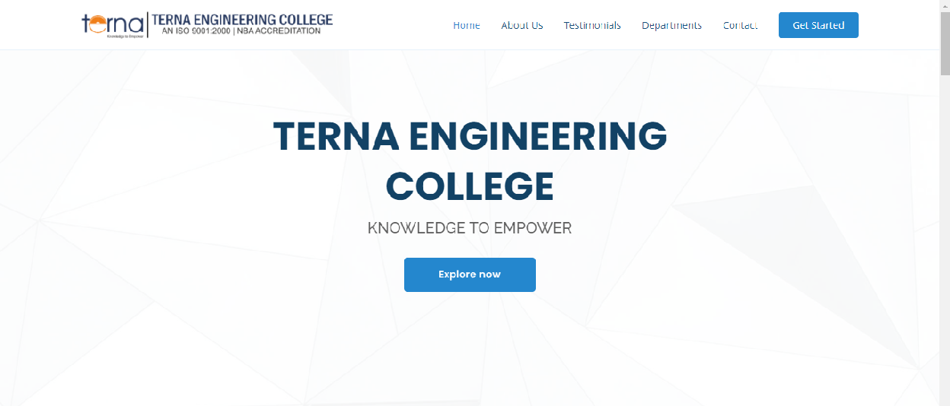

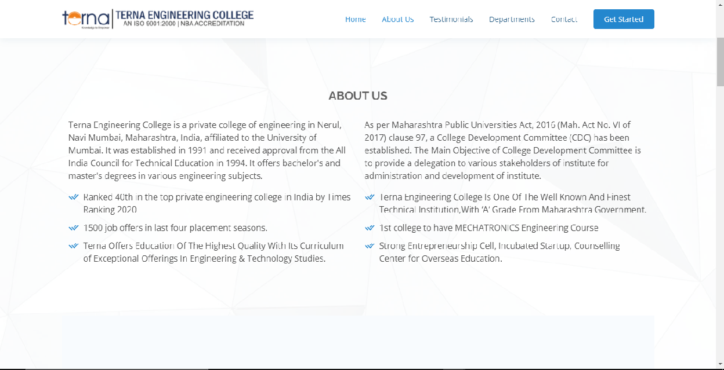

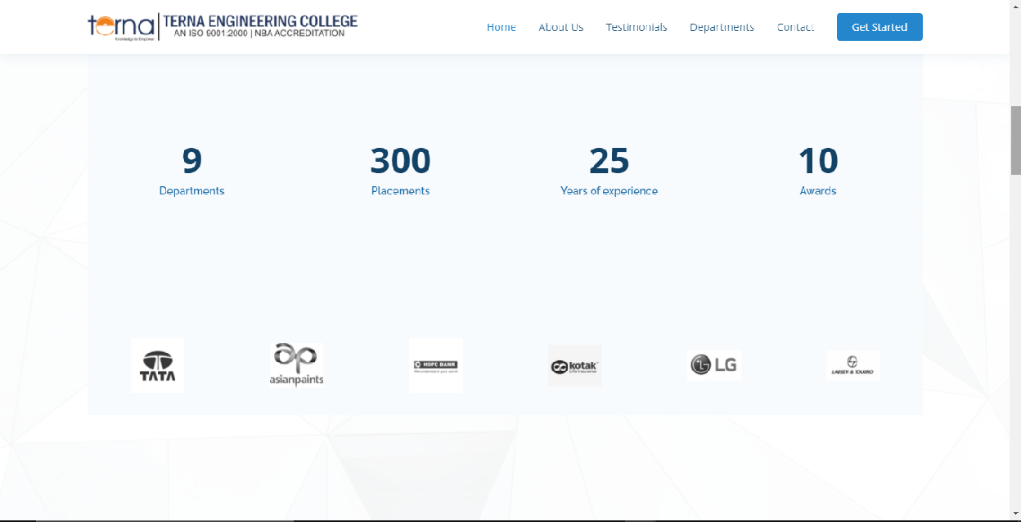

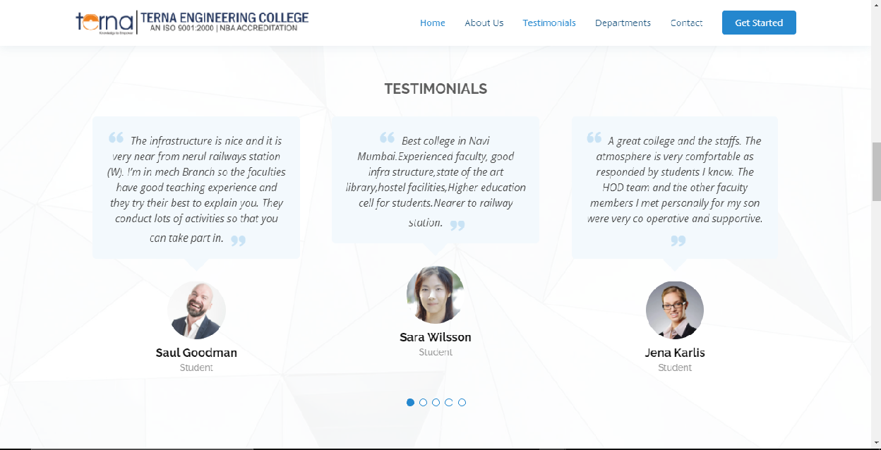

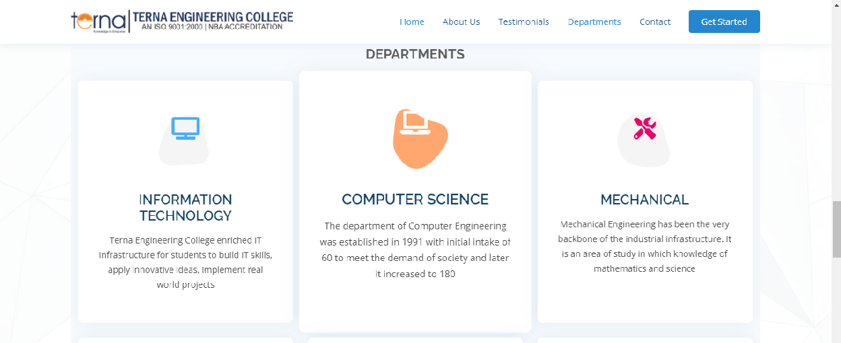

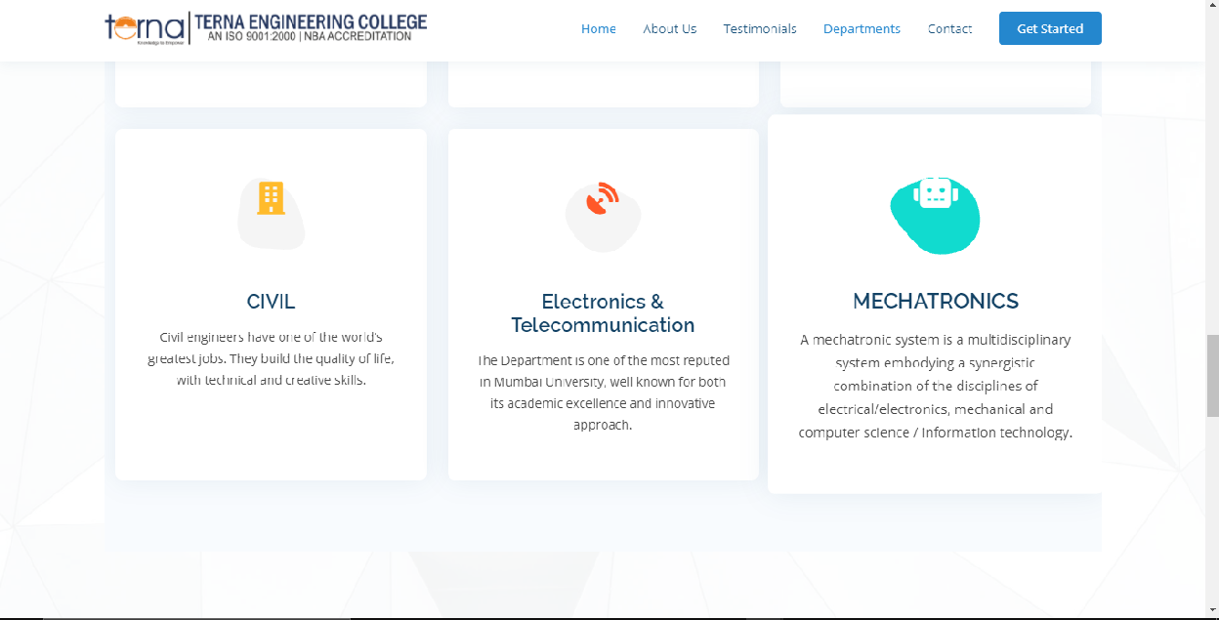

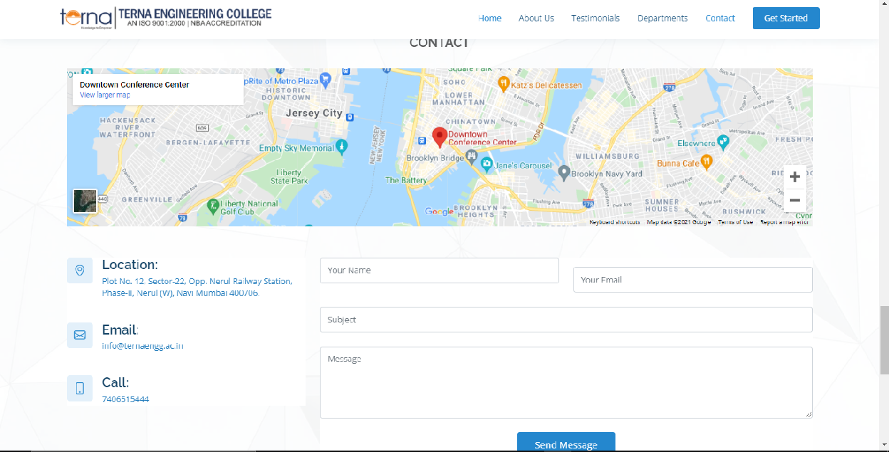

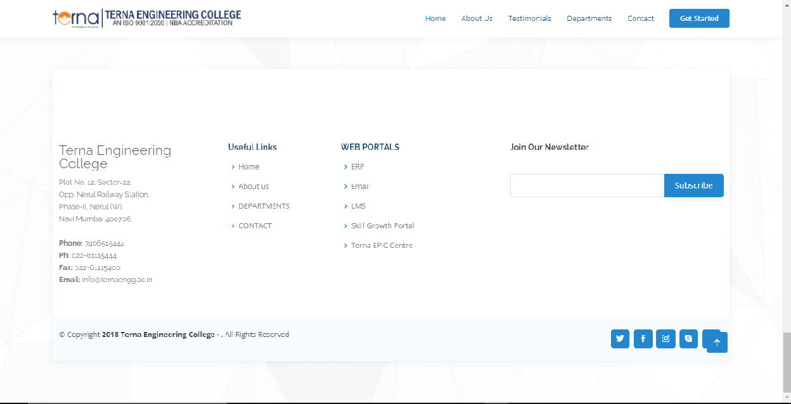

# MOBILE VIEW:

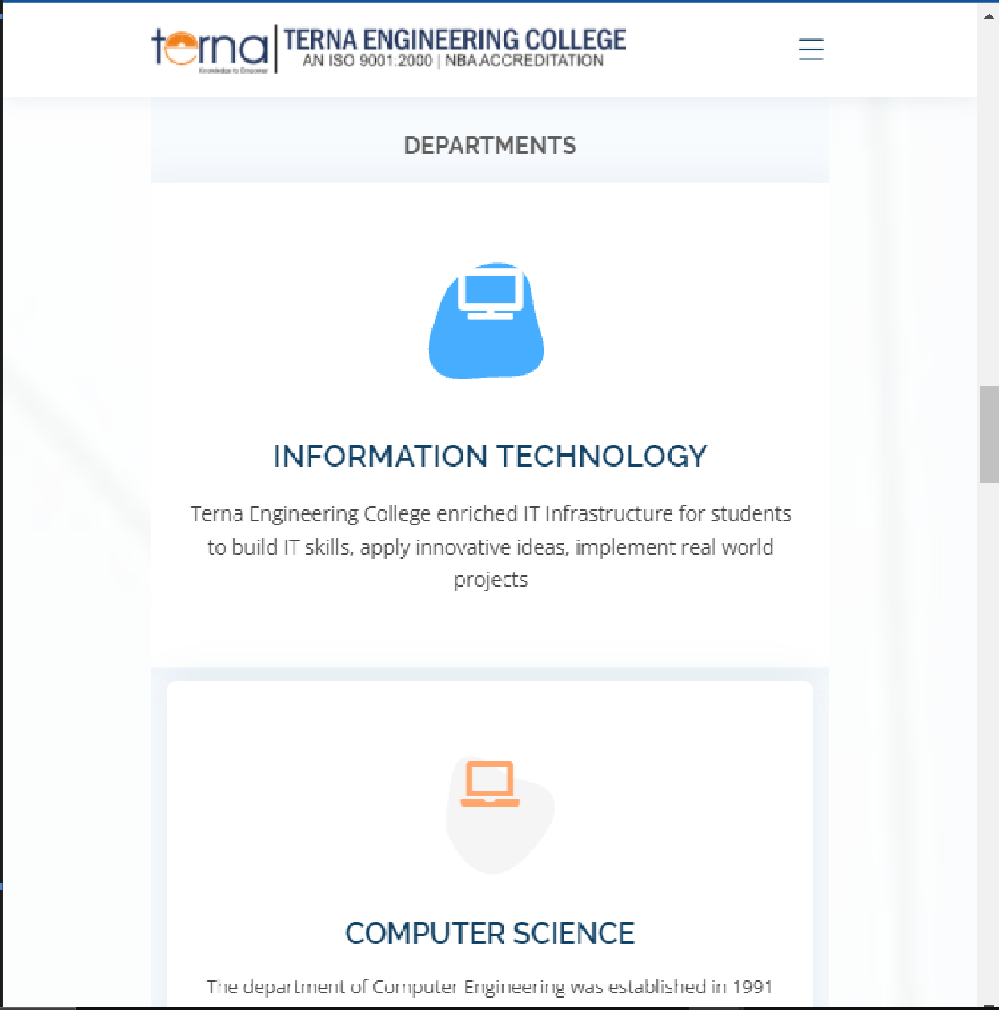

**CONCLUSION:**

In the above experiment we studied about bootstrap along with its different tags and also created a basic web page using bootstrap.