|  |  |
| --- | --- |
| Roll No. | A-75 |
| Student Name | Prasad Kashid |
| Subject | Internet Programming |
| Date Of Experiment |  |
| Date Of Submission |  |

# SUBJECT: INTERNET PROGRAMMING EXPERIMENT NO. 7

**AIM:** Implement State and Prop in react

**OBJECTIVE:** To apply the knowledge to implement State and Prop in react.

## LAB OUTCOMES: LO5

Construct front end applications using React

**THEORY:**

**State:**

React has another special built-in object called state, which allows components to create and manage their own data. So unlike props, components cannot pass data with state, but they can create and manage it internally.

State is a plain JavaScript object used by React to represent an information about the component’s current situation. It’s managed in the component (just like any variable declared in a function). The difference is while a “normal” variable “disappears” when their function exits, the state variables are preserved by React.

The state is an instance of React Component Class can be defined as an object of a set of observable properties that control the behavior of the component. In other words, the State of a component is an object that holds some information that may change over the lifetime of the component.

States can be used in Class Components, Functional components with the use of React Hooks (useState and other methods).

**Props:**

Props is short for properties and they are used to pass data between React components. Props are basically kind of global variable or object.

The ‘this.props’ is a kind of global object which stores all of a components props to access a prop from a function we do not need to use the ‘this’ keyword anymore. Functional components accept props as parameters and can be accessed directly.

The propName, that is the names of props are keys of this object.In Props React’s data flow between components is uni-directional (from parent to child only).We will consider two components Parent and Children to explain this. We will pass some information as props from our Parent component to the Child component. We can pass as many props as we want to a component.

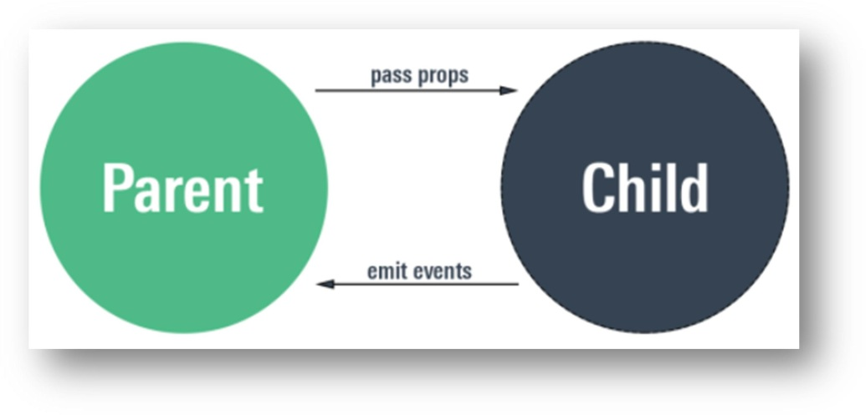

# Differences between state and props:

1. Components receive data from outside with props, whereas they can create and manage their own data with state
2. Props are used to pass data, whereas state is for managing data
3. Data from props is read-only, and cannot be modified by a component that is receiving it from outside
4. State data can be modified by its own component, but is private (cannot be accessed from outside)
5. Props can only be passed from parent component to child (unidirectional flow)
6. Modifying state should happen with the setState ( ) method.

## OUTCOMES:

**CODE:**

# index.js

import React from 'react';

import ReactDOM from 'react-dom'; import './index.css';

import Stateclass from './StateClass'

import reportWebVitals from './reportWebVitals';

ReactDOM.render(

<Stateclass clgname="Terna College Of Engineering"></Stateclass>, document.getElementById('root')

);

// If you want to start measuring performance in your app, pass a function

// to log results (for example: reportWebVitals(console.log))

// or send to an analytics endpoint. Learn more: https://bit.ly/CRA-vitals reportWebVitals();

import StateClass from './StateClass'; function App() {

return (

<div>

<StateClass></StateClass>

</div>

)

}

export default App;

import React from "react"; import './Stateclass.css'

export default class StateClass extends React.Component { constructor(props) {

super(props); this.state = {

Course: "Information Technology", Duration: "4 years",

collegename: this.props.clgname }

}

render() { return (

<div>

<link rel="stylesheet" href="https://cdnjs.cloudflare.com/ajax/libs/font- awesome/5.15.2/css/all.min.css" />

<div className="state">

<div class="shadow p-3 mb-5 bg-body rounded">

<div className="container">

<div className="title">

<div class="alert alert-info" role="alert">

******State And Props******

</div><br />

</div>

<div className="clgname">

<h3>{this.state.collegename}</h3>

</div><br />

<div className="clgdetails">

<div class="card" style={{ width: "22 rem" }}>

<div class="card-body">

<h5 class="card-title">College Details</h5>

<p class="card-text" style={{ color: "black" }}>

<i class="fas fa-phone-alt"></i><b style={{ marginLeft: "10px"

}}>022 6111 5444</b>

</p>

<p class="card-text" style={{ color: "black" }}>

<i class="far fa-envelope"></i><b style={{ marginLeft: "10px"

}}>[info@ternaengg.ac.in](mailto:info@ternaengg.ac.in)</b>

</p>

<p class="card-text" style={{ color: "black" }}>

<i class="fas fa-map-marker-alt"></i><b style={{ marginLeft:

"10px" }}>

Plot No. 12, Sector-22, Opp. Nerul Railway Station, Phase-II,

Nerul (W), Navi Mumbai 400706.</b>

</p>

<a href="https://ternaengg.ac.in/" target="_blank"

style={{ textDecoration: "None", color: "black" }} class="card- link"><i class="fas fa-globe">

</i><b style={{ marginLeft: "10px"

}}>https://ternaengg.ac.in/</b></a>

</div>

</div>

</div><br />

<div className="clgdetails">

<div class="card" style={{ width: "22 rem" }}>

<div class="card-body">

<p class="card-text" style={{ color: "black" }}><b>Course Name: </b>{this.state.Course}</p>

<p class="card-text" style={{ color: "black" }}><b>Duration:

</b>{this.state.Duration}</p>

</div> </div> </div>

</div>

</div>

</div>

</diV

@import url('https://fonts.googleapis.com/css2?family=Poppins:wght@800&display=swap');

.state{

width: 700px; margin-left: 450px; margin-top: 50px;

}

.title{

margin-left: 25px; width: 600px; text-align: center; font-weight: bold;

}

.clgname{

text-align: center;

}

.clgname h3{

font-family: Poppins,sans-serif;

}

## OUTPUT:



**CONCLUSION:** In the above experiment we have studied and performed the experiment to implement state a