1. SEM Defect Detection Hackathon Phase 1 Description
- Project Title: SEM Defect Detection & Edge AI Porting
- Team Name: Prasad MALAI
- Phase: Phase 1

2. Problem Statement
- Understanding the challenge of detecting defects in SEM images
- Importance of defect classification in semiconductor manufacturing
- Challenges: Limited datasets, edge deployment constraints

3. Idea Summary & Approach
- Generate synthetic SEM defect images using diffusion models
- Train lightweight CNN model for multi-class classification
- Two-stage inference pipeline:
  - Stage 1: Defect screening
  - Stage 2: Detailed defect classification
- Edge AI porting using NXP eIQ targeting i.MX RT series

4. Proposed Solution / Technology & Feasibility

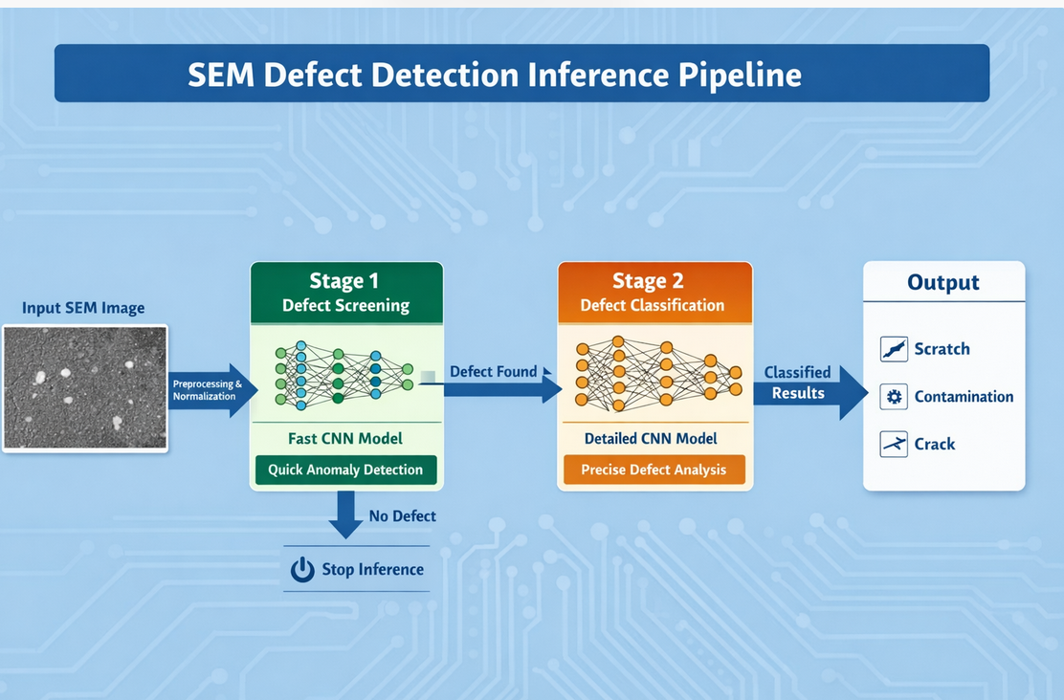
- Architecture overview

- Framework used: PyTorch
- Edge porting plan: ONNX → NXP eIQ
- Current status: ONNX generated, eIQ import pending

5. Dataset Plan & Class Design
- Total images planned/current: 500+
- Number of classes: 6 defect types + Clean + Other (8 total)
- Class List: Scratch, Open, Short, Bridge, Contamination, Other, Clean, TBD
- Class balance plan: Minimum ~50 images per class
- Train/Val/Test split: 70 / 15 / 15 %
- Image type: Grayscale SEM micrographs
- Labeling method/source: Generated using diffusion models

6. Baseline Model & Results (Phase 1)
- Architecture: CNN / MobileNet-style
- Training approach: From scratch
- Input size: 224×224
- Model size: ~X MB
- Framework: PyTorch
- Metrics on Test Split:
  - Accuracy: XX%
  - Precision / Recall: XX / XX
  - Confusion Matrix: [Image/Table placeholder]
- Notes: Model exported to ONNX, ready for eIQ porting (import pending)

7. Artifacts & Links
- GitHub Repository: https://github.com/PrasadM033/Hackathon_Submission_Semicunductor_defect_classification
- Dataset ZIP: https://github.com/PrasadM033/Hackathon_Submission_Semicunductor_defect_classification/tree/main/sem-dataset
- ONNX model: https://github.com/PrasadM033/Hackathon_Submission_Semicunductor_defect_classification/tree/main/output
- Results report (optional):

8. Research & References
- NXP eIQ documentation:
- DeepSEM-Net: Enhancing SEM defect analysis in semiconductor manufacturing with a dual-branch CNN-Transformer architecture (https://www.sciencedirect.com/science/article/abs/pii/S0360835224004224)
- Scanning electron microscopy-based automatic defect inspection for semiconductor manufacturing: a systematic review

