Stock Data Intelligence Dashboard — Turning Market Data into Actionable Insights

A mini financial analytics platform that transforms raw stock market data into meaningful insights through a clean backend system and interactive dashboard.

---

## Problem Statement

Raw stock data (open, close, high, low) is difficult to interpret directly.

This project focuses on:
- Converting raw financial data into **actionable insights**
- Providing a simple interface to **analyze stock performance**
- Demonstrating a **data → processing → insight → visualization pipeline**

This enables users to:
- Quickly understand stock performance without digging into raw data
- Compare companies efficiently
- Make better data-driven observations
---

## Features

- Fetches real stock data using **yfinance (NSE stocks)**
- Computes key financial metrics:
- Daily Return
- Moving Average (7-day)
- Volatility
- Trend Score
- Custom **Stock Health Score** with interpretation:
- Strong / Moderate / Risky
- Interactive chart visualization (Chart.js)
- Compare two stocks with performance insights
- REST API built with FastAPI

---

## Architecture

Raw Stock Data (yfinance)
↓
Data Processing (Pandas)
↓
Metrics & Insights Layer
↓
FastAPI Backend (REST APIs)
↓
Frontend Dashboard (HTML + Tailwind + Chart.js)

The system separates data fetching, transformation, and presentation layers to ensure modularity, clarity, and scalability.
---

## API Endpoints

### 1. Get Companies
GET /companies

### 2. Get Stock Data (Last 30 Days)
GET /data/{symbol}

### 3. Get Summary & Insights
GET /summary/{symbol}

Returns:
- 52-week high/low
- Average close
- Volatility
- Trend score
- Health score
- Insight (Strong / Moderate / Risky)

### 4. Compare Two Stocks
GET /compare?symbol1=INFY&symbol2=TCS

Returns:
- Performance difference
- Winner
- Human-readable insight

---

## Custom Insights

### Trend Score
Measures overall price movement:
(last_close - first_close) / first_close

### Volatility
Measures risk using standard deviation of returns.

### Stock Health Score
Combines trend and risk:
health_score = (trend * 0.6) + ((1 - volatility) * 0.4)

### 🔹 Insight Interpretation
- **Strong** → positive trend, low risk
- **Moderate** → balanced
- **Risky** → negative trend or high volatility

---

## Frontend Dashboard

- Sidebar with company list
- Interactive price chart
- Summary cards with metrics
- Compare feature with insights

---

## Setup Instructions

1. Clone the repository
git clone https://github.com/PrasadNaik1310/jarnox_stockDashboard
cd jarnox-stock-dashboard

2. Install dependencies

pip install -r requirements.txt

3. Run backend server
uvicorn backend.app.main:app --reload

4. Open frontend
cd frontend
Open frontend/index.html in browser

---

## Screenshots
- Dashboard view
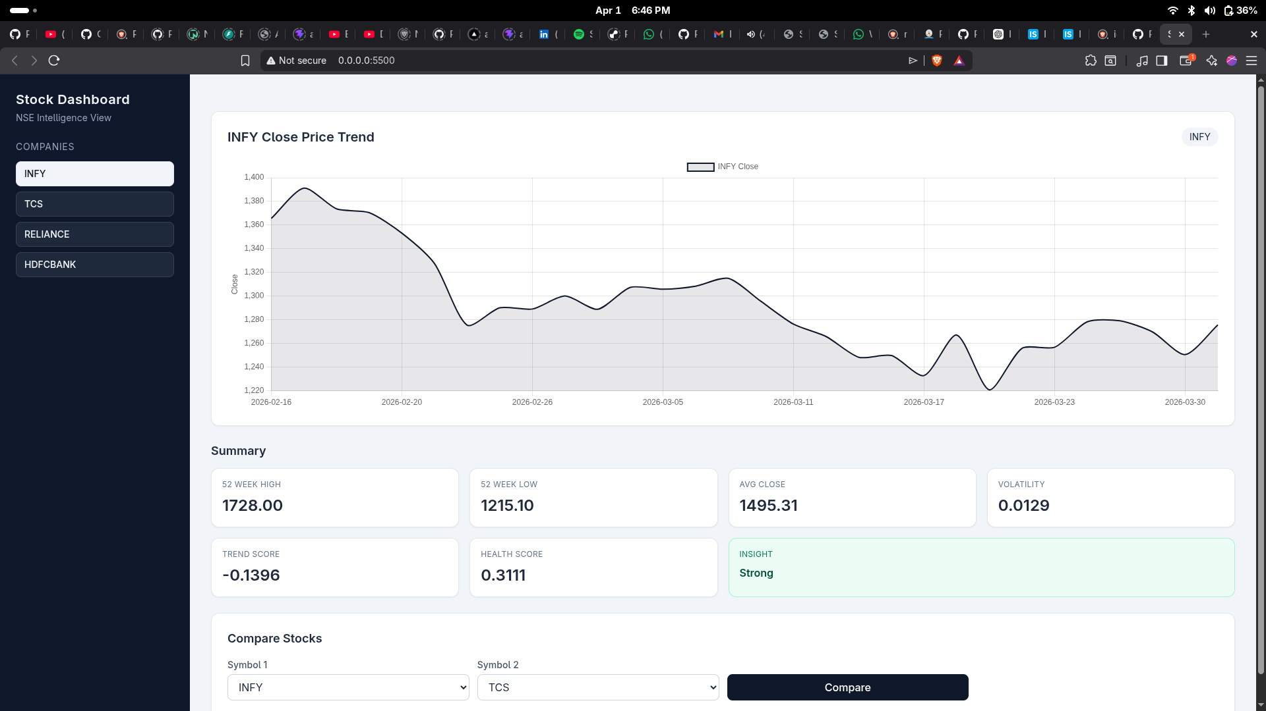
- Chart
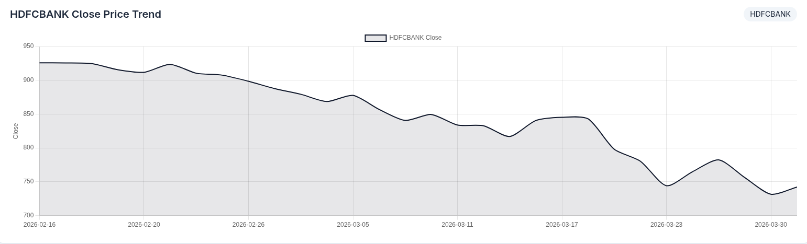
- Compare feature
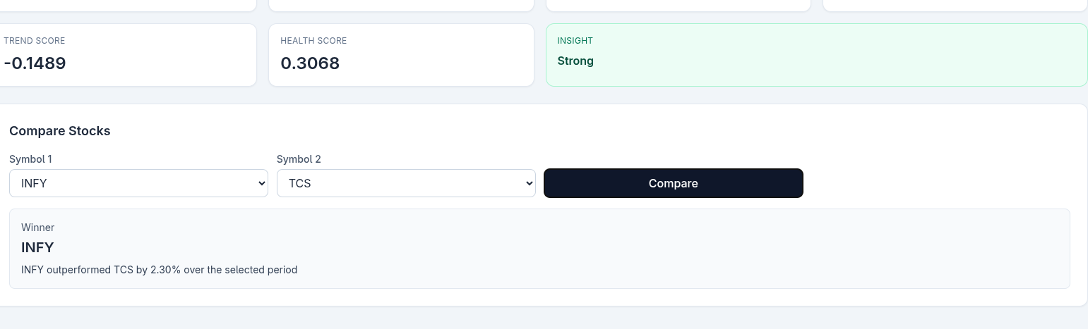

---

## Future Improvements

- Real-time stock data integration (using yfinance for now).
- Machine learning-based price prediction
- Caching for performance optimization
- Authentication & user watchlists

---

## Tech Stack

- **Backend:** FastAPI, Python
- **Data Processing:** Pandas, NumPy
- **Data Source:** yfinance
- **Frontend:** HTML, Tailwind CSS, Chart.js

---

## Conclusion

This project demonstrates how raw financial data can be transformed into meaningful insights through a structured backend system and simple visualization layer.

It emphasizes:
- Clean API design
- Data processing pipelines
- Insight generation over raw data

It focuses not just on data retrieval, but on interpretation — which is critical in real-world financial systems.

