Branch :- Computer Sci. & Engg. Class :- IV Year
Subject :- CG Sem :- VII
Teacher Manual
PRACTICAL NO 6

AIM: Write a program to draw a line using Bresenhem’s Algorithm.

Theory:
Basic Concept:
Move across the x axis in unit intervals and at each step choose between two different y coordinates

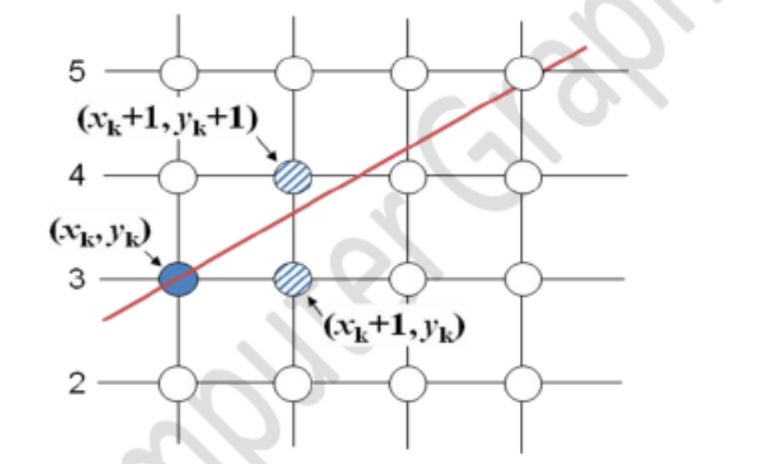

 For example, from position (2, 3) we have to choose between (3, 3) and (3, 4). We
would like the point that is closer to the original line
 So we have to take decision to choose next point. So next pixels are selected based
on the value of decision parameter p. The equations are given in below algorithm.

Algorithm :
1. Input the two line end-points, storing the left end-point in (x0, y0)
2. Plot the point (x0, y0)
3. Calculate the constants Δx, Δy, 2Δy, and (2Δy - 2Δx) and get the first value for the decision parameter as:
4. At each xk along the line, starting at k = 0, perform the following test. If pk < 0, the next point to plot is (xk+1, yk ) and:
Otherwise, the next point to plot is (xk+1, yk+1) and:
5.Repeat step 4 (Δx – 1) times

C Program Code:

#include<stdio.h>
#include<graphics.h>
void drawline(int x0, int y0, int x1, int y1)
{
int dx, dy, p, x, y;
dx=x1-x0;
dy=y1-y0;
x=x0;
y=y0;
p=2*dy-dx;
while(x<x1)
{
if(p>=0)
{
putpixel(x,y,7);
y=y+1;
p=p+2*dy-2*dx;
}
else
{
putpixel(x,y,7);
p=p+2*dy;}
x=x+1;
}
}
int main()
{
int gdriver=DETECT, gmode, error, x0, y0, x1, y1;
initgraph(&gdriver, &gmode, "c:\\turboc3\\bgi");
printf("Enter co-ordinates of first point: ");
scanf("%d%d", &x0, &y0);
printf("Enter co-ordinates of second point: ");
scanf("%d%d", &x1, &y1);
drawline(x0, y0, x1, y1);
return 0;
}

CONCLUSION:
Thus a program to draw a line using Bresenhem’s algorithm studies and executed.

